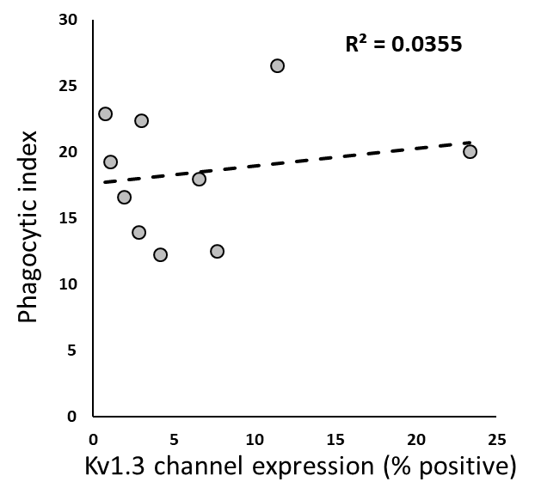
Additional file 5: Figure S5. Correlation between functional Kv1.3 channel expression and phagocytic capacity for fluorescent microspheres in acutely-isolated CNS MPs following tMCAO. Samples collected from ipsilateral and contralateral hemispheres were treated as independent events and PE-microsphere phagocytosis and functional Kv1.3 channel measurement by ShK-F6CA were performed in parallel on the sample samples.

