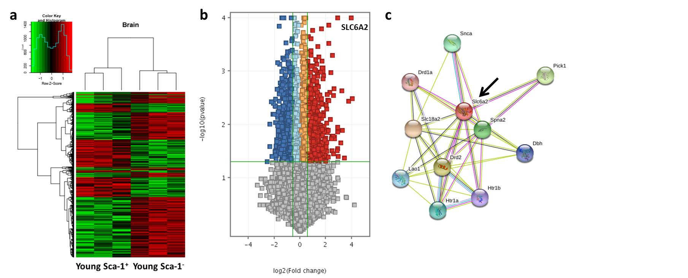
Figure S3: Genetic changes in the whole brain of old mice reconstituted with young Sca-1⁺ or Sca-1⁻ cells. (a) Hierarchical clustering on gene level counts of differentially expressed genes as a function of experimental treatment for n = 3 mice per groups (FC ≥ 1.5, P ≤ 0.05). (b) Volcano plot of 2056 significantly dysregulated genes and (c) a STRING interaction network for the norepinephrine transporter gene, SLC6A2, depicted by the black arrow (right).

