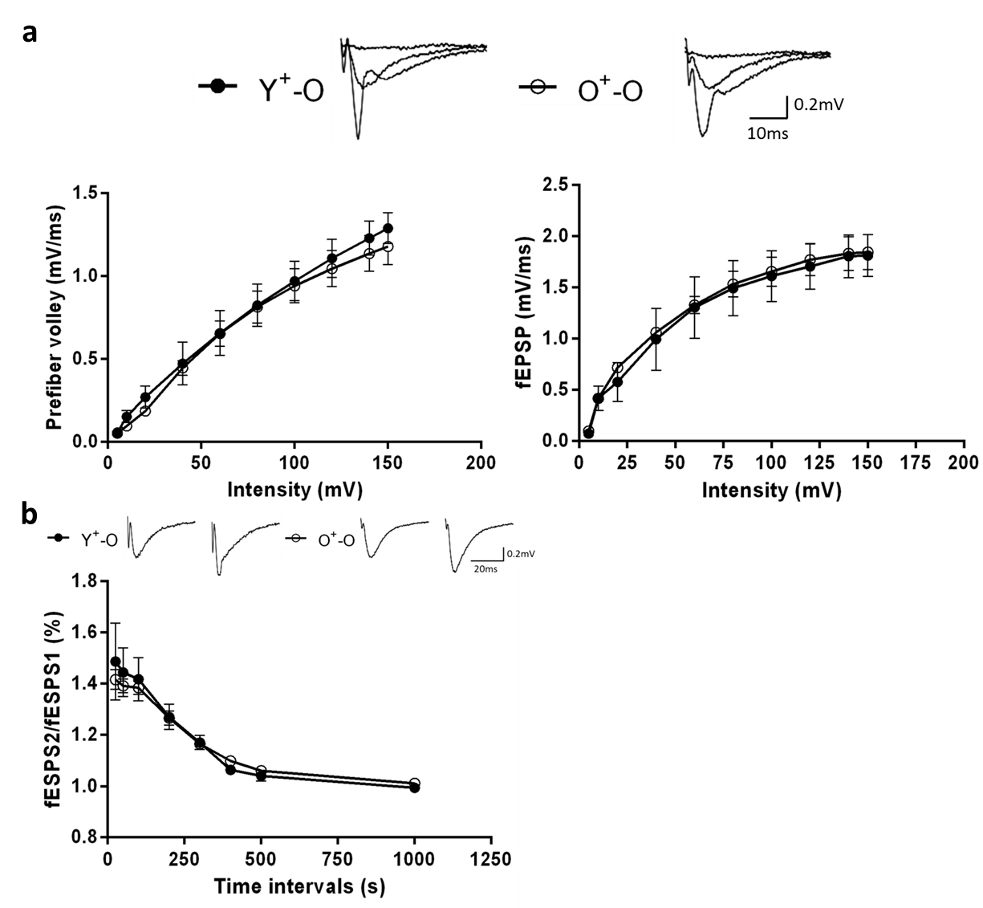

Figure S6: Basal synaptic transmission and presynaptic function in the CA1 hippocampus. (a) Input-output curves for n = 4 hippocampal slices per group. (b) Paired-pulse facilitation for at least n = 7 hippocampal slices per group.

