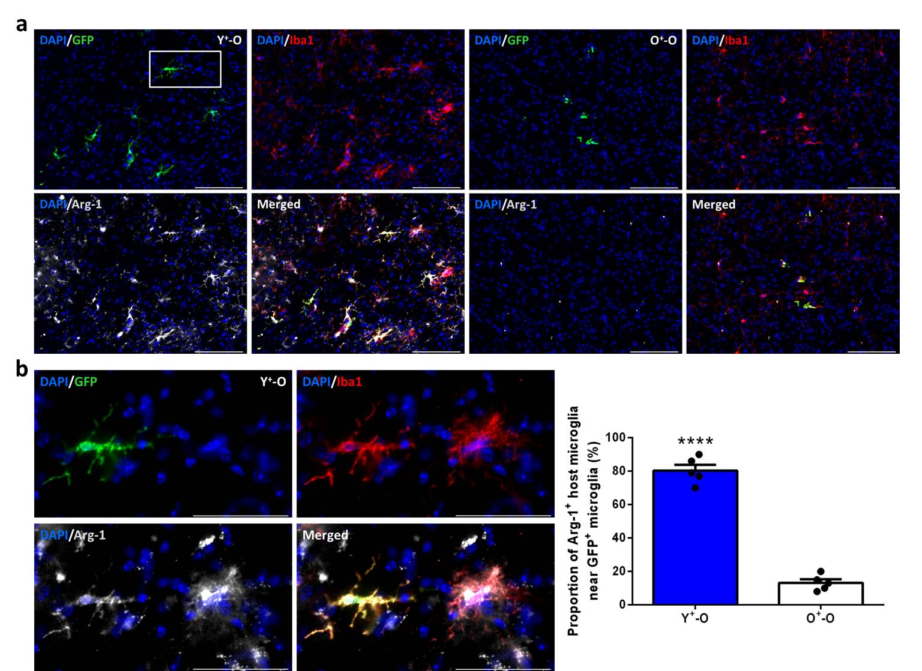
Figure S7: Young donor microglia can influence the polarized state of old host microglia. (a) Immunostaining for anti-inflammatory (Arg-1⁺) donor (GFP⁺) and host (GFP⁻) microglia in a midbrain section containing the hippocampus. (b) Higher magnification inset from a Y⁺-O mouse demonstrating signal localization and cell proximity (left) and quantification of immunostaining (right). n = 5 mice per group for five randomly selected regions. Scale bars 100 µm (a) and 50 µm for inset (b). Data are mean ± s.e.m. ****P ≤ 0.0001 (unpaired two-sided t-tests (b)).

