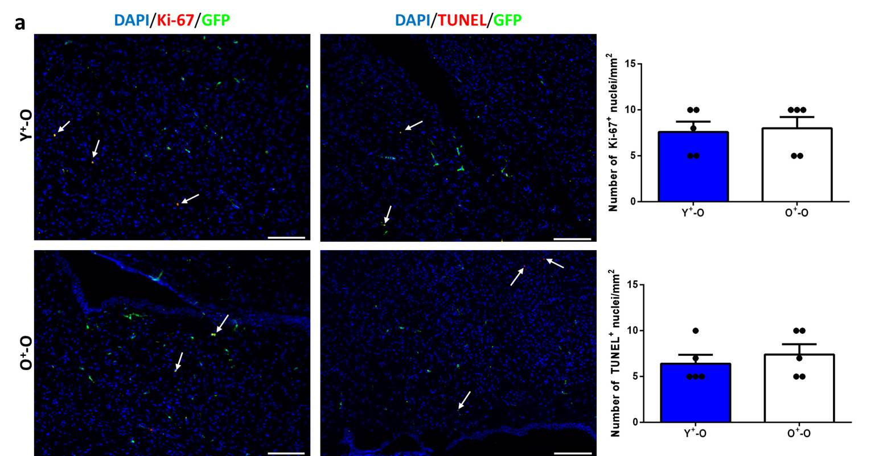
Figure S8: Apoptosis and cell proliferation around the locus coeruleus and fourth ventricle. (a) Immunostaining and quantification of proliferating Ki-67⁺ and apoptotic TUNEL⁺ nuclei (shown in red). n = 5 mice per group. Scale bar, 200 µm (a). Data are mean ± s.e.m. (unpaired two-sided t-tests (a)).

