Supporting Information for:
A Primary Neural Cell Culture Model to Study Neuron, Astrocyte and Microglia Interactions in Neuroinflammation
Noah Goshi¹, Rhianna K. Morgan², Pamela J. Lein², Erkin Seker³
Departments of ¹Biomedical Engineering, ²Molecular Biosciences, and ³Electrical and Computer Engineering, University of California - Davis, Davis, CA 95616
Supplementary Figure 1: Immunostained images of the co- and tri-cultures at DIV 14 showing the co-localization of f-actin (cyan) and β-III tubulin (red) indicative of dendritic spines. Scale bar = 20 µm.
Supplementary Figure 2: Tri-culture media supplement requirements for microglia survival at DIV 7. The results indicate that IL-34 is required for microglial survival in the tri-culture. The figure shows the mean ± SD of the technical replicates (n = 4) of a single biological replicate.

Supplementary Figure 3: The tri-culture shows reduced caspase 3/7 activity at DIV 9 (n = 6). The letters above the bars indicate statistically-distinct groups (p < 0.05), while the points indicate the values of the technical replicates.

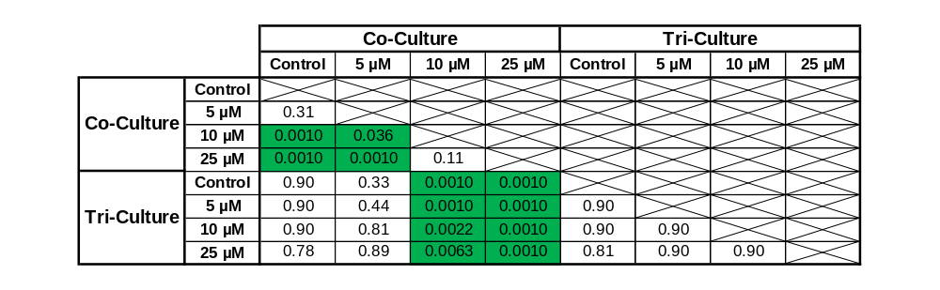
Supplementary Data Table 1: Analysis of the simple main effects (Tukey test) from Figure 4B. The p-values from each pairwise result are shown on the table, with p-values less than 0.05 highlighted in green.

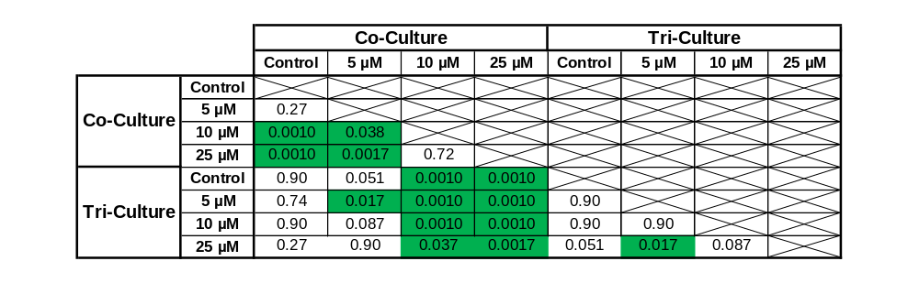
Supplementary Data Table 2: Analysis of the simple main effects (Tukey test) from Figure 4C. The p-values from each pairwise result are shown on the table, with p-values less than 0.05 highlighted in green.

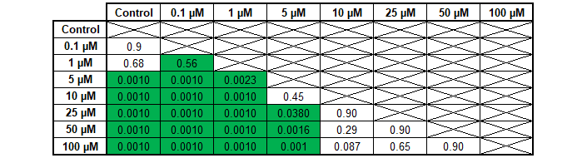
Supplementary Data Table 3: Analysis of the simple main effects (Tukey test) from Figure 4E. The p-values from each pairwise result are shown on the table, with p-values less than 0.05 highlighted in green.

Supplementary Figure 4: Representative images of the co- and tri-cultures 48 h following a 1 h treatment with different concentrations of glutamate or vehicle control. The cultures were immunostained for the three cell types of interest: neurons – anti-βIII-tubulin (red), astrocytes – anti-GFAP (green), microglia – anti-Iba1 (orange) and the general nuclear stain DAPI (blue). Scale bar = 100 µM.

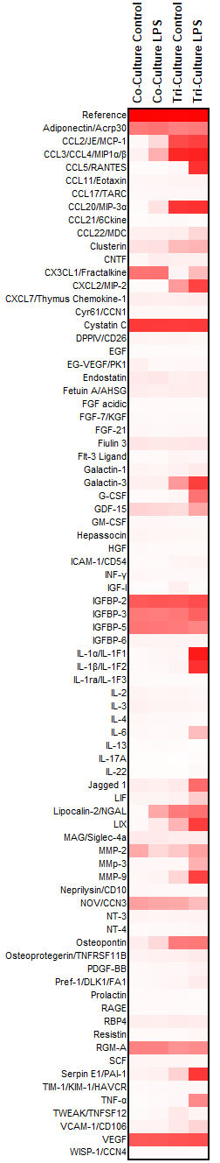
Supplementary Figure 5: Complete cytokine profile from Figure 5A.
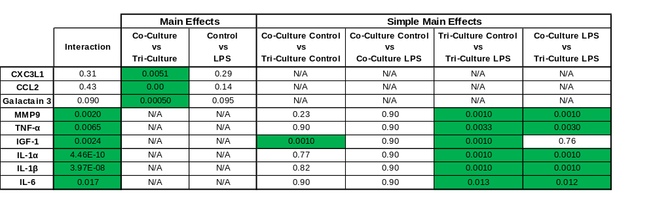
Supplementary Data Table 4: Statistical analysis of Figure 5B-J. The p-values from the 2-way ANOVA and simple main effects analysis (Tukey Test) are shown. p-values < 0.05 are highlighted in green.

Supplementary Figure 6: There are approximately 2% of the total cell population that was not clearly identifiable as neurons, astrocytes or microglia. (A) Mean ± SD of cells from each culture type not reactive for antibodies selective for neurons, astrocytes or microglia (n = 3). (B) Representative images from DIV 7 co- and tri-cultures immunostained for NG2 (red), a biomarker of oligodendrocyte precursor cells (OPCs), and reacted with DAPI (blue), scale bar = 100 µm.

Supplementary Figure 7: Change in number of cells following incubation with LPS or 25 µM glutamate. (A) Percent change in cell number following incubation with LPS. (B) Percent change in cell number following incubation with 25 µM glutamate. All graphs display mean ± SD (n = 3).

