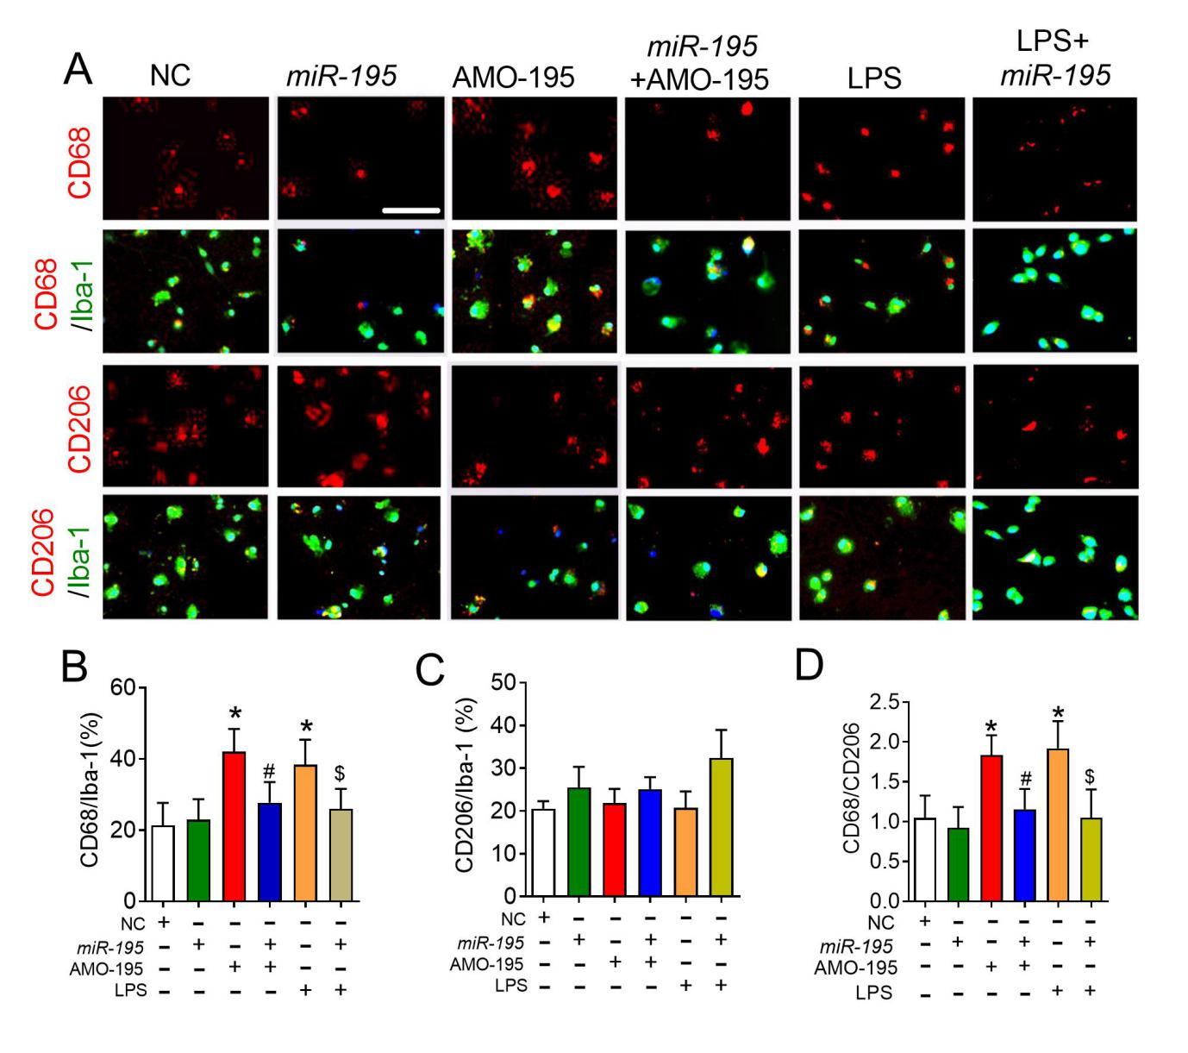
Supplementary Fig.2. MiR-195 prevents LPS induced activation of microglia towards M1 profile of cultured BV2 cells.
(A) Representative images of CD68 or CD206 expression in Iba-1⁺ BV2 cells by immunofluorescence staining after transfection of NC, miR-195, AMO-195, miR-195+AMO-195, LPS or LPS+miR-195.Scale bar: 40 μm. (B&C) Quantification of the percentage of CD68 (B) or CD206 (C) in Iba-1⁺ BV2 cells. (D) Quantification of the ratio of CD68/CD206 in BV2 cells. Bars represent the mean ± SD; n= 9 from 3 batches of cell culture. *P<0.05 vs NC; #P<0.05 vs AMO-195; $P<0.05 vs LPS. All data were analyzed using one-way ANOVA followed by Tukey test.

