Additional file 1.
Supplementary Materials

Supplementary Methods
Cell viability measurement
Cell viability was measured by a colorimetric assay with methyl thiazolyl tetrazolium (MTT). Primary cultures of astrocytes or U251 cells grown in 96-well plates were exposed to SAA (1 μM), SB203580 (5-10 μM), FR180204 (5-10 μM), SP600125 (5-10 μM), or LY294002 (5-10 μM) for 12 h and 16 h. The culture medium was removed and the cells were incubated with MTT (1 mg/ml) at 37 °C for 4 h. After three washes with phosphate-buffered saline (PBS, pH 7.4), the insoluble formazan product was dissolved in dimethyl sulfoxide. The optical density at 570 nm was determined on a FlexStation III plate reader (Molecular Devices, Mountain View, CA). Cell viability was expressed as a percentage of control.

Supplementary Figures
Figure Legends
Figure S1. Effect of SAA, MAPKs and PI3K inhibitors on cell viability of primary astrocytes and/or U251 cells. (A) Primary cultures of astrocytes and U251 cells were exposed to SAA (1 μM), and the cell viability was detected after 16 h by MTT. U251 cells were exposed to SB203580 (5-10 μM), FR180204 (5-10 μM), SP600125 (5-10 μM), or LY294002 (5-10 μM), and the cell viability was detected after 12 h (B) or 16 h (C) by MTT. Data are expressed as percentage of surviving cells over control cells. Results are expressed as the mean ± SEM based on three independent experiments, each in triplicate. *** p < 0.001 compared with the control (DMEM medium).

Figure S2. Inhibiting p38 alleviates the interference of SAA on astrocyte migration in a dose-dependent manner. U251 cells were incubated with SAA (1 μM) with or without a 15 min pretreatment with SB203580 (1-10 μM), FR180204 (0.1-5 μM), SP600125 (0.1-5 μM), or LY294002 (0.1-5 μM). At 12 h after incubation, the cell migration was examined by 48-well chemotaxis chambers. Representative images of migrated cells on membrane filters were shown in (A) and quantified data were shown in (B). Magnification, × 400. Results are expressed as the mean ± SEM based on three independent experiments, each in triplicate. *** p < 0.001 compared with the control (DMEM medium). # p < 0.05 compared with SAA treatment group.

Figure S3. Effect of MAPKs and PI3K inhibitors on the migration of U251 cells. U251 cells were treated for 12 h with SB203580 (10 μM), FR180204 (5 μM), SP600125 (5 μM), or LY294002 (5 μM). The cell migration was examined by 48-well chemotaxis chambers. Representative images of migrated cells on membrane filters were shown in (A) and quantified data were shown in (B). Magnification, × 400. Results are expressed as the mean ± SEM based on three independent experiments, each in triplicate.

Figure S1
Figure S2
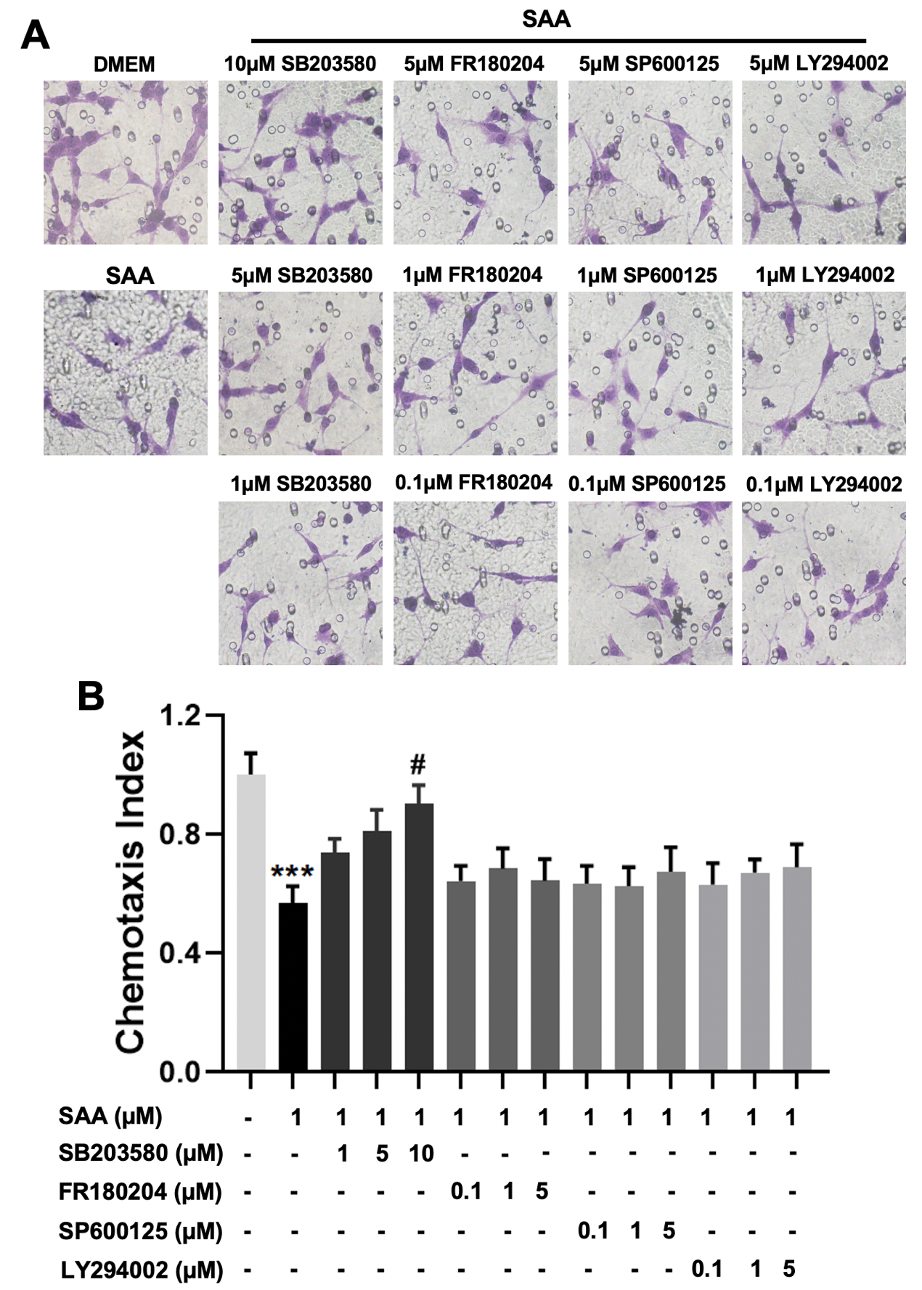

Figure S3

