Supporting information for:
Astrocyte remodeling in the beneficial effects of long-term voluntary exercise in Alzheimer’s disease
Irina Belaya¹, Mariia Ivanova¹, Annika Sorvari¹, Marina Ilicic², Sanna Loppi¹, Hennariikka Koivisto¹, Alessandra Varricchio¹, Heikki Tikkanen³, Frederick R. Walker², Mustafa Atalay³, Tarja Malm¹, Alexandra Grubman^{4,5,6}, Heikki Tanila¹, Katja M. Kanninen¹
¹ A.I. Virtanen Institute for Molecular Sciences, University of Eastern Finland, 70211, Kuopio, Finland,² School of Biomedical Sciences and Pharmacy and the Priority Research Centre for Stroke and Brain Injury, The University of Newcastle, University Dr, Callaghan, NSW 2308, Australia, ³ Institute of Biomedicine, University of Eastern Finland, 70211 Kuopio, Finland, ⁴ Department of Anatomy and Developmental Biology, Monash University, Australia, ⁵ Development and Stem Cells Program, Monash Biomedicine Discovery Institute, Australia, ⁶ Australian Regenerative Medicine Institute, Monash University, Australia.

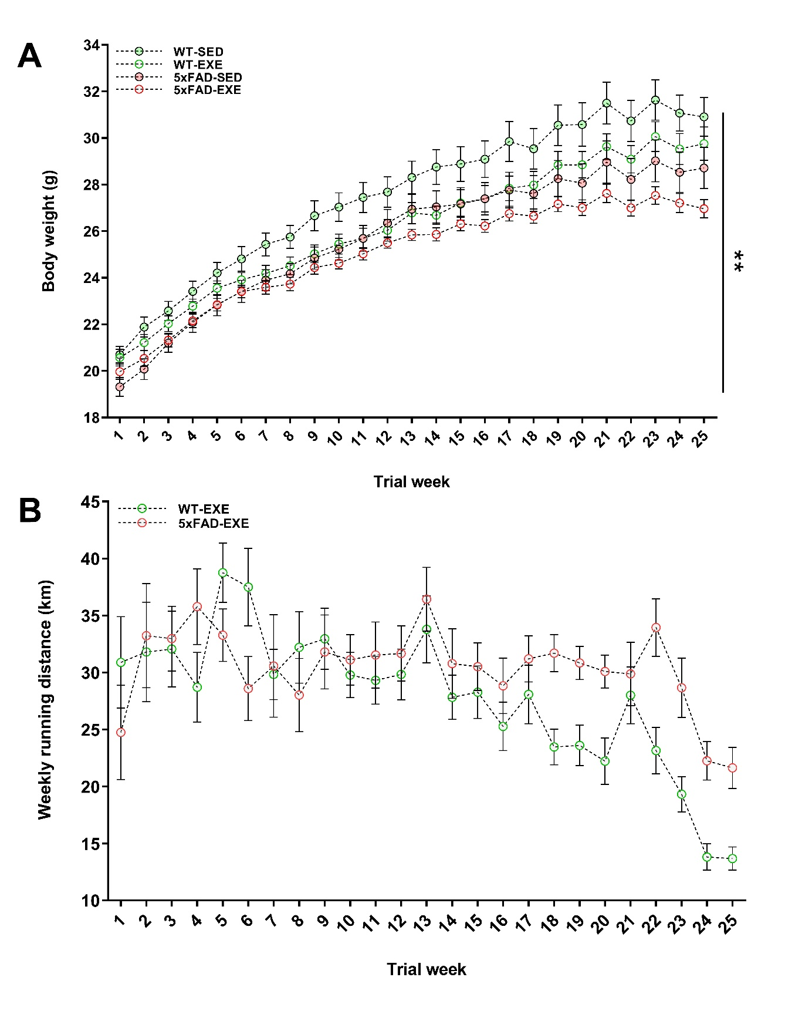Supplementary Figure 1. Body mass and running activity evolution of WT and 5xFAD mice as measured on a weekly basis. A 5xFAD mice have significantly lower body weight than WT mice, whereas exercise slightly reduces body weight in all mice (*p <0.01, #p = 0.054). B Mice had free access to a running wheel from 1.5 to 7 months of age. The running distance was monitored for each mouse by using running counters. No significant differences were observed in the running distance between WT and 5xFAD mice (p = 0.166). Data is presented as mean ± SEM, one-way and two-way ANOVA for repeated measures, n = 20-22/group. « * » genotype effect, **p<0.01.
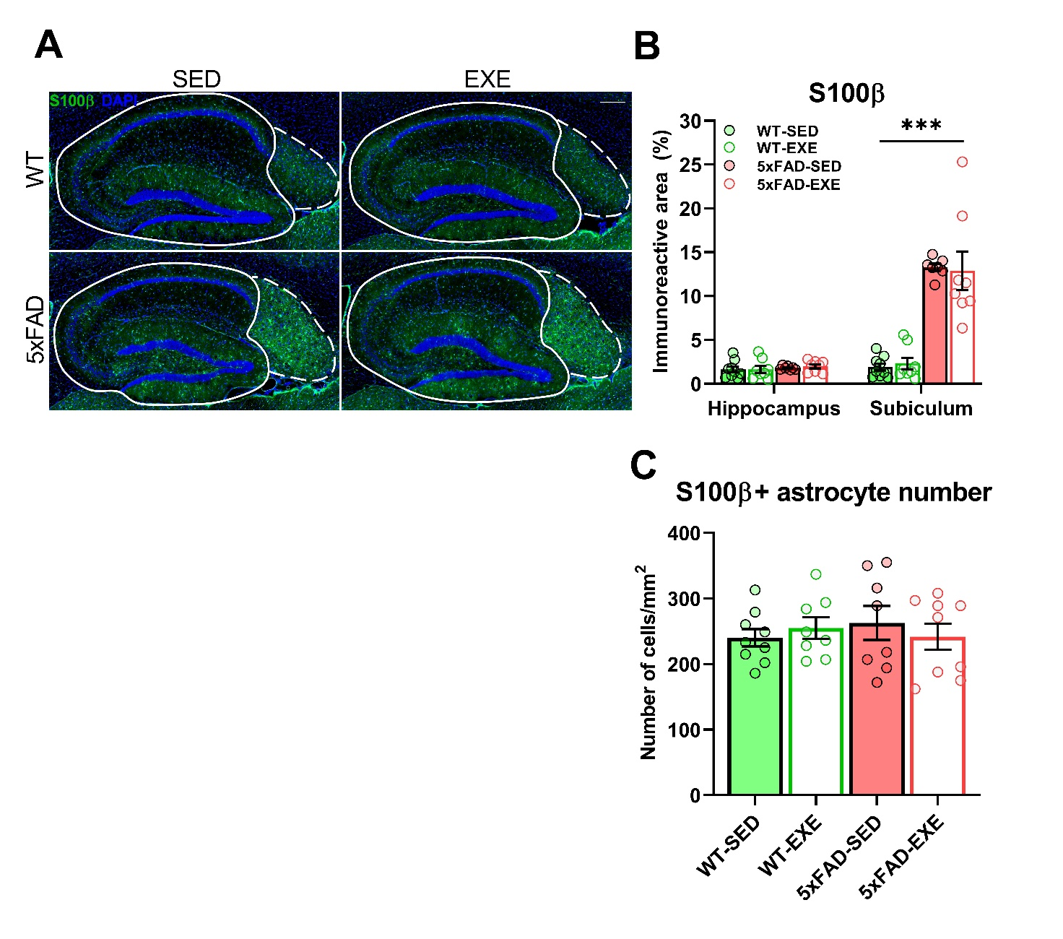

Supplementary Figure 2. Effect of voluntary physical exercise on S100β-positive astrocytes in hippocampi. Representative images of S100β-positive astrocytes (A, green) and DAPI (blue) in the hippocampal area of WT-SED, WT-EXE, 5xFAD-SED, 5xFAD-EXE mice. Solid and dotted lines represent quantified hippocampi and subiculum areas, respectively. Scale bars: 200 μm. S100β (B) levels were quantified by measuring the percentage of positive immunoreactive area in hippocampi and subiculum. Number of S100β -positive astrocytes per squared mm in hippocampi (C). All data are presented as mean (±SEM). 2-way ANOVA used to measure genotype and exercise effect between WT and 5xFAD mice. n=8/group, « * » genotype effect: ***p<0.001.

Antibody | Catalog number | Company
Amyloid β,clone WO-2, mouse | MABN10 | Millipore, Burlington, MA, USA
Iba-1, rabbit | 019-19741 | Wako, Tokyo, Japan
GFAP, rabbit | Z033429-2 | Dako, Glostrup, Denmark
GFAP, chicken | ab4674 | Abcam, Cambridge, MA, USA
S100β, rabbit | ab52642 | Abcam, Cambridge, MA, USA
GS, rabbit | ab73593 | Abcam, Cambridge, MA, USA
ALDH1L1, rabbit | ab87117 | Abcam, Cambridge, MA, USA
NeuN, rabbit | 711054 | Invitrogen, Waltham, MA, USA
Doublecortin, rabbit | 4604 | Cell Signaling Technology, Danvers, MA, USA
BDNF, rabbit | SAB2108004 | Sigma-Aldrich, St. Louis, MO, USA
BDNF, rabbit | ab108319 | Abcam, Cambridge, MA, USA
Synaptophysin, rabbit | MA5-14532 | Invitrogen, Waltham, MA, USA
PSD95, rabbit | 3450 | Cell Signaling Technology, Danvers, MA, USA
β-actin, mouse | A5441 | Sigma-Aldrich, St. Louis, MO, USA
Goat anti-rabbit IgG, Alexa Fluor 488 | A11008 | ThermoFisher Scientific, Waltham, MA, USA
Goat anti-mouse IgG, Alexa Fluor 568 | A11004 | ThermoFisher Scientific, Waltham, MA, USA
Goat anti-chicken IgG, Alexa Fluor 568 | A11041 | ThermoFisher Scientific, Waltham, MA, USA
Goat anti-rabbit IgG-HRP conjugate | 170-65-15 | BioRad, Hercules, CA, USA
Donkey anti-mouse IgG-Cy5 cojugate | 715-175-151 | Jackson Immuno Res. Lab., West Grove, PA, USA
TaqMan primer (Amplicon Length) | Catalog number, ThermoFisher Scientific, Waltham, MA, USA
Gapdh (93) | Hs02758991_g1
Gfap (75) | Mm01253033_m1
S100β (69) | Mm00485897_m1
Slc1a3 (71) | Mm00600697_m1
Atp1b2 (80) | Mm00442612_m1
Glul (112) | Mm00725701_s1
Adh1l1 (73) | Mm03048957_m1
Serping1_A1(103) | Mm00437835_m1
Fkbp5_A1(74) | Mm00487406_m1
Srgn_A1(111) | Mm01169070_m1
S100f10_A2(71) | Mm00501457_m1
Aif1(82) | Mm00479862_g1
Bdnf (108) | Mm01334042_m1

Supplementary Table 1. List of antibodies and TaqMan primers used in this study.

 | Cytokine concentration (pg/ml) |  |  |  | Statistics
 | WT-SED | WT-EXE | 5xFAD-SED | 5xFAD-EXE | Genotype | Exercise | Interaction
 | (n=7) | (n=5) | (n=7) | (n=6) | Genotype | Exercise | Interaction
IL-6 | 2.1 ± 0.2 | 2.5 ± 0.3 | 2.2 ± 0.2 | 2.6 ± 0.1 | 0.65 | 0.07 | 0.97
IL-10 | 0.0 ± 0.0 | 0.8 ± 0.6 | 0.3 ± 0.2 | 0.9 ± 0.3 | 0.50 | 0.03# | 0.61
MCP-1 | 30.4 ± 1.6 | 32.3 ± 1.9 | 36.1 ± 2.0 | 38.5 ± 1.4 | 0.003** | 0.24 | 0.89
IFNγ | 0.07 ± 0.04 | 0.16 ± 0.05 | 0.17 ± 0.05 | 0.20 ± 0.07 | 0.24 | 0.35 | 0.62
TNFα | 0.6 ± 0.2 | 0.9 ± 0.2 | 1.0 ± 0.1 | 0.9 ± 0.2 | 0.46 | 0.66 | 0.36
IL12p70 | 2.4 ± 0.3 | 3.0 ± 0.4 | 3.7 ± 0.4* | 2.3 ± 0.3# | 0.37 | 0.33 | 0.02§

Supplementary Table 2. Effect of AD and voluntary physical exercise on cytokine levels in the hippocampus. Data are presented as mean (±SEM). 2-way ANOVA was used to measure genotype and exercise effect between WT and 5xFAD mice followed by unpaired t-test comparison in case of significant interaction between two factors (genotype*exercise). « * » genotype effect, « # » exercise effect, « § » interaction: *p<0.05, **p<0.01, #p<0.05, §p<0.05.

 | ΔCт |  |  |  | Statistics
 | WT-SED | WT-EXE | 5xFAD-SED | 5xFAD-EXE | Genotype | Exercise | Interaction
 | (n=5) | (n=5) | (n=5) | (n=5) | Genotype | Exercise | Interaction
GFAP | 4.2 ± 0.1 | 4.1 ± 0.1 | 2.2 ± 0.1 | 2.4 ± 0.2 | <0.0001*** | 0.78 | 0.20
S100β | 5.0 ± 0.1 | 4.9 ± 0.1 | 4.7 ± 0.1 | 4.7 ± 0.2 | 0.02* | 0.80 | 0.25
Slc1a3 | 4.8 ± 0.2 | 4.8 ± 0.3 | 5.2 ± 0.2 | 5.2 ± 0.3 | 0.02* | 0.56 | 0.47
Atp1b2 | 4.9 ± 0.1 | 5.2 ± 0.4 | 5.4 ± 0.1 | 5.4 ± 0.1 | 0.04* | 0.37 | 0.32
Glul | 1.10 ± 0.08 | 1.06 ± 0.03 | 1.14 ± 0.07 | 1.27 ± 0.09 | 0.11 | 0.57 | 0.30
ALDH1L1 | 7.13 ± 0.04 | 7.20 ±0.10 | 7.06 ±0.04 | 7.16 ± 0.16 | 0.43 | 0.27 | 0.66
Serping1_A1 | 10.3 ± 0.3 | 10.8 ± 0.3 | 10.3 ± 0.3 | 10.8 ± 0.1 | 0.88 | 0.09 | 0.98
Fkbp5_A1 | 7.1 ± 0.1 | 7.1 ± 0.3 | 6.7 ± 0.1 | 6.8 ± 0.1 | 0.02* | 0.91 | 0.88
Srgn_A1 | 10.4 ± 0.4 | 11.0 ± 0.3 | 10.0 ± 0.2 | 10.2 ± 0.2 | 0.07 | 0.19 | 0.59
S100A10_A2 | 7.52 ± 0.04 | 7.45 ± 0.02 | 7.19 ± 0.06** | 7.41 ± 0.06# | 0.002** | 0.17 | 0.014§
Aif1 | 9.2 ± 0.1 | 9.1 ± 0.1 | 7.7 ± 0.1 | 7.7 ± 0.1 | <0.0001*** | 0.96 | 0.63
BDNF | 7.5 ± 0.1 | 7.5 ± 0.1 | 7.6 ± 0.1 | 7.5 ± 0.1 | 0.48 | 0.79 | 0.49

Supplementary Table 3. Effect of AD and voluntary physical exercise on mRNA expression of glial markers and BDNF in the hippocampus. Data are normalized by GAPDH C_{T} values and presented as mean (±SEM). 2-way ANOVA was used to measure genotype and exercise effect between WT and 5xFAD mice followed by unpaired t-test comparison in case of significant interaction between two factors (genotype*exercise). « * » genotype effect, « # » exercise effect, « § » interaction: *p<0.05, **p<0.01, ***p<0.001, #p<0.05, §p<0.05.

 | Plaque associated |  | Non-plaque associated |  | Statistics
 | SED | EXE | SED | EXE | Plaque | Exercise | Interaction
 | (n=6) | (n=8) | (n=6) | (n=8) | Plaque | Exercise | Interaction
N of Primary Branches | 6.8 ± 0.2 | 7.7 ± 0.3# | 5.7 ± 0.3 | 5.7 ± 0.4 | <0.0001*** | 0.18 | 0.15
Total Branch Length | 132 ± 19 | 111 ± 9 | 83 ± 6 | 78 ± 3 | 0.0003*** | 0.27 | 0.48
Cell Radius | 27 ± 1 | 26 ± 1 | 23 ± 1 | 23 ± 1 | 0.0014** | 0.76 | 0.48
Soma Area | 58 ± 7 | 88 ± 10# | 39 ±3 | 38 ± 3 | <0.0001*** | 0.04# | 0.03§
Cell Area | 178 ± 27 | 181 ± 16 | 107 ± 8 | 103 ± 3 | <0.0001*** | 0.93 | 0.74

Supplementary Table 4. Morphological analysis of plaque-associated and non-plaque-associated GFAP-positive astrocytes in hippocampus of 5xFAD mice. Data are presented as mean (±SEM). 2-way ANOVA was used to measure plaque-association and exercise effect between sedentary (SED) and exercised (EXE) mice followed by unpaired t-test comparison in case of significant interaction between two factors (plaque*exercise). « * » plaque effect, « # » exercise effect, « § » interaction: **p<0.01, ***p<0.01, #p<0.05, §p<0.05.

