Supplemental Information

Microglial TonEBP mediates LPS-induced inflammation and memory loss as transcriptional cofactor for NF-κB and AP-1

Gyu Won Jeong, Hwan Hee Lee, Whaseon Lee-Kwon, Hyug Moo Kwon*

Supplemental Figure Legends
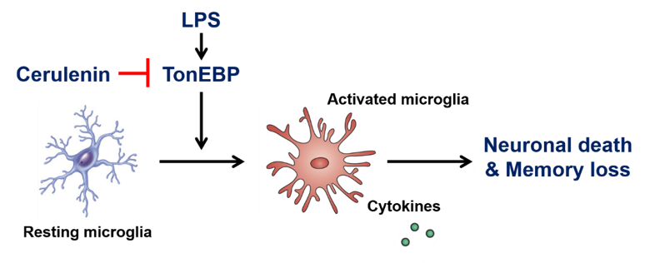
Supplementary Figure 1. Model of TonEBP in microglia-mediated memory loss induced by LPS.
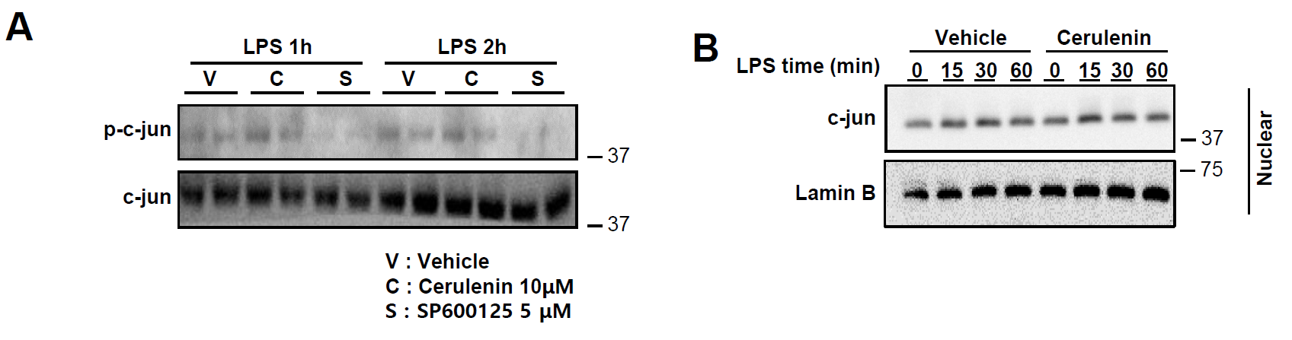
Supplementary Figure 2. Effects of cerulenin in phosphorylation and nuclear translocation of c-jun.
A BV2 cells were pretreated for 1 h with vehicle (V), 10 μM cerulenin (C), or 5 μM SP600125 (S, a JNK inhibitor), followed by treatment with 10 ng/ml of LPS for 1 or 2 h as indicated. Cell lysates were immunoblotted for phosphorylated c-jun (p-c-jun) and c-jun. B Cells were pretreated for 1 h with vehicle or cerulenin, followed by a treatment with LPS for up to 60 min as indicated. Nuclear fractions were obtained as described in Methods and immunoblotted for c-jun and Lamin B.

Supplementary Table 1. Primer sequences for quantitative PCR.


