Supplementary information for

K284-6111 alleviates memory impairment and neuroinflammation in Tg2576 mice by inhibition of Chitinase-3-like 1 regulating ERK dependent PTX3 pathway

Hyeon Joo Ham¹, Yong Sun Lee¹, Jaesuk Yun¹, Dong Ju Son¹, Hee Pom Lee¹, Sang-Bae Han¹, and Jin Tae Hong¹

¹College of Pharmacy and Medical Research Center, Chungbuk National University, Osongsaengmyeong 1-ro, Osong-eup, Heungdeok-gu, Cheongju, Chungbuk, 28160, Republic of Korea
*Correspondence: Dr. Jin Tae Hong (jinthong@chungbuk.ac.kr), College of Pharmacy and Medical Research Center, Chungbuk National University, Osongsaengmyeong 1-ro, Osong-eup, Heungdeok-gu, Cheongju, Chungbuk, 28160, Republic of Korea, Tel: +82-043-261-2813, Fax: +82-043-268-2732.

Hyeon Joo Ham: prodijoo0918@nate.com
Yong Sun Lee: kallintz@gmail.com
Jaesuk Yun: jyun@chungbuk.ac.kr
Dong Ju Son: sondj1@chungbuk.ac.kr
Hee Pom Lee: heepom@empas.com
Sang-Bae Han: shan@chungbuk.ac.kr

Supplementary Table S1. List and sequences of qPCR primers for mRNA expression

 | Forward (5’→3’) | Reverse (5’→3’) | Species
β-actin | GGCTGTATTCCCCTCCATCG | CCAGTTGGTAACAATGCCATGT | Mouse
Tnf | TCTTCTCATTCCTGCTTGTGG | CACTTGGTGGTTTGCTACGA | Mouse
Il1b | CCTTCCAGGATGAGGACATGA | TGAGTCACAGAGGATGGGCTC | Mouse
Il6 | GAGGATACCACTCCCAACAGACC | AAGTGCATCATCGTTGTTCATACA | Mouse
Chi3l1 | GTACAAGCTGGTCTGCTACTTC | ATGTGCTAAGCATGTTGTCGC | Mouse
Cd86 | TGTTTCCGTGGAGACGCAAG | TTGAGCCTTTGTAAATGGGCA | Mouse
Arg1 | CTCCAAGCCAAAGTCCTTAGAG | AGGAGCTGTCATTAGGGACATC | Mouse
Mrc1 | CTCTGTTCAGCTATTGGACGC | CGGAATTTCTGGGATTCAGCTTC | Mouse
Tgfb | CTCCCGTGGCTTCTAGTGC | GCCTTAGTTTGGACAGGATCTG | Mouse
Il10 | GCTCTTACTGACTGGCATGAG | CGCAGCTCTAGGAGCATGTG | Mouse
Ptx3 | CCTGCGATCCTGCTTTGTG | GGTGGGATGAAGTCCATTGTC | Mouse
Cd163 | ATGGGTGGACACAGAATGGTT | CAGGAGCGTTAGTGACAGCAG | Mouse
Ctsd | CCTGGCTTCGTCCTCCTTC | GGCGATGACTGCATGGAGT | Mouse
Ido1 | GCTTTGCTCTACCACATCCAC | CAGGCGCTGTAACCTGTGT | Mouse

Supplementary figure S1.

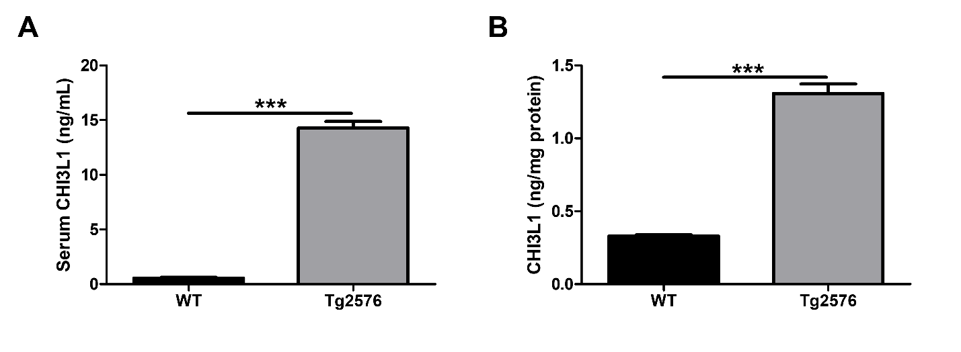
The CHI3L1 levels (A) in serum and (B) in brain were assessed using the specific ELISA kits.

Supplementary figure S2. PTX3 is associated with CHI3L1

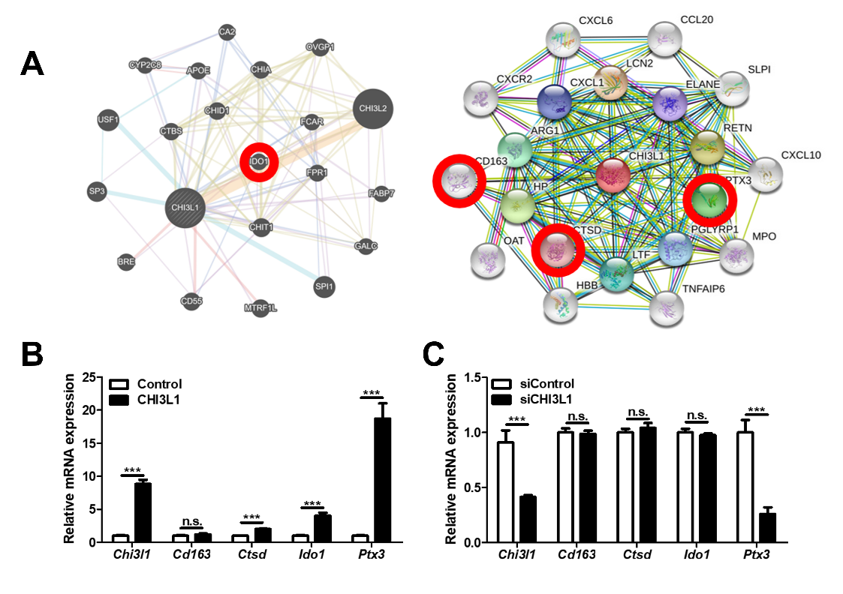
(A) Gene network analysis associated with CHI3L1 was carried out using the web-based analysis tool. The mRNA expression level of Chi3l1, Cd163, Ctsd, Ido1, and Ptx3 were assessed by qRT-PCR. (B) BV-2 cells were transfected with CHI3L1-expression vector. (C) BV-2 cells were transfected with CHI3L1 siRNA (40 nM).

