Supplementary Information
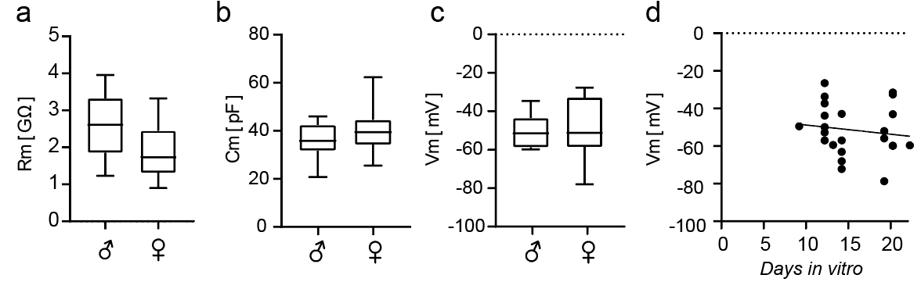
Additional file 1. Cell parameters in microglia of male and female mice show no differences in slice cultures. Duration of slice culture in vitro has no significant effect on microglia membrane potential. (a) Membrane resistance (n=14/9, male/female), (b) Membrane capacitance (n=9/12, male/female), (c) Membrane resting potential (n=12/8, male/female), (d) Membrane resting potential vs. days in vitro (n=23). Spearman’s ρ = -0.24, P = 0.27, n = 23 experiments.

