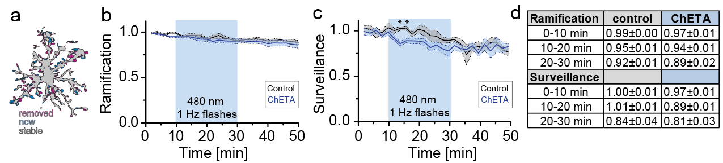Additional file 2 – Optogenetic depolarization mildly affects microglia baseline properties. (A) Superimposed images of the same microglia at two timepoints one minute apart showing process movement during surveillance (purple, retracted; blue, extended and gray stable processes). (B-C) Relative microglia ramification (B) and surveillance index (C) over the time course of 50 min (ChETA_480, n = 4 microglia in 3 slices, control_480, n = 8 microglia in 5 slices). Light application (20 min with 480 nm) was started after 10 min of baseline recording. Statistical analysis: Two-way ANOVA with Bonferroni post-hoc comparison (*p < 0.05) (D) Overview table of relative ramification and surveillance indices in the 10 min before light application and the first 10 minutes of light application (Average ± SEM).

