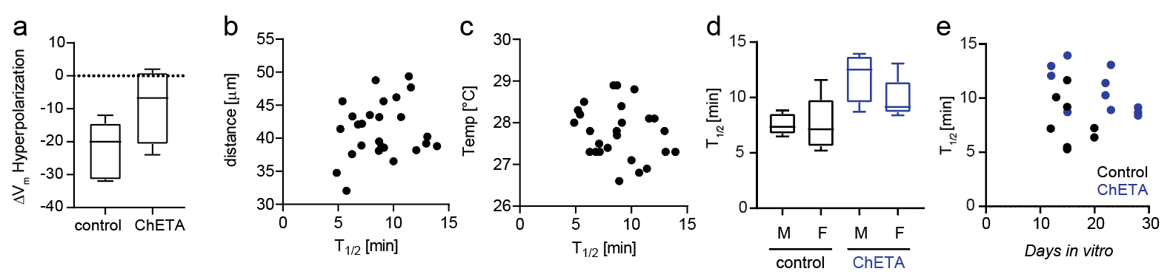
Additional file 3 - Microglia response time is independent from distance of ablation, temperature, sex, or days in vitro. (a) Amount of hyperpolarization of microglia membrane potential induced by laser-damage with and without activation of ChETA (n=5 controls, n=4 ChETA, DIV 20-22) (b) T_{1/2} plotted against the distance of microglia processes from the laser damage (Spearman’s ρ = 0.15, P = 0.47, n = 26 experiments). (c) T_{1/2} plotted against the temperature of the extracellular solution (Spearman’s ρ =$-$0.24, P = 0.25, n = 26 experiments). (d) T_{1/2} plotted for microglia in slice cultures from male (n=5/4 control/light) and female (n=8/7 control/light) animals. (e) T_{1/2} plotted against DIV for control slices (black) and ChETA slices (blue). Control: Spearman’s ρ = -0.2, P = 0.66, n = 8 experiments, ChETA: Spearman’s ρ = -0.6, P = 0.06, n = 11 experiments.

