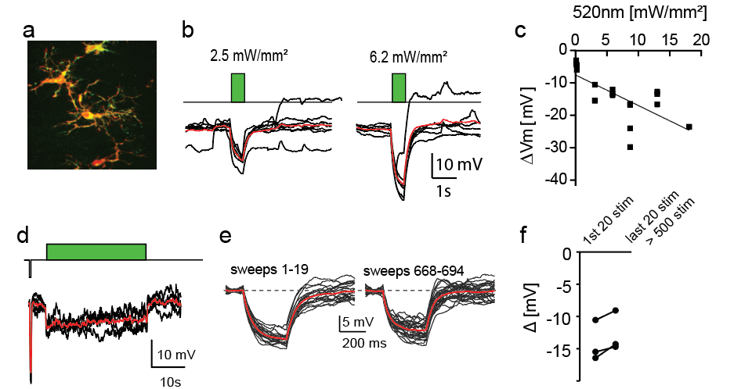
Additional file 4 - ArchT effectively hyperpolarizes microglia under resting conditions. (a) Immunohistochemical staining of ArchT (green) in microglia (red). (b) Light -induced currents in microglia expressing ArchT. Red lines: Average time course. (c) Light-dose dependence of currents induced in microglia. (d) Prolonged light stimulation induces robust, lasting currents in microglia. (e-f) Repetitive light stimulation induces stable light-induced currents in microglia.

