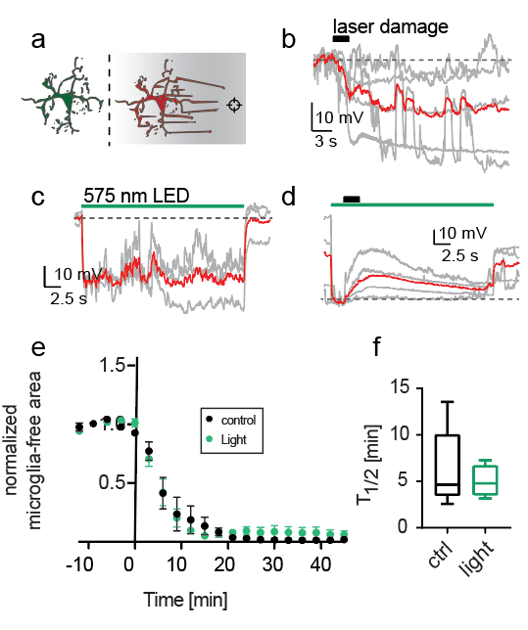
Additional file 5 - ArchT activation during laser damage does not further increase hyperpolarization and has no effect on laser-damage induced chemotactic responses. (a) Schematic drawing of a chemotactic microglia response. (b) ATP-mediated hyperpolarization in microglia. Red line: Average time course. (c) ArchT light- induced hyperpolarization. (d) Combination of ArchT induced hyperpolarization with laser-damage response. (e) Chemotactic response over time while constantly applying light during acquisition of stacks. (n = 9 (5 female, 4 male)) (f) T1/2 of microglia responses in control and ArchT expressing cultures.

