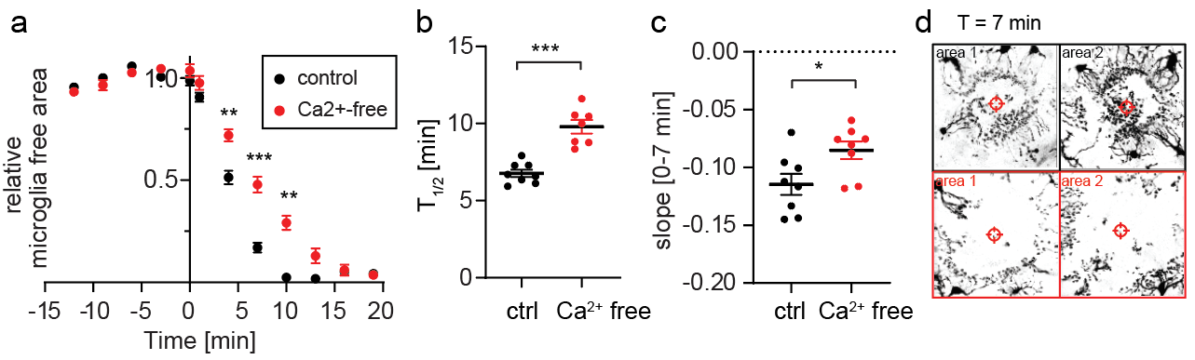
Additional file 6 - Microglia response kinetics towards tissue damage are slowed down in nominally Ca²⁺ free extracellular solution. (a) Relative laser damage response measured as microglia-free area in HEPES solution with 2 mM Ca²⁺ (n = 8, 3 slices, female, DIV 15-21) (black) and in nominally Ca²⁺-free HEPES solution (n = 8, 3 slices, female, DIV 15-16) (red). 2-way ANOVA (** p < 0.01, *** p < 0.001). (b-c) Summary of T_{1/2} and microglia-free area slope (0-7 min). One-way ANOVA with Tukey’s post-hoc comparison (* p < 0.05, *** p < 0.001). (d) Z-projection of individual areas 7 min after laser damage. Black: microglia processes extension in control conditions with 2 mM Ca²⁺. Red: microglia process extension under nominally Ca²⁺-free conditions.

