Amyloid-beta and diabetic pathology cooperatively stimulate cytokine expression in an Alzheimer’s mouse model

Sitara B. Sankar¹, Carmen Infante-Garcia^{2,3}, Laura D. Weinstock¹, Juan Jose Ramos-Rodriguez^{2,4}, Carmen Hierro-Bujalance^{2,3}, Cecilia Fernandez-Ponce^{3,5}, Levi B. Wood^{1,6,¥,}*, Monica Garcia-Alloza^{2,¥,}*

In memoriam of Maria Isabel Murillo-Carretero

¹Wallace H. Coulter Department of Biomedical Engineering, Georgia Institute of Technology, Atlanta, GA 30332 USA
²Division of Physiology. School of Medicine, Universidad de Cadiz. Cadiz, Spain.
³Instituto de Investigacion Biomedica de Cadiz (INIBICA), Cadiz.
⁴Currently at Department of Physiology, School of Health Sciences, Granada University, Spain.
⁵Division of Immunology, School of Medicine, Universidad de Cadiz. Cadiz, Spain.
⁶George W. Woodruff School of Mechanical Engineering and Parker H. Petit Institute for Bioengineering & Bioscience, Georgia Institute of Technology, Atlanta, GA 30332 USA

Running title: Diabetic conditions stimulate expression of cytokines in Alzheimer’s mice.

¥Equally contributing senior authors
*Address correspondence to:
Levi B. Wood  George W. Woodruff School of Mechanical Engineering  Parker H. Petit Institute for Bioengineering & Bioscience  Georgia Institute of Technology  315 Ferst Dr, Rm 3303  Atlanta, GA 30332  levi.wood@me.gatech.edu | Monica Garcia-Alloza  Division of Physiology.School of Medicine.  Universidad de Cadiz. Instituto de Investigacion Biomedica de Cadiz (INIBICA).  Cadiz, Spain.  monica.garcia@uca.es

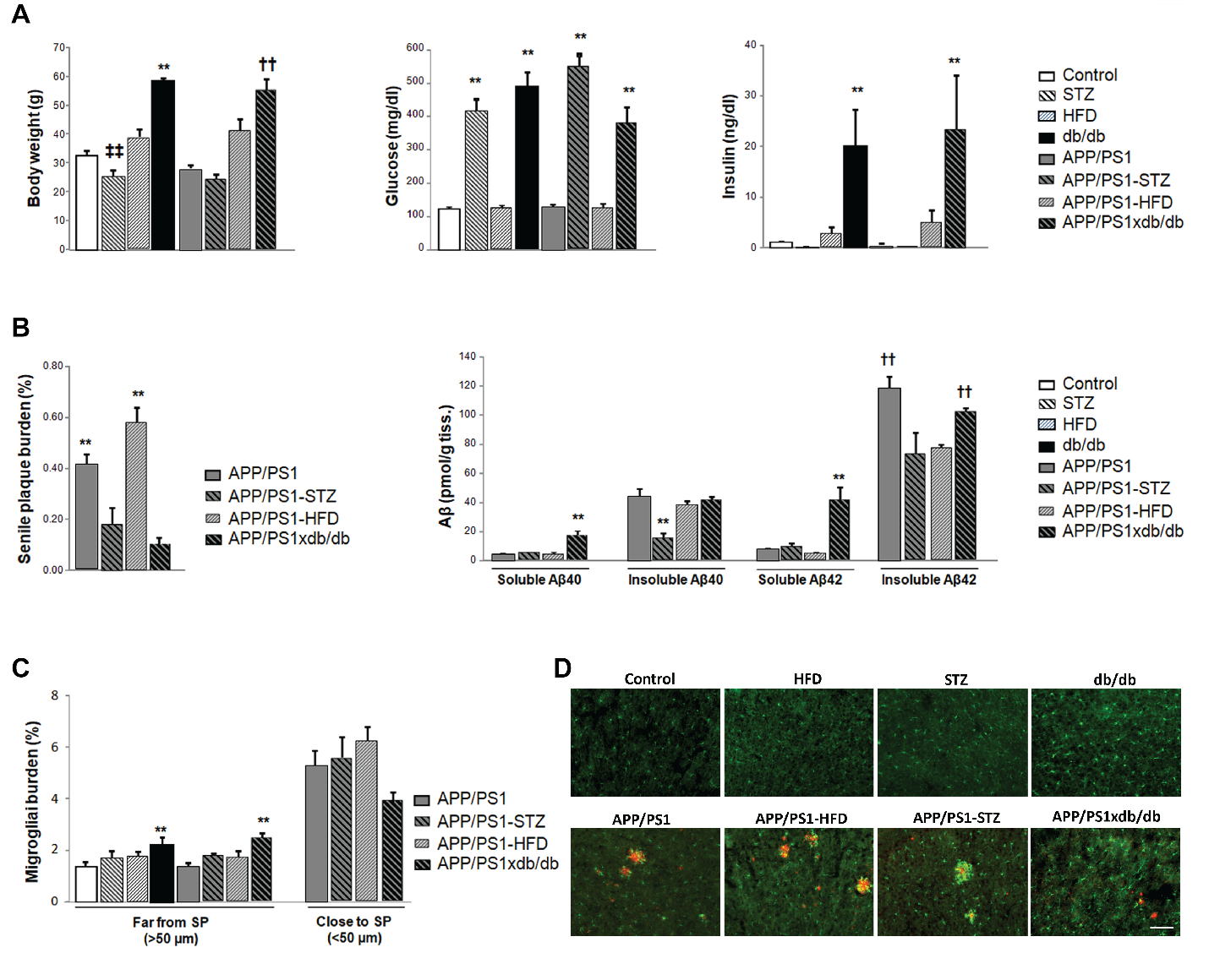
Figure S1. Metabolic assessment, amyloid pathology and microglia burden are altered in mixed models of metabolic disease and AD. A. Body weight was significantly increased in mice on HFD, and this effect was more severe in diabetic animals (db/db and APP/PS1xdb/db) (**p<0.01 vs. Control, HFD, STZ, APP/PS1, APP/PS1-HFD and APP/PS1-STZ; ††p<0.01 vs. Control, STZ, APP/PS1 and APP/PS1-STZ; ‡‡p<0.01 vs. Control and HFD). Glucose levels were significantly increased after inducing T1D by STZ treatment, both in control and APP/PS1 mice, as well as in T2D mice with and without AD (db/db and APP/PS1xdb/db mice) (**p<0.01 vs. Control, HFD, APP/PS1 and APP/PS1-HFD). A slight increase in insulin levels was observed in HFD mice, however differences only reached statistical significance in T2D mice (db/db and APP/PS1xdb/db) (**p<0.01 vs. Control, HFD, STZ, APP/PS1, APP/PS1-HFD and APP/PS1-STZ). Data are presented as mean ±SEM. Control n=14 (10 male and 4 female), HFD n=7 (4 male and 3 female), STZ n=7 (5 male and 2 female), db/db n=7 (2 male and 5 female), APP/PS1 n=14 (5 male and 9 female), APP/PS1-HFD n=7 (4 male and 3 female), APP/PS1-STZ n=7 (4 male and 3 female), APP/PS1xdb/db n=7 (4 male and 3 female). Differences detected by one-way ANOVA followed by Tuckey b or Tamhane tests. B. Amyloid pathology was changed in mice with metabolic alterations. SP burden was significantly lower in APP/PS1-STZ and APP/PS1xdb/db mice (**p<0.01 vs. APP/PS1-STZ and APP/PS1xdb/db). Soluble Aβ levels are increased in APP/PS1xdb/db mice (Aβ40: **p<0.01 vs. rest of the groups; Aβ42: **p<0.01 vs. rest of the groups). Insoluble Aβ40 levels were lower in APP/PS1-STZ mice (Aβ40: **p<0.01 vs. rest of the groups; Aβ42: ††p<0.01 vs. APP/PS1-HFD). Data are presented as mean ±SEM. Control n=10 (7 male and 3 female), HFD n=5 (3 male and 3 female), STZ n=5 (3 male and 2 female), db/db n=5 (1 male and 4 female), APP/PS1 n=5 (3 male and 7 female), APP/PS1-HFD n=5 (3 male and 2 female), APP/PS1-STZ n=5 (3 male and 2 female), APP/PS1xdb/db n=5 (3 male and 7 female) and 6 sections/mouse were included in the study. Differences detected by one-way ANOVA followed by Tuckey b or Tamhane tests. C. Microglia burden. Microglia burden was increased in SP-free areas in db/db and APP/PS1xdb/db mice when all groups under study were compared ([F_{(7,42)=}4.68, **p=0.001 vs. Control and APP/PS1]). Differences did not reach statistical significance in close proximity to plaques when SP-bearing groups were compared ([F_{(7,21)}=1.98, p=0.147]). Data are presented as mean ±SEM. Control n=10 (7 male and 3 female), HFD n=5 (3 male and 3 female), STZ n=5 (3 male and 2 female), db/db n=5 (1 male and 4 female), APP/PS1 n=5 (3 male and 3 female), APP/PS1-HFD n=5 (3 male and 2 female), APP/PS1-STZ n=5 (3 male and 2 female), APP/PS1xdb/db n=5 (3 male and 3 female) and 6 sections/mouse were included in the study. Differences detected by one-way ANOVA followed by Tuckey b test. D. Illustrative example of 4G8 (Aβ, red) and Iba1 (microglia, green) immunostaining in a cortical section from all groups under study. Scale bar= 100 µm.

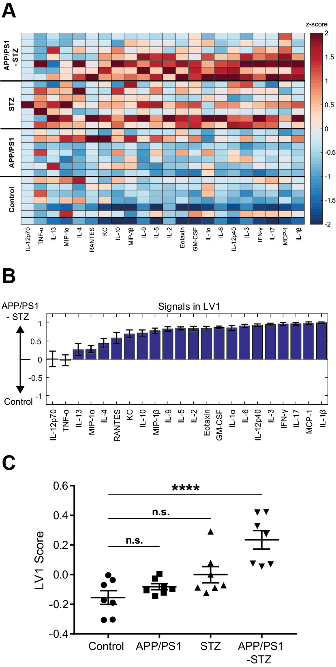
Figure S2. APP/PS1-STZ pathology upregulates a profile of cytokines compared to wild-type control.
A. Luminex analysis of 22 cytokines (columns, z-scored) expressed in the cortex of control (wild-type), APP/PS1, STZ, and APP/PS1-STZ mice (each row is a cortex sample). B. Discriminant partial least squares (PLSDA) analysis identified a profile of cytokines, LV1, that best distinguished APP/PS1-STZ mice (positive) from controls (negative). Errors bars on each cytokine were computed by PLSDA model regeneration using iterative subsampling of 80% of the samples (mean ± SD). C. Scoring the data for each sample in A on LV1 revealed that APP/PS1-STZ group is significantly increased on the LV1 cytokine profile compared to control (****p<0.0001; ordinary one-way ANOVA with Dunnett’s test).
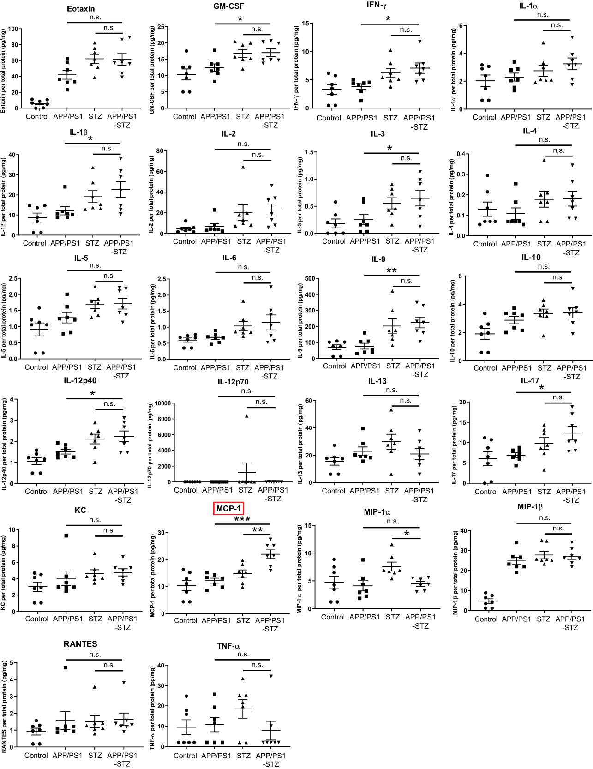
Figure S3. Individual cytokines measured for APP/PS1, STZ, and APP/PS1-STZ groups.
Bar plots of 22 analytes measured for APP/PS1, STZ, and APP/PS1-STZ groups. APP/PS1-STZ pathology upregulates GM-CSF, IFN-γ, IL-9, IL-12p40, IL-17, and MCP-1 when compared to APP/PS1, and MCP-1 only when compared to STZ (*p<0.05, **p<0.01, ***p<0.001; ordinary one-way ANOVA among APP/PS1, STZ, and APP/PS1-STZ groups with Holm-Sidak’s test). Red box highlights cytokine that is significantly up-regulated in combined group compared to both APP/PS1 and STZ models.
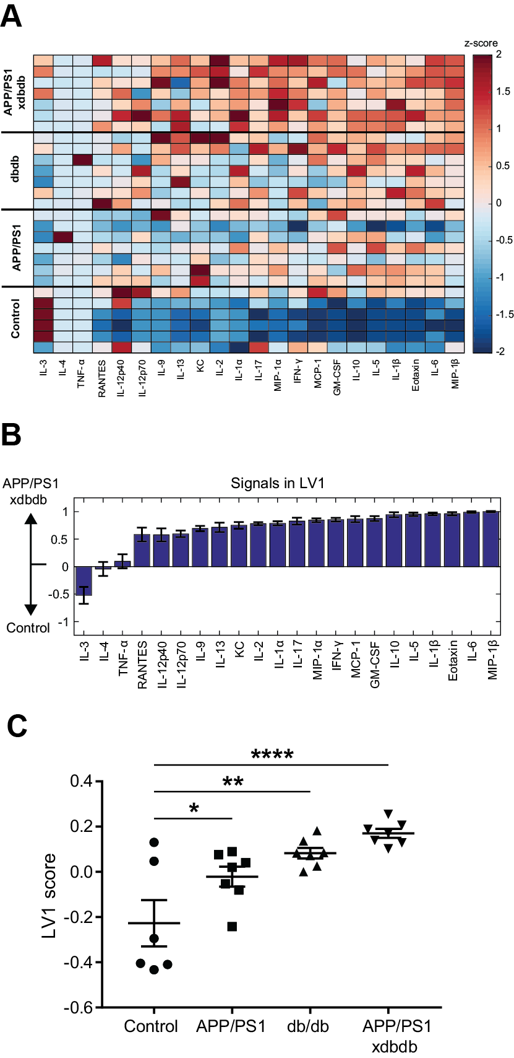
Figure S4. APP/PS1xdbdb pathology upregulates a profile of cytokines compared to wild-type controls.
A. Luminex analysis of 22 cytokines (columns, z-scored) expressed in the cortex of control (wild-type), APP/PS1, dbdb, and APP/PS1xdbdb mice (each row is a cortex sample). B. PLSDA identified a profile of cytokines, LV1, that best distinguished APP/PS1xdbdb mice (positive) from controls (negative). Errors bars on each cytokine were computed by PLSDA model regeneration using iterative subsampling of 80% of the samples (mean ± SD). C. Scoring the data for each sample in A on LV1 revealed that the APP/PS1, dbdb, and APP/PS1xdbdb groups are increased on the LV1 cytokine profile compared to control (*p<0.05, **p<0.01,****p<0.0001; ordinary one-way ANOVA with Dunnett’s test).
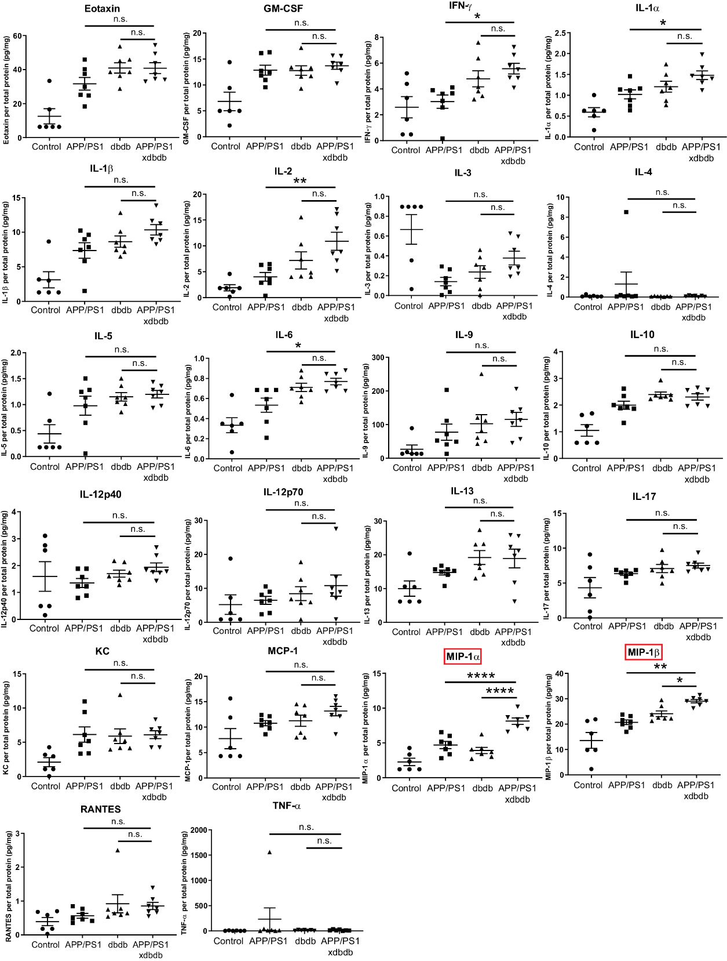
Figure S5. Individual cytokines measured for APP/PS1, dbdb, and APP/PS1xdbdb groups.
Bar plots of 22 analytes measured for APP/PS1, STZ, and APP/PS1-STZ groups. APP/PS1-STZ pathology upregulates IFN-γ, IL-1α, IL-2, IL-3, IL-6, IL-12p40, IL-17, MIP-1α, and MIP-1β when compared to APP/PS1, and MIP-1α and MIP-1β only when compared to dbdb (*p<0.05, **p<0.01, ****p<0.0001; ordinary one-way ANOVA among APP/PS1, dbdb, and APP/PS1xdbdb groups with Holm-Sidak’s test). Red boxes highlight cytokines that are significantly up-regulated in combined group compared to both APP/PS1 and dbdb models.
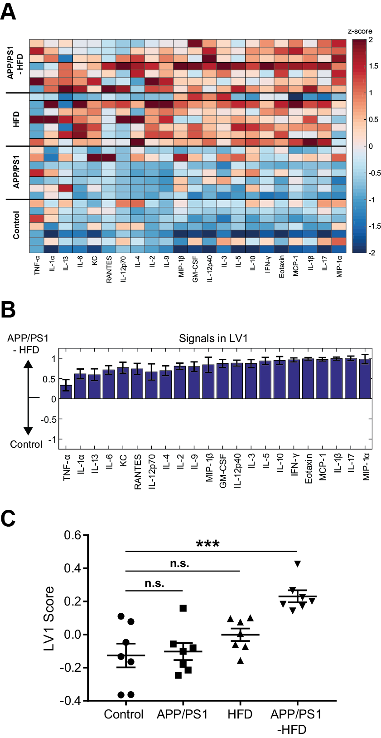
Figure S6. APP/PS1-HFD pathology upregulates a profile of cytokines compared to wild-type controls.
A. Luminex analysis of 22 cytokines (columns, z-scored) expressed in the cortex of control (wild-type), APP/PS1, HFD, and APP/PS1-HFD mice (each row is a cortex sample). B. PLSDA identified a profile of cytokines, LV1, that best distinguished APP/PS1-HFD mice (positive) from controls (negative). Errors bars on each cytokine were computed by PLSDA model regeneration using iterative subsampling of 80% of the samples (mean ± SD). C. Scoring the data for each sample in A on LV1 revealed that APP/PS1-HFD group is significantly increased on the LV1 cytokine profile compared to control (***p<0.001; ordinary one-way ANOVA with Dunnett’s test).
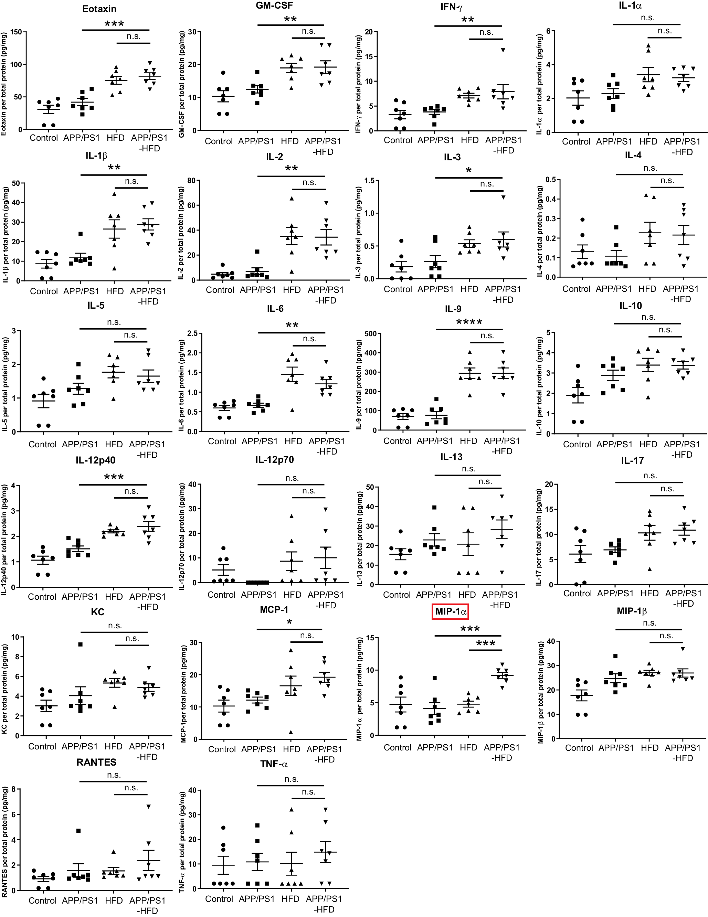
Figure S7. Individual cytokines measured for APP/PS1, HFD, and APP/PS1-HFD groups.
Bar plots of 22 analytes measured for APP/PS1, HFD, and APP/PS1-HFD groups. APP/PS1-HFD pathology upregulates Eotaxin, GM-CSF, IFN-γ, IL-1β, IL-2, IL-3, IL-6, IL-9, IL-12p40, IL-17, MCP-1, and MIP-1α when compared to APP/PS1, and MIP-1α only when compared to HFD (*p<0.05, **p<0.01, ***p<0.001, ****p<0.0001; ordinary one-way ANOVA among APP/PS1, HFD, and APP/PS1-HFD groups with Holm-Sidak’s test). Red box highlights cytokine that is significantly up-regulated in combined group compared to both APP/PS1 and HFD models.

