Supplementary Tables
Table S1. Composition of the rat striatum N-glycome categorised according to the main 26 glycan peaks, as per characterisation by Samal et al. in the HILIC-UPLC profile ⁴¹. A more detailed characterisation can be found at this reference. These are the significant glycans' structures identified in each chromatographic peak and the average percentage area for each peak in LPS-injected striatum vs non-injected (NI) striatum. Structural schemes are given in accordance with Symbol Nomenclature for Glycan (SNFG) format terms of N-Acetylglucosamine (), mannose (), fucose (), galactose () and sialic acid (Neu5Ac and Neu5Gc). Statistical significance between groups is also described, as well as the p-values derived from a paired Student t-test comparison of glycan peaks between different groups after Log transforming each GP area.
 | Composition# | Structure# | Average peak area (%) in LPS-injected striatum | Average peak area (%) in NI striatum | Significance | p-value
GP1 | M3 | 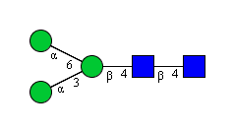 | 0.368±0.078 | 0.098±0.025 | *** | 0.0009
GP2 | M3B | 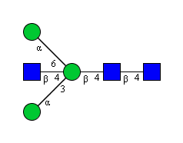 | 1.884±0.183 | 1.116±0.051 | *** | 0.0004
GP3 | A1B | 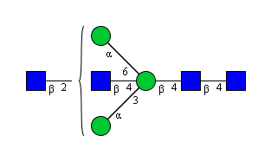 | 0.724±0.050 | 0.802±0.042 | ** | 0.0050
GP4 | FA2 | 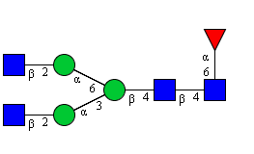 | 4.03±0.180 | 5.128±0.188 | ** | 0.0018
GP5 | FA3 | 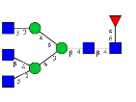 | 20.3±0.621 | 20.81±0.986 | ns | 0.4326
GP6 | FA2G1 | 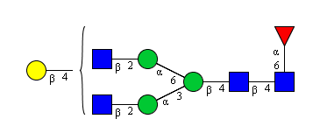 | 1.346±0.044 | 1.086±0.077 | ** | 0.0020
GP7 | A2F1G1 | 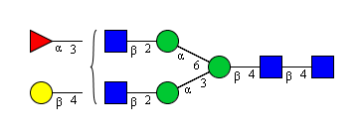 | 0.17±0.025 | 0.186±0.018 | ns | 0.3977
GP8 | M6 | 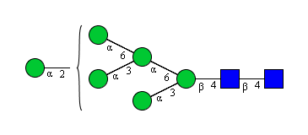 | 8.056±0.226 | 7.896±0.149 | ns | 0.3091
GP9 | FA2F1G1 | 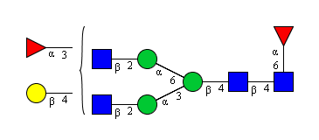 | 2.078±0.150 | 2.958±0.114 | ** | 0.0012
GP10 | FA1BF1G1S(3,8P)2 | 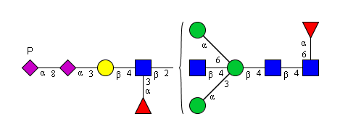 | 2.12±0.075 | 1.842±0.056 | ** | 0.0017
GP11 | FA3F1G1 | 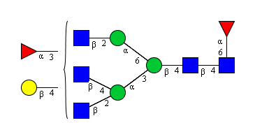 | 2.94±0.286 | 3.334±0.198 | ns | 0.0891
GP12 | A2G2S(6Ac)1 | 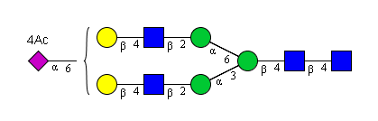 | 1.588±0.106 | 1.886±0.091 | * | 0.0161
GP13 | M7D1 | 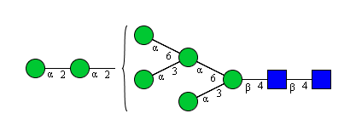 | 6.564±0.113 | 6.526±0.165 | ns | 0.7319
GP14 | A2G2S(3)1 | 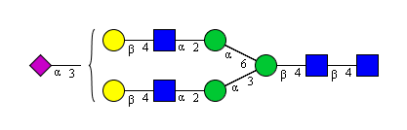 | 2.21±0.064 | 2.006±0.046 | ** | 0.0036
GP15 | FM5A1F1G1 | 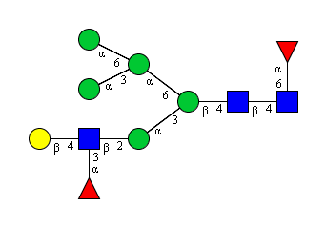 | 4.108±0.101 | 3.164±0.137 | *** | 0.0004
GP16 | M8 | 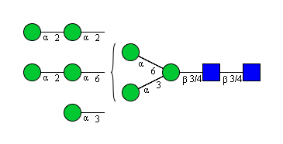 | 4.884±0.202 | 4.394±0.151 | * | 0.0200
GP17 | FA2F2G2 | 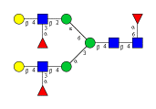 | 4.602±0.064 | 4.288±0.339 | ns | 0.1517
GP18 | FA3F2G2 | 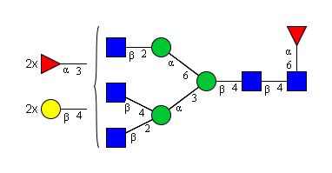 | 1.564±0.073 | 1.66±0.083 | ns | 0.1678
GP19 | A2G2S(3,6)2 | 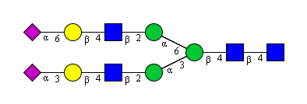 | 0.668±0.088 | 0.9±0.032 | ** | 0.0057
GP20 | M9 | 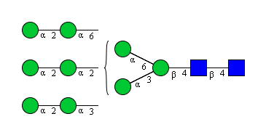 | 11.898±0.722 | 9.598±0.211 | ** | 0.0016
GP21 | A2F1G2S(6,6)2 | 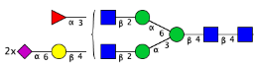 | 2.908±0.147 | 2.488±0.061 | ** | 0.0063
GP22 | FA3F2G3S(3)1 | 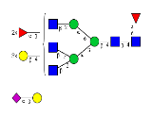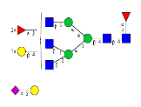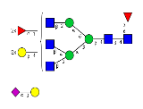 | 4.57±0.157 | 4.764±0.242 | ns | 0.1836
GP23 | FA3F3G3 | 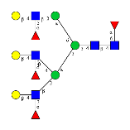 | 3.262±0.092 | 4±0.132 | **** | <0.0001
GP24 | FA3F1G3S(3,3,3)3 | 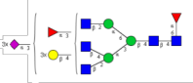 | 2.29±0.123 | 2.212±0.105 | ns | 0.2463
GP25 | FA4F3G4S(3)1 | 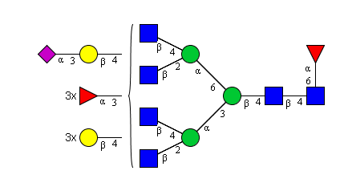 | 2.45±0.156 | 4.154±0.383 | *** | 0.0001
GP26 | FA4F2G4S(3,8P)2 | 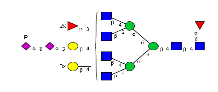 | 2.424±0.252 | 2.706±0.277 | ns | 0.1995

Table S2. Complete detailed MALDI-MSI data outlining m/z values and corresponding N-glycan structure as part of the spatial characterisation of the rat striatal N-glycome. Structural schemes are given in accordance with Symbol Nomenclature for Glycan (SNFG) format terms of N-Acetylglucosamine (), mannose ( ), fucose (), galactose () and sialic acid (Neu5Ac and Neu5Gc)).
Observed [m/z]  [M+Na]+ | Monosaccharide composition | Structure
933.3301 m/z | Hex3HexNAc2
1079.3523 m/z | Hex3dHex1HexNAc2 | 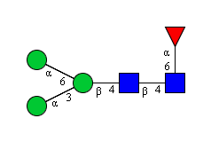
1095.3961 m/z | Hex4HexNAc2 | 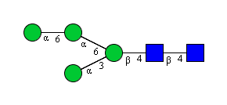
1136.3656 m/z | Hex3HexNAc3
1241.4365 m/z | Hex4dHex1HexNAc2
1257.4421 m/z | Hex5HexNAc2 | 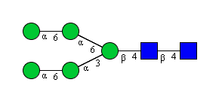
1282.4299 m/z | Hex3dHex1HexNAc3
1298.4637 m/z | Hex4HexNAc3
1339.4853m/z | Hex3HexNAc4
1403.4777m/z | Hex5dHex1HexNAc2
1419.4981 m/z | Hex6HexNAc2
1444.5380 m/z | Hex4dHex1HexNAc3 | 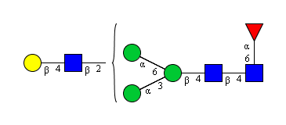
1460.4677 m/z | Hex5HexNAc3
1485.5595 m/z | Hex3dHex1HexNAc4 | 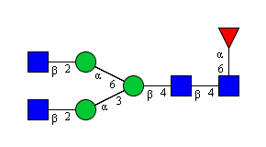
1501.5413 m/z | Hex4HexNAc4 | 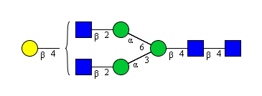
1542.5384 m/z | Hex3HexNAc5 | 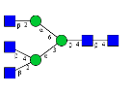
1581.5021 m/z | Hex7HexNAc2
1606.594 m/z | Hex5dHex1HexNAc3 | 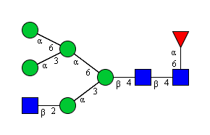
1622.5237 m/z | Hex6HexNAc3
1647.6156 m/z | Hex4dHex1HexNAc4
1663.5973 m/z | Hex5HexNAc4
1688.5851 m/z ± | Hex3dHex1HexNAc5 | 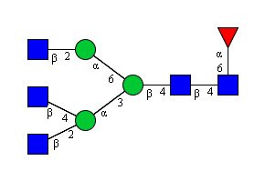
1704.6189 m/z | Hex4HexNAc5 | 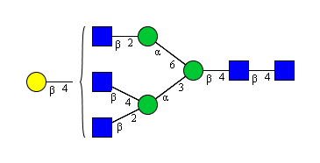
1743.6102 m/z | Hex8HexNAc2
1768.598 m/z | Hex6dHex1HexNAc3
1791.6565 m/z | Hex4HexNAc4NeuAc1 | 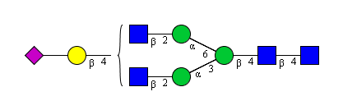
1793.6836 m/z | Hex4dHex2HexNAc4
1809.7236 m/z | Hex5dHex1HexNAc4
1825.6013 m/z | Hex6HexNAc4 | 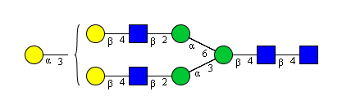
1850.6932 m/z | Hex4dHex1HexNAc5 | 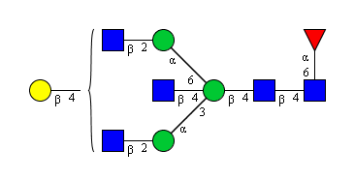
1866.6229 m/z | Hex5HexNAc5 | 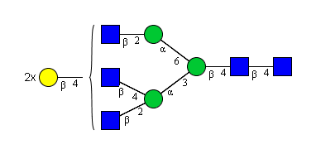
1891.7147 m/z | Hex3dHex1HexNAc6 | 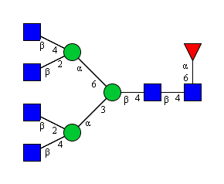
1905.6142 m/z | Hex9HexNAc2
1954.7047 m/z | Hex5HexNAc4NeuAc1 | 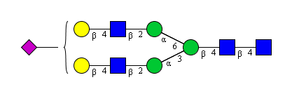
1971.7276 m/z | Hex6dHex1HexNAc4 | 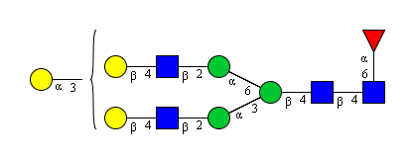
1996.6967 m/z | Hex4dHex2HexNAc5 | 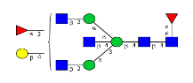
2012.7492 m/z | Hex5dHex1HexNAc5 | 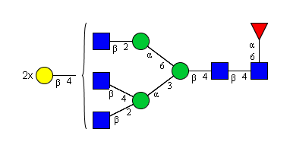
2053.8228 m/z | Hex4dHex1HexNAc6 | 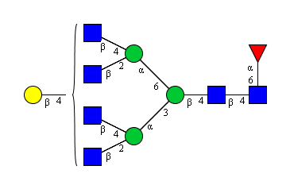
2067.7223 m/z | Hex10HexNAc2
2101.7586 m/z | Hex5dHex3HexNAc4
2122.7474 m/z | Hex5dHex1HexNAc4NeuAc1 + 2Na
2158.7714 m/z | Hex5dHex2HexNAc5
2174.8052 m/z | Hex6dHex1HexNAc5 | 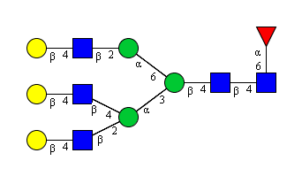
2215.8095 m/ | Hex5dHex1HexNAc6 | 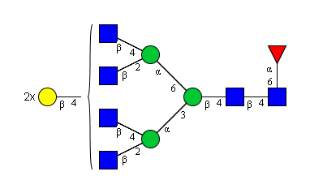
2304.8342 m/z | Hex5dHex3HexNAc5
2320.7621 m/z | Hex6dHex2HexNAc5 | 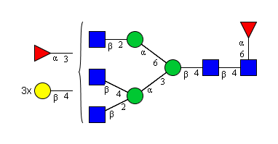
2361.8555 m/z | Hex5dHex2HexNAc6 | 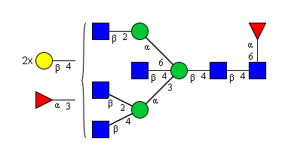
2377.9288 m/z | Hex6dHex1HexNAc6 | 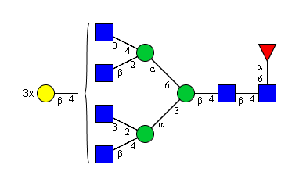
2466.8858 m/z | Hex6dHex3HexNAc5
2523.9041 m/z | Hex6dHex2HexNAc6 | 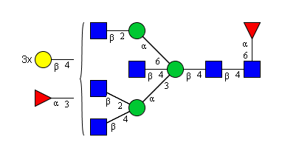
2539.9586 m/z | Hex7dHex1HexNAc6 | 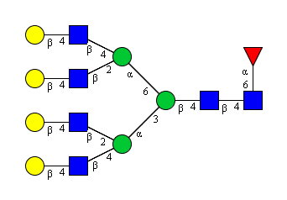
2612.9145 m/z | Hex6dHex4HexNAc5

Table S3. Calculation of derived glycosylation traits in the striatum. The description of each glycosylation trait and the calculation rationale are presented as follows.

Derived Traits | Charge analysis | N1 | The percentage of total neutral glycans in total glycans | SUM(GP1:9,GP11,GP13,GP15:GP18, GP20, GP23)
Derived Traits | Charge analysis | S^{Total} | The percentage of total sialylated glycans in total glycans | SUM(GP10, GP12,GP14,GP19,GP21,GP22,GP24:26)
Derived Traits | Charge analysis | S1 | The percentage of mono-sialylated glycans in total glycans | SUM(GP14, GP25, GP22)
Derived Traits | Charge analysis | S2 | The percentage of di-sialylated glycans in total glycans | SUM(GP10, GP19, GP21, GP26)
Derived Traits | Charge analysis | S3 | The percentage of tri-sialylated glycans in total glycans | GP24
Derived Traits | Charge analysis | Phos | The percentage of phosphorylated glycans in total glycans | GP22
Derived Traits | Charge analysis | S^{Ac} | The percentage of acetylated charged species | GP12
Derived Traits | Charge analysis | Total charged species | The percentage of total charged species in total glycans | SUM(GP10, GP12,GP14,GP19,GP21,GP22,GP24:26)
Derived Traits | Charge analysis | Poly | The percentage of polysialic acids in total glycans | SUM (GP10, GP26)
Derived Traits | Branching | A1 | The percentage of monoantennary glycans in total glycans | GP15
Derived Traits | Branching | A2 or A1B | The percentage of biantennary (or bisecting monoantennary) glycans in total glycans | SUM(GP3,GP4,GP6,GP7,GP9, GP10, GP12, GP14, GP17, GP19, GP21)
Derived Traits | Branching | A3 or A2B | The percentage of triantennary (or bisecting diantennary) glycans in total glycans | SUM(GP5, GP11, GP18, GP22, GP23, GP24)
Derived Traits | Branching | A4 or A3B | The percentage of tetraantennary (or bisecting triantennary) glycans in total glycans | SUM(GP25, GP26)
Derived Traits | Oligomannose | Total oligomannose | The percentage of oligomannose structures in total glycans | SUM(GP1,GP2, GP8, GP13, GP16, GP20)
Derived Traits | Oligomannose | Lower order oligomannose | The percentage of oligomannose structures from M1-M5 in total glycans | SUM(GP1, GP2)
Derived Traits | Oligomannose | Higher order oligomannose | The percentage of oligomannose structures from M6-M9 in total glycans | SUM(GP8, GP13, GP16, GP20)
Derived Traits | Hybrid | Total hybrid glycans | The percentage of hybrid structures in total glycans | SUM (GP15)
Derived Traits | Core fucosylation | CoreF^{Total} | The percentage of core fucosylated glycans in total glycans | SUM(GP4: GP6, GP9: GP11, GP15, GP17, GP18, GP22:GP26)
Derived Traits | Outer arm fucosylation | Outer armF^{Total} | The percentage of outer arm fucosylated glycans in total glycans | SUM(GP7, GP9, GP10, GP11, GP15, GP17, GP18, GP21:GP26)
Derived Traits | Outer arm fucosylation | Lewis^{X} epitopes | The percentage of glycans containing Lewis^{X} epitopes in total glycans | SUM(GP7, GP9, GP11, GP15, GP17, GP18, GP22:GP23, GP25, GP26)
Derived Traits | Outer arm fucosylation | Sialyl-Lewis^{X} epitopes | The percentage of glycans containing Sialyl-Lewis^{X} epitopes in total glycans | SUM(GP10, GP21, GP22, GP24, GP25, GP26)
Derived Traits | Total fucose residues | F1 | The percentage of mono-fucosylated glycans in total glycans | SUM(GP7, GP9, GP10, GP11, GP15, GP17, GP18, GP21:GP26)
Derived Traits | Total fucose residues | F2 | The percentage of di-fucosylated glycans in total glycans | SUM(GP9,GP10,GP11,GP15,GP24)
Derived Traits | Total fucose residues | F3 | The percentage of tri-fucosylated glycans in total glycans | SUM(GP17,GP18,GP22,GP26)
Derived Traits | Total fucose residues | F4 | The percentage of tetra-fucosylated glycans in total glycans | SUM(GP23,GP25)
Derived Traits | Bisected | Bisected | The percentage of bisected glycans in total glycans | SUM (GP2, GP3, GP10)

