Supplementary Material

Supplementary Figure 1. Relationship between inflammatory markers and the metabolite ratios. Each dot represents one measurement (i.e. one individual, one timepoint). Light grey lines indicate the mean association for each individual. The black line shows the predicted mean calculated from the mixed effects model.

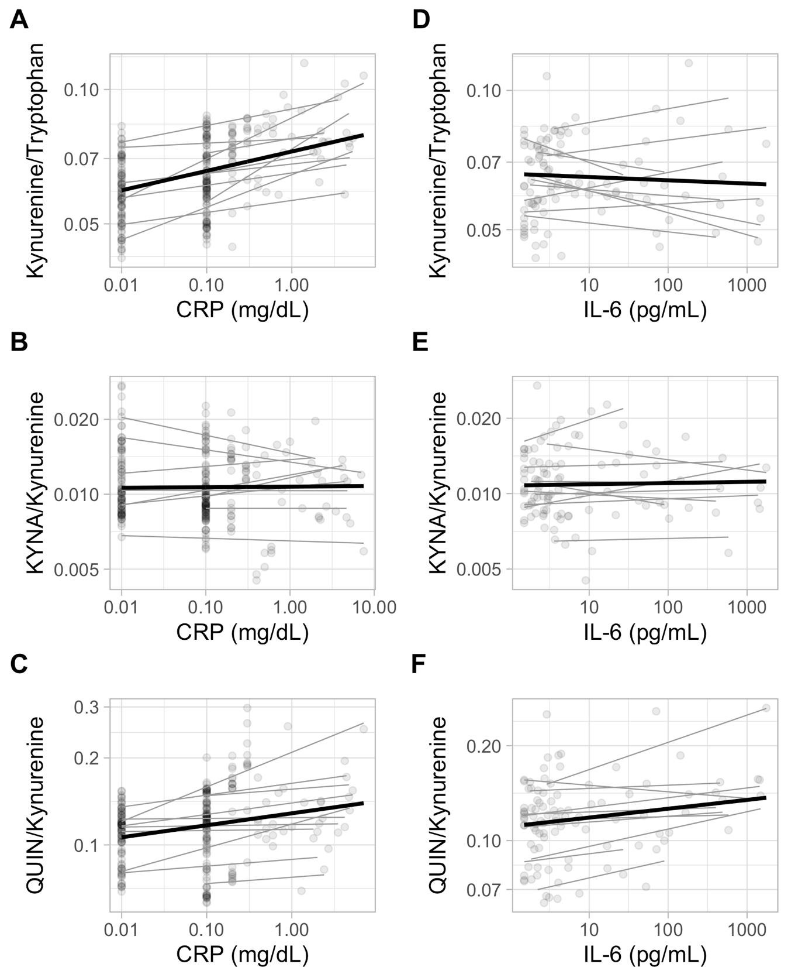

Supplementary Figure 2. Associations between metabolite ratios and CRP or IL-6 over time. The size of the circles indicates the strength of the association (-log₁₀p), the color indicates the direction of the association (red: positive, blue: negative). * <0.0083, + p<0.05. KYNA: Kynureninic acid, QUIN: Quinolinic Acid.

Supplementary Table 1.
Vital parameters presented as mean and standard deviation (SD). The maximum increase is defined as the largest positive difference between any timepoint and the baseline, the maximum decrease is defined as the largest negative difference between any timepoint and the baseline.

 | LPS | Placebo
Baseline | mean (SD) | mean (SD)
Systolic blood pressure (mmhg) | 132 (9) | 129 (13)
Diastolic blood pressure (mmhg) | 74 (11) | 77 (13)
Heart rate (beats per minute) | 72 (7) | 68 (10)
Temperature (°C) | 36 (0.34) | 36 (0.23)
Maximum increase
Systolic blood pressure (mmhg) | 13.7 (7.7) | 9.9 (10.3)
Diastolic blood pressure (mmhg) | 15 (8) | 9.8 (14.1)
Heart rate (beats per minute) | 32.5 (11.5) | 11.9 (8.8)
Temperature (°C) | 1.39 (0.8) | 0.17 (0.17)
Maximum decrease
Systolic blood pressure (mmhg) | -29.6 (7.1) | -19 (9.7)
Diastolic blood pressure (mmhg) | -31.8 (10.5) | -20.2 (11)
Heart rate (beats per minute) | -11.3 (8.3) | -15 (6.6)
Temperature (°C) | -0.07 (0.1) | -0.21 (0.29)

