Supplementary materials
Full western blot from Figure 3 with protein ladder.

Putamen - C1q
Control
C1q
MSA

Putamen – β-actin
Control
C1q
MSA

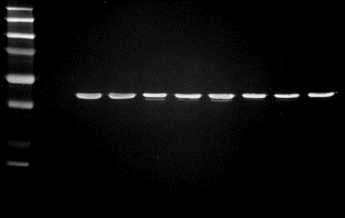

Visual Cortex – C1q
Control
C1q
MSA

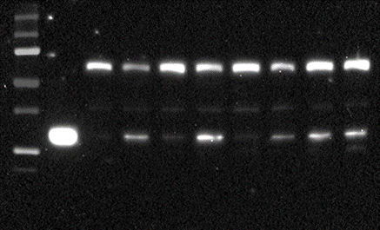

Visual Cortex – β-actin
Control
C1q
MSA

