Attenuating vascular stenosis-induced astrogliosis preserves white matter integrity and cognitive function

Qian Liu ^{1, 2, 3}; Mohammad Iqbal H. Bhuiyan^{2, 3}; Ruijia Liu ^{2, 3}; Shanshan Song ^{2, 3}; Gulnaz Begum ^{2, 3}; Cullen B. Young ^{2, 3}; Lesley M. Foley ⁴; Fenghua Chen ²; T. Kevin Hitchens ^{4, 5}; Guodong Cao ^{2, 6}; Ansuman Chattopadhyay ⁷; Li He¹*; Dandan Sun ^{2, 3, 6}*

¹ Department of Neurology, West China Hospital, Sichuan University, Chengdu, Sichuan, 610041, China
² Department of Neurology, University of Pittsburgh, Pittsburgh, Pennsylvania, 15213, USA
³ Pittsburgh Institute for Neurodegenerative Disorders, University of Pittsburgh, Pittsburgh, Pennsylvania, 15213, USA
⁴ Animal Imaging Center, University of Pittsburgh, Pittsburgh, Pennsylvania, 15213, USA
⁵ Department of Neurobiology, University of Pittsburgh, Pittsburgh, Pennsylvania, 15213, USA
⁶ VA Pittsburgh Healthcare System, Geriatric Research Education and Clinical Center, Pittsburgh, Pennsylvania, 15240, USA
⁷ Molecular Biology-Information Service, Health Sciences Library System, University of Pittsburgh, Pittsburgh, Pennsylvania, 15261, USA

Running title: NHE1 protein in astrogliosis

*Corresponding authors:
Dandan Sun, M.D., Ph.D.
Department of Neurology
University of Pittsburgh Medical Center
7016 Biomedical Science Tower 3
3501 Fifth Ave.
Pittsburgh, PA 15260, USA
Phone number: (412) 624-0418
E-mail address: sund@upmc.edu

Li He, M.D.
Department of Neurology
West China Hospital, Sichuan University
No. 37, Wainan Guoxue Xiang
Chengdu, Sichuan, 610041, China
Phone number: (+86) 18980601670
Email address: heli2003new@126.com

METHODS AND MATERIALS
Materials
HOE-642 (Cariporide, #SML1360) was from Millipore Corporation (Burlington, MA). DAPI (4,6-diamino-2-phenylindole, dhydrochloride) was from Life Technologies Corporation (Carlsbad, CA). Rabbit anti-MBP antibody (ab40390) and rat anti-Lcn2 (ab70287) were from Abcam plc (Cambridge, UK). Rabbit anti-NHE-1 antibody (sc-28758) were from Santa Cruz biotechnology (Santa Cruz, CA). Mouse anti-GFAP antibody (3670s) was from Cell Signaling Technology (Danvers, MA). Rabbit anti-Neurofilament 200 (N4142) and mouse anti-NeuN antibody (MAB377) were from Millipore Corporation (Billerica, MA). Rabbit anti-Phospho-p47phox Antibody (PA536773) was from Invitrogen. Goat anti Iba1 (NB100-1028) was from Novus Biologicals (Centennial, CO). Goat-anti-rabbit AlexaFluor 488 (A11008), goat-anti-rabbit AlexaFluor 546 (A11035) or goat-anti-mouse AlexaFluor 546 (A11030) were from Life Technologies (Grand Island, NY). Donkey anti goat 488 (A-11055) and Donkey anti rabbit 546 (A10040) were from Thermo Fisher Scientific. Adult Brain Dissociation Kit (Miltenyi Biotec, Germany). RNeasy Micro Kit (Qiagen, 74004).

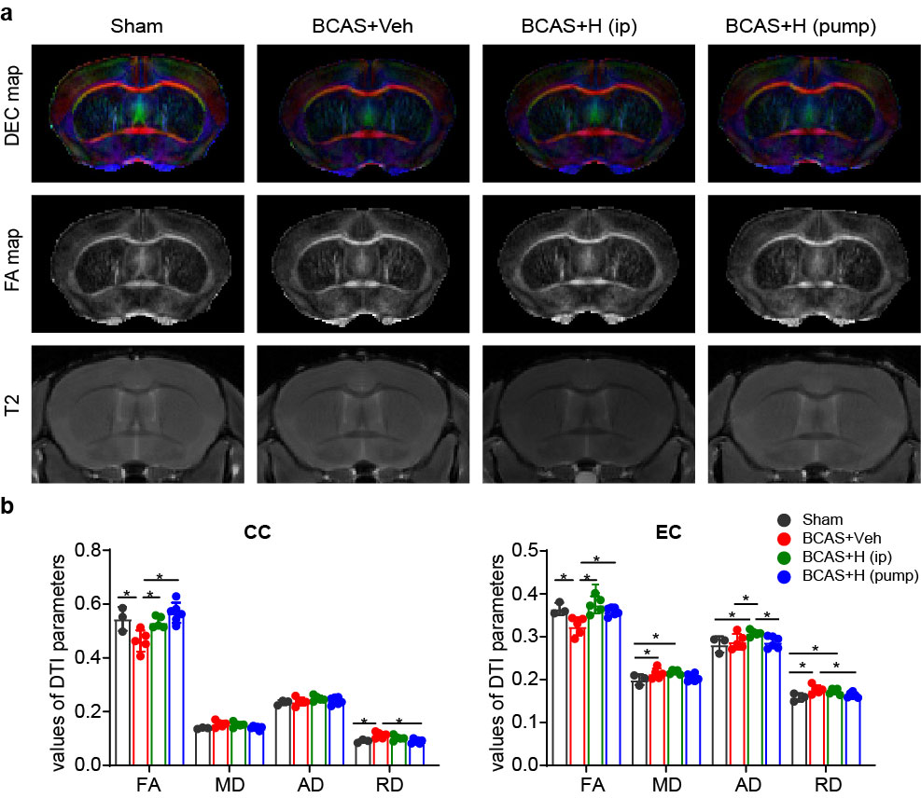

Figure S1. (a) Representative DEC, FA, T2 maps of white matter of ex vivo brains from Sham, BCAS+Veh (i.p.), BCAS+HOE (i.p.), or BCAS+HOE (pump) mice. (b) Mean values of DTI parameters in CC and EC of these brains. All data are presented as mean ± SD, n=3-6. *P < 0.05.

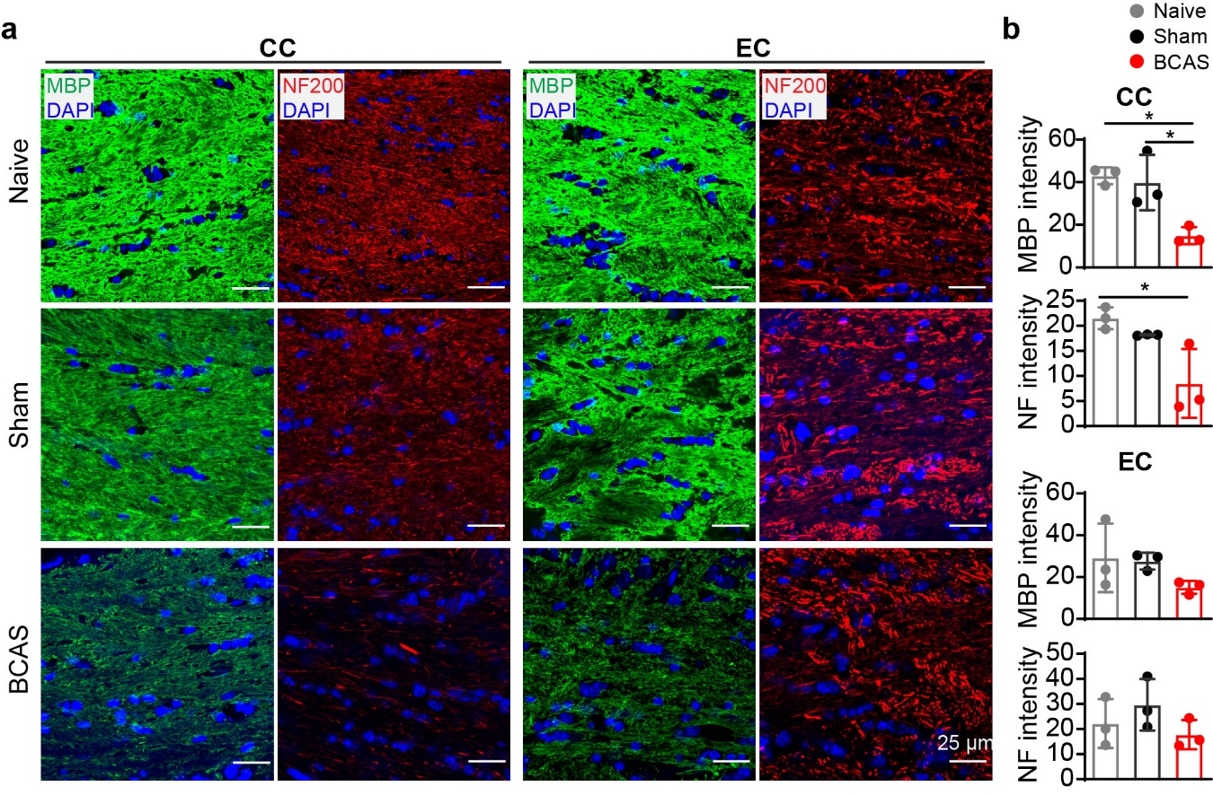
Figure S2. BCAS-induced demyelination and neurofilament loss in white matter at 30 days post-surgery. (a) Representative MBP (green) or NF200 (red) immunostaining in CC and EC. Scale bar=25 µm. (b) Quantitative analysis of the mean intensity of MBP or NF200 in CC and EC. All data are presented as mean ± SD. n=3. *P < 0.05.

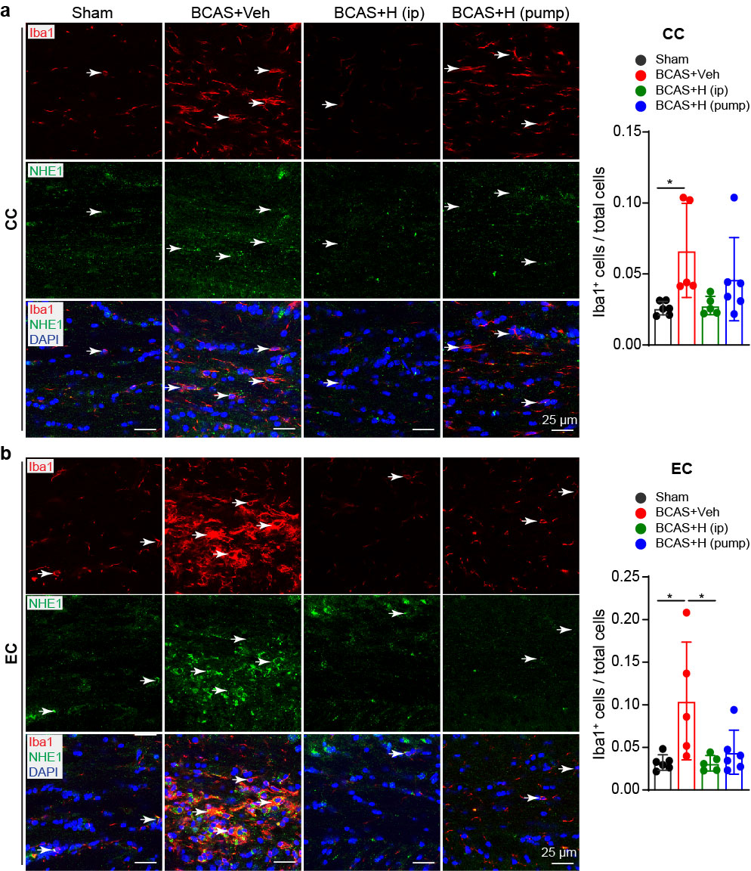
Figure S3. HOE642 treatment suppressed BCAS-induced elevation of Iba1 microglia in white matter. (a, b) Representative images of NHE1 expression in Iba1⁺ cells and quantitative analysis of Iba1⁺ cell counts in CC (a) and EC (b) of sham, BCAS+Veh (i.p.) and BCAS+HOE (i.p.) and BCAS+HOE (pump) mice. White arrow: Iba1⁺ microglia with NHE1 expression. Scale bar=25 µm. All data are presented as mean ± SD. n = 5-6. *P < 0.05.
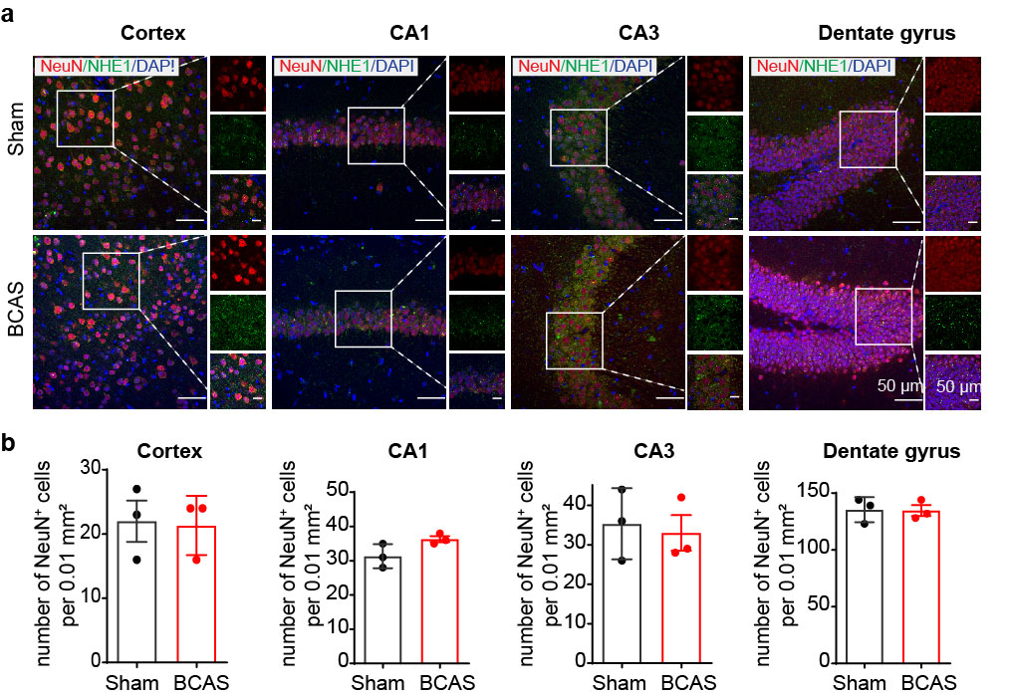

Figure S4. Lack of BCAS-induced neuronal loss in cortex and hippocampus. (a) Representative immunostaining images of NHE1 (green) and NeuN (red) in cortex, hippocampal CA1, CA3 and dentate gyrus in Sham and BCAS at 30d post-surgery. Selective detailed signal information (from the white square frames) in each channel was further displayed in the right panel. Scale bar=50 µm. (b) Quantitative analysis of the number of neurons in cortex, CA1, CA3 and dentate gyrus (per 0.01m²). All data are presented as mean ± SD. n = 3.

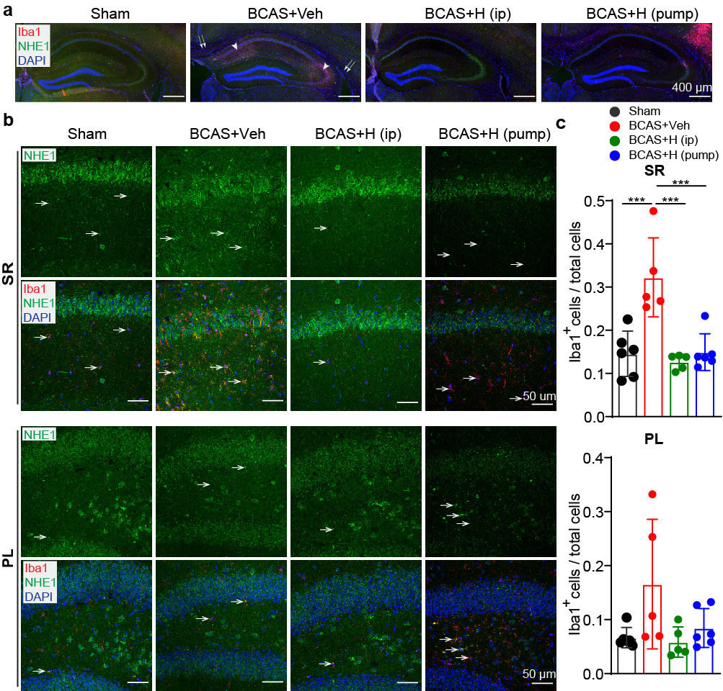
Figure S5. HOE642 suppressed microglial activation in hippocampus of BCAS mice at 30d post-surgery. (a) Representative staining images of hippocampus for NHE1 (green) and Iba1 (red) at 30d post-surgery. Double arrows: increased Iba1⁺ microglia in CC and EC. Arrow heads: increased Iba1⁺ microglia in hippocampus. Magnification X10, Scale bar=400 µm. (b) Representative immunostaining images of NHE1 (green) and Iba1 (red) in SR and PL of hippocampus at 30d post-surgery. Magnification X40, Scale bar=50 µm. White Arrows: the Iba1⁺ microglia with NHE1 expression. (c) Quantitative analysis of Iba1⁺ cells /total cells in SR and PL of hippocampus. All data are presented as mean ± SD. n=5-6. ***P < 0.001.

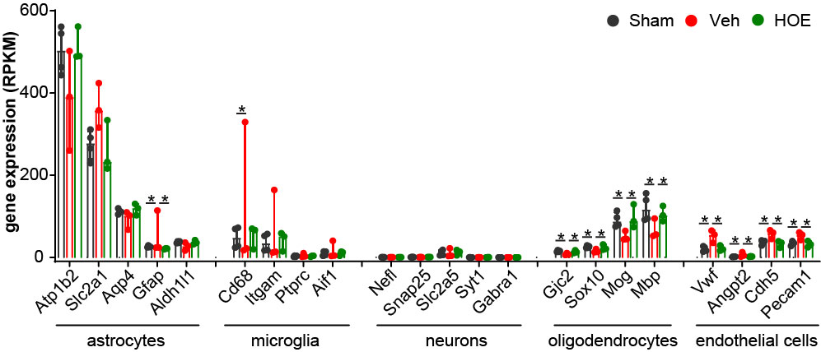
Figure S6. Purity of isolated brain ACSA2⁺ astrocytes assessed by cell specific gene expression analysis. Expression of astrocyte, microglia, neuron, oligodendrocyte and endothelial cell marker genes in the astrocytes isolated from Sham, BCAS+Veh (i.p.), and BCAS+HOE642 (i.p.) brains at 30d post-surgery. Data are RPKM values, which shown as median and interquartile range. n = 3-4, *p ≤ 0.05 and FC > 1.5

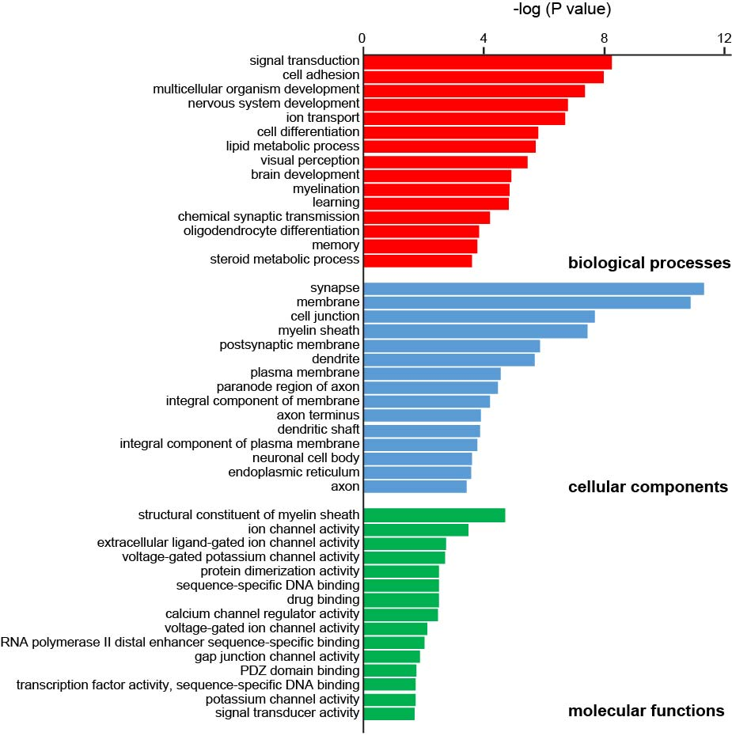
Figure S7. The top 15 enriched GO terms of upregulated genes in astrocytes of the BCAS+HOE642-treated brains, compared to the BCAS+Veh brains. The three GO categories [cellular component, biological process and molecular function] were detected using DAVID, which are statistically significant with p < 0.05 and a gene count ≥ 2 as the thresholds to indicate a difference.

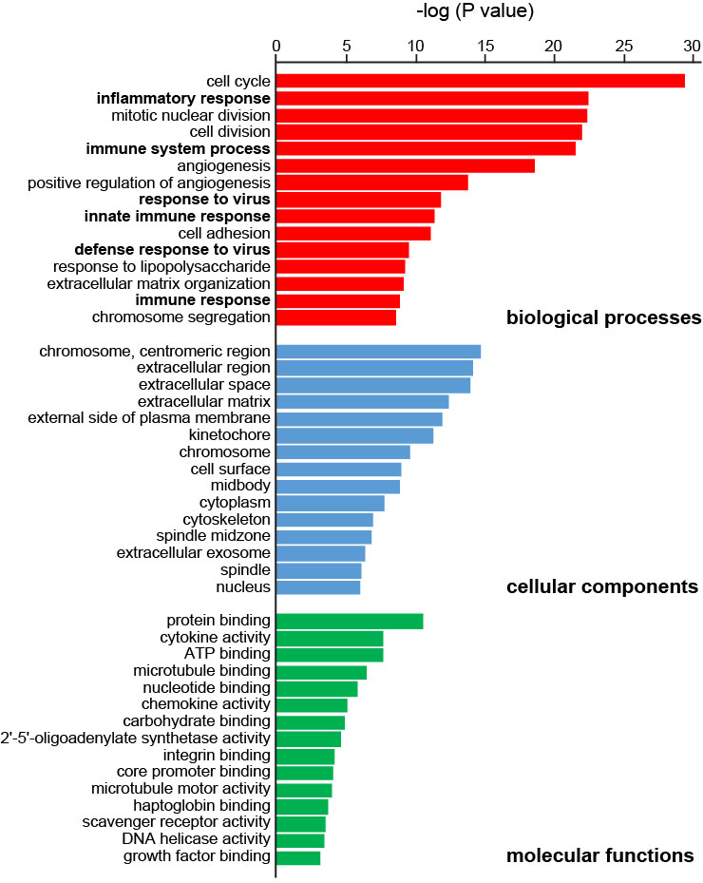
Figure S8. The top 15 enriched GO terms of downregulated genes in astrocytes of the BCAS+HOE642-treated brains, compared to the BCAS+Veh brains. The three GO categories [cellular component, biological process and molecular function] were detected using DAVID, which are statistically significant with p < 0.05 and a gene count ≥ 2 as the thresholds to indicate a difference.

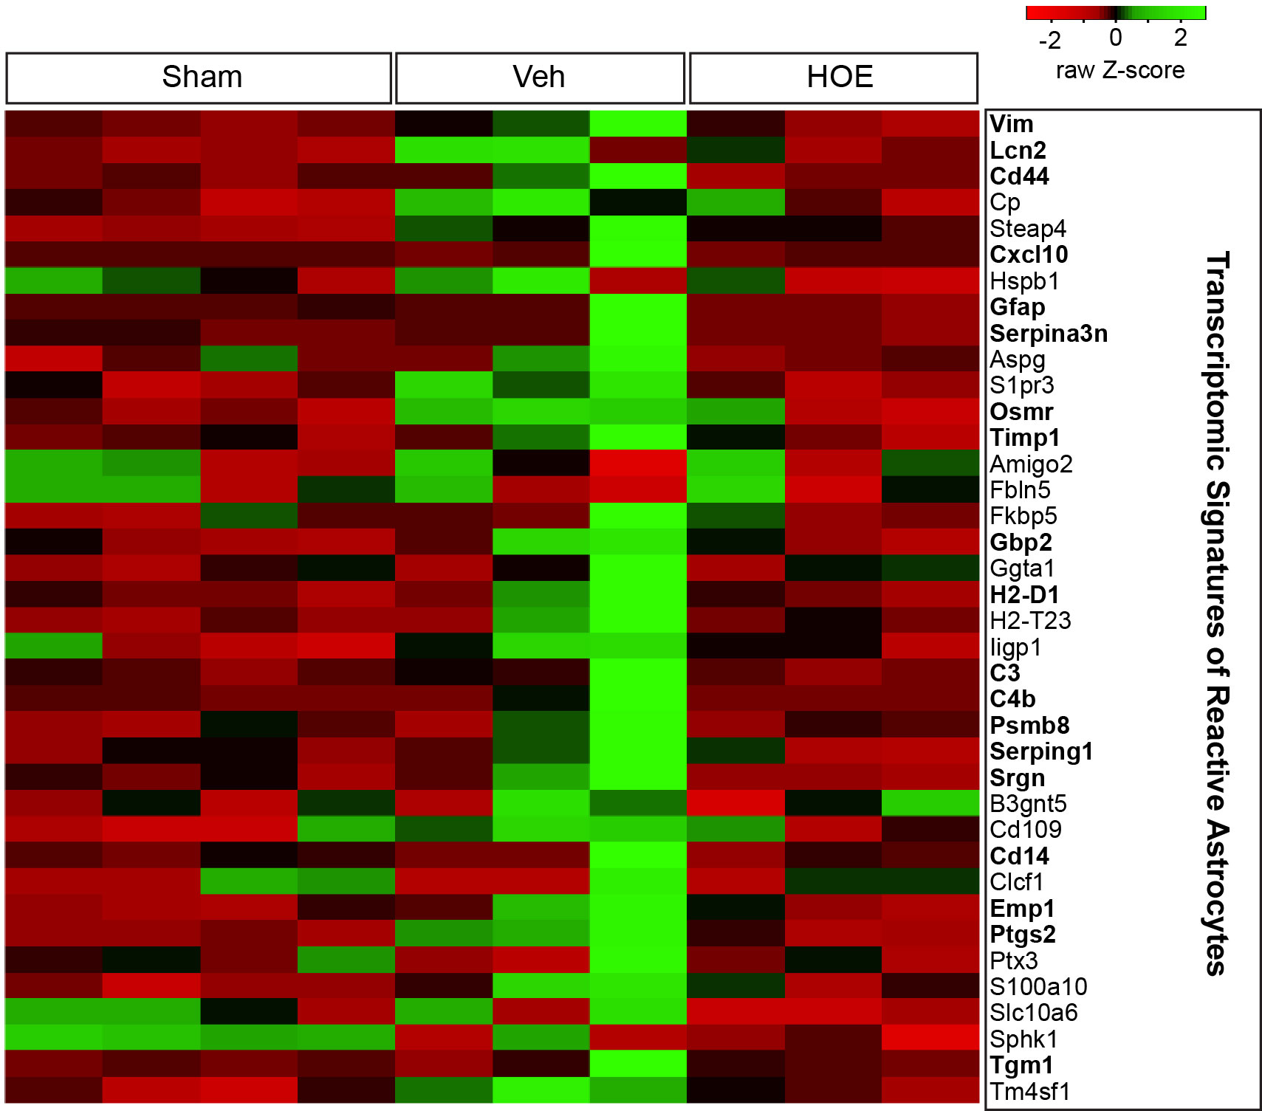
Figure S9. Changes of astrocyte transcriptomes in Sham, BCAS+Veh, and BCAS+HOE642 groups. Heatmap of transcriptomic signatures of reactive astrocyte was created with the HEATMAPPER [1]. Z scores of RPKM values of these genes were displayed in the heatmap. n = 3-4. Genes with DEG (p ≤ 0.05 and FC ≥ 1.5) between HOE642 vs. Veh were indicated with bold font.

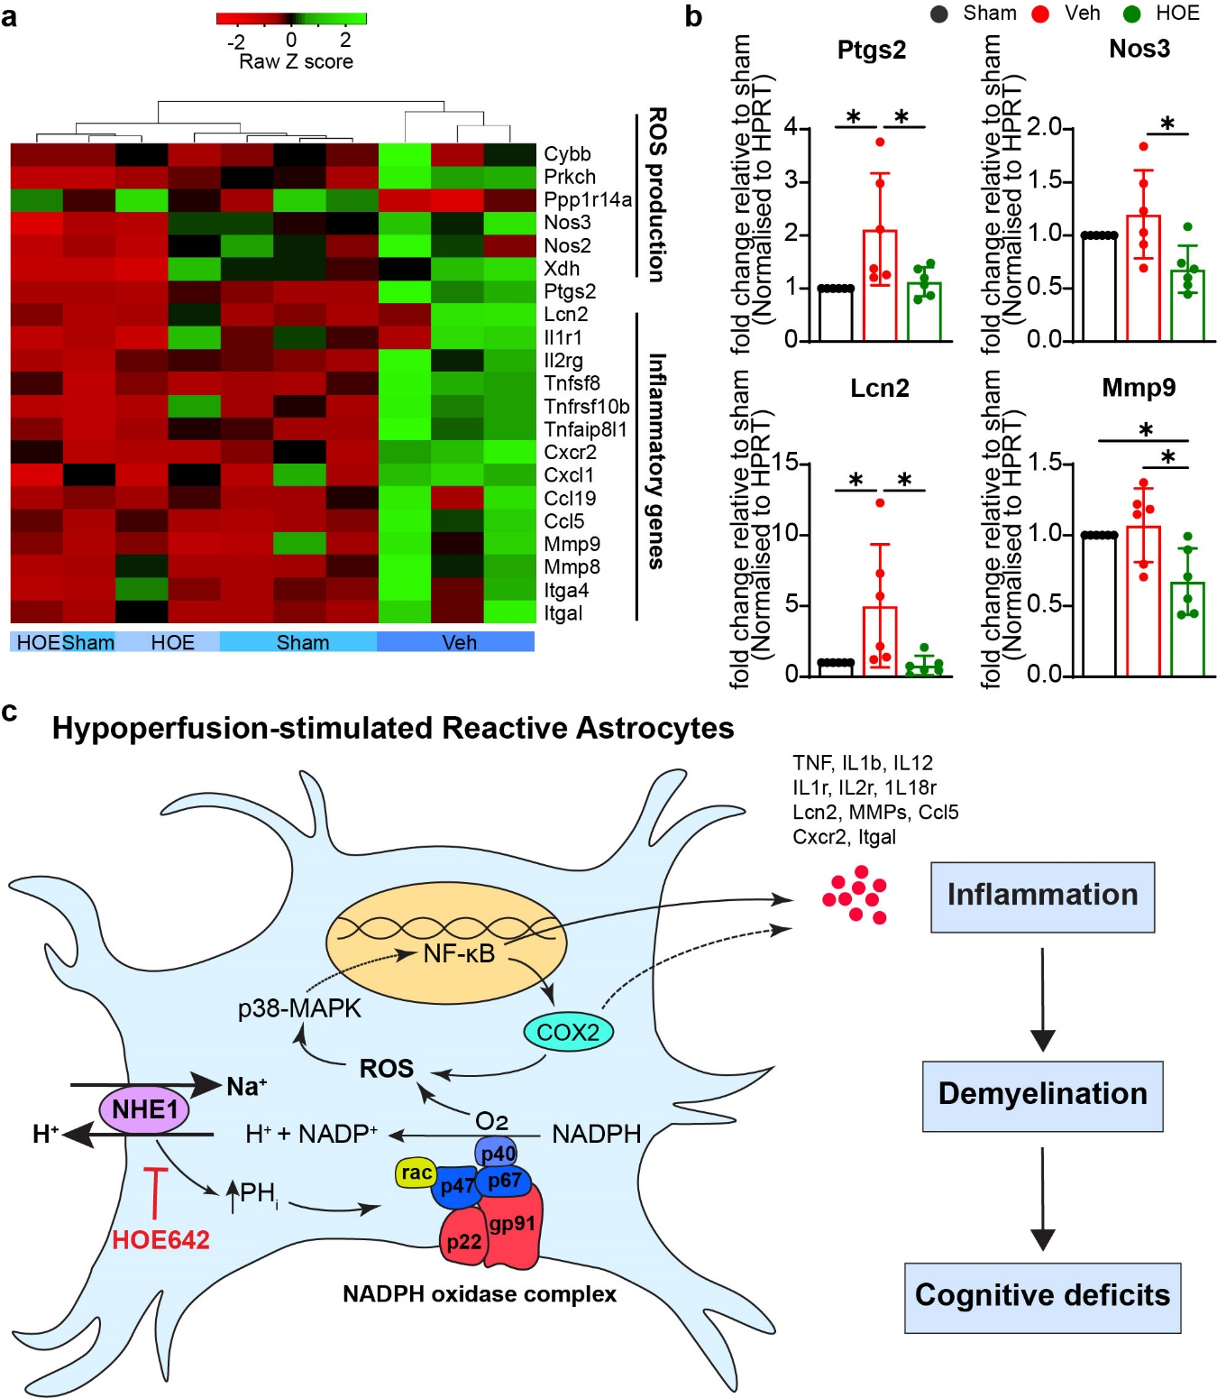
Figure S10. HOE642 treatment suppressed upregulation of ROS production and pro-inflammatory gene transcriptomes in astrocytes of BCAS mice. (a) Heatmap of differentially expressed ROS production genes and inflammatory genes in Sham, BCAS+Veh, and BCAS+HOE642 groups. Heatmap was created with the HEATMAPPER [1], using a complete linkage as a clustering method and the Euclidean as a distance measurement method. Z scores of RPKM values of these ROS production genes and inflammatory genes were displayed in the heatmap. n = 3-4. (b) qRT-PCR quantification of Ptgs2, Nos3, Lcn2, Mmp9. Data are mean ± SD, n = 6. *p < 0.05. (c) Schematic summary of NHE1 protein involved in ROS signaling and pro-inflammatory cytokine release in reactive astrocytes in response to cerebral hypoperfusion.

Table S1: Pearson correlation coefficient r between spatial working cognition, microstructural and pathologic change in white matter tracts and hippocampus.
Corpus callosum
Variables | FA | MD | AD | RD | alternation |  | GFAP | IBA1 | MBP | NF | -
alternation | .473* | -0.306 | 0.012 | -.457* | 1 |  | -.733** | -.622** | .474* | 0.278 | -
GFAP | -.558* | 0.107 | -0.28 | 0.355 | -.733** |  | 1 | .554* | -0.293 | -0.398 | -
IBA1 | -0.247 | -0.02 | -0.227 | 0.13 | -.622** |  | .554* | 1 | -0.221 | -0.295 | -
MBP | 0.227 | -0.118 | 0.04 | -0.2 | .474* |  | -0.293 | -0.221 | 1 | .552* | -
NF | .663** | -0.32 | 0.09 | -.533* | 0.278 |  | -0.398 | -0.295 | .552* | 1 | -
External capsule
Variables | FA | MD | AD | RD | alternation |  | GFAP | IBA1 | MBP | NF | -
alternation | .640** | -0.284 | 0.03 | -.475* | 1 |  | -.609** | -.653** | 0.446 | 0.34 | -
GFAP | -.623** | 0.152 | -0.137 | 0.344 | -.609** |  | 1 | 0.36 | -0.338 | -0.245 | -
IBA1 | -.699** | 0.328 | -0.02 | .537* | -.653** |  | 0.36 | 1 | -0.188 | -.563* | -
MBP | 0.375 | -0.085 | 0.108 | -0.215 | 0.446 |  | -0.338 | -0.188 | 1 | 0.427 | -
NF | .805** | -0.114 | 0.277 | -0.386 | 0.34 |  | -0.245 | -.563* | 0.427 | 1 | -
Hippocampus
 | FA | MD | AD | RD | alternation |  | GFAP# | Iba1# | GFAP§ | Iba1§ | -
alternation | 0.3 | -0.27 | -0.095 | -0.355 | 1 |  | -.468* | -.835** | -.607** | -.543* | -
GFAP# | 0.123 | -0.058 | 0.011 | -0.099 | -.468* |  | 1 | 0.318 | .518* | 0.336 | -
Iba1# | -.586** | 0.243 | -0.081 | 0.437 | -.835** |  | 0.318 | 1 | .644** | .787** | -
GFAP§ | -0.2 | 0.276 | 0.133 | 0.337 | -.607** |  | .518* | .644** | 1 | .573* | -
Iba1§ | -.570* | 0.157 | -0.153 | 0.354 | -.543* |  | 0.336 | .787** | .573* | 1 | -
Strata of hippocampus
 | FA^{sr} | MD^{sr} | AD^{sr} | RD^{sr} | FA^{slm} | MD^{slm} | AD^{slm} | RD^{slm} | FA^{ml} | MD^{ml} | AD^{ml} | RD^{ml}
alternation | -0.124 | 0.169 | 0.056 | 0.21 | 0.253 | -.518* | -0.41 | -.544* | 0.384 | -0.403 | 0.103 | -.464*
*: Correlation is significant at the 0.05 level (2-tailed).
**: Correlation is significant at the 0.01 level (2-tailed).
#: In stratum radiatum of hippocampus.
§: In polymorph layer of dentate gyrus.
sr: stratum radiatum; slm: stratum lacunosum moleculare; ml: molecular layer of dentate gyrus (ml).

Reference:
1. Babicki, S., et al., Heatmapper: web-enabled heat mapping for all. Nucleic Acids Res, 2016. 44(W1): p. W147-53.

