Supplementary figures
Figure S1. TUDCA protected cortical neurons from oxidative stress induced by H₂O₂. (A) Cells were treated with different concentrations of TUDCA for 48h. Cells treated with TUDCA showed similar cell viabilities as control, indicating TUDCA is nontoxic to mouse cortical neurons. (B) Cortical neurons were exposed to H₂O₂ and treated with 200μM TUDCA for 24h. Cell viability was measured by CCK-8 assay. H₂O₂ treatment caused a significant decrease in cell viability as compared with that in control, while co-treatment with TUDCA significantly increased the cell viability comparing to the cells treated with H₂O₂ alone. (C, D) Cortical neurons were treated with 300μM H₂O₂ or H₂O₂ plus 200μM TUDCA for 24h, intracellular ROS generation was detected using DCFH-DA. TUDCA treatment significantly reduced ROS generation caused by H₂O₂. (E, F) Detection of LDH release and SOD activity. TUDCA treatment significantly reduced LDH release caused by H₂O₂ treatment and restored SOD activity. All experiments were performed in triplicated and data were presented as means ± SD, n=3. *P < 0.05, **P < 0.01.

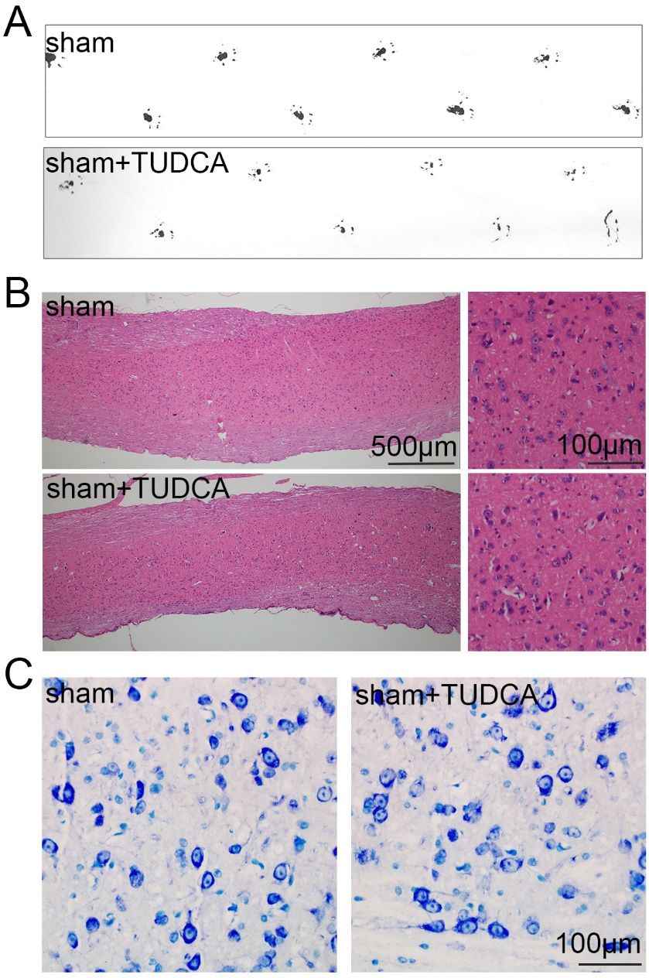
Figure S2. The motor function, histological morphology, and the normal neurons in normal mice treated with TUDCA. (A) Footprint analysis of normal mice treated with TUDCA for 14 days. (B) Representative images from H&E staining in longitudinal section. (C) The survived neurons were stained by Nissl Staining.

Figure S3. The distribution of astrocytes and neurons in normal mice treated with TUDCA. Co-immunofluorescence images showed the distribution of astrocytes (GFAP positive, red) and neurons (MAP2 positive, green) in normal mice treated with TUDCA for 14 days.

