Additional file 1: Table S1 Primers and siRNA used in the study.
Primer | Forward sequence | Reverse sequence
H2-T23 | GGACCGCGAATGACATAGC | GCACCTCAGGGTGACTTCAT
Serping1 | ACAGCCCCCTCTGAATTCTT | GGATGCTCTCCAAGTTGCTC
H2-D1 | TCCGAGATTGTAAAGCGTGAAGA | ACAGGGCAGTGCAGGGATAG
Ggta1 | GTGAACAGCATGAGGGGTTT | GTTTTGTTGCCTCTGGGTGT
Ligp1 | GGGGCAATAGCTCATTGGTA | ACCTCGAAGACATCCCCTTT
Gbp2 | GGGGTCACTGTCTGACCACT | GGGAAACCTGGGATGAGATT
Fbln5 | CTTCAGATGCAAGCAACAA | CCTATGGGTCACTTGCCACT
Ugt1a | CCTATGGGTCACTTGCCACT | AAAACCATGTTGGGCATGAT
Fkbp5 | TATGCTTATGGCTCGGCTGG | CAGCCTTCCAGGTGGACTTT
Psmb8 | CAGTCCTGAAGAGGCCTACG | CACTTTCACCCAACCGTCTT
Srgn | GCAAGGTTATCCTGCTCGGA | TGGGAGGGCCGATGTTATTG
Amigo2 | GAGGCGACCATAATGTCGTT | GCATCCAACAGTCCGATTCT
C3 | AAAAGGGGCGCAACAAGTTC | GATGCCTTCCGGGTTCTCAA
Clcf1 | CTTCAATCCTCCTCGACTGG | TACGTCGGAGTTCAGCTGTG
Ptx3 | AACAAGCTCTGTTGCCCATT | TCCCAAATGGAACATTGGAT
S100a10 | CCTCTGGCTGTGGACAAAAT | CTGCTCACAAGAAGCAGTGG
Sphk1 | GATGCATGAGGTGGTGAATG | TGCTCGTACCCAGCATAGTG
Cd109 | CACAGTCGGGAGCCCTAAAG | GCAGCGATTTCGATGTCCAC
Ptgs2 | GCTGTACAAGCAGTGGCAAA | CCCCAAAGATAGCATCTGGA
Emp1 | GAGACACTGGCCAGAAAAGC | GCAGCGATTTCGATGTCCAC
Slc10a6 | GCTTCGGTGGTATGATGCTT | CCACAGGCTTTTCTGGTGAT
Tm4sf1 | GCCCAAGCATATTGTGGAGT | AGGGTAGGATGTGGCACAAG
B3gnt5 | CGTGGGGCAATGAGAACTAT | CCCAGCTGAACTGAAGAAGG
Cd14 | GGACTGATCTCAGCCCTCTG | GCTTCAGCCCAGTGAAAGAC
GAPDH | CCTGGAGAAACCTGCCAAGTA | TCATACCAGGAAATGAGCTTGAC
5-HT_{2B}R siRNA1 | GGGAAGCAUUUGGCAGGUAUU | UACCUGCCAAAUGCUUCCCUUU
5-HT_{2B}R siRNA2 | CCAUCCCAGUCCCUAUUAATT | UUAAUAGGGACUGGGAUGGTT

Additional file 1: Fig. S1 CMS-induced anxiety-like behaviors are reduced by fluoxetine administration. A Schematic diagram of CMS preferment and fluoxetine treatment experimental design. B-D The circuit diagram (B), bouts of mice in center (C) and duration of mice staying in center (D) in the OFT. E The latency time of mice to the first sniff in SIT. F The latency time of mice to the first feed > 3 s in NSFT. Quantitative data are mean ± s.e. Data were analyzed using two-way ANOVA, then combined with Tukey’s multiple comparison to assess the differences between groups. n = 8 per group, biologically independent animals. *P < 0.05, **P < 0.01, and ***P < 0.001.
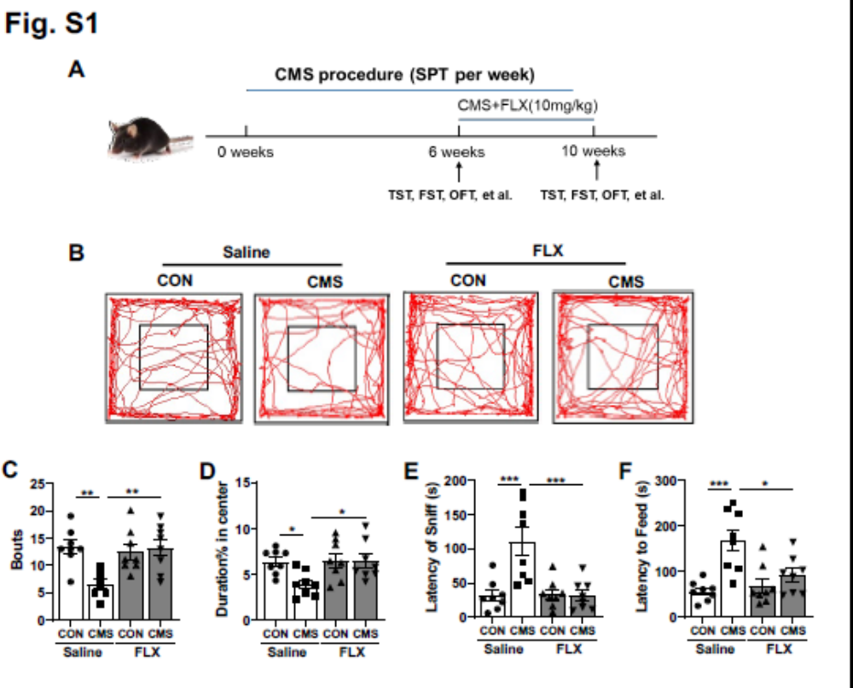
Additional file 1: Fig. S2 A1 astrocyte reactivity in cortex of mice is protected by fluoxetine administration. A Heatmap of A1-special and A2-special transcripts in the cortex as analyzed by RT-qPCR. ***P < 0.001 vs control mice treated with saline; ###P < 0.001 vs CMS mice treated with saline. B-C The expression of C3 in the cortex. D The protein levels of IL-6 in the serum, cortex and hippocampus. Quantitative data are mean ± s.e. Data were analyzed using two-way ANOVA, then combined with Tukey’s multiple comparison to assess the differences between groups. n = 4 per group, biologically independent animals. *P < 0.05, **P < 0.01, and ***P < 0.001.
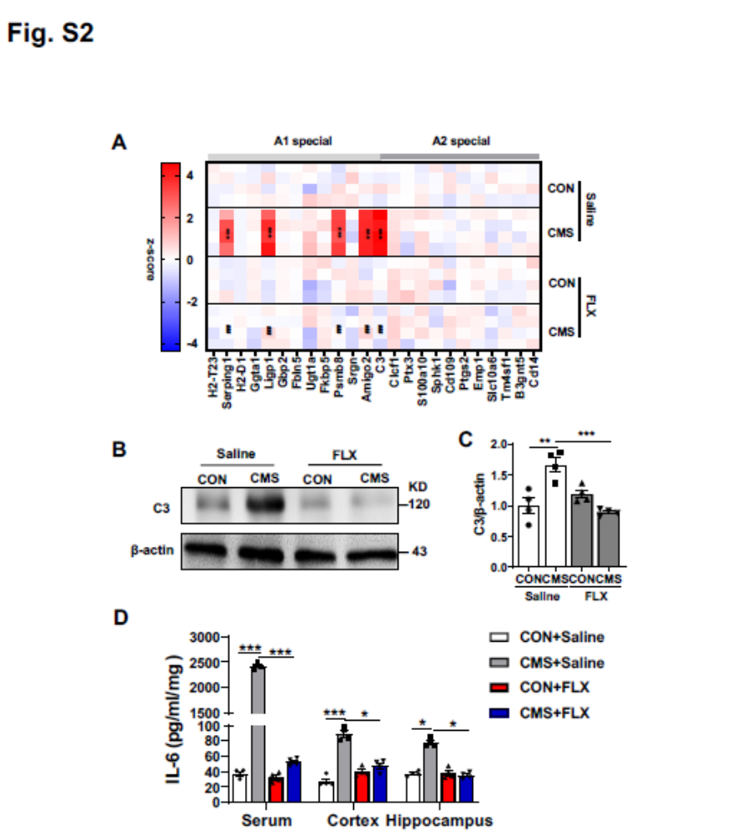
Additional file 1: Fig. S3 The effects of fluoxetine on the releases of LDH in the supernatants of astrocyte. A Primary cultured microglia, astrocyte and neuron were sained with Iba 1, GFAP and Map2 (Scale bars, 50 µm), respectively. B-D The effects of fluoxetine on the releases of LDH in the supernatants of astrocyte after A1 (B), activated (LPS)-MCM (C) and IL-6 (D) stimulation. Quantitative data are mean ± s.e. Data were analyzed using two-way ANOVA, then combined with Tukey’s multiple comparison to assess the differences between groups. All data represent the results of three independent experiments. *P < 0.05, **P < 0.01, and ***P < 0.001.
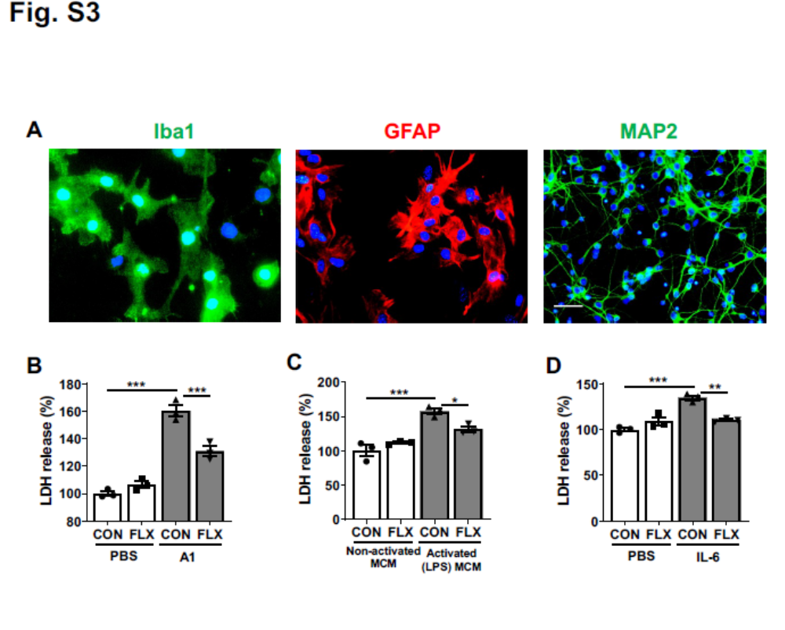
Additional file 1: Fig. S4 The expression of 5-HT_{2B}R in astrocyte after transfection with siRNA for 48h. A Representative blots. B Quantitative data shown in (A). Quantitative data are mean ± s.e. Data were analyzed using Student’s t test. All data represent the results of three independent experiments. ***P < 0.001.
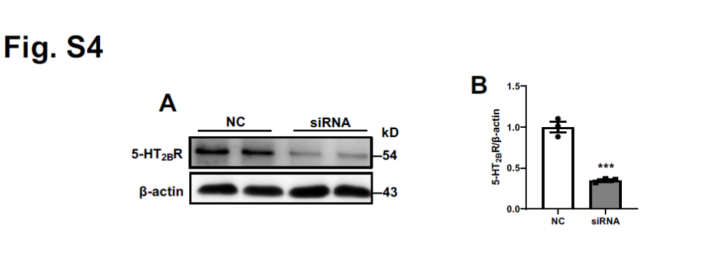
Additional file 1: Fig. S5 AAV-mediated depletion of 5-HT_{2B}R in astrocyte. A Schematic representation of the AAV virus construct used to express 5-HT_{2B}R or control siRNA in astrocyte under the gfaABC1D promoter. B The protein levels of 5-HT_{2B}R in the hippocampus of mice after AAV injection for 4 weeks. Quantitative data are mean ± s.e. Data were analyzed using Student’s t test. All data represent the results of three independent experiments. ***P < 0.001. C The expression of 5-HT_{2B}R on astrocyte in the hippocampus DG of mice. Scale bars, 20 µm. Similar results were obtained in three separate experiments. D Schematic diagram of AAV injection experimental design.
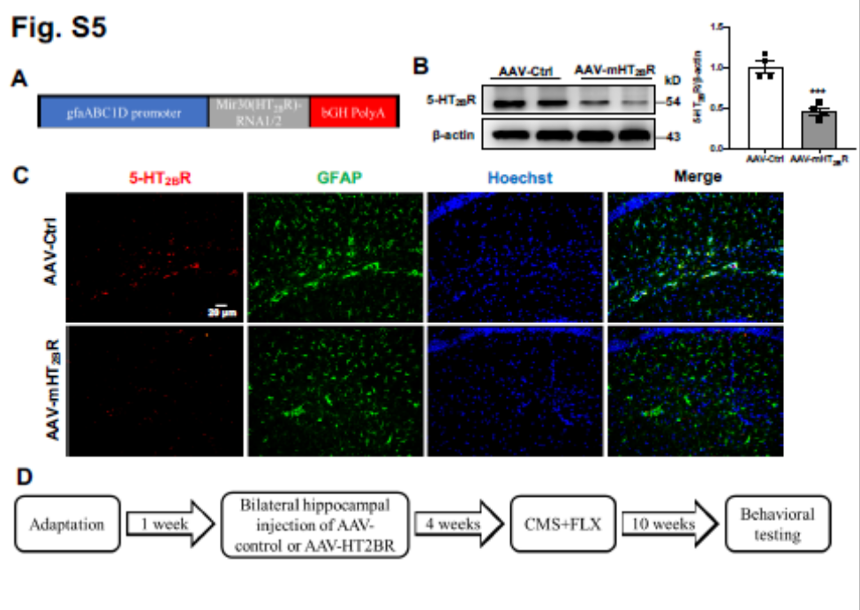
Additional file 1: Fig. S6 Astrocytic 5-HT_{2B}R knockdown reverses the functions of fluoxetine in anxiety-like behaviors and the expression of A1-special markers in cortex of mice. A-C The circuit diagram (A), bouts of mice in center (B) and duration of mice with or without fluoxetine treatment after AAV injection staying in center (C) in the OFT. D The latency time of mice to the first sniff in SIT. E The latency time of mice to the first feed > 3 s in NSFT. F The levels of A1-special genes in the cortex of CON and CMS mice after AAV injection. Quantitative data are mean ± s.e. Data were analyzed using two-way ANOVA, then combined with Tukey’s multiple comparison to assess the differences between groups. B-E: n = 8 (C, E), n = 9 (B, D) CON with Control AAV and saline; n = 8 (C, E), n = 9 (B, D) CON with Control AAV and FLX; n = 8 (D, E), n = 9 (B, C) CMS with Control AAV and saline; n = 8 (B, E), n = 9 (C, D) CMS with Control AAV and FLX; n = 8 CON with mHT_{2B}R AAV and saline; n = 8 (D, E), n = 9 (B, C) CON with mHT_{2B}R AAV and FLX; n = 8 (E), n = 9 (B-D) CMS with mHT_{2B}R AAV and saline; n = 8 (B, D, E), n = 9 (C) CMS with mHT_{2B}R AAV and FLX; F: n = 4 per group; biologically independent animals. *P < 0.05, and ***P < 0.001 vs respective control mice treated with saline; #P < 0.05, and ###P < 0.001 vs CMS mice injected with control AAV and treated with saline; $P < 0.05, $$P < 0.01, and $$$P < 0.001.
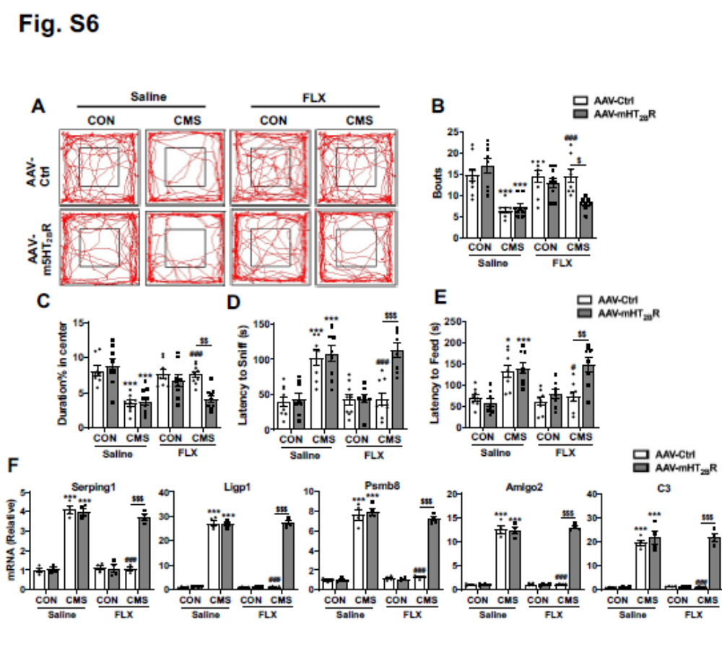
Additional file 1: Fig. S7 β-arrestin 2 is contribute to the effects of fluoxetine on A1 astrocyte reactivity in vitro. A The expression of β-arrestin 1 in primary astrocyte isolated from WT and β-arrestin 1 knockout mice. B The expression of β-arrestin 2 in primary astrocyte of isolated from WT and β-arrestin 2 knockout mice. C Effects of β-arrestin 2 knockout on the levels of A1-special genes in astrocyte with or without fluoxetine treatment after activated (LPS)-MCM stimulation. Quantitative data are mean ± s.e. Data were analyzed using two-way ANOVA, then combined with Tukey’s multiple comparison to assess the differences between groups. All data represent the results of three independent experiments. ***P < 0.001 vs respective control cells treated with non-activated MCM; ##P < 0.01, and ###P < 0.001 vs WT control cells treated with LPS-MCM stimulation; $$P < 0.01, and $$$P < 0.001.
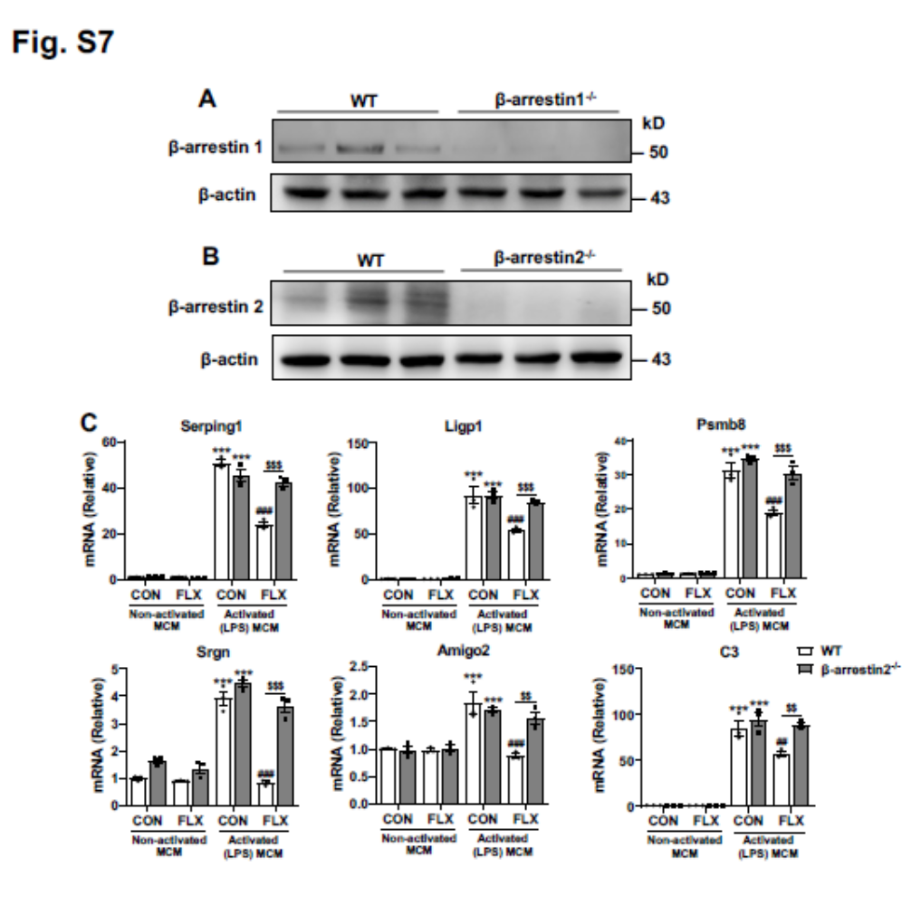
Additional file 1: Fig. S8 β-arrestin 2 knockout reduces the effects of fluoxetine on the expression of A1-special markers in cortex of CMS mice. A-C The circuit diagram (A), bouts of WT and β-arrestin 2 knockout mice in center (B) and duration of WT and β-arrestin 2 knockout mice staying in center (C) in the OFT. D The latency time of mice to the first sniff in SIT. E The latency time of mice to the first feed > 3 s in NSFT. F The levels of A1-special genes in the cortex of WT and β-arrestin 2^{-/-} mice. Data were analyzed using two-way ANOVA, then combined with Tukey’s multiple comparison to assess the differences between groups. Quantitative data are mean ± s.e. B-E: n = 8 (D, E), n = 9 (B, C) WT CON with saline; n = 8 (C-E), n = 9 (B) WT CON with FLX; n = 8 (D, E), n = 10 (B, C) WT CMS with saline; n = 8 (D, E), n = 9 (B, C) WT CMS with FLX; n = 8 (E), n = 9 (B, C), n = 10 (D) β-arrestin 2^{-/-} CON with saline; n = 8 (B, D, E), n = 9 (C) β-arrestin 2^{-/-} CON with FLX; n = 8 β-arrestin 2^{-/-} CMS with saline; n = 8 (D, E), n = 9 (B, C) β-arrestin 2^{-/-} CMS with FLX; F: n = 4 per group; biologically independent animals. ***P < 0.001 vs respective control mice treated with saline; #P < 0.05, and ###P < 0.001 vs WT CMS mice treated with saline; $P < 0.05, $$P < 0.01, and $$$P < 0.001.
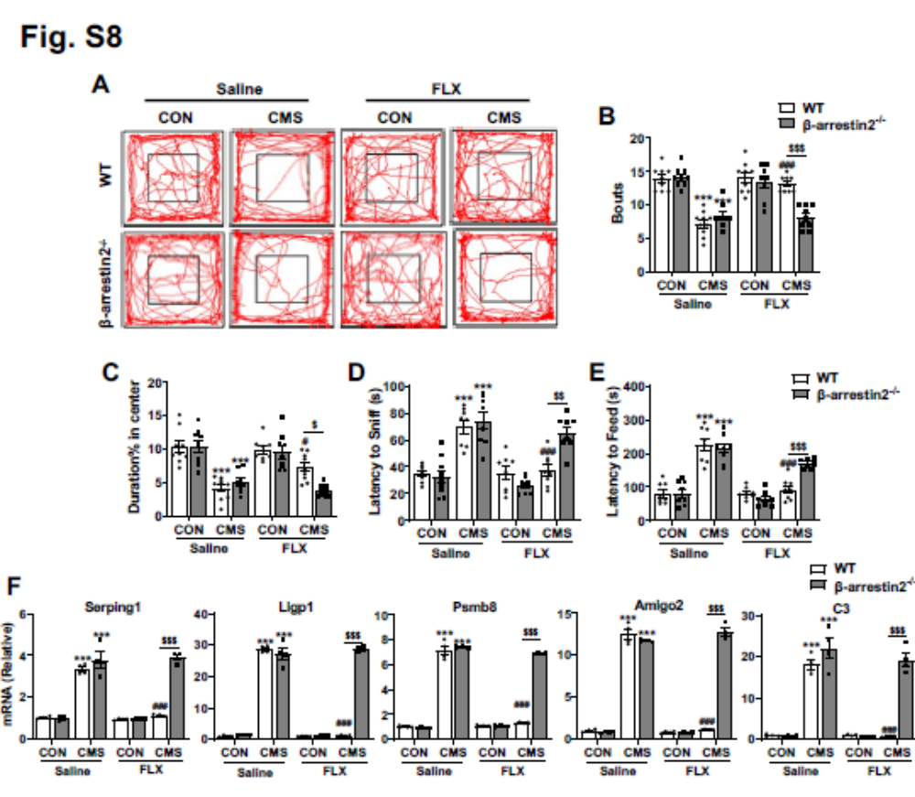
Additional file 1: Fig. S9 The overall experimental design of this study.
