Supplementary materials

Title: Astrocyte reactivation in medial prefrontal cortex contributes to obesity promoted depressive-like behaviors
Authors: Gang Yu, et al.

Contents: Table S1, Figure S1-7

Table S1. Primers used for qPCR
Gene | Forward primer (5'-3') | Reverse primer (5'-3')
Leptin | GTGGCTTTGGTCCTATCTGTC | CGTGTGTGAAATGTCATTGATCC
Il1b | GAAATGCCACCTTTTGACAGTG | TGGATGCTCTCATCAGGACAG
Il6 | CTGCAAGAGACTTCCATCCAG | AGTGGTATAGACAGGTCTGTTGG
Il12a | AGACATCACACGGGACCAAAC | CCAGGCAACTCTCGTTCTTGT
Tnf | CAGGCGGTGCCTATGTCTC | CGATCACCCCGAAGTTCAGTAG
Ifng | ATGAACGCTACACACTGCATC | CCATCCTTTTGCCAGTTCCTC
Ccl5 | TTTGCCTACCTCTCCCTCG | CGACTGCAAGATTGGAGCACT
Ccl20 | GCCTCTCGTACATACAGACGC | CCAGTTCTGCTTTGGATCAGC
Cxcl1 | CTGGGATTCACCTCAAGAACATC | CAGGGTCAAGGCAAGCCTC
Cxcl10 | TGCAAGTCTATCCTGTCCGC | ACGGAGCTCTTTTTGACCTTC
Csf2 | GGCCTTGGAAGCATGTAGAGG | GGAGAACTCGTTAGAGACGACTT
Cd16 | AATGCACACTCTGGAAGCCAA | CACTCTGCCTGTCTGCAAAAG
Cd86 | TCAATGGGACTGCATATCTGCC | GCCAAAATACTACCAGCTCACT
Nos2 | GTTCTCAGCCCAACAATACAAGA | GTGGACGGGTCGATGTCAC
Il1ra | GCTCATTGCTGGGTACTTACAA | CCAGACTTGGCACAAGACAGG
Il4 | GGTCTCAACCCCCAGCTAGT | GCCGATGATCTCTCTCAAGTGAT
Tgfb1 | CCACCTGCAAGACCATCGAC | CTGGCGAGCCTTAGTTTGGAC
Ccl22 | ATGCGCGTCCATTACCTGTG | TCAACGGTCCAATCATTTGCT
Cd206 | CTCTGTTCAGCTATTGGACGC | TGGCACTCCCAAACATAATTTGA
Cd163 | GGTGGACACAGAATGGTTCTTC | CCAGGAGCGTTAGTGACAGC
Arg1 | CTCCAAGCCAAAGTCCTTAGAG | GGAGCTGTCATTAGGGACATCA
Ym1 | CAGGTCTGGCAATTCTTCTGAA | GTCTTGCTCATGTGTGTAAGTGA
Fizz1 | CCAATCCAGCTAACTATCCCTCC | ACCCAGTAGCAGTCATCCCA
Il10 | CTTACTGACTGGCATGAGGATCA | GCAGCTCTAGGAGCATGTGG
Il4ra | ACACTACAGGCTGATGTTCTTCG | TGGACCGGCCTATTCATTTCC
Csf3 | ATGGCTCAACTTTCTGCCCAG | CTGACAGTGACCAGGGGAAC
Lcn2 | CCGACACTGACTACGACCAG | AATGCATTGGTCGGTGGGAA
Steap4 | CAAACGCCGAGTACCTTGCT | CAGACAAACACCTGCCGACT
S1pr3 | CTTGCAGAACGAGAGCCTGT | CCTCAACAGTCCACGAGAGG
Timp1 | CGCTAGAGCAGATACCACGA | CCAGGTCCGAGTTGCAGAAA
Hspb1 | GAGATCACTGGCAAGCACGA | ATTGTGTGACTGCTTTGGGC
Cxcl10 | TGCAAGTCTATCCTGTCCGC | ACGGAGCTCTTTTTGACCTTC
Cd44 | TCAGGATAGCCCCACAACAAC | GACTCCGTACCAGGCATCTTC
Osmr | GTCATTCTGGACATGAAGAGGT | AATCACAGCGTTGGGTCTGA
Cp | GATGTTTCCCCAAACGCCTG | GTAGCTCTGAGACGATGCTTGA
Serpina3n | GTCTTTCAGGTGGTCCACAAGG | GCCAATCACAGCATAGAAGCG
Aspg | CAGGTGCCCAGGTTCCTATC | GTCCACCTTGGTTGTCCGAT
Vim | GAGGAGATGAGGGAGTTGCG | CTGCAATTTTTCTCGCAGCC
Gfap | AACCGCATCACCATTCCTGT | TCCTTAATGACCTCGCCATCC
H2.T23 | ATTGGAGCTGTTGTGAGGAGG | CCACGAGGCAACTGTCTTTTC
Serping1 | TGGCTCAGAGGCTAACTGGC | GAATCTGAGAAGGCTCTATCCCCA
H2.D1 | ATGGAACCTTCCAGAAGTGGG | GAAGTAAGTTGGAGTCGGTGGA
Ggta1 | TCTCAGGATCTGGGAGTTGGA | GAGTTCTATGGAGCTCCCGC
Iigp1 | ATTTGGCTCGAAGCCTTTGC | ACGGCATTTGCCAGTCCTTA
Gbp2 | TAAAGGTCCGAGGCCCAAAC | AACATATGTGGCTGGGCGAA
Fbln5 | AGGGGGTTAAGCGAAACCAG | GTGAGTATCCTTTTAATCCTGGCA
Ugt1a | GGAAGCTGTTAGTGATCCCC | TGCTATGACCACCACTTCGT
Fkbp5 | TGCAGTGTCGGCAGTTGTAT | GGGTCGCCCAAGTTAGAACA
Psmb8 | TATCTGCGGAATGGGGAACG | AAAGTCCCGGTCCCTTCTTG
Srgn | GTTCAAGGTTATCCTGCTCGGA | AAACAGGATCGGTCATCGGG
Amigo2 | GTTCGCCACAACAACATCAC | GTTTCTGCAAGTGGGAGAGC
Clcf1 | GACTCGTGGGGGATGTTAGC | CCCCAGGTAGTTCAGGTAGGT
Tgm1 | AGACCCAATTTTCCTGGGGC | AGCGAGGACCTTCCATTGTG
Ptx3 | CATCCCGTTCAGGCTTTGGA | CACAGGGAAAGAAGCGAGGT
S100a10 | GAAAGGGAGTTCCCTGGGTT | CCCACTTTTCCATCTCGGCA
Sphk1 | AAAGCGAGACCCTGTTCCAG | CAGTCTGCTGGTTGCATAGC
Cd109 | GTCGCTCACAGGTACCTCAA | CTGTGAAGTTGAGCGTTGGC
Ptgs2 | CTCAGCCATGCAGCAAATCC | GGGTGGGCTTCAGCAGTAAT
Emp1 | ACCATTGCCAACGTCTGGAT | TGGAACACGAAGACCACGAG
Slc10a6 | TCCATAGAGACCGGAGCACA | ATGCCTGATATGCTGCGACA
Tm4sf1 | CTGAGGGACAGTACCTTCTGGATTC | GGCTAGGCCTCAACACAGTTA
B3gnt5 | TGCTCCTGGATGAAAGGTCC | ACATGCTTGATCCGTGTGGT
Cd14 | TCAGAATCTACCGACCATGAAGC | GGACACTTTCCTCGTCCTGG
Gapdh | AGGTCGGTGTGAACGGATTTG | GGGGTCGTTGATGGCAACA

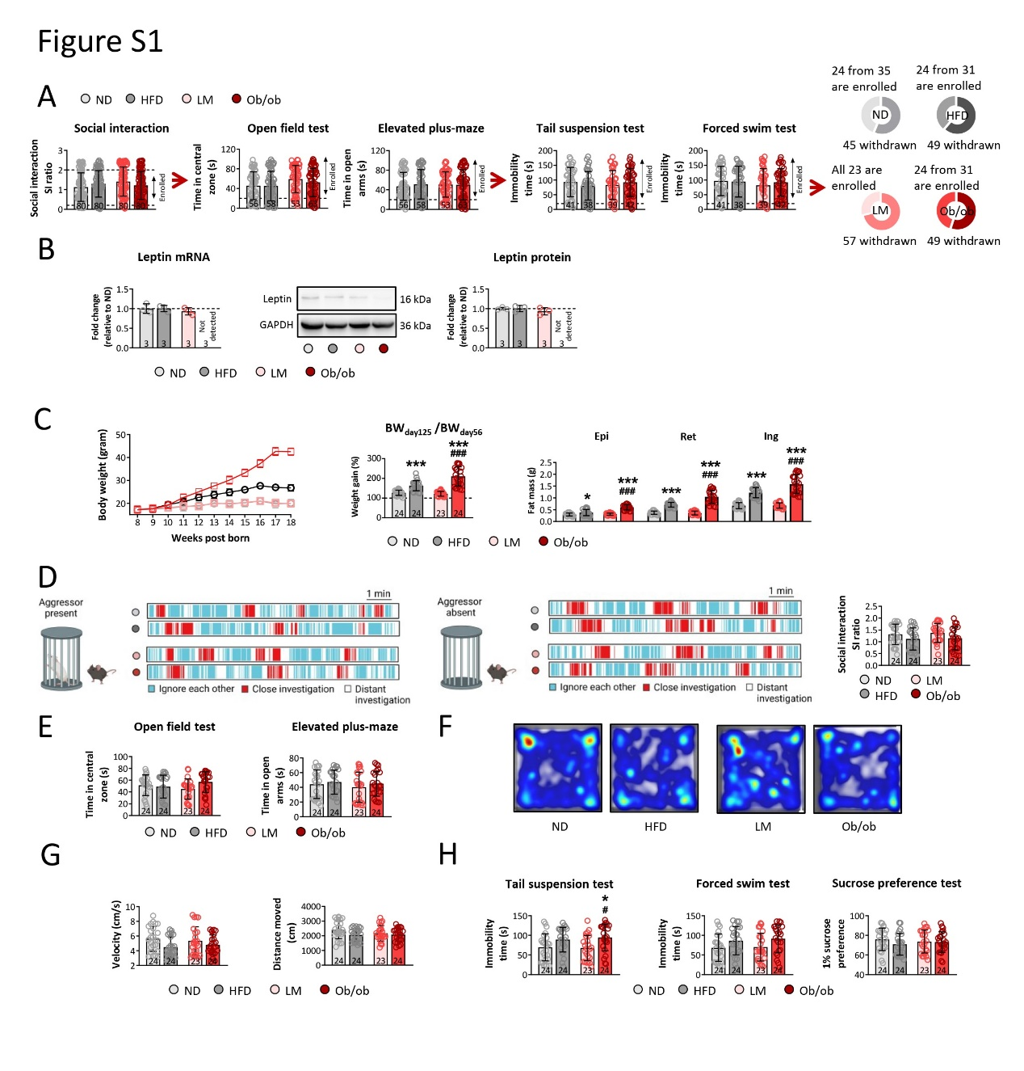
Neither high fat diet nor leptin knockout induce depressive-like behavior. (A) To avoid the bias induced by individual differences, the mice used for further study were screened by social interaction, open field test, elevated plus-maze, tail suspension test, and forced swim test. (B) The mRNA and protein level were detected in the brain of different mice model. (C) The body weight was recorded, weight gain was measured by dividing 125-day body weight to 56-day body weight, and fat mass was measured in epididymal, inguinal, and retroperitoneal regions. (D) To assess the behavioral changes among different mice model, social interaction was performed under aggressor present and absent. (E) The anxiety behaviors of mice were evaluated by open field test and elevated plus-maze, (F and G) the locomotor activity was evaluated by analyzing velocity and distance moved on open field test, and (H) depressive behaviors of mice were investigated by tail suspension test, forced swim test, and sucrose preference test. (ND represented as normal diet, HFD represented as high fat diet, LM represented as littermate mice, and ob/ob represented as obesity transgenic mice; data is presented as mean ± SD, *p<0.05, ***p<0.001 compared with ND mice; ###p<0.001 compared with LM mice).

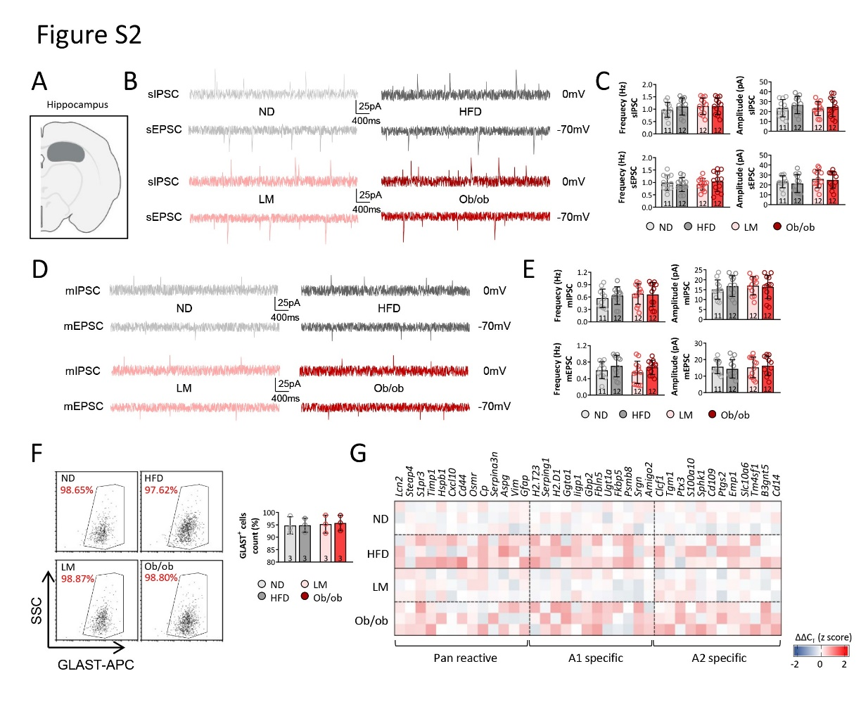
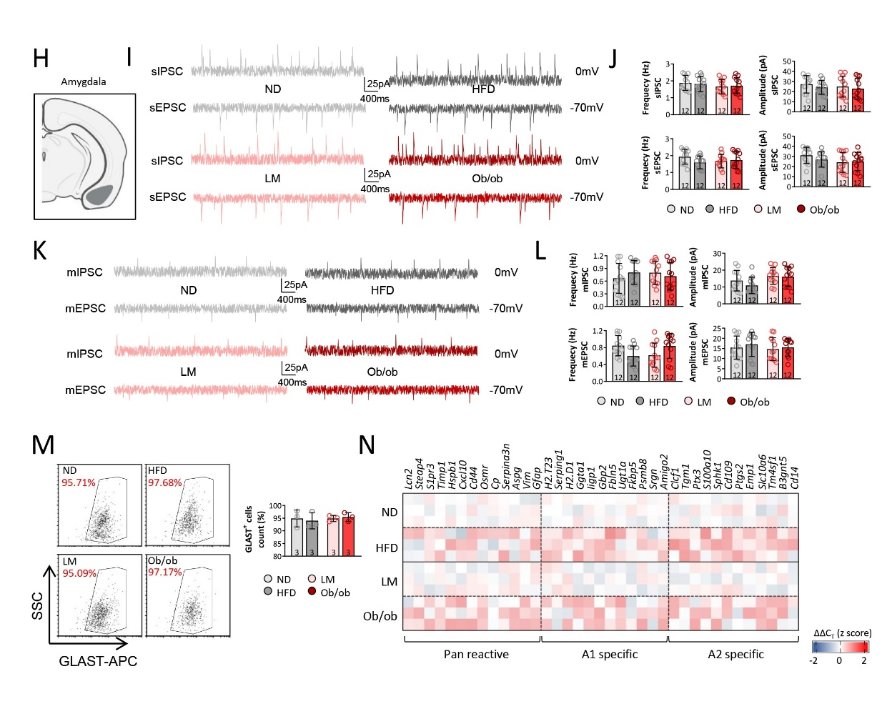
Neuronal activities and astrocytes reactivity in hippocampus and amygdala were not altered among ND, HFD, LM, and ob/ob mice. To detected neuronal activities in hippocampus (A), sIPSC, sEPSC (B, C), mIPSC, and mEPSC (D, E) were recorded, and frequency and amplitude were calculated. Astrocyte response in hippocampus was detected by investigating activation related genes expression of isolated astrocyte (F and G). To detected neuronal activities in amygdala (H), sIPSC, sEPSC (I, J), mIPSC, and mEPSC (K, l) were recorded, and frequency and amplitude were calculated. Astrocyte response in amygdala was detected by investigating activation related genes expression of isolated astrocyte (M and N). (Data is presented as mean ± SD, p<0.05 was considered as significant difference).

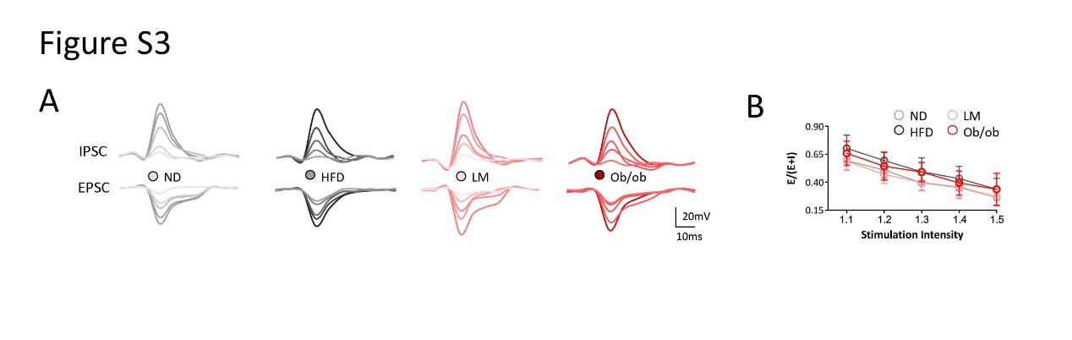
E/I balance was not altered by high fat diet or leptin knockout. (A) IPSC and EPSC was recorded in mPFC brain slices and (B) E/I balance was calculated by E/(E+I). (Data is presented as mean ± SD, p<0.05 was considered as significant difference)

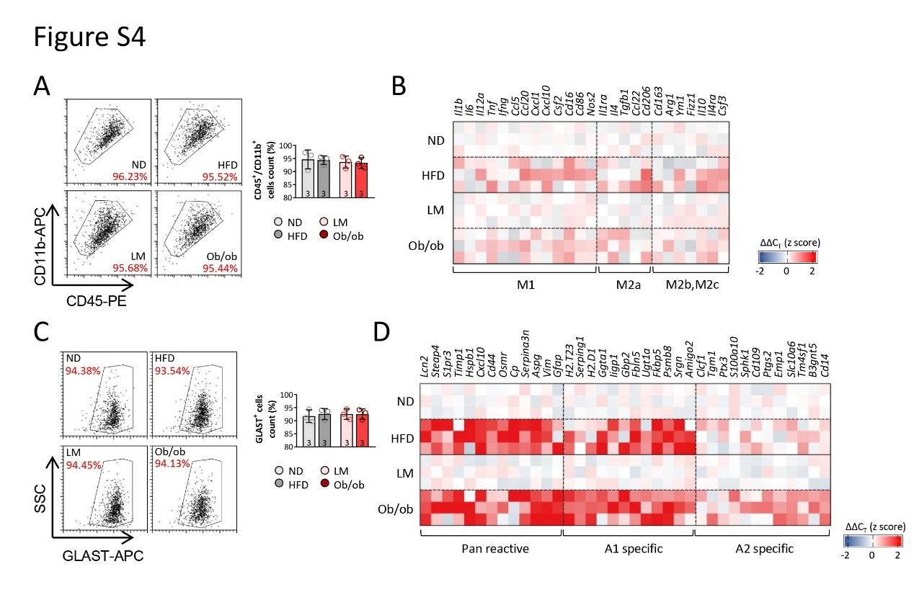
Astrocyte reactivation was significantly upregulated by high fat diet or leptin knockout, but microglia response was not altered. Microglia response was detected by investigating activation related genes expression of isolated microglia (A and B). Astrocyte response was detected by investigating activation related genes expression of isolated astrocyte (C and D). (Data is presented as mean ± SD, p<0.05 was considered as significant difference).
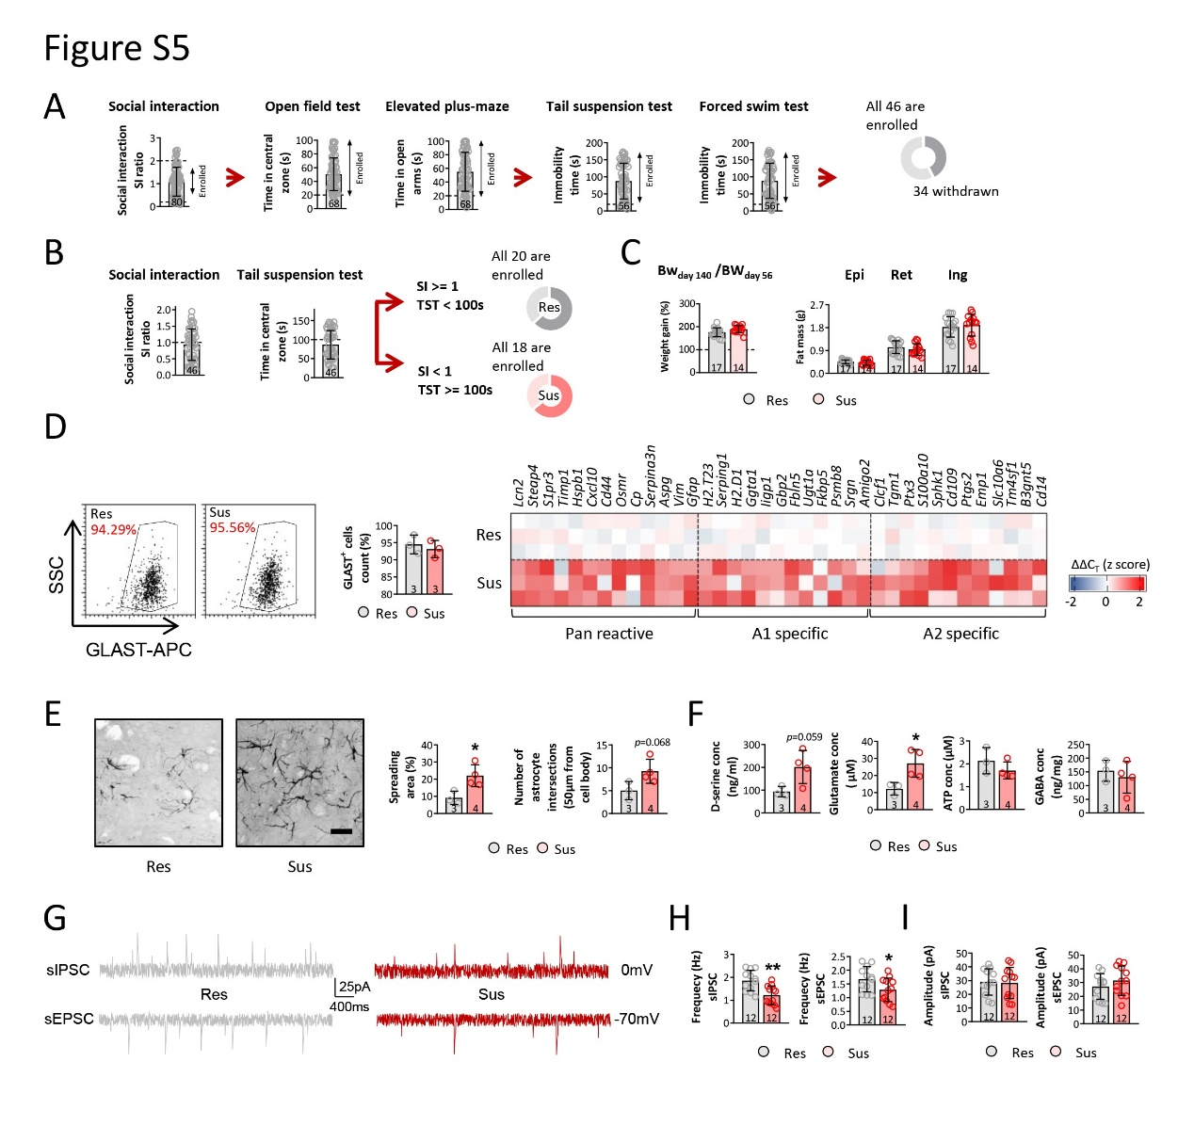
Astrocyte reactivity was increased in susceptible mice. (A) To avoid the bias induced by individual differences, the mice used for further study were screened by social interaction, open field test, elevated plus-maze, tail suspension test, and forced swim test. (B) The resilient mice were defined as SI >= 1 and TST < 100s while susceptible mice were defined as SI < 1 and TST >= 100s. (C) Fat mass was measured in epididymal, inguinal, and retroperitoneal regions. (D) Astrocyte response was detected by investigating activation related genes expression of isolated astrocyte. (E) Astrocyte morphology was measured by calculating spreading area and number of interactions. (F) The level of D-serine, glutamate, ATP, and GABA were also assessed in microdialysate from mPFC. To detected neuronal activities in mPFC, sIPSC and sEPSC were recorded (G), and frequency and amplitude were calculated (H and I). (Res represented as resilient mice, Sus represented as susceptible mice; data is presented as mean ± SD, *p<0.05, **p<0.01 compared with Res mice).

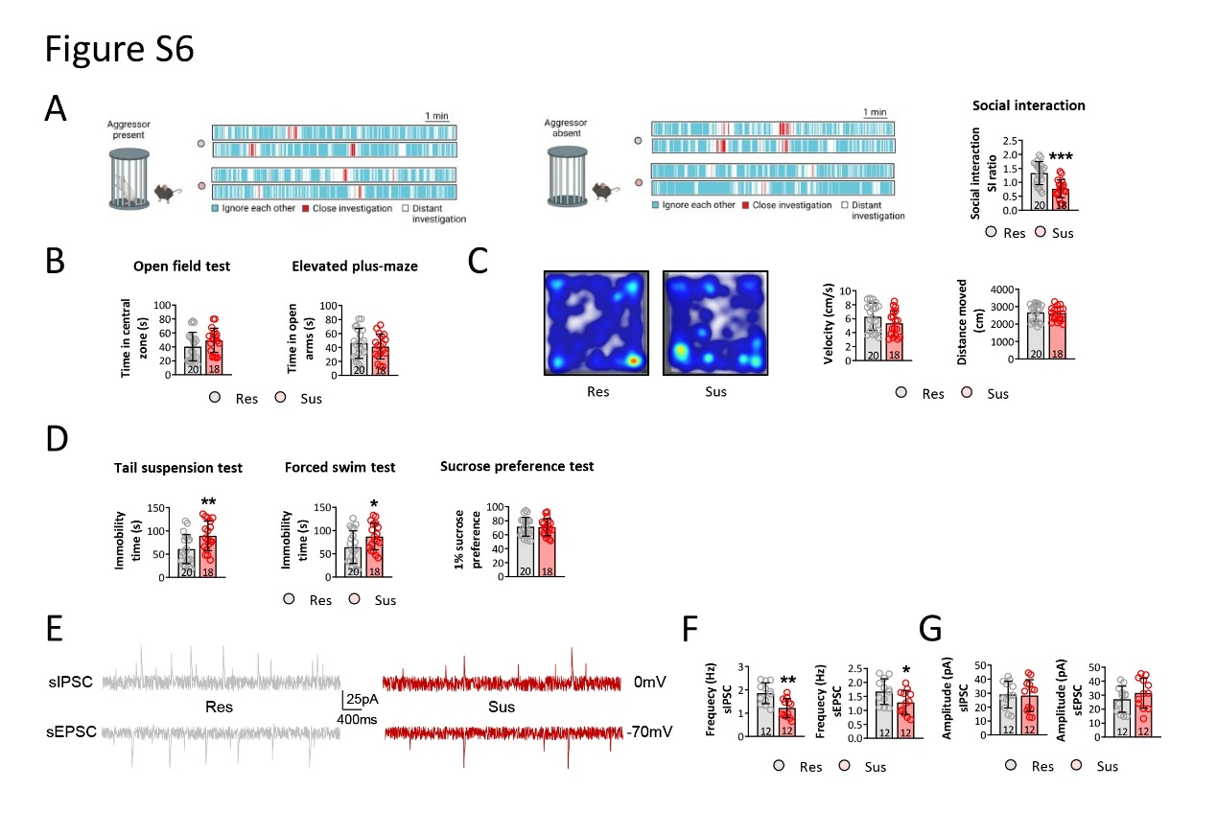
Depressive-like behaviors were increased in susceptible mice. (A) To assess the behavioral changes among different mice model, social interaction was performed under aggressor present and absent. (B) The anxiety behaviors of mice were evaluated by open field test and elevated plus-maze, (C) the locomotor activity was evaluated by analyzing velocity and distance moved on open field test, and (D) depressive behaviors of mice were investigated by tail suspension test, forced swim test, and sucrose preference test. To detected neuronal activities in mPFC, sIPSC and sEPSC were recorded (E), and frequency and amplitude were calculated (F and G). (Res represented as resilient mice, Sus represented as susceptible mice; data is presented as mean ± SD, *p<0.05, **p<0.01, ***p<0.001 compared with Res mice).

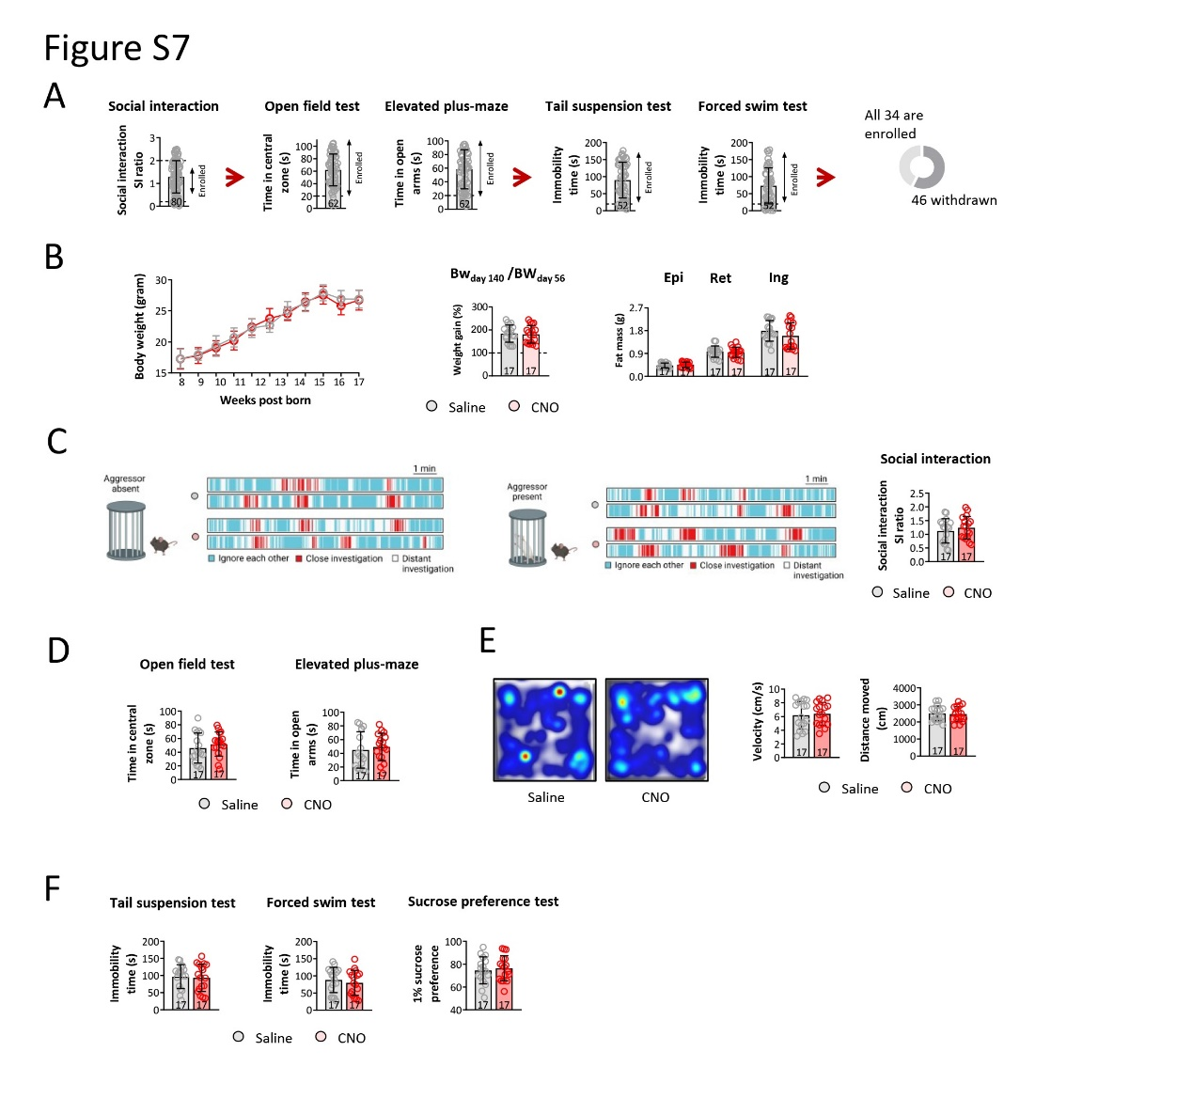
Behavioral functions were not altered before CNO injection. (A) To avoid the bias induced by individual differences, the mice used for further study were screened by social interaction, open field test, elevated plus-maze, tail suspension test, and forced swim test. (B) The body weight was recorded, weight gain was measured by dividing 125-day body weight to 56-day body weight, and fat mass was measured in epididymal, inguinal, and retroperitoneal regions. (C) To assess the behavioral changes among different mice model, social interaction was performed under aggressor present and absent. (D) The anxiety behaviors of mice were evaluated by open field test and elevated plus-maze, (E) the locomotor activity was evaluated by analyzing velocity and distance moved on open field test, and (F) depressive behaviors of mice were investigated by tail suspension test, forced swim test, and sucrose preference test. (Data is presented as mean ± SD, p<0.05 was considered as significant difference).

