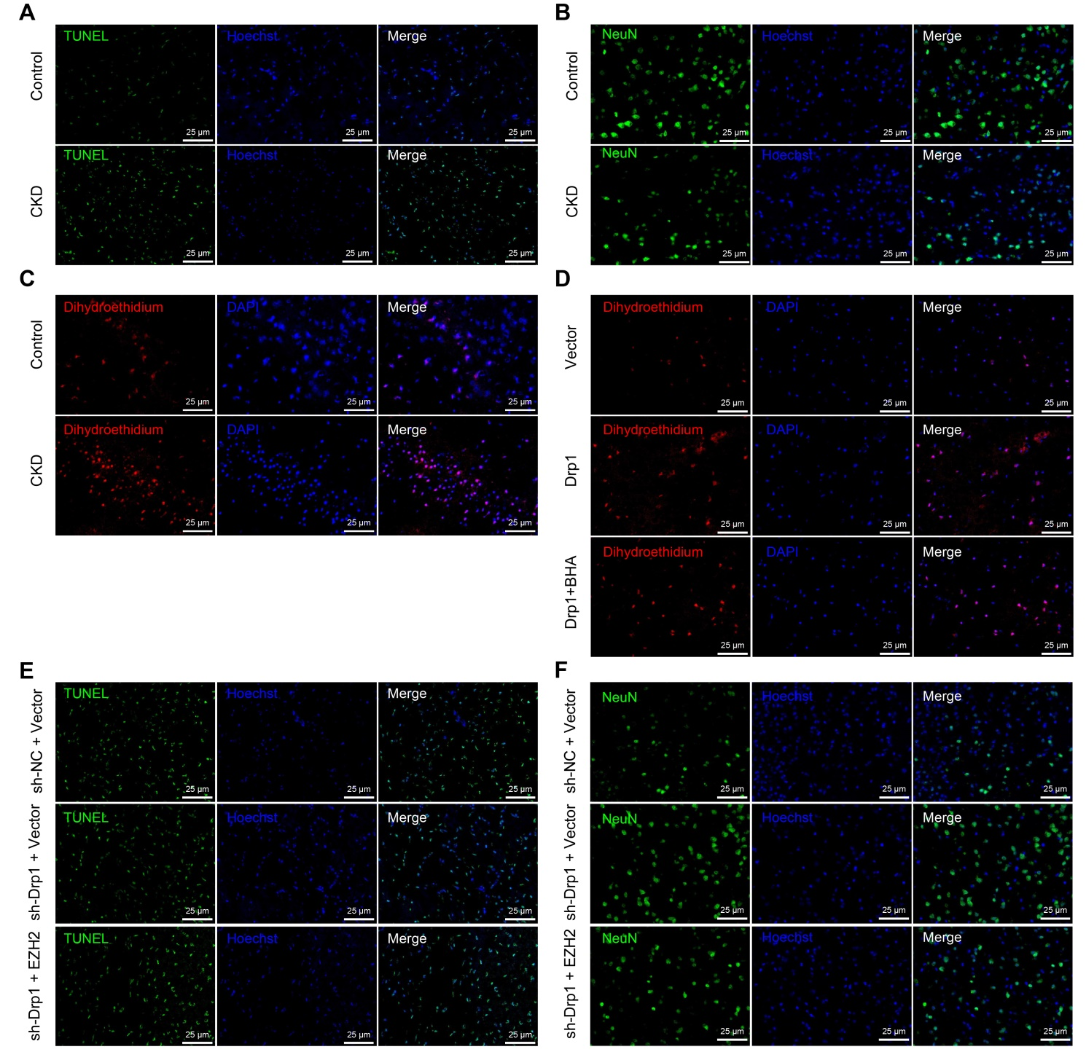
Figure S1 Representative TUNEL, immunofluorescence staining, and DHE staining images. A, Representative images showing TUNEL-positive cells in prefrontal cortical tissues of control and CKD mice; B, Representative immunofluorescence staining images showing NeuN-positive cells in prefrontal cortical tissues of control and CKD mice; C, Representative DHE staining images showing ROS level in prefrontal cortical tissues of control and CKD mice; D, Representative DHE staining images showing ROS level in mouse primary cortical neurons; E, Representative images showing TUNEL-positive cells in prefrontal cortical tissues of CKD mice following treatments; F, Representative immunofluorescence staining images showing NeuN-positive cells in prefrontal cortical tissues of CKD mice following treatments.

