Supplementary Information

Helicobacter pylori outer membrane vesicles induce astrocyte reactivity through Nuclear Factor-κappa B activation and cause neuronal damage in vivo in a murine model

Running title: H. pylori vesicles and astrocyte reactivity

Esteban Palacios^{1,2,3}, Lorena Lobos-González^{3,6}, Simón Guerrero^{3,4,7}, Marcelo J. Kogan^{3,4}, Baohai Shao⁵, Jay W. Heinecke⁵, Andrew F.G. Quest^{2,3}, Lisette Leyton^{2,3,}* and Manuel Valenzuela-Valderrama^{1,3,}*

Affiliations
¹Laboratorio de Microbiología Celular, Instituto de Investigación y Postgrado, Facultad de Ciencias de la Salud, Universidad Central de Chile, Santiago 8330546, Chile.
² Laboratory of Cellular Communication, Center for Studies on Exercise Metabolism and Cancer (CEMC), Institute of Biomedical Sciences (ICBM). Facultad de Medicina, Universidad de Chile, Santiago 8380453, Chile.
³ Advanced Center for Chronic Diseases (ACCDiS), Facultad de Ciencias Químicas y Farmacéuticas, Universidad de Chile, Santiago 8380494, Chile.
⁴ Departamento de Química Farmacológica y Toxicológica, Facultad de Ciencias Químicas y Farmacéuticas, Universidad de Chile, Santiago 8380494, Chile.
⁵ Division of Metabolism, Endocrinology and Nutrition, University of Washington, Seattle, WA 98195-8055, USA.
⁶ Centro de Medicina Regenerativa, Facultad de Medicina, Universidad del Desarrollo-Clínica Alemana, Santiago 7590943, Chile.
⁷ Facultad de Medicina, Universidad de Atacama,1533601 Copiapó, Chile.

*Corresponding Authors: lleyton@uchile.cl (LL) and manuel.valenzuela@ucentral.cl (MVV)

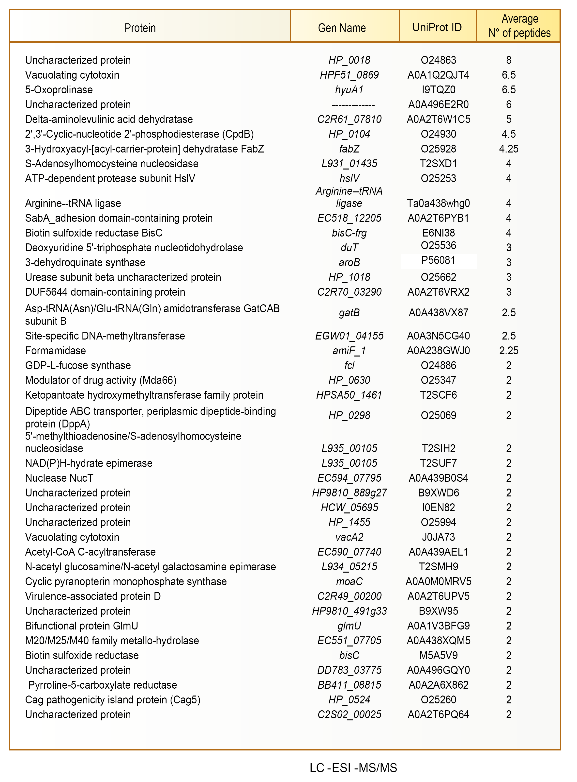
Table S1: Identification of proteins with unique peptides in Helicobacter pylori (Hp) 60190 OMVs. The results of the LC–MS/MS analysis and the search using the Hp UniProtKB database (UP000000429.fasta) allowed to identify the total protein content of OMVs and the parental bacteria Hp 60190. The table shows the protein ID and the average number of unique peptides of proteins found in OMVs.

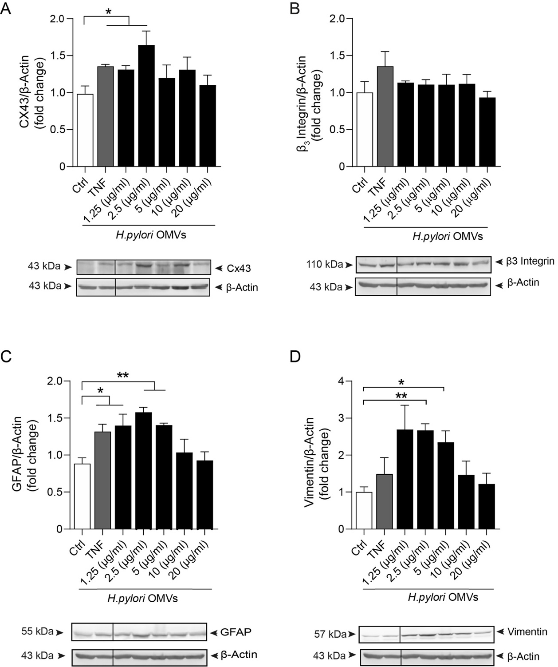

Figure S1. Evaluation of the dose-response of the reactivity markers in DITNC1 ATCC astrocytes treated with different concentrations of OMVs from Helicobacter pylori (Hp) 60190. DITNC1 ATCC cells were incubated in the absence or presence of OMVs (1.25 to 20 µg/ml) from Hp 60190, at 37 °C for 24 h. As a positive reactivity control, the astrocytes were incubated with TNF (10 ng/ml, 48 h). After treatment, whole cell lysates were evaluated by immunoblot analysis of total connexin 43 (A), β₃ integrin (B), GFAP (C), and vimentin (D), normalized to β-actin. Values in the graphs were obtained by averaging the immune-specific band intensity normalized to β-actin from 3 independent experiments (mean ± S.E.M). *p < 0.05 and **p < 0.01, compared to controls (Ctrl).
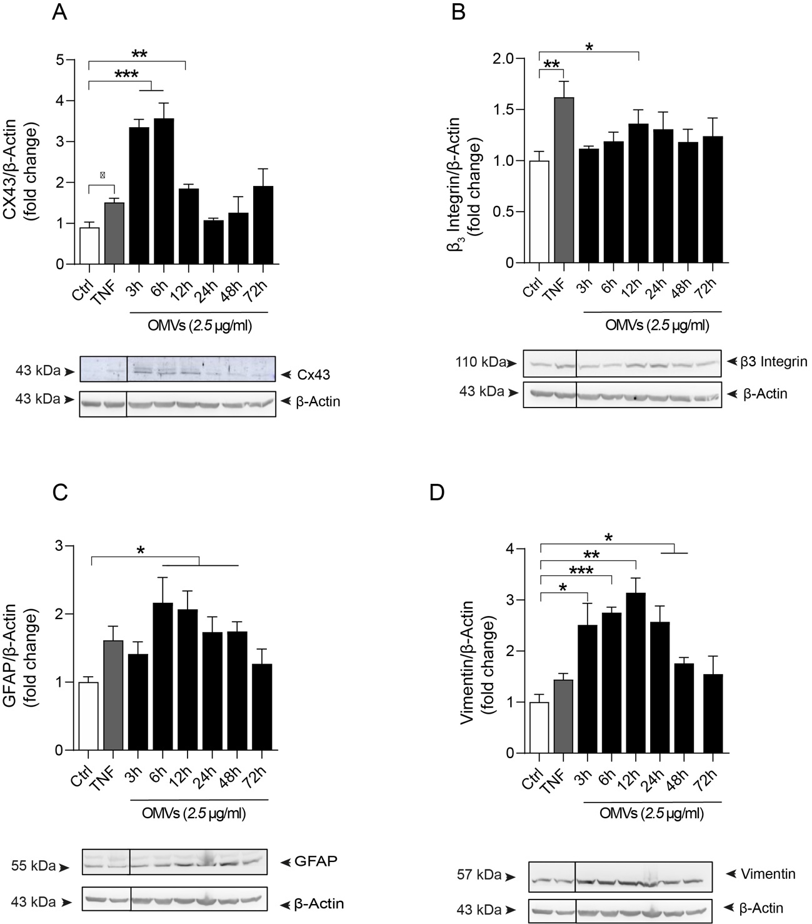
Figure S2. Dose-response of the reactivity markers in DITNC1 ATCC astrocytes treated with 2.5 µg/ml of Helicobacter pylori (Hp) OMVs at different times. DITNC1 ATCC cells were incubated in the absence or presence of 2.5 µg/ml of Hp 60190 OMVs at 37 °C, from 3 to 72 h. As a positive reactivity control, the astrocytes were incubated with TNF (10 ng/ml, 48 h). After treatment, whole cell lysates were evaluated by immunoblot analysis of total connexin 43 (A), β₃ integrin (B), GFAP (C), and vimentin (D), normalized to β-actin. Values in the graphs were obtained by averaging the immune-specific band intensity, normalized to β-actin, from 3 independent experiments (mean ± S.E.M). *p < 0,05, **p < 0.01, and ***p < 0.001, compared to controls (Ctrl).
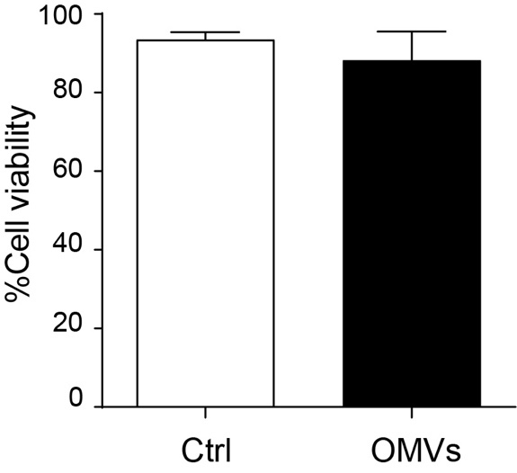
Figure S3. Effect of Helicobacter pylori (Hp) OMVs on astrocyte cell viability. Primary astrocytes (post 17 days in vitro) were incubated in the absence or presence of 2.5 µg/ml of OMVs for 12 h. Cell viability was evaluated with the Trypan blue assay in a Neubauer chamber. Values in the graph represent the average of the percentage of negative trypan blue cells from 3 independent experiments (mean ± S.E.M.).
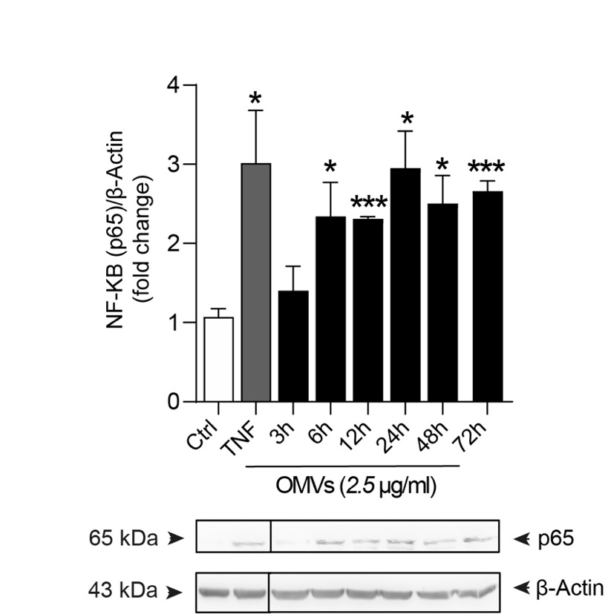
Figure S4. Effect of Helicobacter pylori (Hp) OMVs on p65 NF-ĸB subunit protein levels in DITNC1 ATCC astrocytes, following different times of exposure. DITNC1 ATCC cells were incubated in the absence or presence of 2.5 µg/ml of OMVs from 3 to 72 h, at 37 °C. As a positive reactivity control, the astrocytes were incubated with TNF (10 ng/ml, 48 h). After treatment, whole cell lysates were evaluated by immunoblot analysis of p65 NF-ĸB total levels. Values in the graph were obtained by averaging the immune-specific band intensity, normalized to β-actin, from 3 independent experiments (mean ± S.E.M). *p < 0.05, **p < 0.01, and ***p < 0.001, compared to controls (Ctrl).
Table 2. Research Resource Identifiers. List of reagents, antibodies, inhibitors, kits, experimental models used in this study. Tee catalog number is included when available.
REAGENT or RESOURCE | SOURCE | IDENTIFIER
Antibodies
Mouse monoclonal anti-GFAP | Sigma-Aldrich | Cat# G3893; AB_477010
Mouse monoclonal anti-β-actin | Sigma-Aldrich | Cat# A5316; AB_476743
Mouse monoclonal anti-vimentin | Santa Cruz | Cat# SC-66002; AB_1131285
Rabbit polyclonal anti-connexin 43 | Santa Cruz | Cat# SC-9059; AB_638640
Rabbit polyclonal anti-β₃ integrin | Millipore | Cat# AB2984; AB_10806204
Rabbit monoclonal anti-NF-κB (p65) | Cell Signaling | Cat# 8242; AB_10859369
Rabbit monoclonal anti-pS536p65 | Cell Signaling | Cat# 3033; AB_331284
Mouse monoclonal anti-Thy-1/CD90 | BD Biosciences | Cat# 554894; AB_395585
Mouse monoclonal anti-βIII tubulin | Promega | Cat# G7121; AB_430874
Mouse monoclonal anti-LAP2 | BD Biosciences | Cat# 611000; AB_398313
Goat- anti-mouse IgG (H+L) polyclonal antibody (HRP) | SeraCare KPL | Cat# 074-1806; AB_2891080
Goat anti-rabbit IgG (H+L) polyclonal antibody (HRP) | SeraCare KPL | Cat# 074-1506; AB_2721169
Goat anti-mouse IgG, Alexa 488 | Molecular Probes | Cat# A-11029; AB_138404
Goat anti-rabbit IgG; Alexa 546 | Molecular Probes | Cat# A-11010; AB_2534077
Bacterial and virus strains
Helicobacter pylori 60190 (cag PAI+, VacA s1m1) | ATCC | ATCC 49503
Biological samples
Chemicals, peptides, and recombinant proteins
Thy-1-Fc | Department of Biochemistry, University of Lausanne, Switzerland | Dr. Pascal Schneider
TRAIL-R2-Fc | Department of Biochemistry, University of Lausanne, Switzerland | Dr. Pascal Schneider
Fc-TNF | Department of Biochemistry, University of Lausanne, Switzerland | Dr. Pascal Schneider
Invitrogen™ Exosome Spin Columns (MW 3000) | Invitrogen | Cat# 4484449
Vitox | Thermo Fisher Scientific | Cat# SR0090A
Amicon Ultra 15 ml-100 kDa | Sigma-Aldrich | Cat# UFC910008
Trypan Blue Solution | Gibco | Cat# 11538886
Granulated agar | Difco | Cat# 214530
Complete mini protease inhibitor cocktail tablets | Roche | Cat# 0469312401
β-cyclodextrin | Sigma-Aldrich | Cat# C4767
IMD 0354 | Sigma-Aldrich | Cat# I3159
BMS 345541 | Sigma-Aldrich | Cat# B9935
Glycine | Sigma-Aldrich | Cat# G7126
Paraformaldehyde | Sigma-Aldrich | Cat# P6148
DAPI | Invitrogen | Cat#: 62248
Brucella broth | Thermo Fisher Scientific | Cat# R452662
Dent | Thermo Fisher Scientific | Cat# SR0147E
Acrylamide/Bis acrylamide, 40% solution | Bio Rad | Cat# 1610146
Sodium selenite | Sigma-Aldrich | Cat# S5261
Cell Tracker Green CMFDA | Thermo Fisher Scientific | Cat# C2925
DiR | Thermo Fisher Scientific | Cat# D12731
Fetal bovine serum (FBS) | Corning | Cat# 35-010-CU
Etoposide | Sigma-Aldrich | Cat# 33419-42-0
AFC | Enzo | Cat# ALX-260-032-M005
RPMI | GIBCO | Cat# 23400-013
DMEM-F12 | GIBCO | Cat# 12400-24
Ampicillin/streptomycin | Biological industries | Cat# 03-031-1B
2-mercaptoethanol | Sigma-Aldrich | Cat# M6250
Triton X-100 | Sigma-Aldrich | Cat# 329830772
BSA | Sigma-Aldrich | Cat# A9418
PBS (10X) | Biological industries | Cat# 02-024-5A
Critical commercial assays
NF-κB (p65) transcription factor assay Kit | Cayman Chemical | Cat# 10007889
Exo-spin™ buffer | Cell Guidance System | Cat# EX01
Pierce™ BCA protein assay Kit | Thermo Fisher Scientific | Cat# 22237
MILLIPLEX map rat cytokine magnetic bead (TNF, IL-6, IL-1β, and IFNγ) | Merck | Cat# RECYTMAG-65K
FITC annexin V apoptosis detection Kit | BD Pharmingen | Cat# 556547
MTS assay | Promega | Cat# G109A
Deposited data
Experimental models: Cell lines
DITNC1 | ATCC | ATCC CRL-2005
CAD cells ("CATH.a-differentiated") | ECACC General Collection | 08100805
Experimental models: Organisms/strains
Male BALB/c mice | Instituto de Salud Pública Chile (ISP) | https://www.ispch.cl/
Wistar neonatal rats | Animal facility at Universidad  de Chile | CBA #1123 FMUCH
Oligonucleotides
Recombinant DNA
Software and algorithms
GraphPad Prism (version 9.0) | GraphPad Software | https://www.graphpad.com
Software Q-View | Quansys Biosciences | https://www.quansysbio.com/imaging/q-view-software/
FlowJo version 10.8.0. | Becton, Dickinson & Company | https://www.flowjo.com/
ImageJ | National Institutes of Health | https://imagej.nih.gov/ij/

