Supplementary Materials for

Cannabinoids modulate the microbiota-gut-brain axis in HIV/SIV infection through reducing neuroinflammation and dysbiosis while concurrently elevating endocannabinoid and indole-3-propionate levels

Marina McDew-White, Eunhee Lee, Lakmini S. Premadasa, Xavier Alvarez, Chioma M. Okeoma, Mahesh Mohan

*Corresponding author. Email: mmohan@txbiomed.org

This file includes:

Supplementary Figures 1 to 7

Supplemental Figures

Additional file 1: Fig. S1 Basal ganglia (A) and colon (B) viral loads in chronically SIV-infected rhesus macaques administered vehicle (VEH/SIV) or delta-9-tetrahydrocannabinol (THC/SIV).
A
B

Additional file 1: Fig. S2 QQ plots showing normal distribution of WFS1 (A) and CRYM (B) confocal image quantitation data

Additional file 1: Fig. S3 Cannabinoid receptor 1 (CB1R) (A) and 2 (CB2R) (B) is abundantly expressed in in vitro cultured HCN2 neuronal cells. Both panels involve dual labels with CB1R (A) and CB2R (B) in red and topro3 for nuclear staining in blue.

Table S1.
Type or paste caption here. Create a page break and paste in the Table above the caption.

<insert Table S1 here followed by a page break >

Table S2.
Type or paste caption here. Create a page break and paste in the Table above the caption.

<insert Table S2 here followed by a page break >

Additional file 1: Fig. S4 Concentrations of trans-urocanate (A), xanthurenate (B) and other tryptophan metabolites (C-I) that showed statistically significant increase or decrease in plasma of uninfected control RMs and chronically SIV-infected RMs administered vehicle or delta-9-tetrahyrdocannabinol.
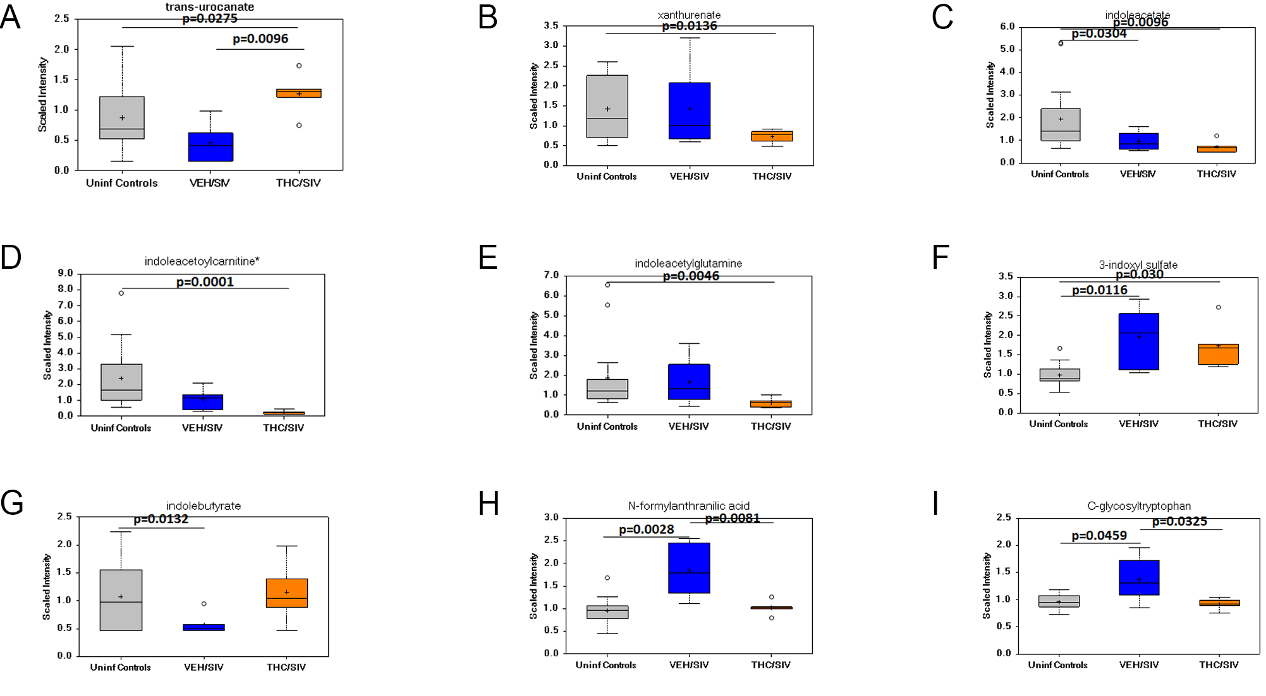

Additional file 1: Fig. S5 Relative abundance of seven phenyllactate dehydratase gene cluster or its homolog encoding Clostridia and Peptostreptococcus species that were detected in colonic contents of THC/SIV (A) and VEH/SIV (B) relative to uninfected control RMs and in THC/SIV relative to VEH/SIV RMs (C). (*) indicates p<0.05.

Additional file 1: Fig. S6 Relative abundance of statistically significant Ruminococcus and Lachnospira species that were detected in colonic contents of THC/SIV (A, and D) and VEH/SIV (B and E) relative to uninfected control RMs, and in THC/SIV relative to VEH/SIV RMs (C and F).

Additional file 1: Fig. S7 Linear discriminant analysis effect size (LEfSe) analysis were used to generate the cladograms (A-C) and LDA scores (D-F) to show taxa differences that were detected in colonic contents of VEH/SIV (A and D) and THC/SIV (B and E) relative to uninfected control RMs, and THC/SIV relative to VEH/SIV RMs (C and F).
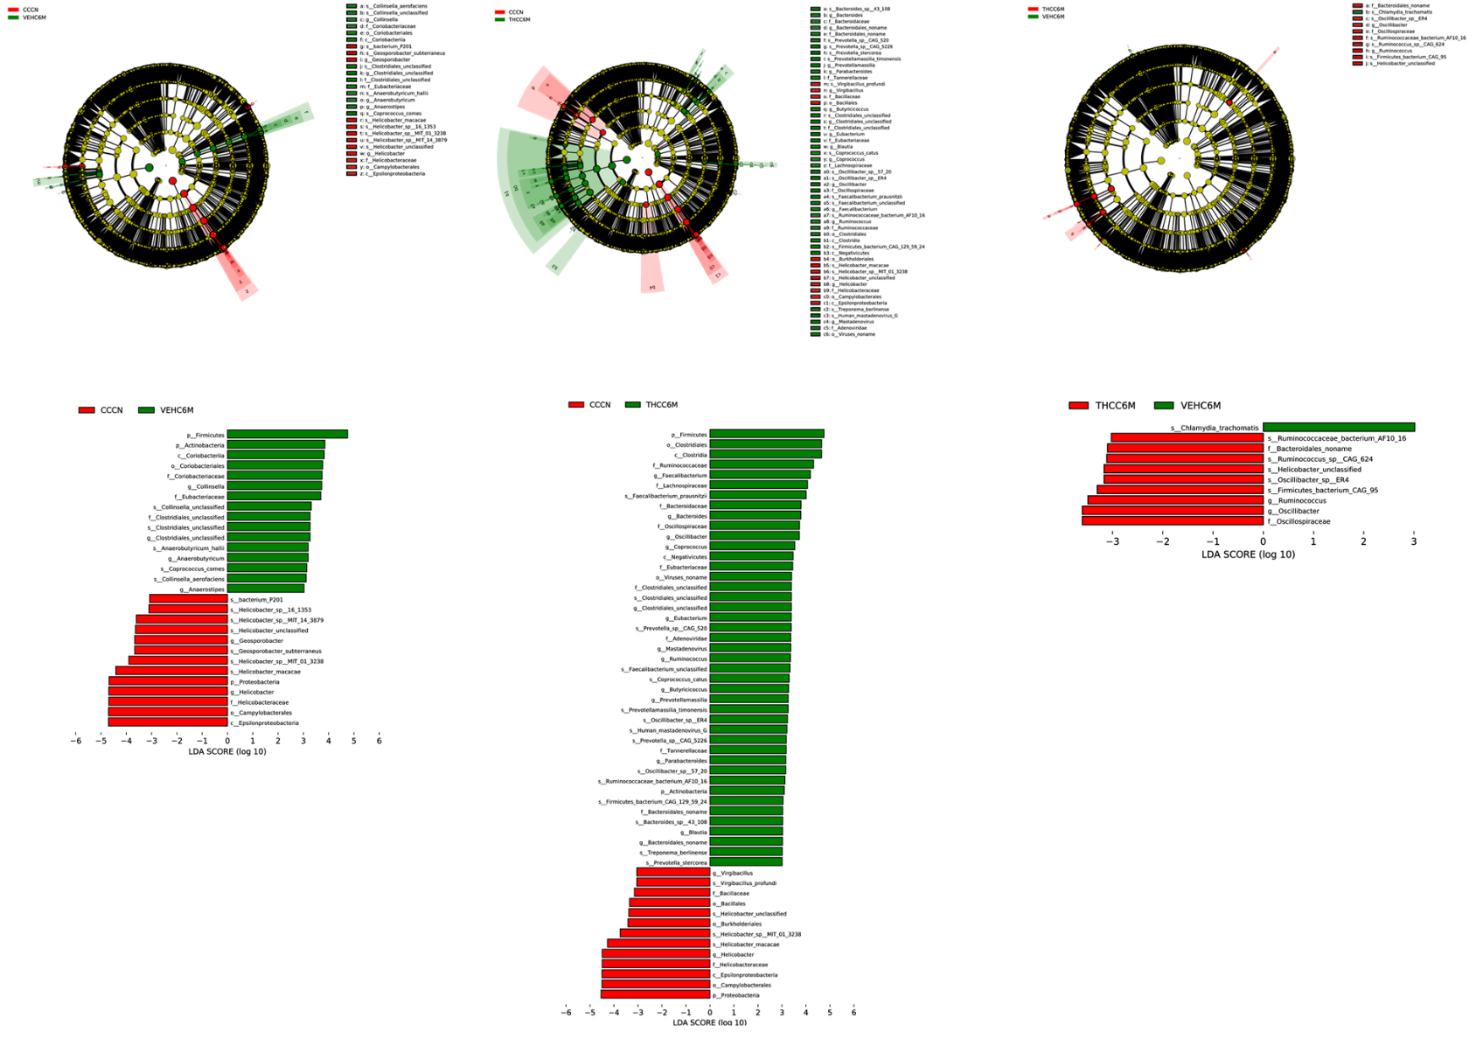
Additional file 1: Fig. S7 Linear discriminant analysis effect size (LEfSe) analysis were used to generate the cladograms (A-C) and LDA scores (D-F) to show taxa differences that were detected in colonic contents of VEH/SIV (A and D) and THC/SIV (B and E) relative to uninfected control RMs, and THC/SIV relative to VEH/SIV RMs (C and F).
A

B

C

D

E

F

