Additional file 1
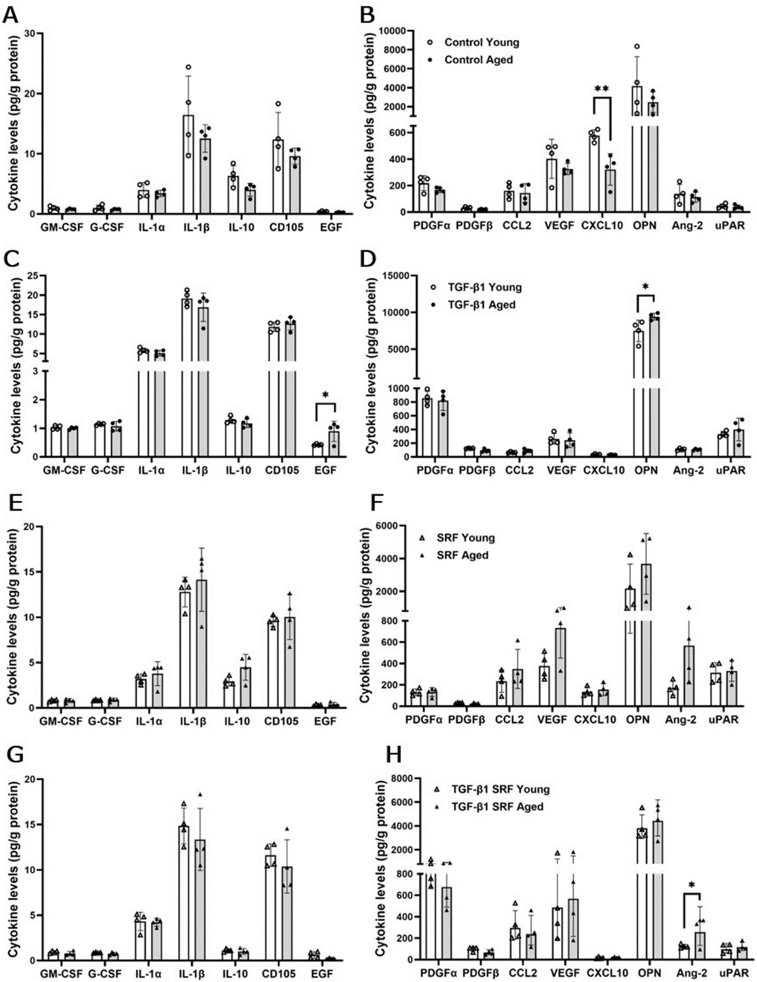
Figure S1: Cytokines/chemokines production in BMDMs from young and aged mice. BMDMs from young (3-month) and aged (16-month) mice were treated with/without mouse recombinant TGF-β1 (10ng/ml) for 96 h. Supernatants were collected and used for Luminex multiplex cytokine assay. All value were normalised by the total protein levels of the sample. (A-B) The production of cytokines and growth factors in the supernatants of BMDMs from normal young and aged mice without TGF-β1 treatment. (C - D) The production of cytokines and growth factors in the supernatants of BMDMs from normal young and aged mice after TGF-β1 treatment. (E - F) The production of cytokines and growth factors in the supernatants of BMDMs from young and aged mice with subretinal fibrosis under normal culture conditions. (G - H) The production of cytokines and growth factors in the supernatants of BMDMs from young and aged mice with subretinal fibrosis after TGF-β1 treated. Mean ± SD, n=4, *p < 0.05 , Student t test.

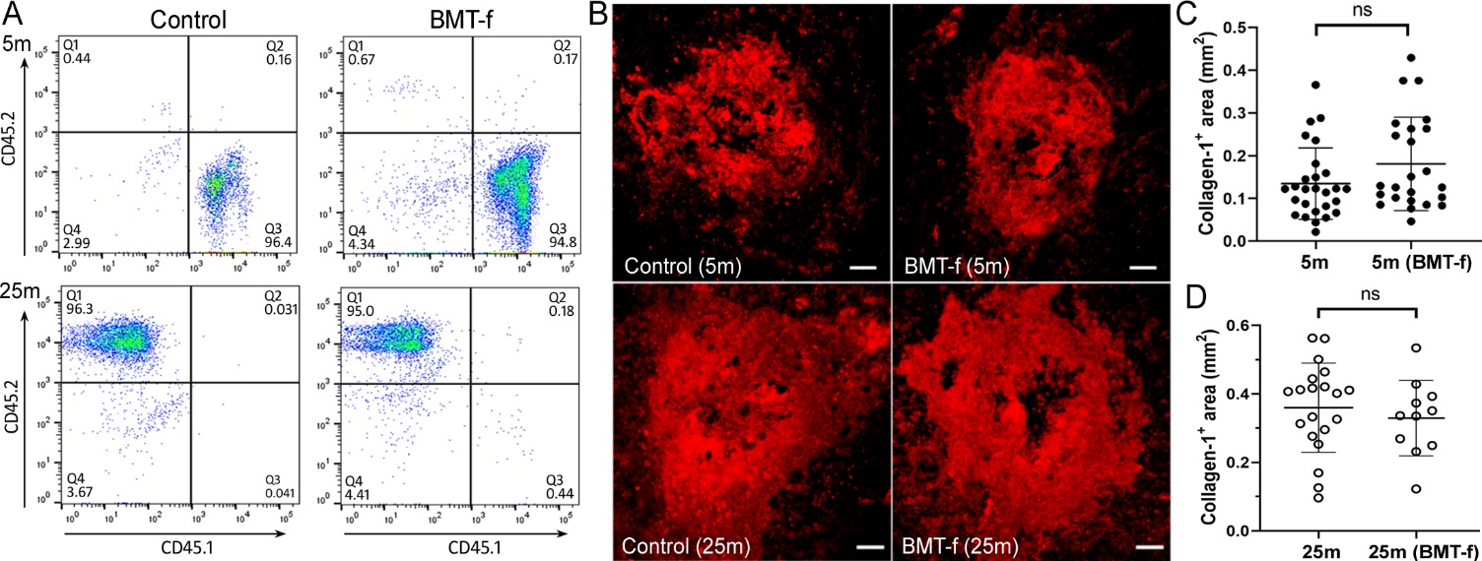
Figure S2. Effects of X-ray irradiation on subretinal fibrosis in young and aged mice. (A) Representative flow cytometry data showing CD45.1 and CD45.2 expression in control and unsuccessful bone marrow transplanted (BMT-f) young (5-month) and aged (25-month) mice. Young BMT mice (CD45.1) received aged BM (CD45.2). Aged BMT mice (CD45.2) received young BM (CD45.1). (B) Representative confocal images of RPE/choroid flatmounts stained for collagen-1(red) from young and aged mice with or without BMT (x-ray irradiated, but no immune system reconstitution by transplanted BM cells). (C - D) Quantitative analysis of subretinal collagen-1⁺ lesion area in young (C) and aged (D) mice with or without x-ray irradiation. Mean ± SD, n = 24~27 lesions per group from 6-7 eyes (C), or n = 11~20 lesions per group from 3-5 eyes (D), Student t test.

Table S1. Primer sequences of mouse genes for quantitative RT-PCR.
Gene | Forward sequence 5'-3' | Reverse sequence 5'-3'
Col1a1 | CTGGCGGTTCAGGTCCAAT | TTCCAGGCAATCCACGAGC
Fn1 | GCCGTTAGATGTGCAAGCTG | TGCTGAAGCTGAGAACTAGGC
Acta2 | GGACGTACAACTGGTATTGTGC | TCGGCAGTAGTCACGAAGGA
Tgfb1 | CATCCATGACATGAACCGGC | GAAGTTGGCATGGTAGCCCT
GAPDH | CTCAGGAGAGTGTTTCCTCGTC | ATGGGCTTCCCGTTGATGAC

