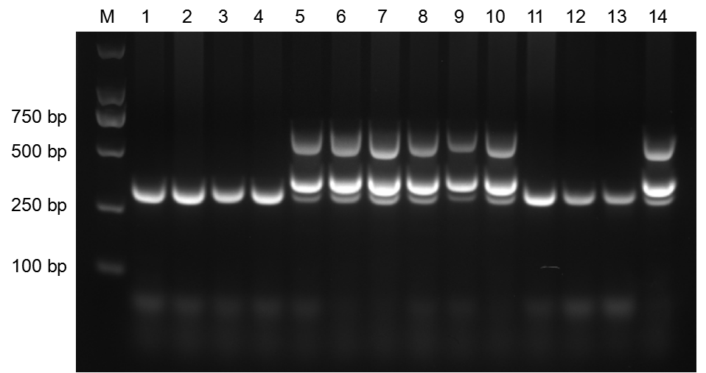
Fig. S1 Schematic diagram of partial results of mouse genotyping. PCR products with simultaneous 377 bp (APP) and 608 bp (PS1) were identified in 5xFAD mice; Littermates only had 324 bp PCR products.

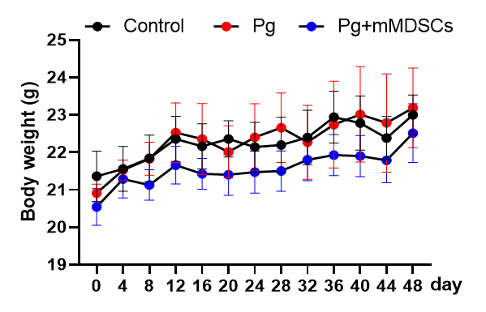
Fig. S2 Body weight of 5xFAD mice during experiment. There was no significant difference in body weight of three groups of mice during the whole experiment.
.

