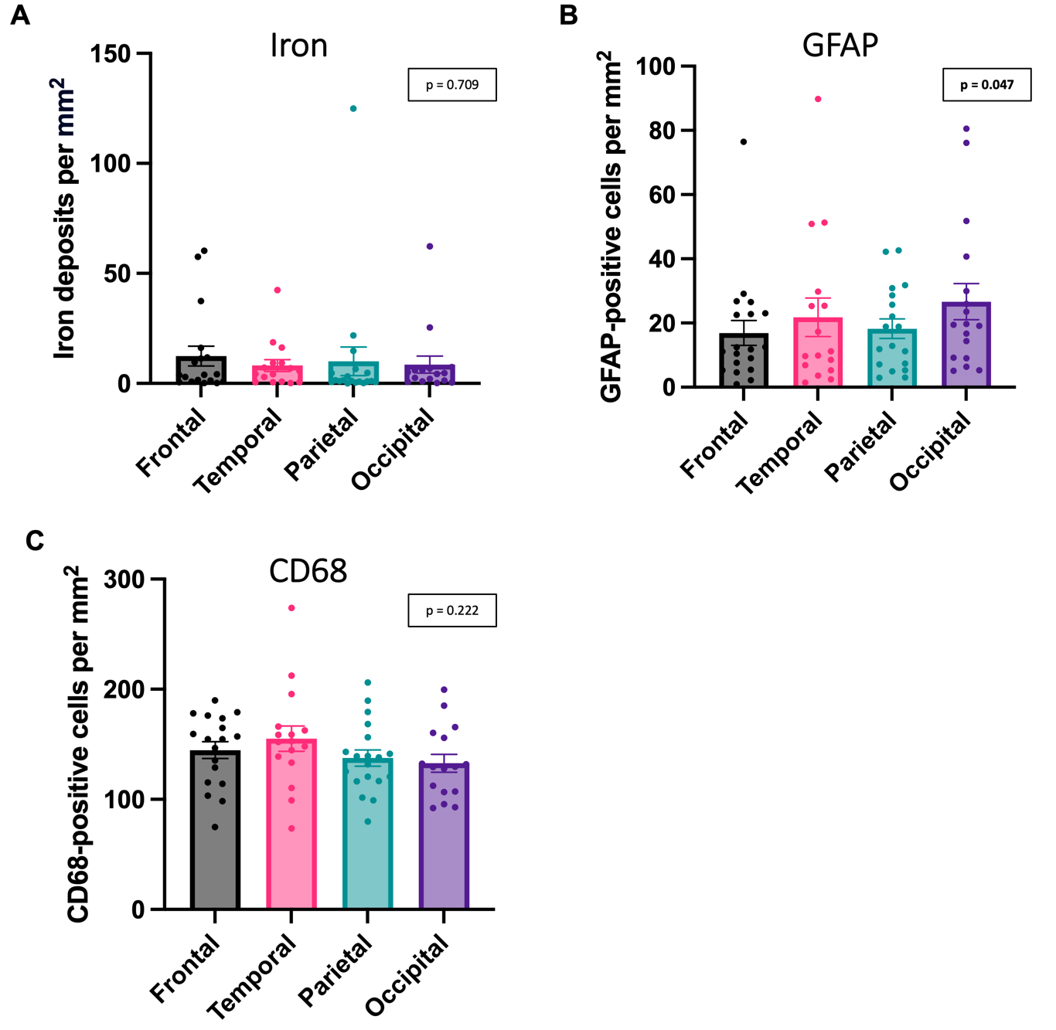
Fig. S1
Comparisons of iron deposit densities and inflammatory cell densities across cortical regions.
The density of objects does not significantly differ between cortical lobes for (A) iron deposits (Skillings-Mack χ² (d.f. = 3) = 1.386, p = 0.709), (B) GFAP-positive cells (Skillings-Mack χ² (d.f. = 3) = 7.962, p = 0.047), or (C) CD68-positive cells (Skillings-Mack χ² (d.f. = 3) = 4.393, p = 0.222), n = 19 cases.

