Additional file
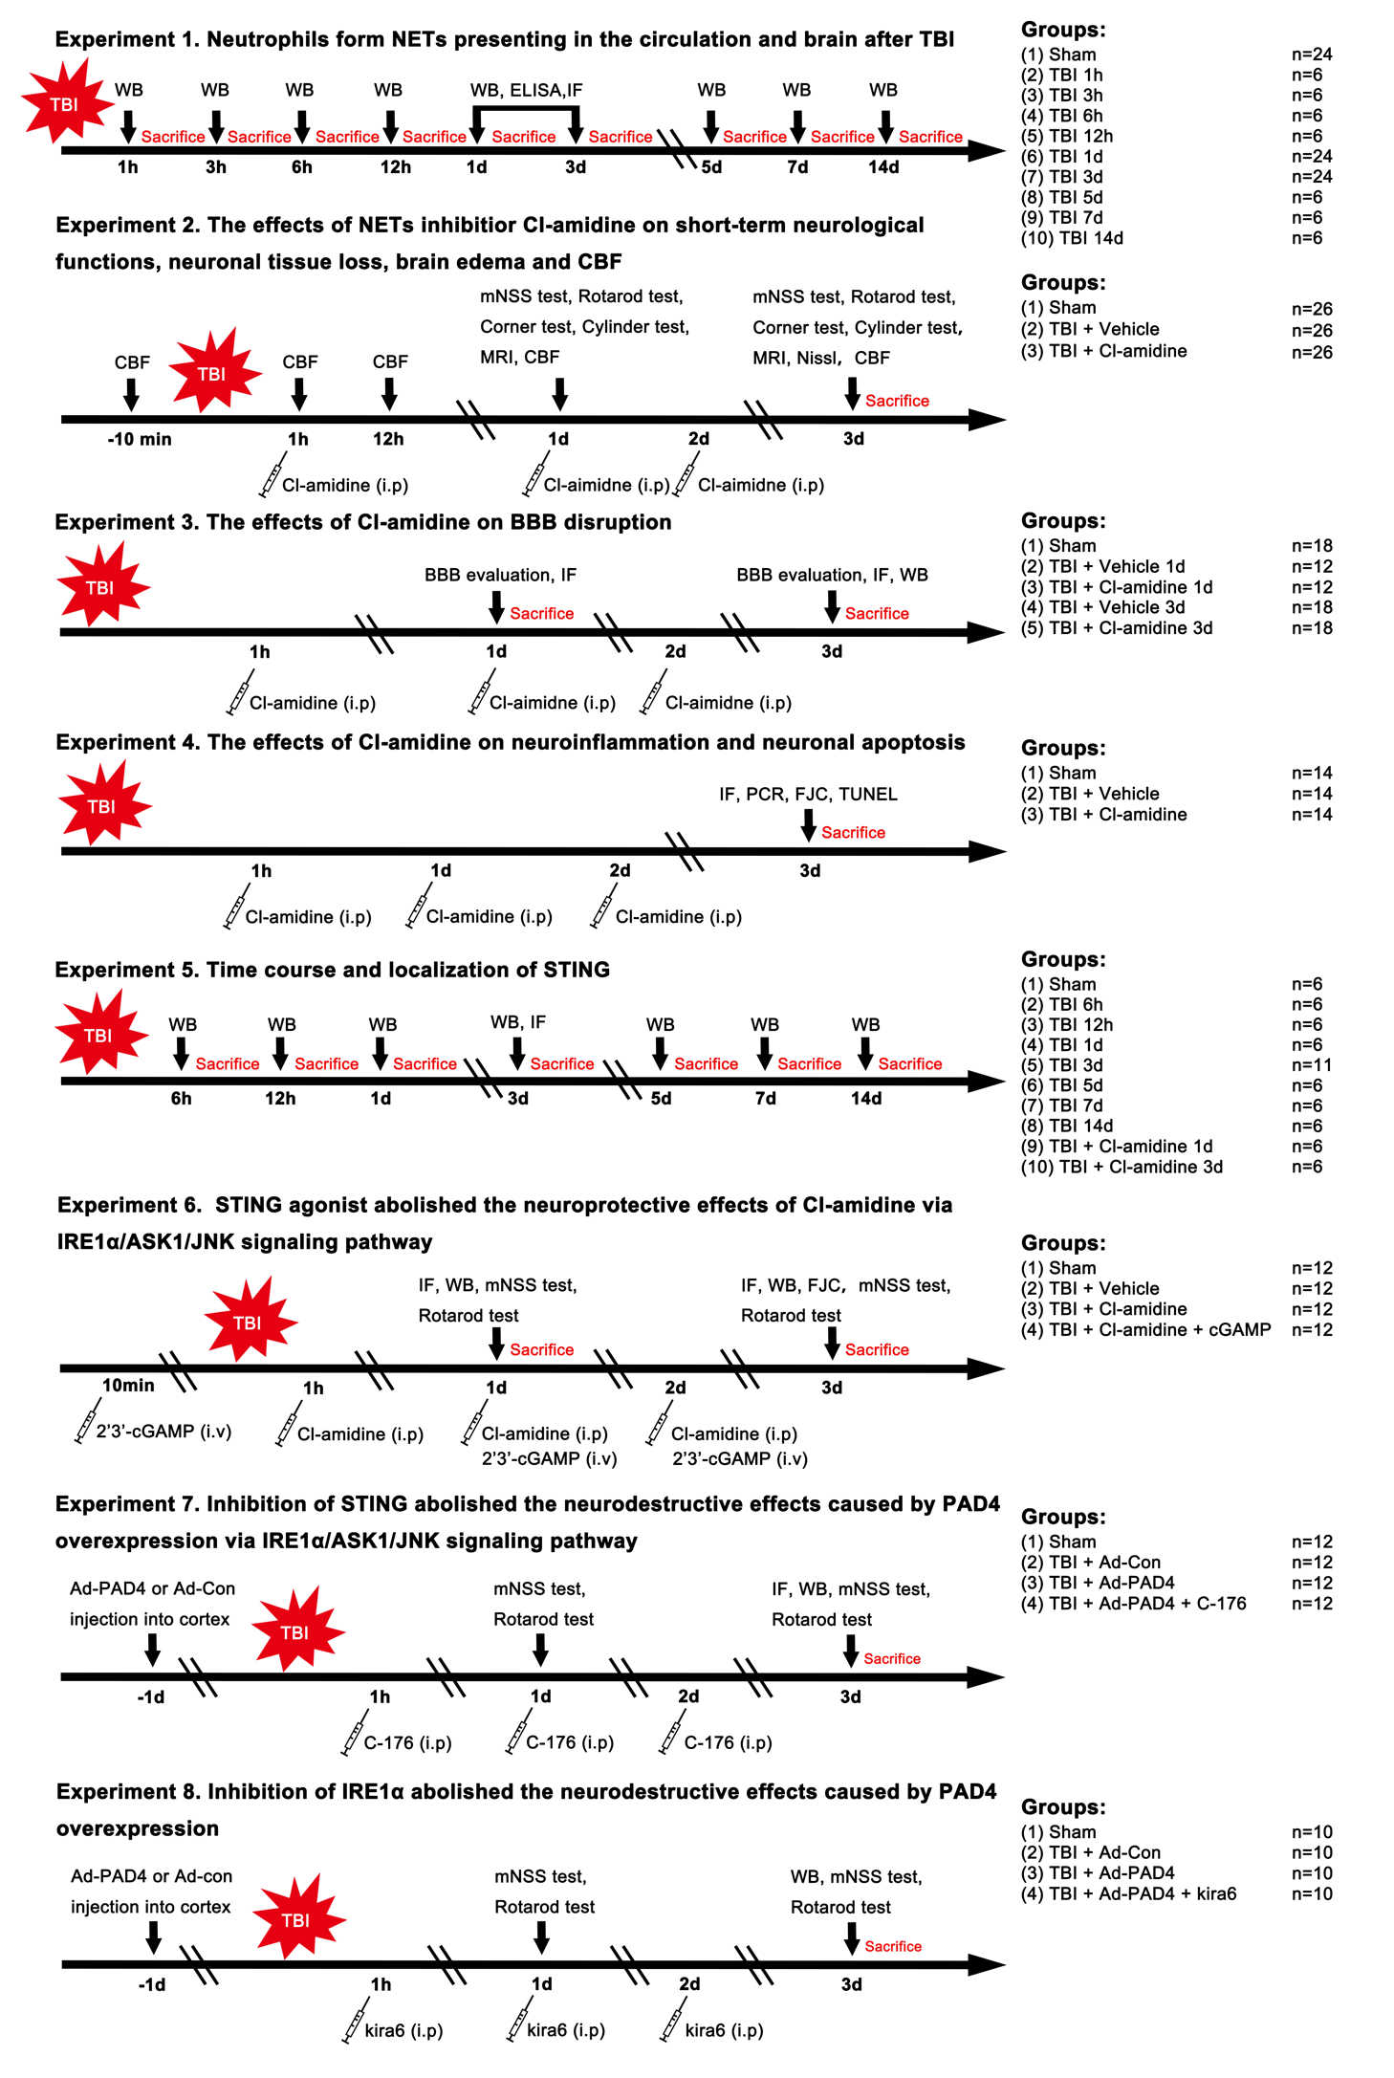
Part 1: Experimental design
All mice were randomly assigned to the following experiments in the present study.
Figure S1. Schematic diagram of different experimental protocols and setups of this study. TBI, traumatic brain injury; NETs, neutrophil extracellular traps; WB, western blot; ELISA, enzyme-linked immunosorbent assay; qPCR, quantitative real-time polymerase chain reaction; IF, immunofluorescence; FJC, Fluoro-Jade C; TUNEL, terminal deoxynucleotidyl transferase dUTP nick-end labeling; BBB, blood-brain barrier; CBF, cerebral blood flow; mNSS, modified neurological severity score; MRI, magnetic resonance imaging; LSCI, laser speckle contrast imaging; Ad-PAD4, PAD4 adenovirus; Ad-con, empty adenovirus; PAD4, peptidyl arginine deiminase 4; IRE1α, inositol-requiring enzyme-1 alpha; ASK1, apoptosis signal-regulating kinase 1; JNK, c-Jun N-terminal kinase; i.p, intraperitoneal; i.v, intravenous.

Experiment 1
To evaluate the time course of Ly6G and H3cit expression in the contused cortex post-TBI, 60 mice were randomly assigned to ten groups (n = 6/group): 0 h (Sham), 1 h, 3 h, 6 h, 12 h, 1 d, 3 d, 5 d, 7 d, and 14 d after CCI for western blot analysis. To validate neutrophils-derived NETs were presented in the circulation and contused cortex post-TBI, an Enzyme-linked Immunosorbent Assay (ELISA) was performed to evaluate the plasma DNA concentration, plasma H3cit-DNA complexes, cortex H3cit-DNA complexes, and cortex MPO activity at 1 d and 3 d after TBI (n = 12/group). An additional six mice were used for double-labeling immunofluorescence staining to co-localize NETs (H3cit) with neutrophils (MPO) at 1 d and 3 d post-TBI.
Experiment 2
To determine the effects of peptidyl arginine deiminase 4 (PAD4) inhibitor Cl-amidine treatment on short-term neurological functions, brain edema, neuronal tissue loss, and cerebral blood flow (CBF) at 1d and 3d after TBI. First, to determine the optional dose of Cl-amidine after TBI in mice at 1d and 3d after TBI, 78 mice were randomly assigned into three groups: Sham, TBI + Vehicle, and TBI + Cl-amidine (n = 26/group). To test Cl-amidine post-treatment on mNSS test, Rotarod test, Corner test, and Cylinder test. 30 mice were randomly assigned into three groups: Sham, TBI + Vehicle, and TBI + Cl-amidine (n = 10/group). In addition, 24 mice were used for MRI and neuronal tissue loss after TBI (n = 8/group). In another set of experiments, additional 24 mice were randomly assigned into three groups (n = 8/group): Sham, TBI + Vehicle, and TBI + Cl-amidine and used for laser speckle contrast imaging (LSCI) after TBI.
Experiment 3
To investigate the effects of Cl-amidine on blood-brain barrier (BBB) disruption after TBI, a total of 78 mice were randomized into five groups: Sham (n=18/group), TBI 1 d + Vehicle (n=12/group), TBI 1d + Cl-amidine (n=12/group), TBI 3 d + Vehicle (n=18/group), TBI 3 d + Cl-amidine (n=18/group). Among these mice, 30 mice were randomly divided into five groups (n=6/group): Sham, TBI 1 d + Vehicle, TBI 1d + Cl-amidine, TBI 3 d + Vehicle, TBI 3 d + Cl-amidine for Evans blue assessment. 30 mice were randomly divided into five groups (n=6/group): Sham, TBI 1 d + Vehicle, TBI 1d + Cl-amidine, TBI 3 d + Vehicle, TBI 3 d + Cl-amidine for double immunofluorescence staining. The rest 18 mice were randomly divided into three groups (n=6/group): Sham, TBI 3 d + Vehicle, and TBI 3 d + Cl-amidine for western blot.
Experiment 4
To evaluate the effects of Cl-amidine on neuroinflammation and neuronal apoptosis at 3 d after TBI, a total of 42 mice were randomized into three groups (n=14/group): Sham, TBI 3 d + Vehicle, and TBI 3 d + Cl-amidine. Among these mice, 18 mice were randomly divided into three groups (n=6/group): Sham, TBI 3 d + Vehicle, and TBI 3 d + Cl-amidine for immunofluorescence staining and FJC staining. To further assess the effects of Cl-amidine on microglia/macrophage polarization, 24 mice were randomized into three groups (n=8/group) to perform quantitative real-time PCR (q-PCR): Sham, TBI 3 d + Vehicle, and TBI 3 d + Cl-amidine.
Experiment 5
To evaluate the time course and localization of STING expression in the contused cortex post-TBI, 48 mice were randomly assigned to seven groups (n = 6/group): 0 h (Sham), 6 h, 12 h, 1 d, 3 d, 5 d, 7 d, and 14 d after CCI for western blot analysis. Additional 5 mice were used for immunofluorescence and immunohistochemistry staining at 3 d post-TBI. The cellular localization of STING was assessed using double-labeling immunofluorescence staining to co-localize STING with neurons (NeuN), microglia (Iba-1), astrocytes (GFAP), neutrophils (Ly6G), and endothelial cells (CD31) at 3 d after TBI. To test the effects of Cl-amidine administration on the expression of STING in the contused cortex at 1 d and 3 d after TBI. 30 mice were randomly assigned to FIVE groups (n = 6/group): Sham, TBI 1 d + Vehicle, TBI 1d + Cl-amidine, TBI 3 d + Vehicle, TBI 3 d + Cl-amidine.
Experiment 6
To test the effects of Cl-amidine administration on neuroinflammation and neuronal death and to elucidate the underlying mechanism of neuroprotection of Cl-amidine after TBI, a total of 48 mice were randomized into four groups: Sham (n=12/group), TBI + Vehicle (n=12/group), TBI + Cl-amidine (n=12/group), and TBI + Cl-amidine +2′3′-cGAMP (n=12/group). 24 mice were randomly divided into four groups (n=6/group): Sham (n=6/group), TBI + Vehicle (n=6/group), TBI + Cl-amidine (n=6/group), and TBI + Cl-amidine +2′3′-cGAMP (n=6/group) for immunofluorescence staining and FJC staining. The rest 24 mice were randomly divided into four groups (n=6/group) for western blot at 3 d after TBI. Among these mice, 40 mice were subjected to the mNSS test and Rotarod test to evaluate short-term neurological function (n=10/group).
Experiment 7
To explore whether STING-dependent IRE1α/ASK1/JNK signaling pathway was involved in PAD4-mediated neurodestructive effects after TBI, a total of 48 mice were randomized into four groups: Sham (n=12/group), TBI + Ad-Con (n=12/group), TBI + Ad-PAD4 (n=12/group), and TBI + Ad-PAD4 + C-176 (n=12/group). Among these mice, half of them were used for immunofluorescence staining and a half for western blot. Among these mice, 40 mice were subjected to the mNSS test and Rotarod test to evaluate short-term neurological function (n=10/group).
Experiment 8
To further confirm the key role of IRE1α in NETs-caused neuroinflammation and neuronal death after TBI,
IREα inhibitor Kira6 was used. A total of 40 mice were randomized into four groups (n = 10/group): Sham (n = 10/group), TBI + Ad-Con (n=10/group), TBI + Ad-PAD4 (n=10/group), and TBI + Ad-PAD4 + C-176 (n=10/group) for Rotarod test and mNSS test, in which four groups including Sham (n = 6/group), TBI + Ad-Con (n=6/group), TBI + Ad-PAD4 (n=6/group), and TBI + Ad-PAD4 + C-176 (n=6/group) were used for western blot at 3 d after TBI.

Part 2: Additional file tables
Table S1. Modified neurological severity scores
Tests | Points
Motor tests (Normal score =0; maximum possible summary score = 6)  Raising the rat by the tail  Flexion of forelimb  Flexion of hindlimb  Head moving >10° to vertical axis with 30 seconds  Placing the rat on the floor  Inability to walk straight  Circling toward the paretic side  Falling down to the paretic side | 1  1  1  1  1  1
Sensory tests (Normal score =0; maximum possible summary score = 2)  Visual and tactile placing  Proprioceptive test (deep sensory) | 1  1
Beam balance tests (Normal score =0; maximum possible summary score = 6)  Grasps the side of the beam  Hugs the beam and 1 limb falls down from the beam  Hugs the beam and 2 limbs fall down from the beam, or spins on the beam (< 60 seconds)  Attempts to balance on the beam but falls off (< 40 seconds)  Attempts to balance on the beam but falls off (< 20 seconds)  Falls off: no attempt to balance or hang on to the beam (< 20 seconds) | 1  2  3  4  5  6
Reflex absent and abnormal movement test (Normal score =0; maximum possible summary score = 4)  Pinna reflex (a head shake when touching the auditory meatus)  Corneal reflex (an eye blink when lightly touching the cornea with cotton)  Startle reflex (a motor response to a brief loud paper noise)  Seizures, myoclonus, myodystony | 1  1  1  1
Maximum points | 18
One point is awarded for the inability to perform the tasks or for the lack of a tested reflex; 13 to 18 indicates severe injury; 7 to 12 indicates moderate injury; 1 to 6 indicates mild injury[1].

Gene |  | Sequences of primer (5’to 3’)
CD86 |  | Forward GGAACAACTGGACTCTACGAC  Reverse GTTTCGGGTGACCTTGCTTA
iNOs |  | Forward GGAGCGAGTTGTGGATTGT  Reverse GTGGGAGGGGTCGTAATG
TNF-α |  | Forward CCAGACCCTCACACTCAGATC  Reverse CACTTGGTGGTTTGCTACGAC
IL-1β |  | Forward CCTGTGTTTTCCTCCTTGCCT  Reverse AGTGCGGGCTATGACCAATTC
CD206 |  | Forward TGAGTCCAGTTTTCTGTCATACCGT  Reverse AGCCACTTCCCTTCAACATTTCG
Arginase-1 |  | Forward CTTGGCTTGCTTCGGAACTC  Reverse ACTGCTGGGATACATACTTACTGG
IL-10 |  | Forward ACTGCTATGCTGCCTGCTCTTAC  Reverse GCAACCCAAGTAACCCTTAAAGTCC
YM1/2 |  | Forward CCTGGACATGGATGACTTC  Reverse GGGATTCAATTTAGGAAAGTTCA
GAPDH |  | Forward AATGTGTCCGTCGTGGATCTGA  Reverse GATGCCTGCTTCACCACCTTCT

Table S2. Primers used for quantiﬁcation of mRNA expression in the brain by RT-qPCR

Part 3: Additional file figures
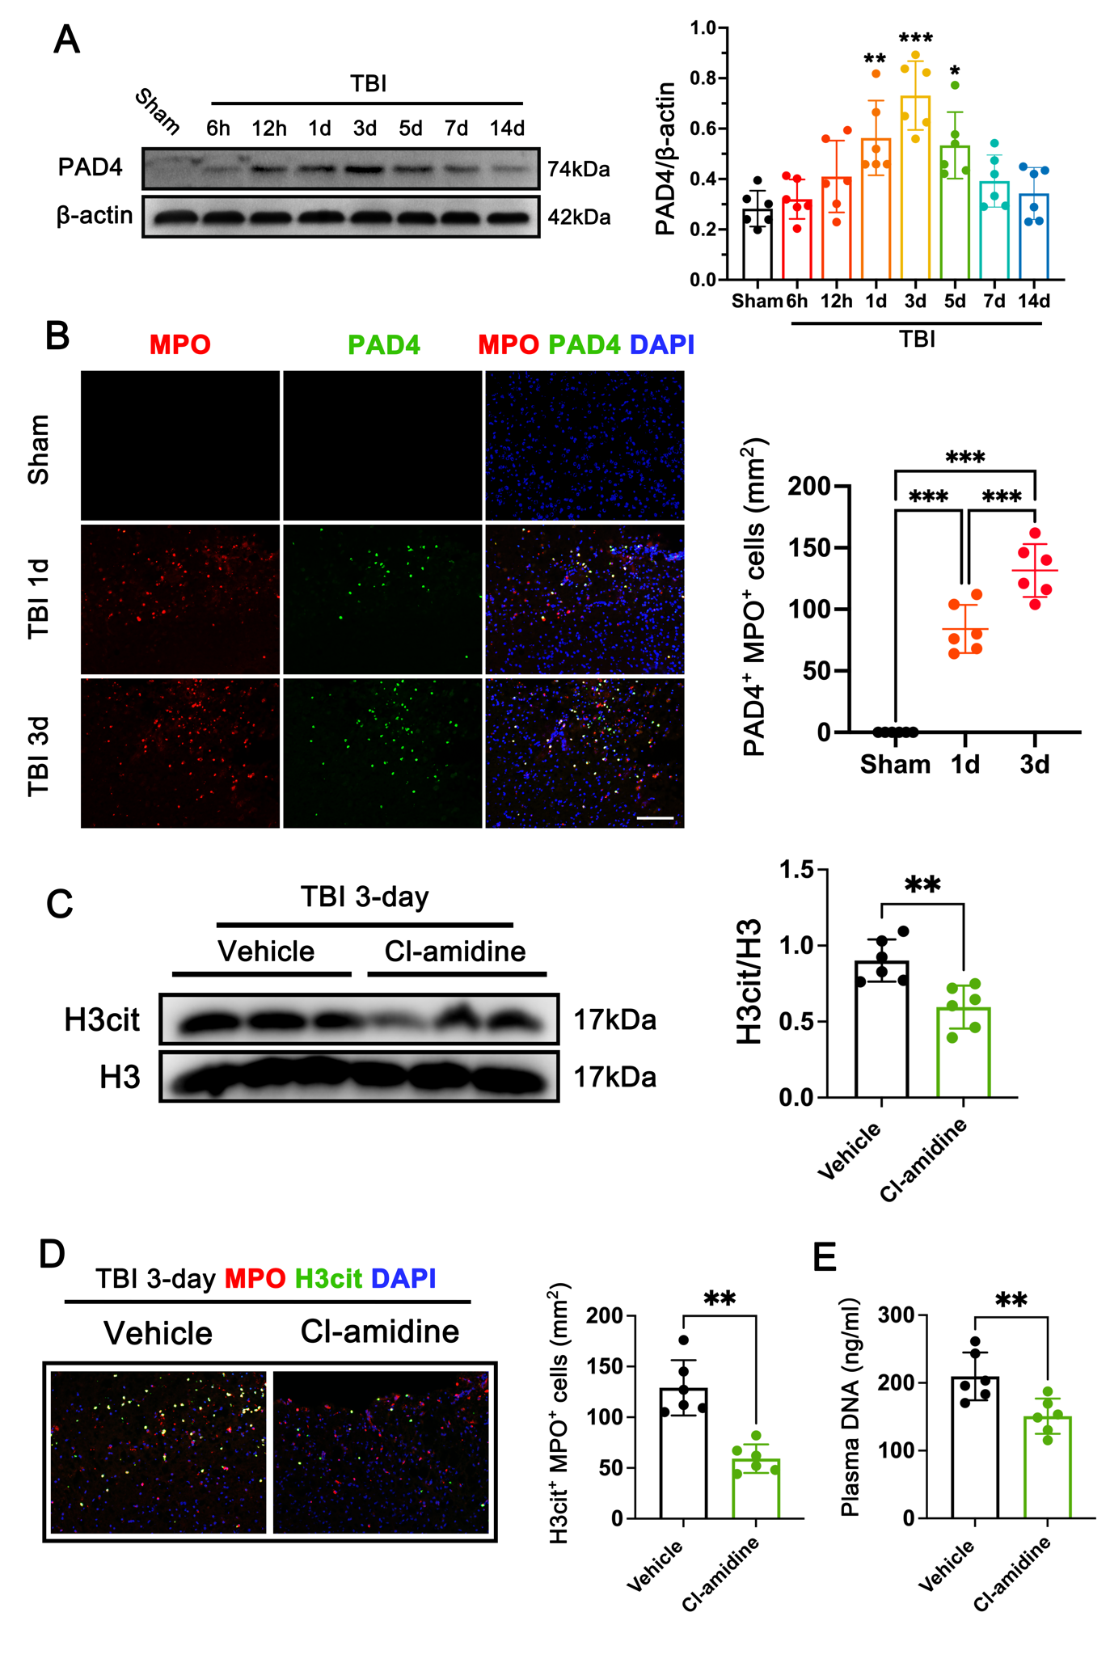
Figure S2. Time course of PAD4 after TBI and alteration of NETs after Cl-amidine treatment.
Figure S2. A Representative western blot bands of the time course of PAD4 and densitometric quantification of PAD4 after TBI. *p < 0.05, **p < 0.01, ***p < 0.001, n = 6 per group. B Representative double immunofluorescence images of PAD4 (green) and neutrophils (MPO, red) and quantitative analysis of PAD4-positive neutrophils in the contused cortex at 1 d and 3 d after TBI. ***p < 0.001, n = 6 per group. Nuclei were stained with DAPI (blue). Scale bar = 100 μm. C Representative western blot bands and densitometric quantification of H3cit after TBI. **p < 0.01, n = 6 per group. D Representative double immunofluorescence images of H3cit (green) and neutrophils (MPO, red) and quantitative analysis of H3cit-positive neutrophils in the contused cortex at 3 d after TBI. **p < 0.01, n = 6 per group. Nuclei were stained with DAPI (blue). Scale bar = 100 μm. E Quantitative analyses of plasma DNA at 3 d after TBI. **p < 0.01, n = 6 per group

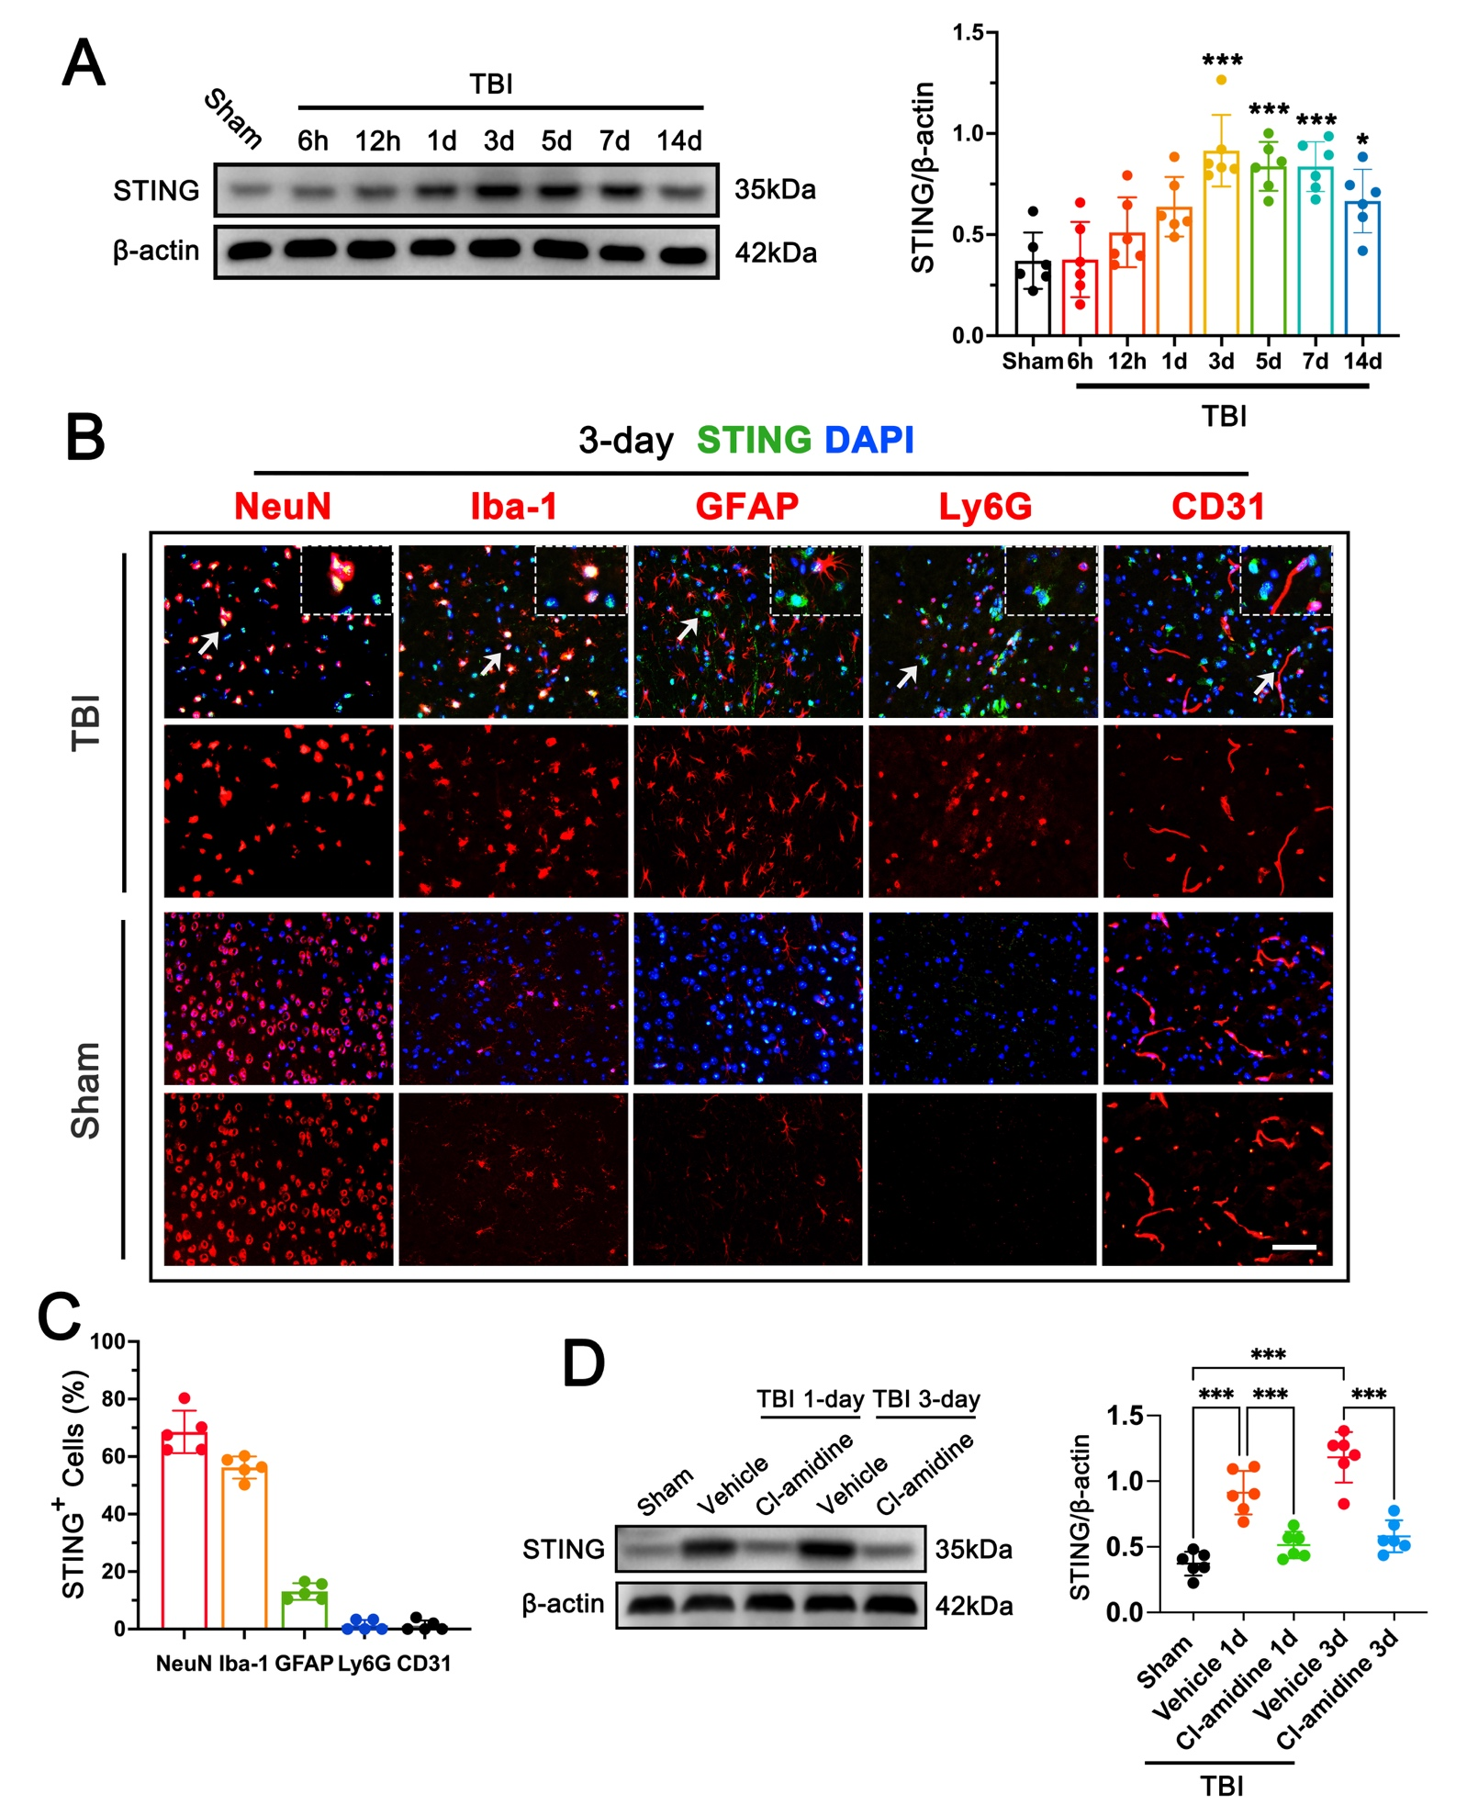
Figure S3. Time course and cellular localization of STING after TBI.
Figure S3. A Representative western blot bands of the time course of STING and densitometric quantification of STING after TBI. *p < 0.05, ***p < 0.001, n = 6 per group. B Representative images of the colocalization of STING (green) with neurons (NeuN, red), microglia (Iba1, red), astrocytes (GFAP, red), neutrophils (Ly6G, red), endotheliocytes (CD31, red) at the lesion site at 3 d after TBI. Nuclei were stained with DAPI (blue). Scale bar = 50 μm. C Quantitative analysis of the percentage of STING-positive neurons to neurons, STING-positive microglia to microglia, STING-positive astrocytes to astrocytes, STING-positive neutrophils to neutrophils, and STING-positive endotheliocytes to endotheliocytes. n = 5 per group. D Representative western blot bands and densitometric quantification of STING after TBI. ***p < 0.001, n = 6 per group.

Figure S4: Overexpression of PAD4 by adenovirus in the cortex increased NET formation in the cortex at 3 d after TBI.
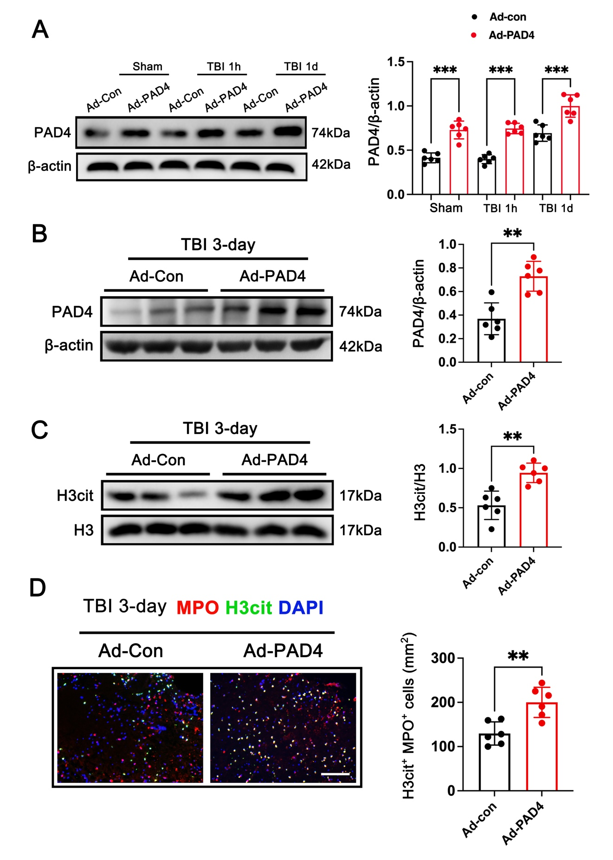
Figure S4. A Representative western blot bands and densitometric quantification of PAD4 after TBI. **p < 0.01, n = 6 per group. B Representative western blot bands and densitometric quantification of PAD4 after TBI. ***p < 0.001, n = 6 per group. C Representative western blot bands and densitometric quantification of H3cit after TBI. **p < 0.01, n = 6 per group. D Representative double immunofluorescence images of H3cit (green) and neutrophils (MPO, red) and quantitative analysis of H3cit -positive neutrophils in the contused cortex at 3 d after TBI. n = 6 per group. Nuclei were stained with DAPI (blue). Scale bar = 100 μm.

1. Chen, J., et al., Therapeutic benefit of intravenous administration of bone marrow stromal cells after cerebral ischemia in rats. Stroke, 2001. 32(4): p. 1005-11.

