Supplementary Figure 1
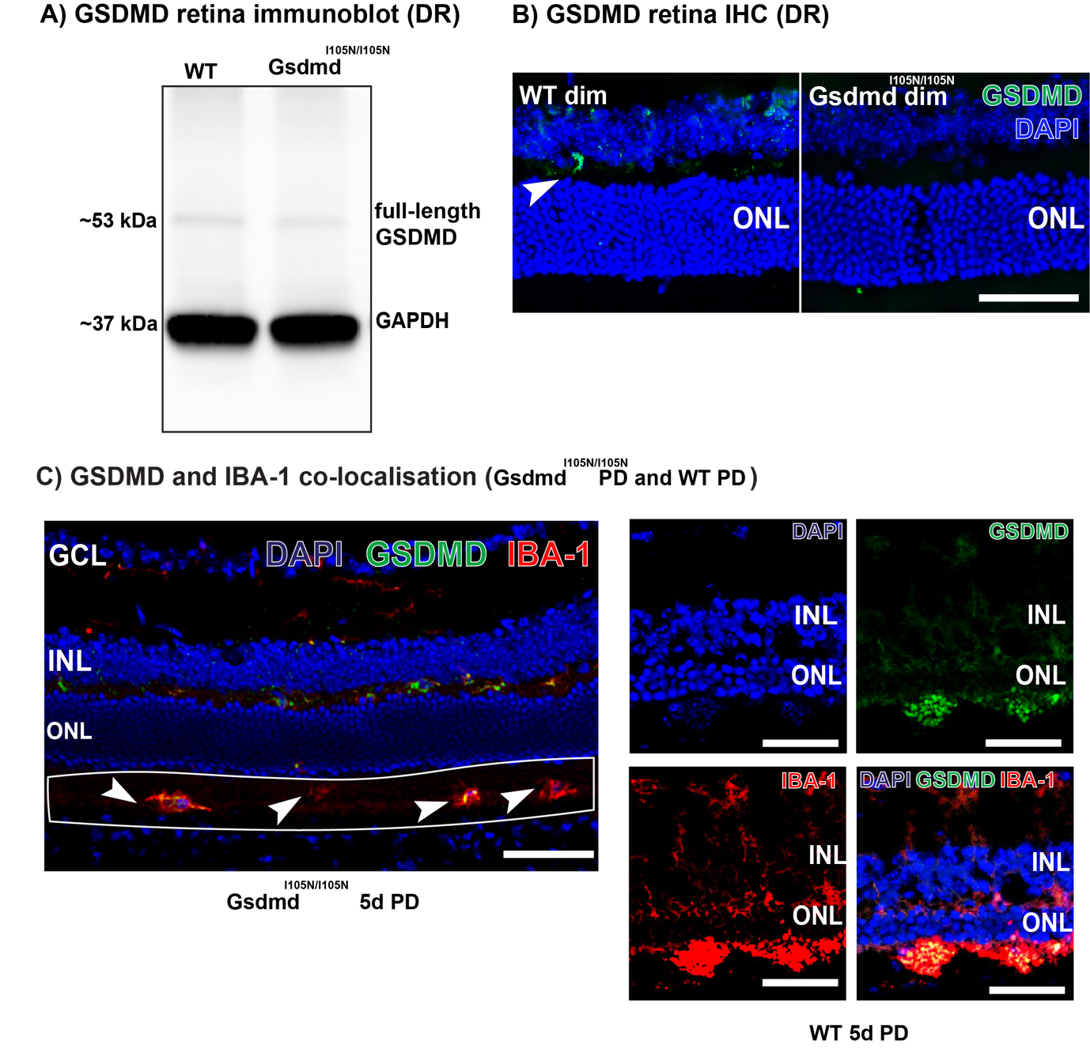Supplementary Figure 1: Gasdermin D characterisation in DR and PD retina (A) Western blots showing bands of ~50 kDa for full-length GSDMD and 37 kDa for GAPDH reference protein in DR retinal lysates of WT and Gsdmd^{I105N/I105N} mice. (B) Representative image showing GSDMD expression in WT and Gsdmd^{I105N/I105N} DR retinal sections. (C) Representative image showing co-localisation of GSDMD and IBA-1 in 5d PD retinal sections from Gsdmd^{I105N/I105N} and WT mice.

