Supplementary Figure 6

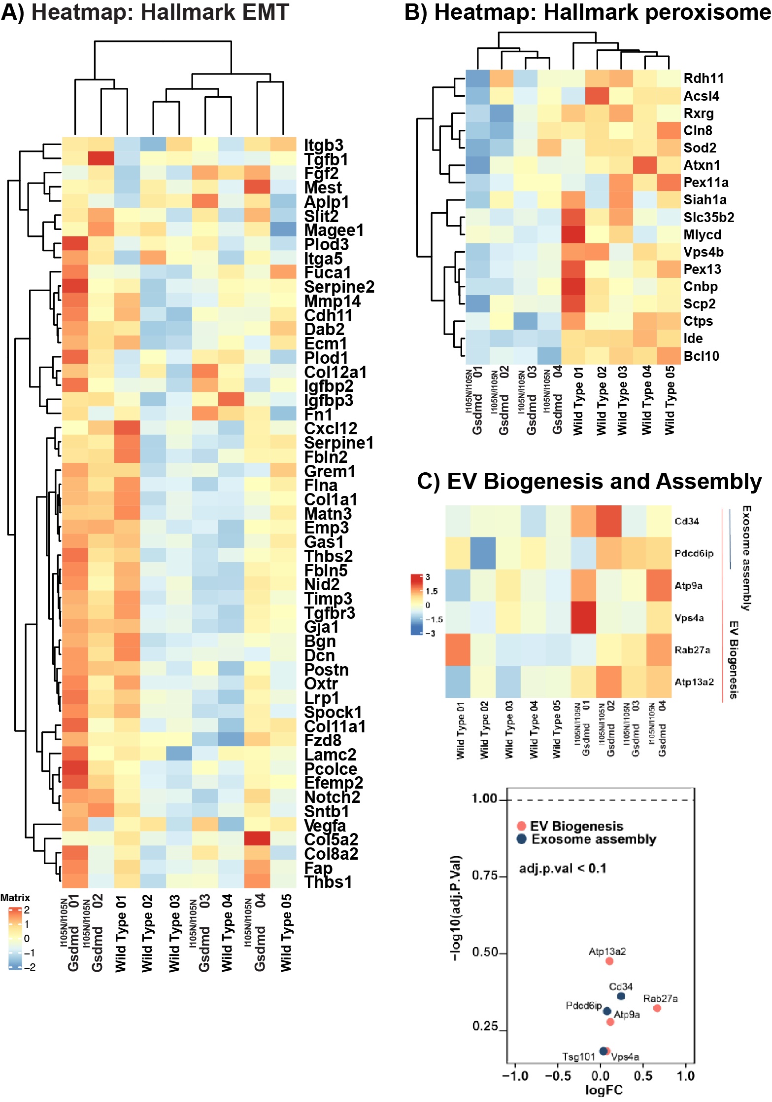
Supplementary Figure 6: WT and Gsdmd^{I105N/I105N} mice retinal RNA profiling and differential expression analysis post PD. Heatmaps showing differential expression profile of genes regulating (A) Epithelial Mesenchymal Transition (EMT) (adj.p.value <0.1) and (B) Peroxisome signalling (adj.p.value <0.1). (C) Scatter plot and heatmap showing no significant change in expression in EV biogenesis and exosome assembly between WT and Gsdmd^{I105N/I105N} whole retina post 5d PD.

