IL-1R1 signaling in TBI: Assessing chronic impacts and neuroinflammatory dynamics in a mouse model of mild closed-head injury.

Jonathan C. Vincent^{1,2,3,4}, Colleen N. Garnett^{1,2,3,5}, James B. Watson^{1,2}, Emma K. Higgins^{1,2}, Teresa Macheda^{1,2}, Lydia Sanders^{1,2}, Kelly N. Roberts^{1,2}, Ryan K. Shahidehpour^{1,2,3}, Eric M. Blalock⁶, Ning Qaun⁷, Adam D. Bachstetter^{1,2,3}

¹Department of Neuroscience, University of Kentucky, Lexington, KY, United States
²Spinal Cord and Brain Injury Research Center, University of Kentucky, Lexington, KY, United States
³Sanders-Brown Center on Aging, University of Kentucky, Lexington, KY, United States
⁴MD/PhD Program, University of Kentucky, Lexington, KY, United States
⁵Department of Cell, Developmental, and Integrative Biology, University of Alabama at Birmingham, Birmingham, AL, United States
⁶Department of Pharmacology and Nutritional Sciences, University of Kentucky, Lexington, KY, United States
⁷Department of Biomedical Science, Charles E. Schmidt College of Medicine and Brain Institute, Florida Atlantic University, Jupiter, FL, United States

CONFLICTS OF INTEREST
The authors declare that there are no commercial, financial, or other relationships that could be construed as a potential conflict of interest when working on this research.

CORRESPODING AUTHOR:
Adam D. Bachstetter
741 S. Limestone St.
Lexington, KY 40536
Phone: 859-218-4315
Email: adam.bachstetter@uky.edu

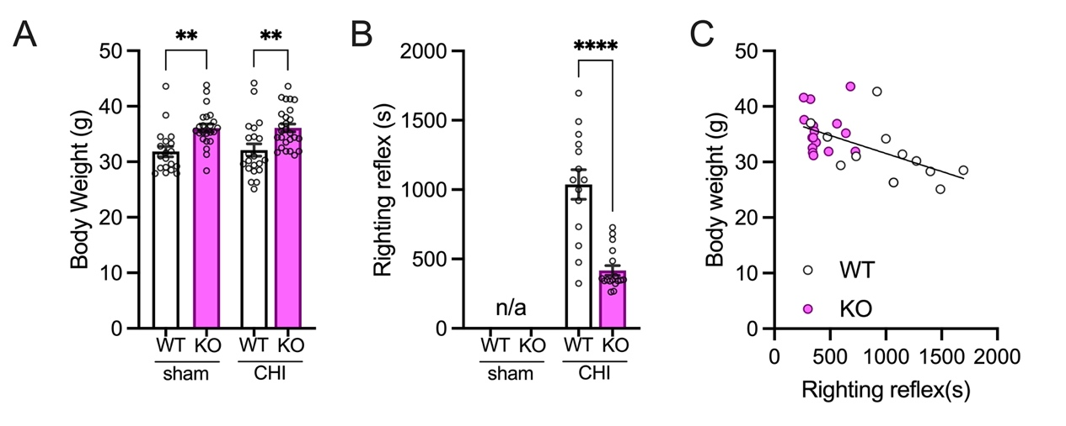
Supplemental Figure 1. Pre-operative body weight and post-operative righting reflex time in WT and IL-1R1 gKO mice. (A) Interleukin-1 receptor 1 global knock-out (KO) mice weighted 12% more than the wild-type (WT). (B) The KO mice were righted 40% quicker after the CHI than the WT mice. (C) Pre-operative body weight correlated with righting reflex time. **p<0.005, ****p<0.0001.

