Additional file 1
Figures and Figure legends
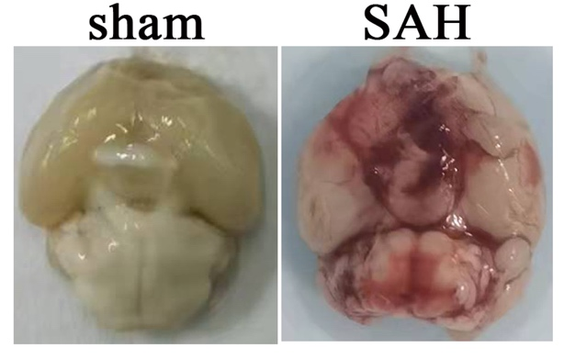
Figure S1. Representative photograph of the brain in the sham and SAH mice.

Figure S2. PI-positive cells showed dramatical neuron death in the hippocampus at 3 days after SAH. Scale bar: 100um.

Figure S3. GFAP-immunofluorescent image showed that astrocytes were highly activated at the hippocampus at 3 days after SAH. Scale bar: 100um.

Figure S4. NeuroD1-AAV application significantly upregulated the expression of NeuroD1 in the hippocampus that has near completely succumbed to SAH. (A). Schematic illustration showed the experimental protocol of SAH induction, AAV injection and tissue harvest. (B-D). Immunofluorescent images indicated that NeuroD1-AAV significantly upregulated the expression of NeuroD1 in the hippocampus at different time points after SAH. Scale bar, 50um.

Figure S5. NeuroD1 expression ameliorated SAH-induced glial cell activation. (A). Schematic illustration of the experimental protocol. (B-D). Immunofluorescent images indicated that NeuroD1-AAV ameliorated the activation of astrocyte and microglia at relative time points after SAH. Scale bar: 100um.

