Additional Document

Contents

- Supplemental Figure 1
- Supplemental Figure 2
- Supplemental Figure 3
- Supplemental Figure 4
- Supplemental Figure 5
- Supplemental Figure 6
- Supplemental Figure 7
- Supplemental Figure 8
- Supplemental Figure 9
- Supplemental Figure 10

- Figure S1
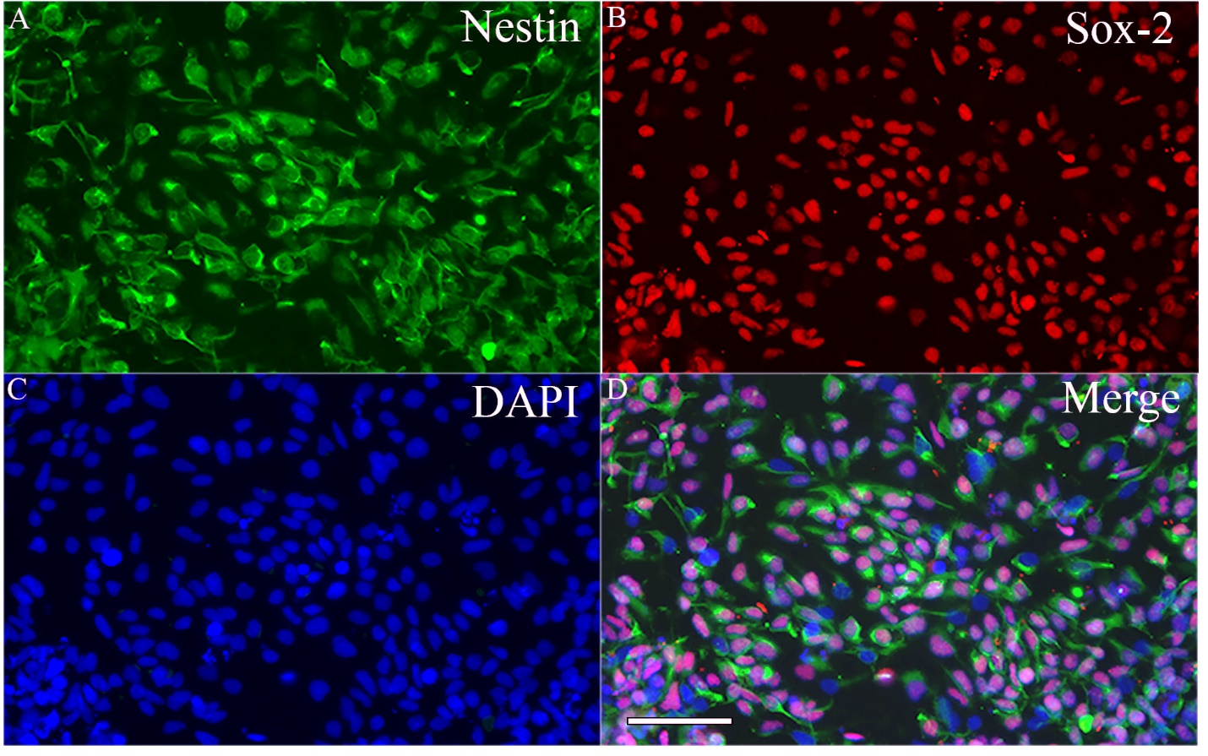

Figure S1 – Human induced pluripotent stem cells derived neural stem cells (hIPSC-NSCs) express specific markers. Images A-D illustrate that all cells in the passage 11 NSCs derived from hiPSCs express NSC markers Nestin (A) and Sox-2 (B). Scale bar, 100 μm.

Figure S2
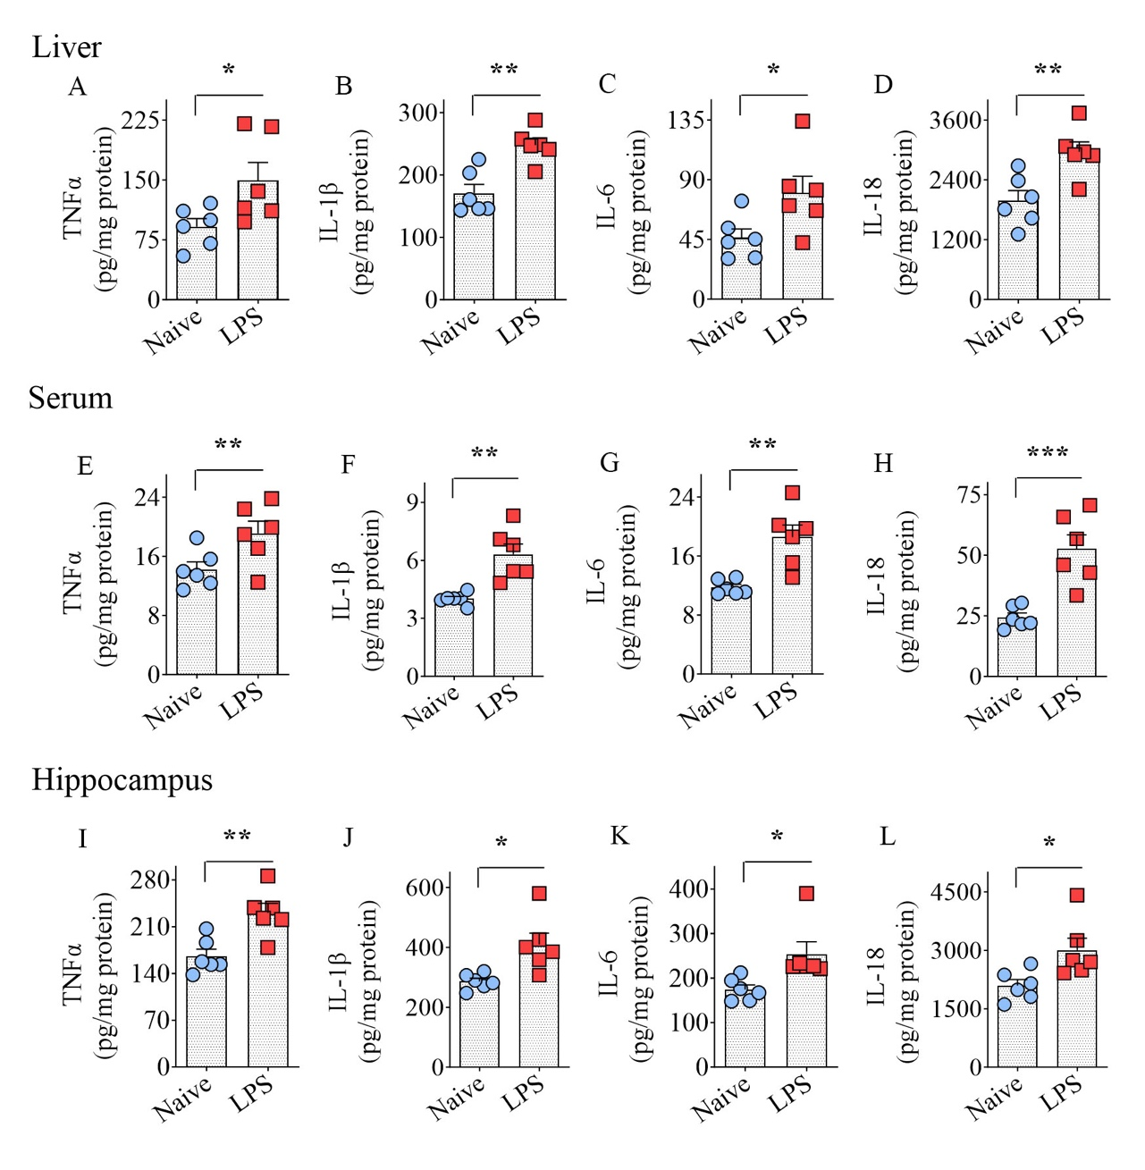

Figure S2 - Seven days of Lipopolysaccharide (LPS) administration induced systemic inflammation and neuroinflammation when examined a day after the last LPS injection. The bar charts A-J compare the concentrations of proinflammatory cytokines in the liver (A-D), serum (E-H), and hippocampus (I-L), such as tumor necrosis factor-alpha (TNF-α, A, E, I); interleukin beta (IL-1β, B, F, J); IL-6 (DC, G, K); and IL-18 (D, H, L). *, p < 0.05; **, p < 0.01; ***, p < 0.001; NS, not significant.

Figure S3
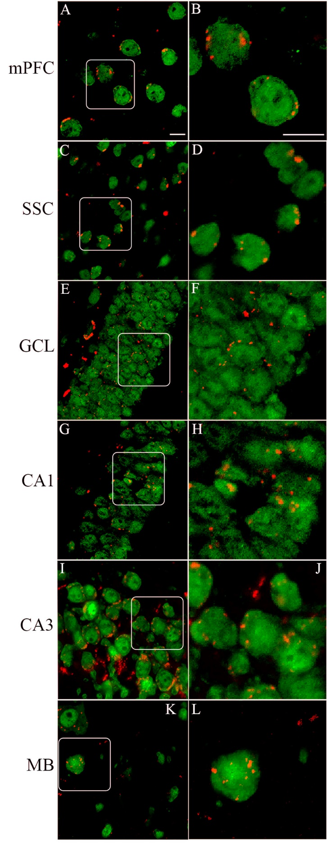

Figure S3. Intranasally administered hiPSC-NSC-EVs incorporated into NeuN + neurons and in multiple brain regions of lipopolysaccharide (LPS) treated mice. A-L: Images illustrating the incorporation of EVs into NeuN+ neurons in the medial prefrontal cortex (mPFC; A, B), the somatosensory cortex (SSC; C, D), dentate granule cell layer (GCL; E, F), the CA1 cell layer (G, H), the CA3 cell layer (I, J) and midbrain (MB; K, L) in LPS-treated mice 6 hours post-administration. The images in B, D, F, H, J, and L represent the magnified versions of images A, C, E, G, I, and K indicated in boxes. Scale bar-A-L, 12.5 μm.
Figure S4
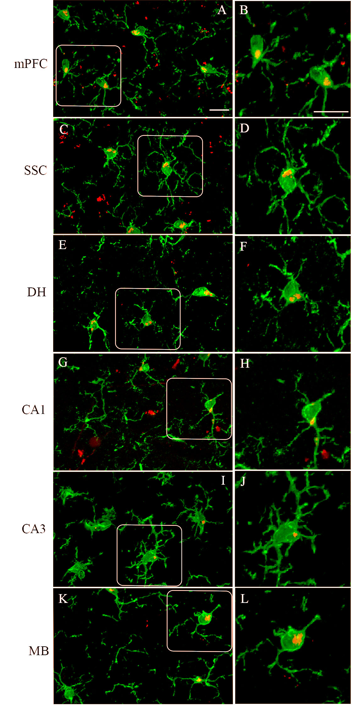

Figure S4. Intranasally administered hiPSC-NSC-EVs incorporated into IBA-1+ microglia in multiple brain regions of lipopolysaccharide (LPS) treated mice. A-L: Images illustrating the incorporation of EVs into IBA-1+ microglia in the medial prefrontal cortex (mPFC; A, B), the somatosensory cortex (SSC; C, D), dentate granule cell layer (GCL; E, F), the CA1 cell layer (G, H), the CA3 cell layer (I, J) and midbrain (MB; K, L) in LPS-treated mice 6 hours post-administration. The images in B, D, F, H, J, and L represent the magnified versions of images A, C, E, G, I, and K indicated in boxes. Scale bar-A-L, 12.5 μm.
Figure S5
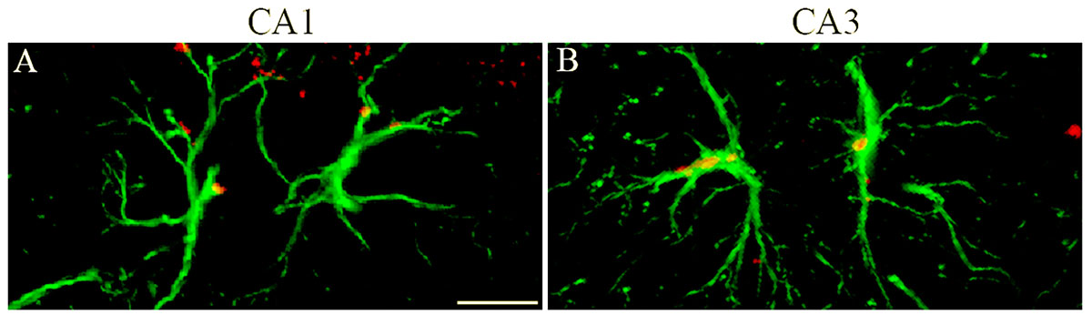

Figure S5. Intranasally administered hiPSC-NSC-EVs incorporated into GFAP+ astrocytes in the hippocampus of lipopolysaccharide (LPS)-treated mice. The figure illustrates the incorporation of EVs into GFAP + astrocytes in the CA1 (A) and CA3 (B) subfields of the hippocampus of Lipopolysaccharide (LPS) treated mice at 6 hours post-administration—scale bar, 12.5 μm.
Figure S6
Figure S6. Additional data of the object-in-place test (OIPT), temporal pattern processing task (TPPT), and pattern separation test (PST). The bar charts A-B compare the total object exploration times (TOETs) in T2 and T3 across groups in OIPT. The bar charts M-P compare the TOETs in T2-T5 across groups in TPPT. The bar charts G-H compare the TOETs in T2 and T3. The bar charts in G-I compare the TOETs in T2-T4 across groups in PST. *, p < 0.05; **, p < 0.01; NS, not significant.

Figure S7
(Blots with corresponding inverts for EV markers shown in figure 1)
Figure S8
(Blots with corresponding original membrane for EV markers shown in figure 1)
Figure S9
(Blots with corresponding inverts for synaptophysin and PSD95 shown in figure 11)
Figure S10
(Blots with corresponding original membrane for synaptophysin and PSD95 shown in figure 11)

