Additional Figures and Figure Legends
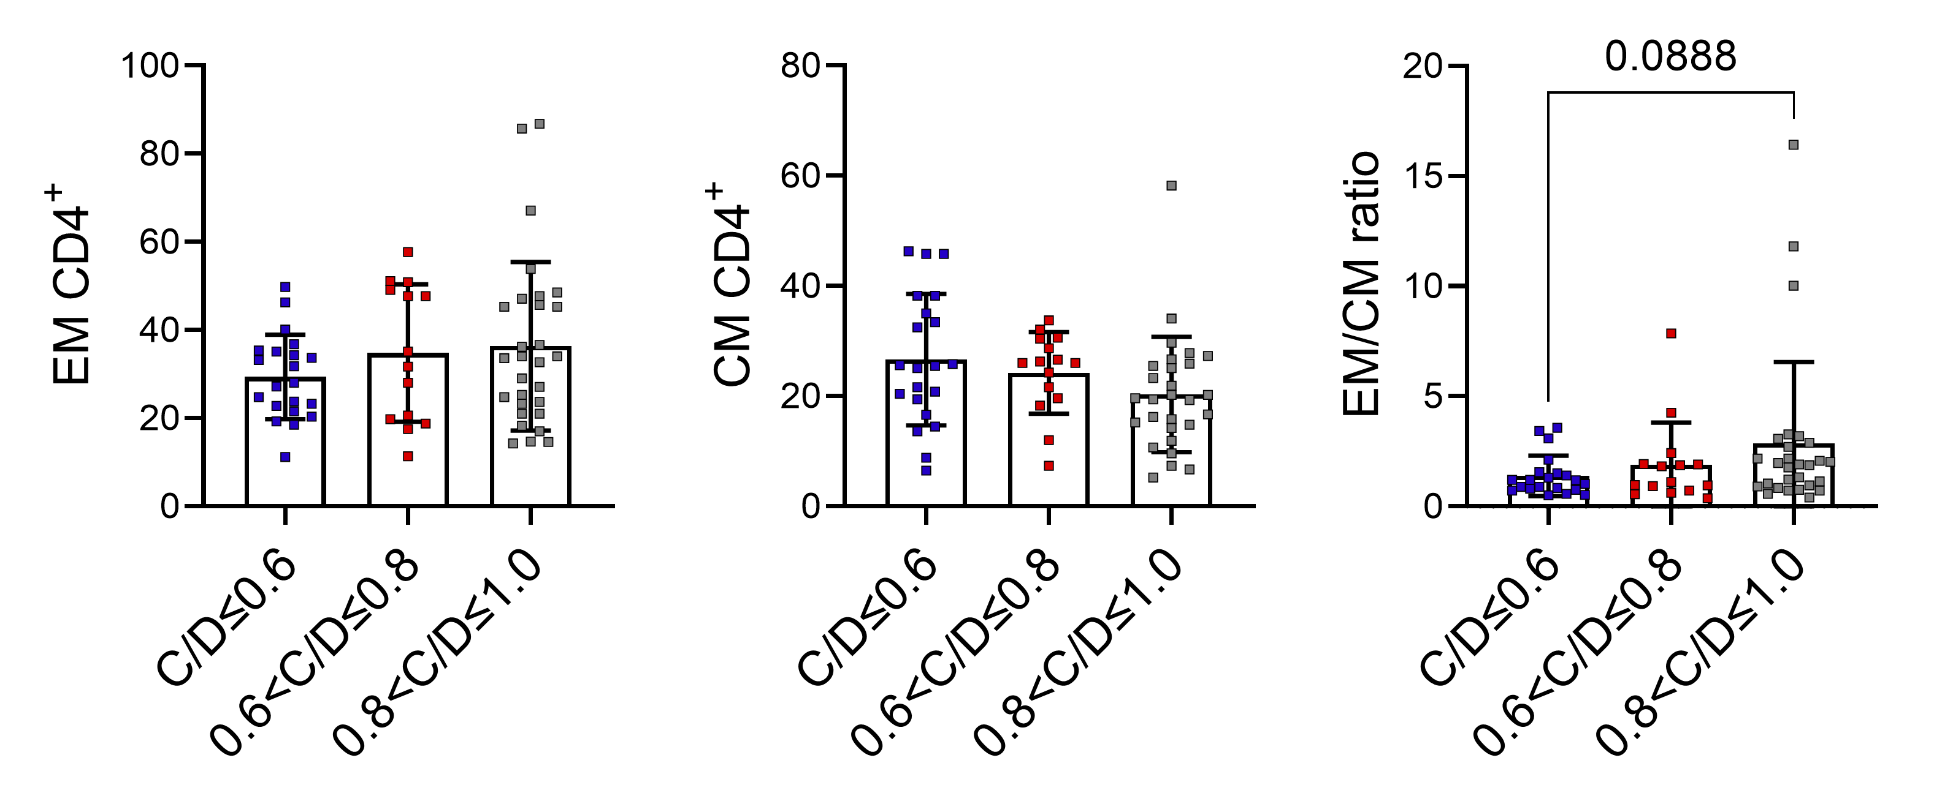
Fig. S1 Association of circulating CD4⁺ T cell response with the cup-to-disc ratio in patients with glaucoma. CD4⁺ T cell status was determined as described in Fig. 1. Shown are comparison of Freq. EM CD4⁺, CM CD4⁺, and EM/CM among different groups stratified according to cup-to-disc ratio (C/D) enlargement. Statistical comparisons were performed using Kruskal-Wallis test followed by Dunn's multiple comparisons test.

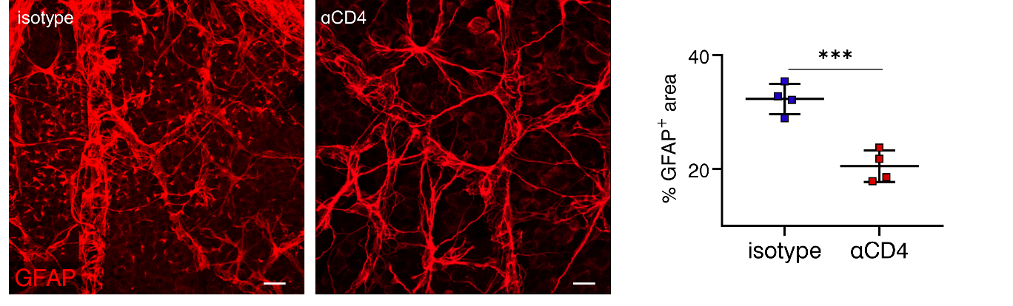
Fig. S2 The depletion of CD4⁺ T cells reduce retinal GFAP expression in glaucoma. The depletion of CD4+ T cells was performed as described in Fig. 3L. The percentage of GFAP⁺ area per microscopic field (size: 319.45 μm²) was calculated. n = 4, n refers to the number of retinas used for GFAP staining. Only one retina per mouse was used. Results presented are representative of three independent experiments. ***P < 0.001, two-tailed unpaired Student’s t test was performed.

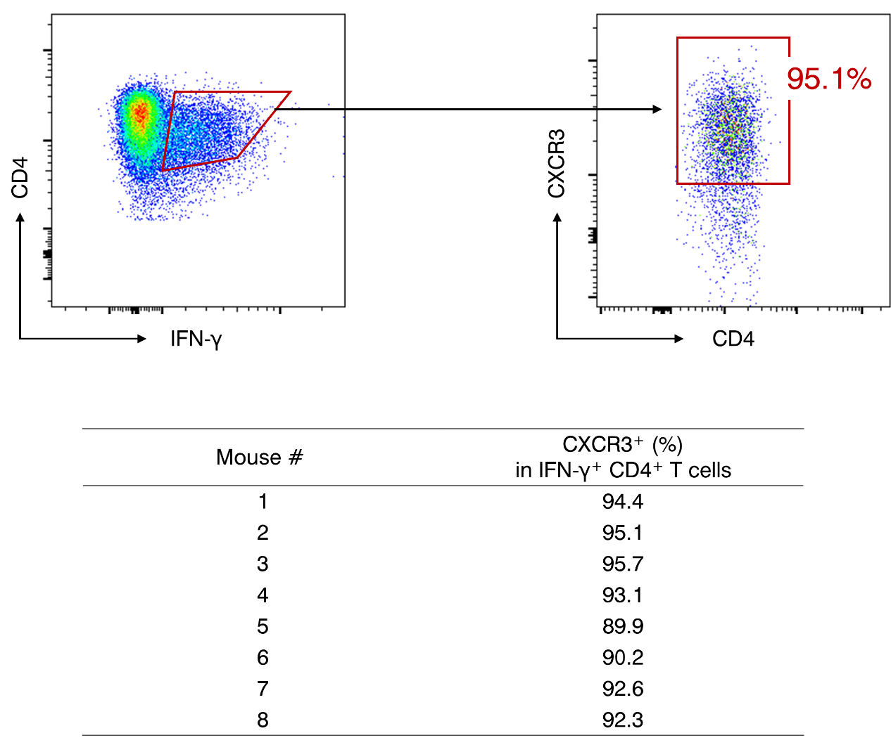
Fig. S3 CXCR3 expression on IFN-γ-producing CD4⁺ T cells. Murine CD4⁺ T cells (n = 8) were stimulated with PMA and ionomycin in the presence of GolgiStop. Flow cytometry was performed to determine CXCR3 and IFN-γ expression. The table is showing individual data of the percentage of the CXCR3⁺ population in total IFN-γ-producing CD4⁺ T cells.

Additional Tables
Table. S1| Demographics of glaucoma patients and healthy controls
 | GL  (Cohort #1) | HC  (Cohort #1) | p value | GL  (Cohort #2) | HC  (Cohort #2) | p value
n | 87 | 98 |  | 113 | 121
Age (year) * | 59 (49−68) | 56 (42−65) | 0.07 | 60 (52−68) | 55 (41-67) | 0.14
Gender
Female | 48 | 54 | 0.99 | 63 | 76 | 0.27
Male | 39 | 44 | 0.99 | 50 | 45 | 0.27
PACG/POAG | 60/27 | - |  | 82/31 | -
IOP (mmHg) * | 21.1 (14.9−29.2) | 15.3 (13.5−19.0) | < 0.001 | 23.7 (19.4−38.2) | 16.2 (14.4-17.9) | < 0.001
Severity
Mild | 28 | - |  | 33 | -
Moderate | 10 | - |  | 14 | -
Severe | 49 | - |  | 66 | -
* Data are presented as median (IQR).
Abbreviations: GL, glaucoma; HC, healthy controls; IQR, interquartile range; PACG, primary angle-closure glaucoma; POAG, primary open-angle glaucoma; IOP, intraocular pressure.
Kolmogorov-Smirnov test was performed for checking data normality. The differences of all parameters between glaucoma patients and healthy controls were examined by Mann-Whitney test, except for the gender, which was examined by Chi-square test. p < 0.05 was considered statistically significant.

Table. S2| Antibodies used for immunofluorescent staining
Primary Antibodies | Source | Clone | Corresponding Isotype Control | Dilution Ratio
Brn3a | Abcam | EPR23257-285 | Rabbit IgG, monoclonal (Abcam, clone EPR25A) | 1:500
GFAP | Neuromics | - | Rabbit IgG, monoclonal (Abcam, clone EPR25A) | 1:500
SMI32 | Biolegend | SMI32 | Mouse IgG1 monoclonal (Abcam, clone 1R312) | 1:500
SMI34 | Biolegend | SMI34 | Mouse IgG1, kappa monoclonal (Abcam, clone 15-6E10A7) | 1:500
Iba1 | Wako | - | Rabbit IgG, monoclonal (Abcam, clone EPR25A) | 1:200
CD4 | Abcam | EPR19514 | Rabbit IgG, monoclonal (Abcam, clone EPR25A) | 1:200
CXCR3 | Boster | - | Rabbit IgG, monoclonal (Abcam, clone EPR25A) | 1:200
VCAM-1 | CST | D8U5V | Rabbit IgG, monoclonal (Abcam, clone EPR25A) | 1:100
Isolectin GS-IB4 | Thermo Fisher Scientific | - | Mouse IgG1, kappa monoclonal (Abcam, clone 15-6E10A7) | 1:200
DAPI | Invitrogen | - | - | 1:10000
CXCL10 | RD | - | Goat IgG, polyclonal (Abcam) | 1:10
Second Antibodies | Source | Clone | -
Goat anti-Mouse IgG (H+L) Highly Cross-Adsorbed Secondary Antibody, Alexa Fluor Plus 488 | Thermo Fisher Scientific | _ | _ | 1:800
Goat anti-Mouse IgG (H+L) Highly Cross-Adsorbed Secondary Antibody, Alexa Fluor Plus 555 | Thermo Fisher Scientific | _ | _ | 1:800
Goat anti-Rabbit IgG (H+L) Highly Cross-Adsorbed Secondary Antibody, Alexa Fluor Plus 488 | Thermo Fisher Scientific | _ | _ | 1:800
Goat anti-Rabbit IgG (H+L) Highly Cross-Adsorbed Secondary Antibody, Alexa Fluor Plus 555 | Thermo Fisher Scientific | _ | _ | 1:800
Goat anti-Rabbit IgG (H+L) Highly Cross-Adsorbed Secondary Antibody, Alexa Fluor Plus 647 | Thermo Fisher Scientific | _ | _ | 1:800
Goat anti-Rat IgG (H+L) Cross-Adsorbed Secondary Antibody, Alexa Fluor 594 | Thermo Fisher Scientific | _ | _ | 1:500

