Supplemental Figures S1 – S14 for “Human serum-derived α-synuclein auto-antibodies mediate NMDA receptor-dependent degeneration of CNS neurons” by Pretty Garg, Franziska Würtz, Fabian Hobbie, Klemens Buttgereit, Abhishek Aich, Kristian Leite, Peter Rehling, Sebastian Kügler and Mathias Bähr

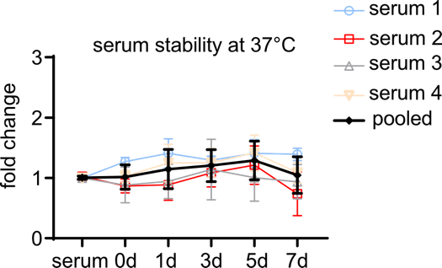

Supplemental Figure S1. α-syn-AAbs remain stable in cell culture medium at 37°C for up to 7 d.
The stability of α-syn AAbs in the serum at 37°C was tested by performing ELISA. The serum-treated medium was collected at 0, 1, 3, 5, and 7 d. ‘serum’ on the X-axis denotes the sample diluted in the media, without any incubation at 37°C. Serum 1-4 refers to 4 different serum samples tested with 4 technical replicates each. The black line indicates pooled data from all 4 serum samples. No significant change in the levels of α-syn AAbs was detected until 7 d.

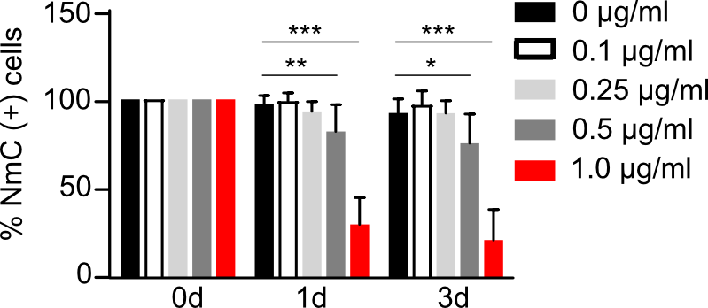

Supplemental Figure S2. Dose dependency of neurodegeneration depending on concentration of α-syn AAbs.
Percent NmC-positive cells at 0 d, 1 d and 3 d after adding serum in amounts resulting in 0, 0.1., 0.25, 0.5 and 1 µg/ml of α-syn AAbs. N = 4 biological replicates. Statistics by One-way ANOVA, followed by Dunnett’s posthoc analysis. Statistical power (1-β error probability) = 1.0 for ***, 0.72 for **, and 0.68 for *. * = p < 0.05; ** = p < 0.01; *** = p < 0.001.

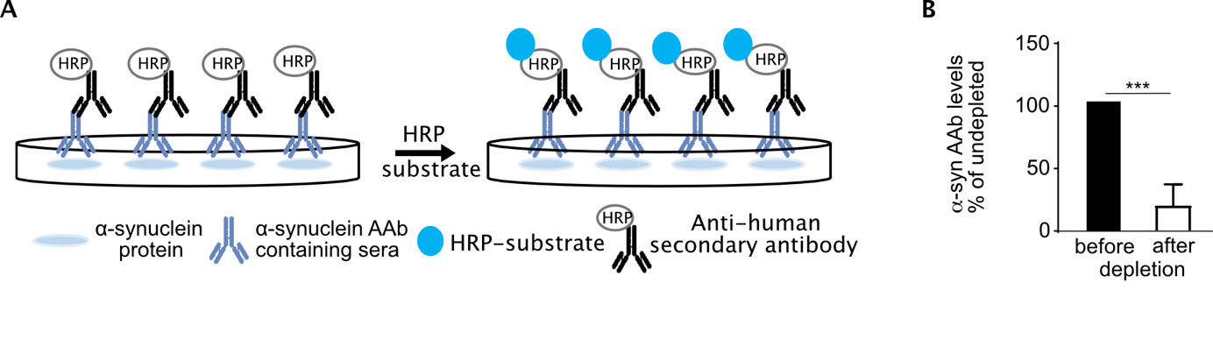
Supplemental Figure S3. Depletion of α-syn AAbs from serum by ELISA.
(A) Schematic representation of ELISA-based measurement of the levels of α-syn autoantibodies in the serum. (B) Levels of α-syn autoantibodies before and 6 days after depletion. N = 3 biological replicates. Statistics by Student’s t-test. Statistical power (1-β error probability) = 1.0 for ***. *** = p < 0.001.

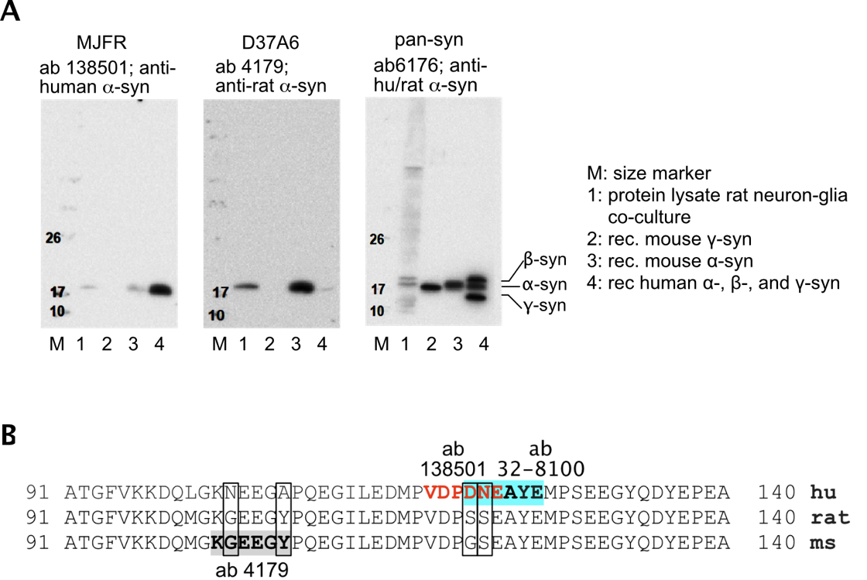

Supplemental Figure S4. Specificity of purified, commercially available synuclein antibodies.
(A) Western blots for different purified, commercially available anti-α-synuclein antibodies, MJFR (ab138501), and D37A6 (4179). All antibodies were probed against whole cell lysare of rat neuron-astrocyte co-culture, recombinant mouse γ- and α-synuclein, and recombinant human α+β+γ synuclein protein. Pan synuclein antibody (ab6176) with an epitope at the highly conserved N-terminal was used as a control. (B) The sequence of human (hu), rat, and mouse (ms) α-synuclein protein from amino acid 91-140. The known epitopes for the antibodies used are highlighted or differently colored, eg: KGEEGY for ab 4179, VDPDNE for ab 138501, and DNEAYE for ab 32-8100. Boxes denote differences in the amino acid sequences between species.

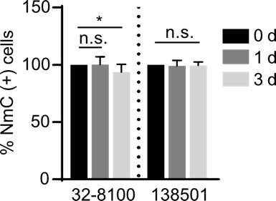

Supplemental Figure S5. Purified, commercial anti-human α-synuclein antibodies cause very low or no toxicity to neurons expressing only NmC.
Percent NmC-positive cells at 0 d, 1 d, and 3 d upon treatment with two anti-human α-syn Abs (32-8100 and 138501) at 1 µg/ml.
N = 4 biological replicates. Statistics by one-way ANOVA with Dunnett’s multiple comparisons test. Statistical power (1-ß error probability) = 0.76 for *. * = p < 0.05.

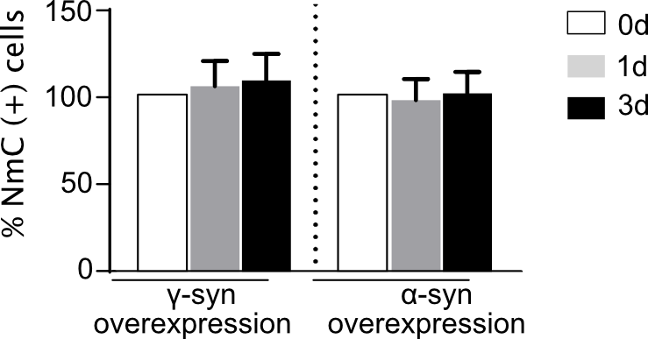

Supplementtal Figure S6: Purified antibody against γ-syn does not cause neurodegeneration in γ-syn or α-syn overexpressing neurons at 1d or 3d of exposure. γ-syn antibody: Ab49206. Statistics by One-way ANOVA, followed by Dunnett’s posthoc analysis.

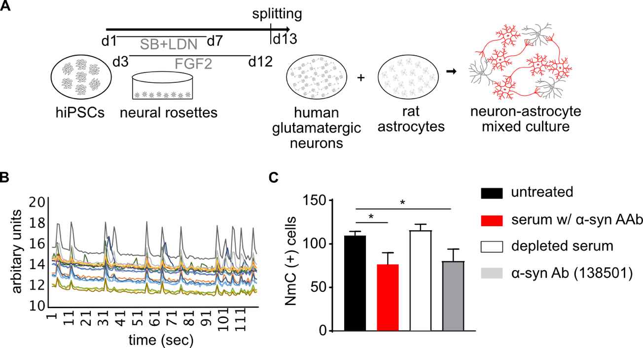

Supplemental Figure S7: Effect of α-syn (auto)antibodies on human iPSC-derived glutamatergic neurons after 1d of treatment. (A) Scheme of differentiation of human glutamatergic neurons from iPSCs, followed by their coculture with rat astrocytes. Co-culture with astrocytes is an absolute prerequisite for generation of spontaneous neuronal activity. (B) Spontaneous calcium transients at d30 of coculture of human glutamatergic neurons with rat astrocytes. (C) NmC positive cells after one day of treatment with serum containing α-syn AAb, with serum depleted from α-syn AAb, or with purified, commercial α-syn Ab, compared to the untreated condition. N = 2 biological replicates (independent differentiations of human neurons) and 8 technical replicates. Statistics by One-way ANOVA, followed by Dunnett’s posthoc analysis. Statistical power (1-β error probability) = 0.99 between untreated and α-syn AAb containing serum and, 0.74 between untreated and commercial α-syn Ab. * = p < 0.05.

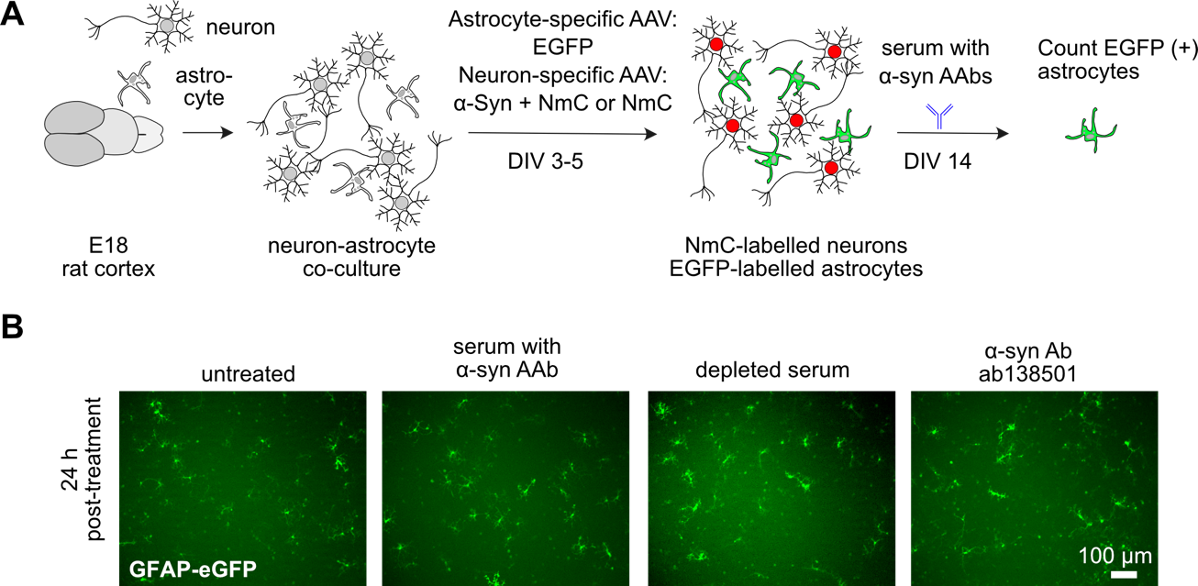

Supplemental Figure S8. No effect of α-syn autoantibodies on astrocyte survival in neuron-glia co-culture.
(A) Experimental outline showing dissociation of E18 rat cortex to generate neuron-astrocyte co-culture transduced with viral vectors encoding GFAP-driven eGFP to label astrocytes (3×10⁷tu/well). Additionally, the cells were transduced with neuron-specific AAV expressing Bcl-XL, αsyn+NmC or NmC alone. At DIV 14, cells were either left untreated or treated with serum containing α-syn AAb, serum depleted from α-syn AAb, or purified commercial α-syn Ab (ab138501). (B) Representative images of GFAP-driven eGFP expression in untreated controls and after 1 d of treatments.

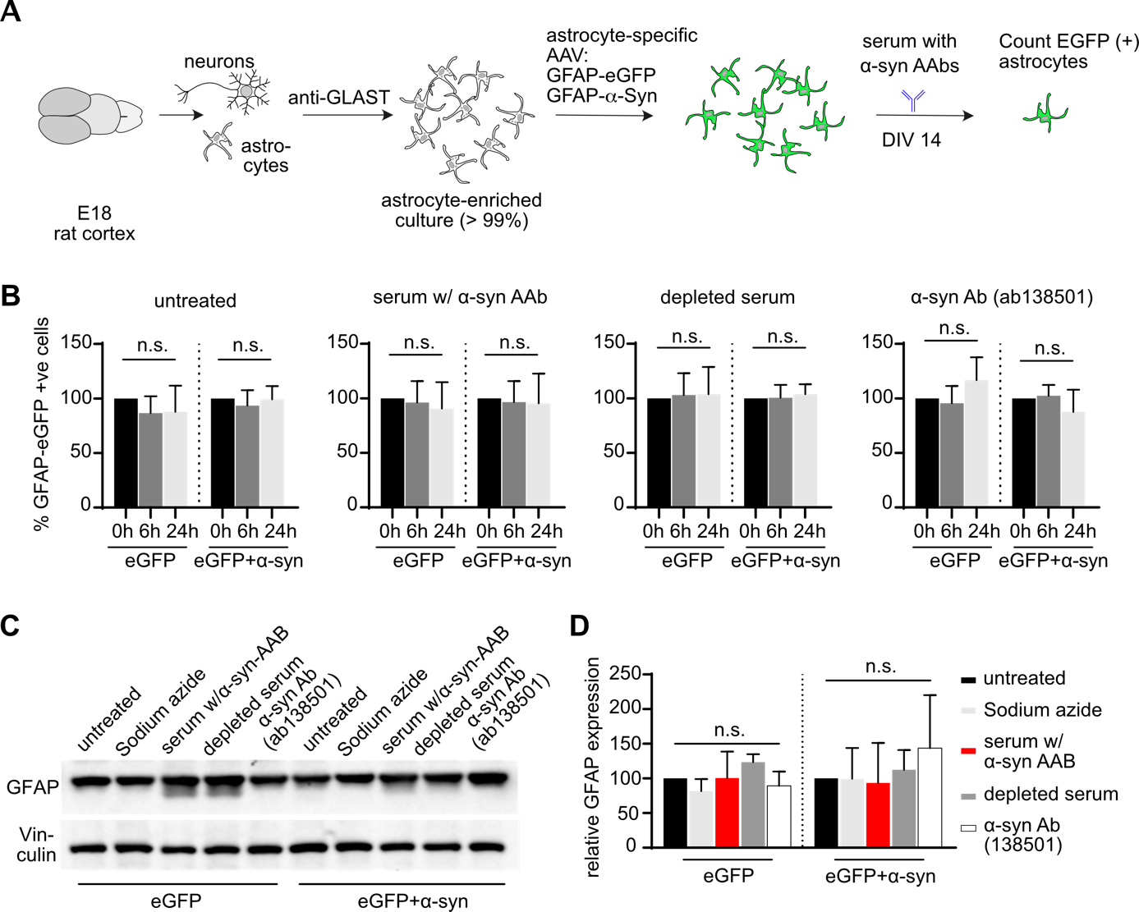

Supplemental Figure S9. α-synuclein (auto)antibodies do not affect astrocyte survival in rat primary astrocyte-enriched cultures.
(A) Experimental outline showing the dissociation of E18 rat cortex, followed by selection with an anti-GLAST antibody to obtain astrocyte-enriched cultures (> 99% astrocytes). Purified cells were transduced with astrocyte-specific AAV expressing eGFP (3×10⁷tu/well) alone or together with α-syn. Cells were then treated with sodium azide (0.0005%) as vehicle control or with serum containing α-syn AAb or with serum depleted from α-syn AAb, or with purified, commercial α-syn Ab (ab138501). (B) Percent eGFP positive cells in eGFP or α-syn+eGFP transduced cultures before treatment (0 h) and after 6 and 24 h of treatment. (C) Western blot for astrocyte marker (GFAP) and internal control (Vinculin) with lysates prepared from eGFP and α-syn+eGFP transduced cultures after 24 h of treatment. (D) Quantification of western blots as relative GFAP expression after normalization to Vinculin signal.
N = 5-7 biological replicates. Statistics by one-way ANOVA with Dunnett’s multiple comparison test

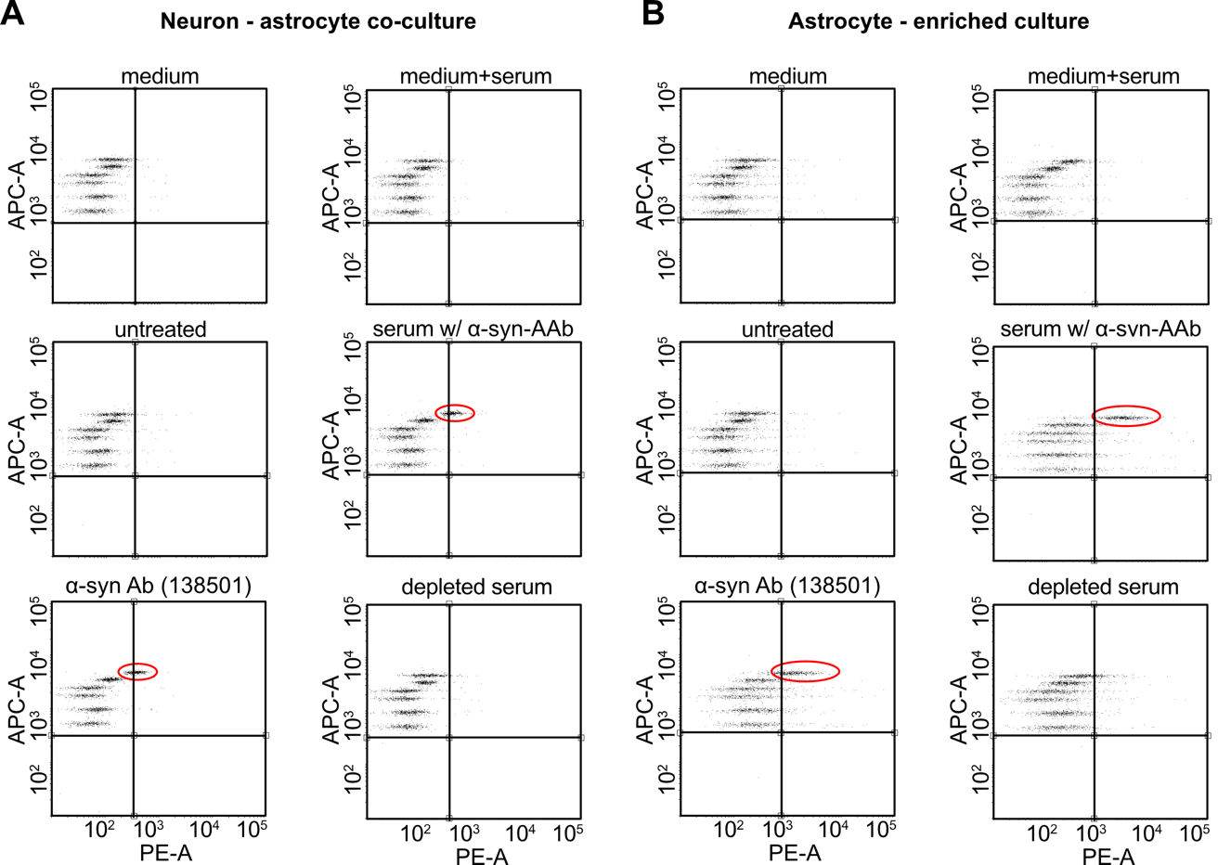

Supplemental Figure S10. Representative graphs showing elevated RANTES upon exposure to α-synuclein (auto)antibodies.
A shift in PE-A fluorescence showing an increase in RANTES levels (marked in red) in the presence of serum containing α-syn AAb, or commercial α-syn Ab (138501), in cell culture supernatant of neuron-astrocyte co-culture (A) and astrocyte-enriched culture (B). RANTES levels in untreated condition or upon treatment with serum depleted from α-syn AAb remained unaltered. Different clusters in APC-A fluorescence depict other tested cytokines (IFN-γ, TNF-α, CCL2, CXCL1, and IL-12) that were unchanged upon any treatment.

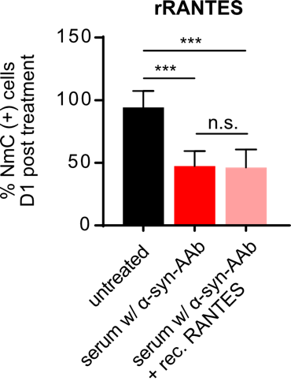

Supplemental Figure S11. Co-treatment with recombinant RANTES does not rescue neurotoxicity caused by serum containing α-syn AAb.
Percent NmC positive cells after 1 d of treatment with serum containing α-syn AAb, in the presence or absence of recombinant RANTES (rRANTES).
N = 4 biological replicates. Statistics by one-way ANOVA with Dunnet’s multiple comparison test; statistical power (1-ß error probability) > 0.9 for all conditions. *** = p < 0.001

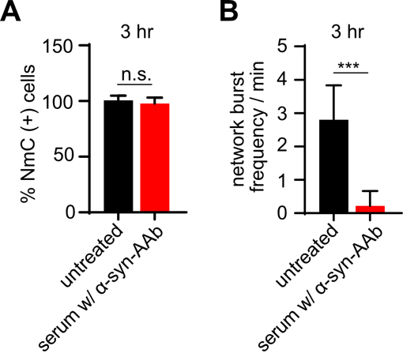

Supplemental Figure S12. Abrogation of neuronal network activity within 3 hrs of exposure to serum that contains α-syn AAb.
(A) Quantification of percentage NmC positive cells and (B) non-stimulated coordinated network bursts per minute after 3 hr of treatment with serum containing α-syn AAb.
N = 4 biological replicates. Statistics by Student’s T-test; statistical power (1-ß error probability) > 0.9. *** = p < 0.001

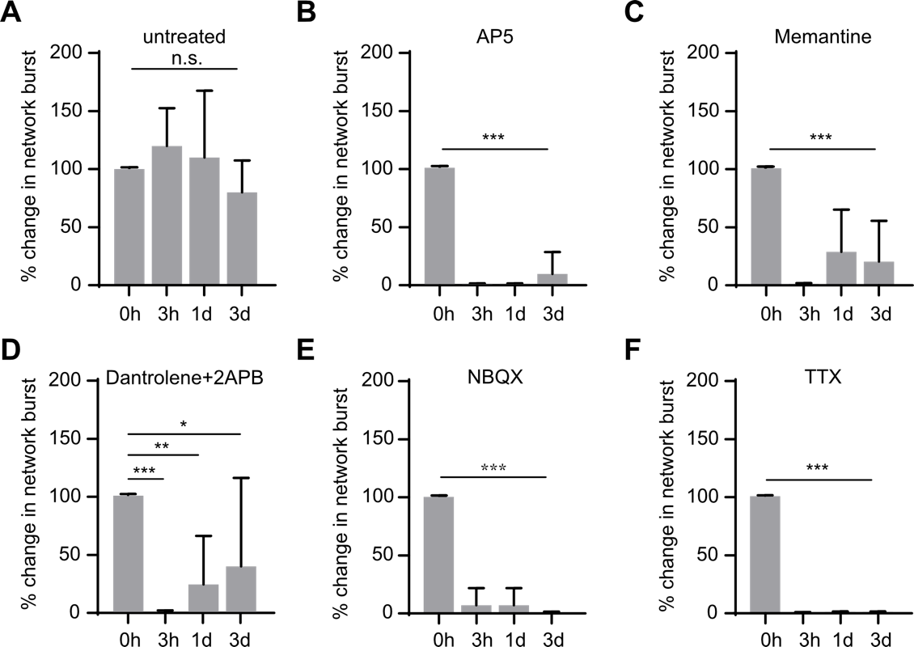

Supplemental Figure S13. Abrogation of neuronal network activity by channel blockers.
Quantification of percentage change in non-stimulated, coordinated neuronal network burst frequency in: (A) untreated controls, (B) upon blocking NMDA receptor with AP5, (C) upon blocking NMDA receptor with Memantine, (D) upon blocking endoplasmic reticulum calcium channels ryanodine and IP3 with Dantrolene and 2-APB, (E) upon blockade of AMPA receptors with NBQX, and (F) upon blockade of sodium channels with tetrodotoxin (TTX), for 0h, 3h, 1d and 3d.
N = 4 - 5 biological replicates for (A – E) and 3 biological replicates for (F). Statistics by one-way ANOVA with Dunnett’s multiple comparison test; statistical power (1-ß error probability) > 0.9 for all conditions, except * in (D), which is 0.5. * = p < 0.05; ** = p < 0.01; *** = p < 0.001.

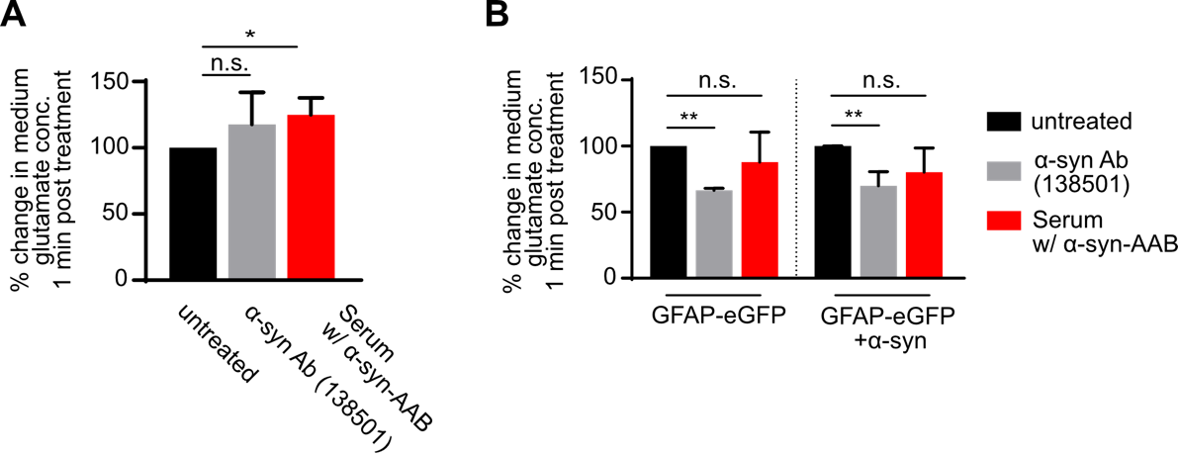

Supplemental Figure S14. Impact of exposure to α-syn (auto)antibodies on medium glutamate concentration.
A) Percent change in the medium glutamate concentration of neuron-astrocyte co-culture after 1 minute of treatment with α-syn (auto)antibodies. Cells expressed NmC in neurons. (B) Percent change in the medium glutamate concentration of astrocyte-enriched culture after 1 minute of treatment with α-syn (auto)antibodies. The astrocytes expressed either eGFP or eGFP+α-syn. N = 5 biological replicates for (A) and 3 biological replicates for (B). Statistics by one-way ANOVA with Dunnett’s multiple comparisons test; statistical power (1-ß error probability) > 0.9 for all conditions. * = p < 0.05; ** = p < 0.01.

