Supplementary figures and figure legends

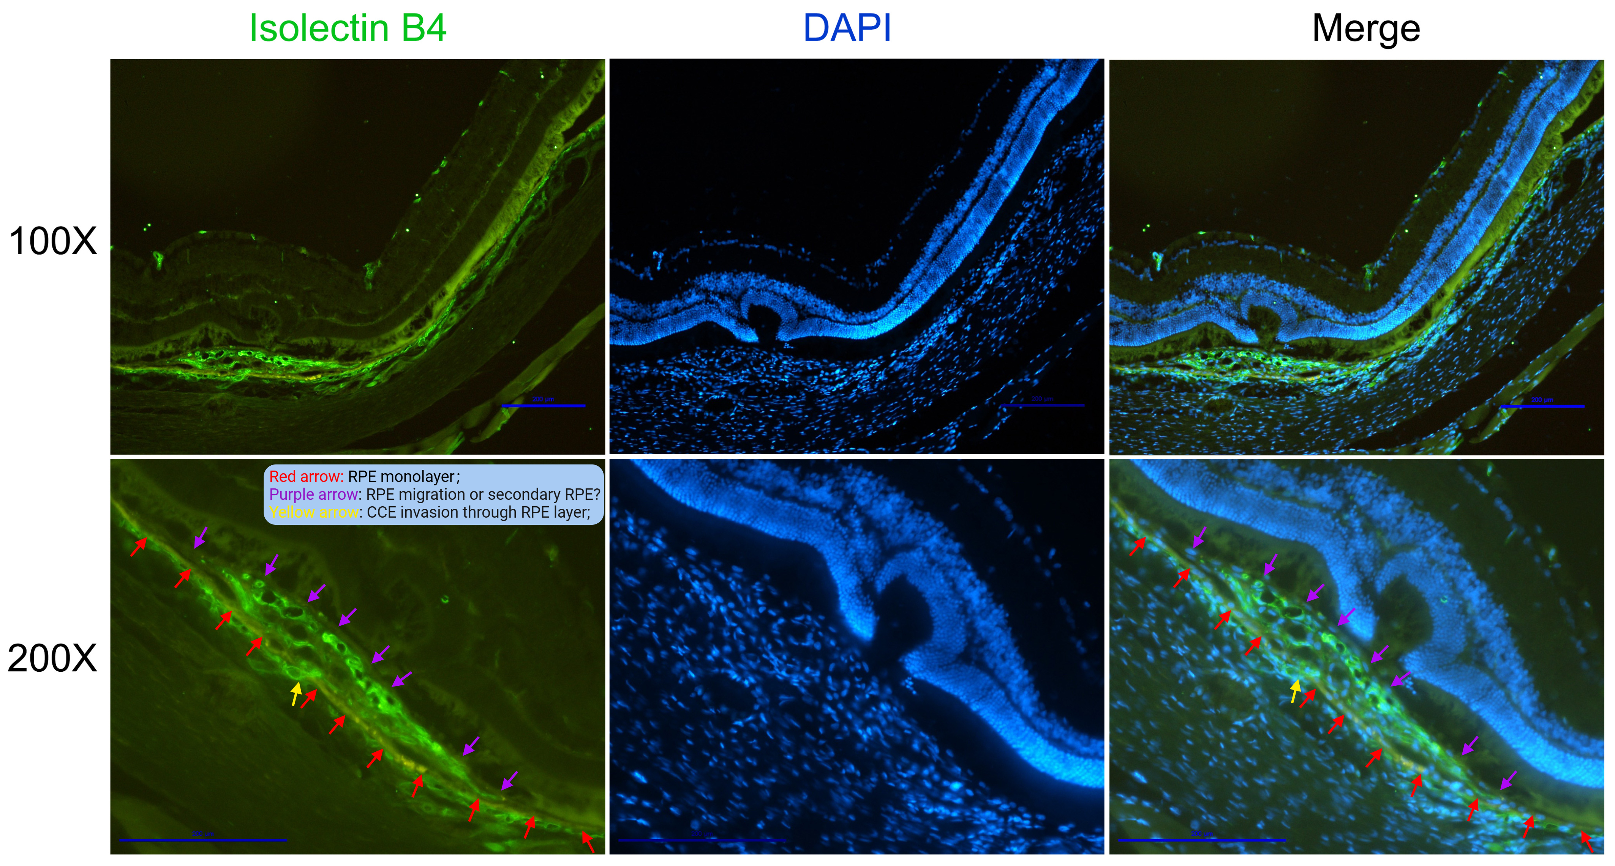
Fig. S1. IB4 (green) and DAPI (blue) staining of 4-week retinal sections showed that RPE cells appeared to surround the pathological choroidal neovascularization resulting from Bruch membrane’s rupture due to subretinal injection. CCE: choroidal capillaries; IB4, isolectin B4; RPE: retinal pigment epithelium. Scale bars = 200 μm.

Fig. S2. The effect of FH535, Box5 and Foxy-5 on the cell viability of ARPE-19 cells. The cell viability of ARPE-19 cells examined with CCK-8 assay after treatment with the indicated doses of (A) FH535, (B) Box5 or (C) Foxy-5 for 48 hours. The Vehicle Control groups for (A) FH535 and (B) Box5 contained DMSO concentrations of 0.2% and 2%, respectively. (Data are expressed as mean ± SEM. * p < 0.05, **p < 0.01, ***p < 0.001, **** p < 0.0001 compared with untreated ARPE-19 cells).

Fig. S3. The inhibitory effect of FH535 on EMT in TGFβ1-induced ARPE-19 cells. (A-F) mRNA and (G-I) protein levels of EMT-related markers, including (A, G) fibronectin, (B) collagen I, (C, H) α-SMA, (D) Snail 1, (E) TAGLN, (F) MMP2, as well as epithelial marker (I) ZO-1 measured by qRT-PCR and Western blot, respectively, in TGFβ1-treated ARPE-19 cells for 48 hours with or without different concentrations of FH535 treatment. α-SMA, alpha-smooth muscle actin; MMP2, matrix metallopeptidase 2; TAGLN, transgelin; TGFβ1, transforming growth factor beta 1; ZO-1, zonula occludens-1. Data are expressed as mean ± SEM. * p < 0.05, ** p < 0.01, *** p < 0.001, **** p < 0.0001 compared with the TGFβ1-treated group.

Fig. S4. Safety assessment of intravitreal administration of Box5 in C57 mice. (A-C) Representative results of scotopic ERG at 0.01 or 3.0 log cds/m² and photopic ERG at 3.0 log cds/m² in 4-month-old male C57BL/6J mice 7 days after intravitreal injection of Box5 (90 μmol/L), compared to the Vehicle group injected with PBS. (D) The mean scotopic ERG b-wave amplitudes elicited by 0.01 log cd-s/m² white-light stimuli. (E) The mean scotopic ERG a-wave amplitudes elicited by 3.0 log cd-s/m² white-light stimuli. (F) The mean scotopic ERG b-wave amplitudes elicited by 3.0 log cd-s/m² white-light stimuli. (G) The mean photopic ERG b-wave amplitudes elicited by 3.0 log cd-s/m² white-light stimuli. ERG, Electroretinography; Data are expressed as mean ± SEM. ns, no significant.

