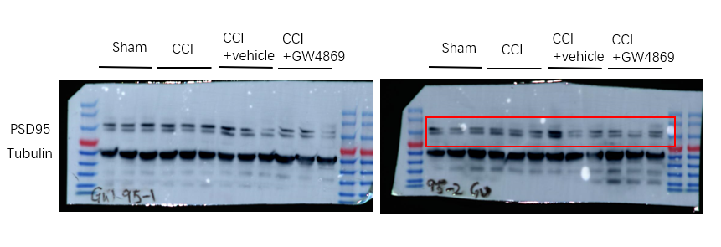
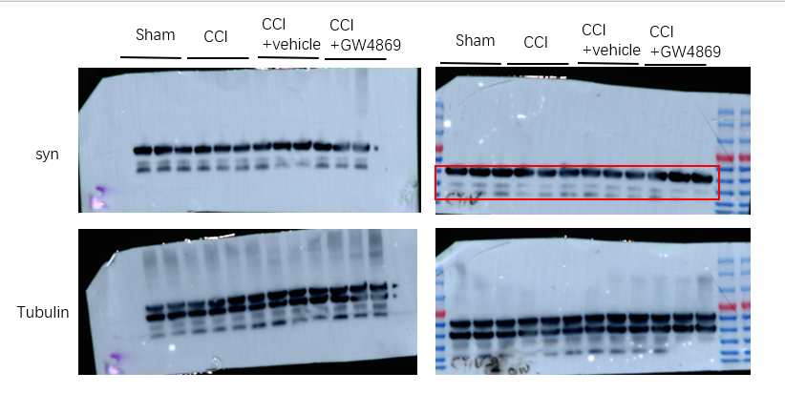
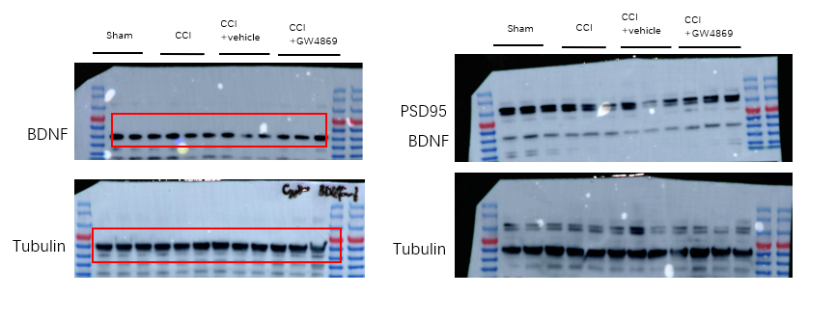
Supplementary Figure 9. Full and unprocessed western blot images corresponding to Figure 1, the square refers to the blots cited in the main article.

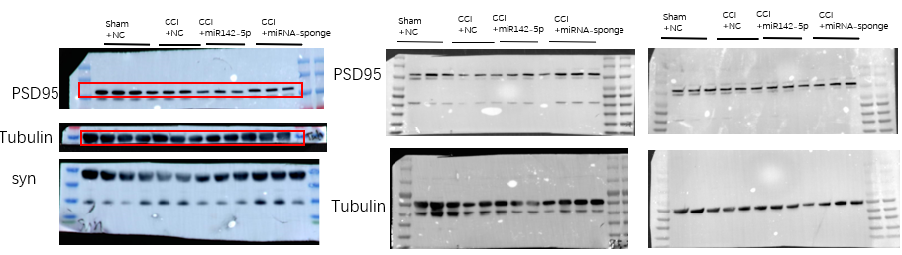
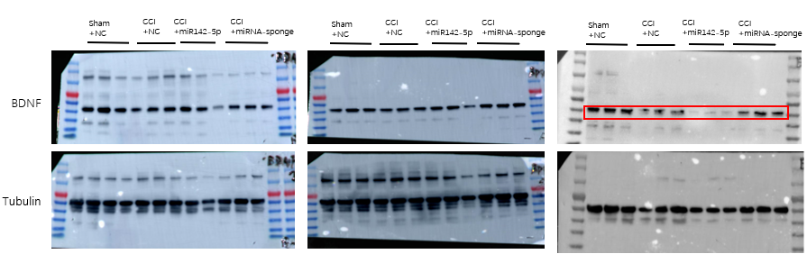
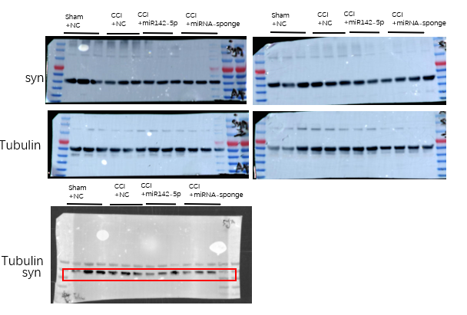
Supplementary Figure 10. Full and unprocessed western blot images corresponding to Figure 4G, the square refers to the blots cited in the main article.

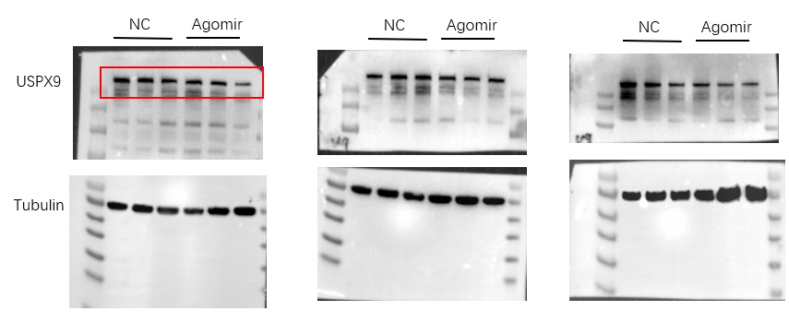
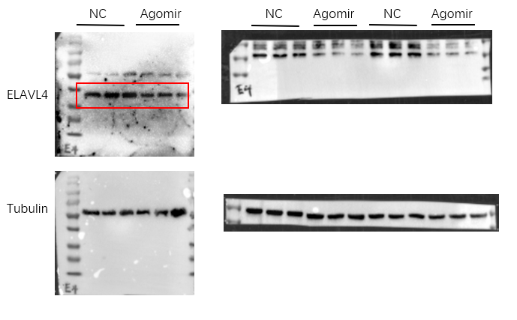
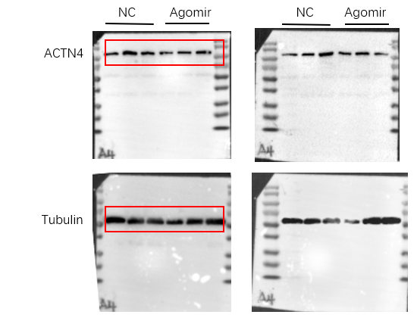
Supplementary Figure 11. Full and unprocessed western blot images corresponding to Figure 4F, the square refers to the blots cited in the main article.

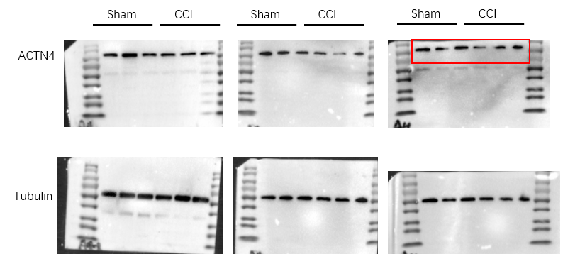
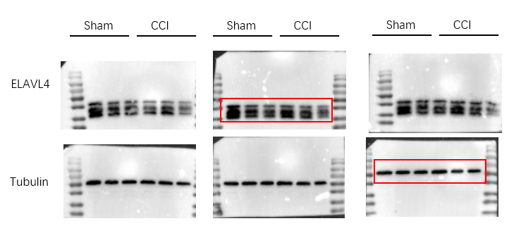
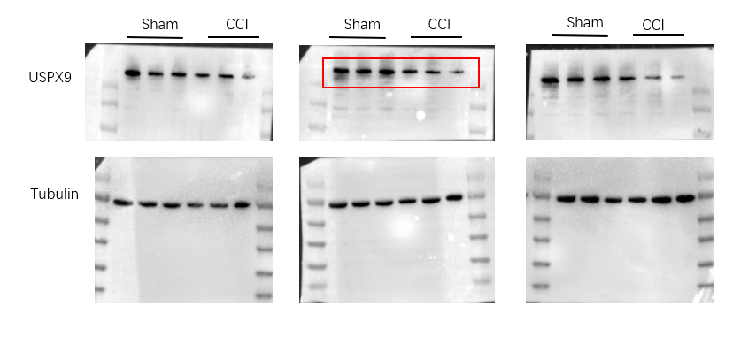
Supplementary Figure 12. Full and unprocessed western blot images corresponding to Figure 5G, the square refers to the blots cited in the main article.
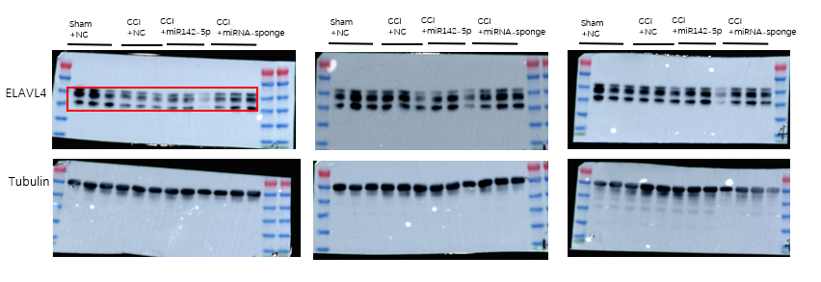
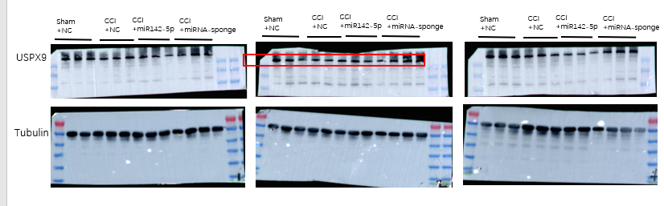
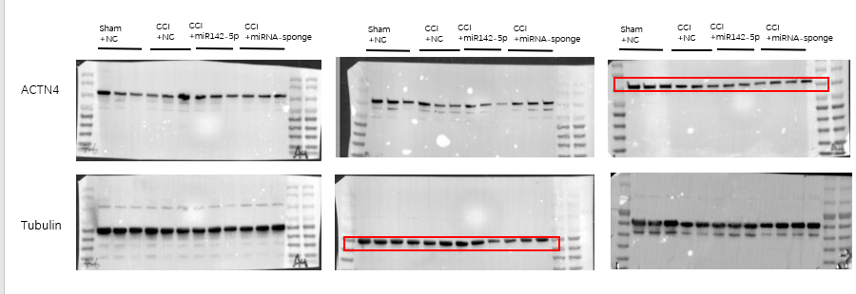
Supplementary Figure 13. Full and unprocessed western blot images corresponding to Figure 5H, the square refers to the blots cited in the main article.

