The extracellular vesicle of depressive patient-derived Escherichia fergusonii induces vagus nerve-mediated neuroinflammation in mice

(a) (b) (c)
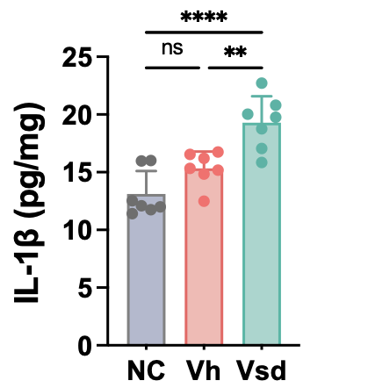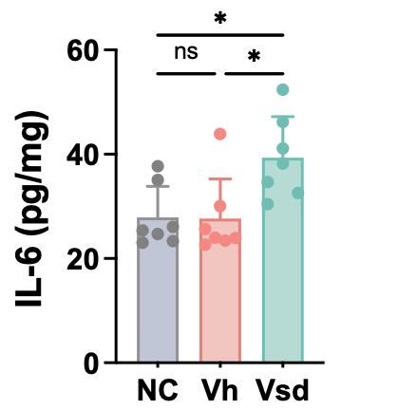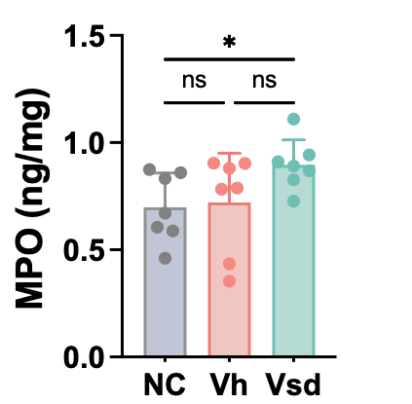
(d) (e)
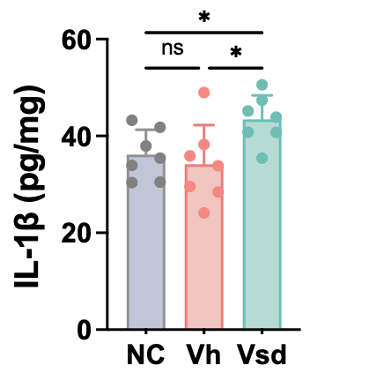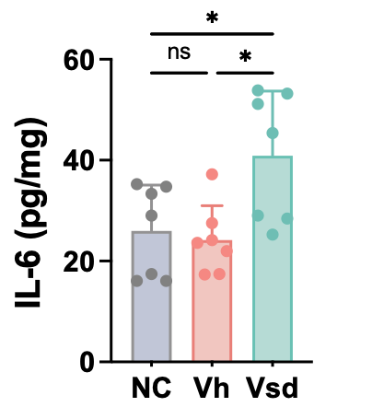
Figure S1. Fecal microbiota transplantation (FMT) from Vsd caused DA-like behavior and neuroinflammation in mice. Effects of FVsd and FVh on IL-1β (a) and IL-6 expression (b) in the hippocampus and myeloperoxidase (MPO, c), IL-1β (d), and IL-6 expression (e) in the colon. NC, vehicle in normal control mice; Vsd, fecal microbiota of Vsd; Vh, the fecal microbiota of Vh. Data values were indicated as mean ± SD (n = 7). *p < 0.05. **p<0.01. ****p<0.0001. ns, no significant.

- (b)
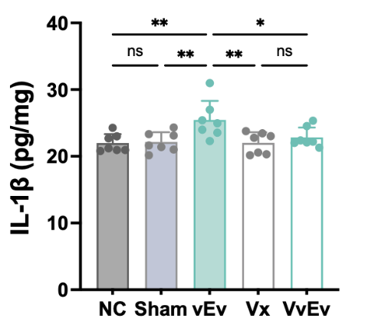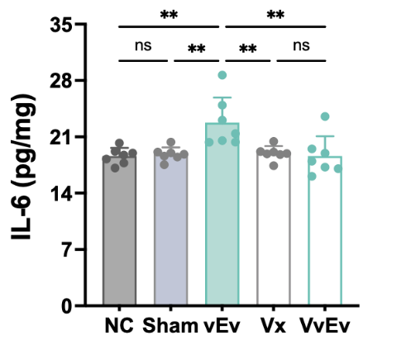
Figure S2. EV from FVsd (vfEV) caused neuroinflammation in mice. Effect on IL-1β (a) and IL-6 expression (b) in the hippocampus. NC, vehicle in normal control mice; Sham, vehicle; vEv, vfEV in mice; Vx, vehicle in mice with vagotomy; VvEv, vfEV in mice with vagotomy. Data values were indicated as mean ± SD (n = 7). *p < 0.05. **p<0.01. ns, no significant.

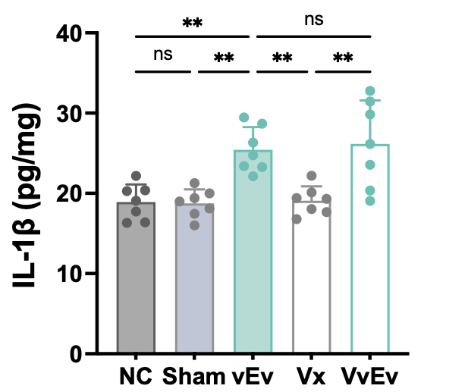
Figure S3. vfEV increased IL-1β expression in the colon. NC, vehicle in normal control mice; Sham, vehicle; vEv, vfEV in mice; Vx, vehicle in mice with vagotomy; VvEv, vfEV in mice with vagotomy. Data values were indicated as mean ± SD (n = 7). **p<0.01. ns, no significant.

Figure S4. The effects of Escherichia fergusonii (Es) on TNF-α in Caco-2 cells (a) and BDNF expression in SH-SY5Y cells (b). Data are indicated as mean ± SD (n = 4). *p < 0.05 vs NC (vehicle alone).
Caco-2 cells or SH-SY5Y cells (purchased from Korea Cell Line Bank, Seoul, Korea) were cultured at 37°C in a 95% air/5% CO₂ atmosphere in DMEM containing 5% fetal bovine serum and 1% antibiotic-antimycotic. Caco-2 cells (1×10⁶ cells/mL) were incubated in the absence or presence of Es (1×10⁴ CFU/mL) for 24 h. In the supernatant of the culture, TNF-α level was assayed using its assay kits. SH-SY5Y cells (1×10⁶ cells/mL) were incubated in the absence or presence of Es (1×10⁴ CFU/mL) for 24 h. In the supernatant of the culture, BDNF level was assayed using its assay kits.

(a) (b)
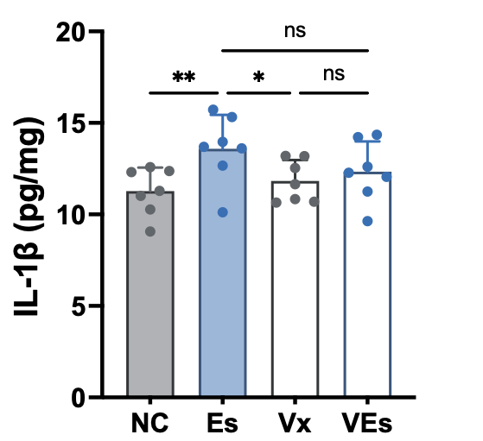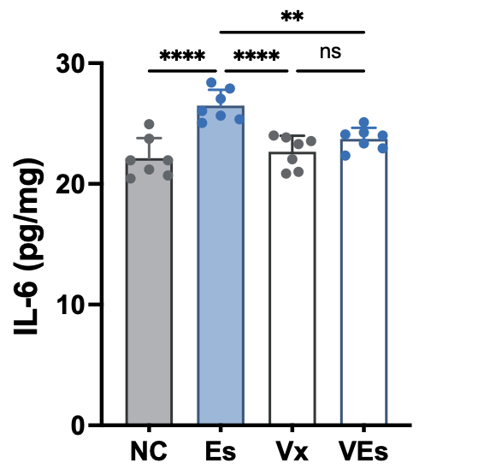
(c) (d) (e)
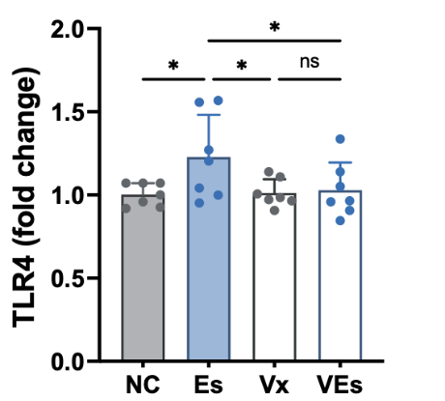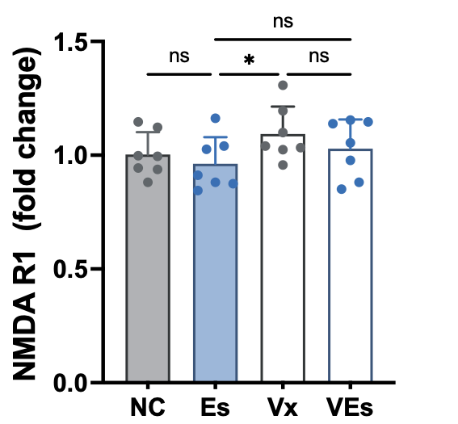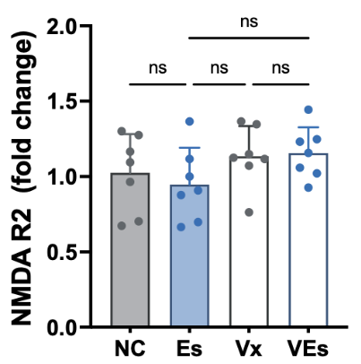
Figure S5. Effect of Esf on DA-related biomarker levels in the hippocampus and prefrontal cortex of mice with or without celiac vagotomy. Effect on IL-1β (a) and IL-6 expression (b) in the hippocampus. Effects on TLR4 (c), NMDAR R1 (d), and NMDAR R2 expression (e) in the prefrontal cortex. NC, vehicle in normal control mice; sham, vehicle; Es, E. fergusonii in mice; Vx, vehicle in mice with vagotomy; VEs, E. fergusonii in mice with vagtomy. Data values were indicated as mean ± SD (n = 7). *p < 0.05. **p<0.01. ****p<0.0001. ns, no significant.

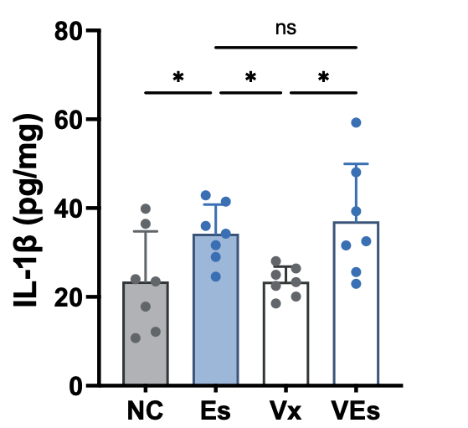
Figure S6. Effect of Esf on IL-1β expression in the colon of mice with or without celiac vagotomy. NC, vehicle in normal control mice; sham, vehicle; Es, E. fergusonii in mice; Vx, vehicle in mice with vagotomy; VEs, E. fergusonii in mice with vagtomy. Data values were indicated as mean ± SD (n = 7). *p < 0.05. ns, no significant.

Figure S7. General properties of esEV and its effect on TNF-α and BDNF expression (a) Transmission electron microscope image of esEV. (b) Sodium-polyacrylamide gel electrophoresis (SDS-PAGE) of esEV. (c) The identified components of esEV.
(d) Effect on TNF-α expression in Caco-2 cells. (e) Effect on BDNF expression in SH-SY5Y cells. Data are indicated as mean ± SD (n = 4). *p < 0.05 vs NC (vehicle alone). Caco-2 cells or SH-SY5Y cells (purchased from Korea Cell Line Bank, Seoul, Korea) were cultured at 37°C in a 95% air/5% CO₂ atmosphere in DMEM containing 5% fetal bovine serum and 1% antibiotic-antimycotic. Caco-2 cells (1×10⁶ cells/mL) were incubated in the absence or presence of esEV (100 or 400 ng/mL) for 24 h. In the supernatant of the culture, TNF-α level was assayed using its assay kits. SH-SY5Y cells (1×10⁶ cells/mL) were incubated in the absence or presence of esEV (100 or 400 ng/mL) for 24 h. In the supernatant of the culture, BDNF level was assayed using its assay kits.

(a) (b)
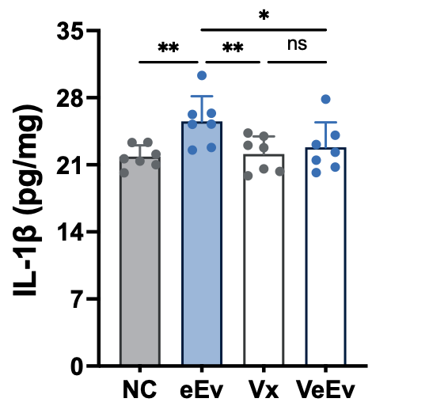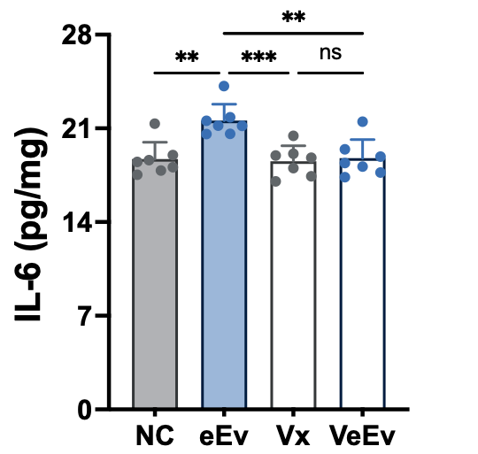
(c) (d) (e)
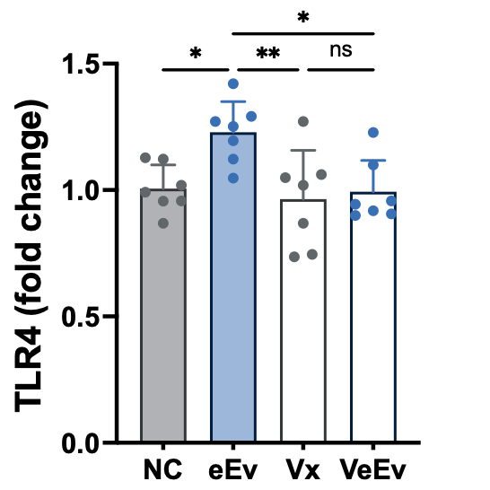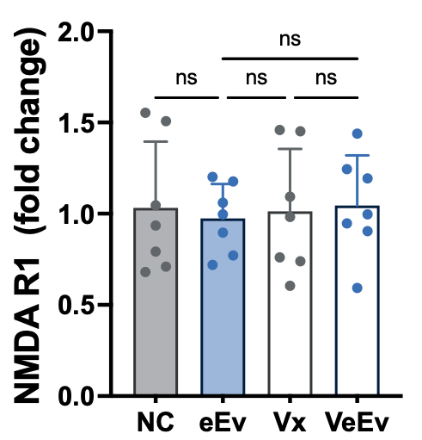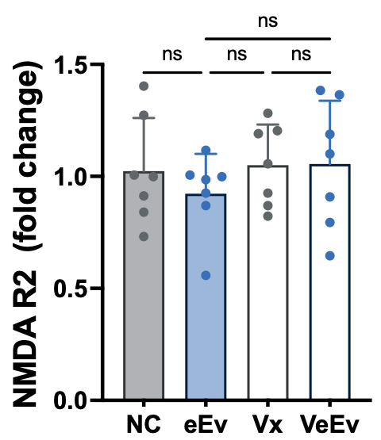

Figure S8. Effect of esEV on DA-related biomarker levels in the hippocampus and prefrontal cortex of mice with or without celiac vagotomy. Effect on IL-1β and IL-6 expression in the hippocampus. Effects on TLR4, NMDAR R1, and NMDAR R2 expression in the prefrontal cortex. NC, vehicle; eEv, esEV in mice; Vx, vehicle in mice with vagotomy; VeEv, esEV in mice with vagotomy. Data values were indicated as mean ± SD (n = 7). *p < 0.05. **p<0.01. ***p<0.001. ns, no significant.

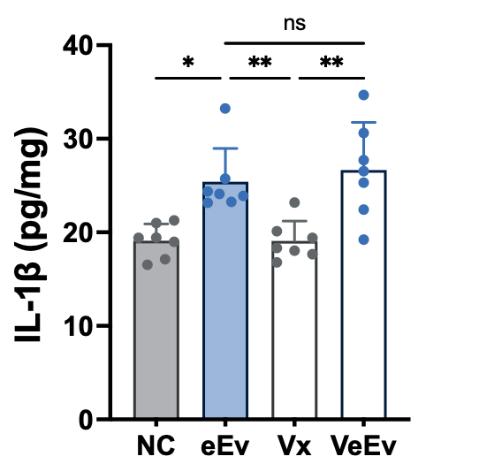
Figure S9. Effect of esEV on IL-1β expression in the colon of mice with or without celiac vagotomy. NC, vehicle; eEv, esEV in mice; Vx, vehicle in mice with vagotomy; VeEv, esEV in mice with vagotomy. Data values were indicated as mean ± SD (n = 7). *p < 0.05. **p<0.01. ns, no significant.

Table S1. Primers for qPCR
Gene | Primer
Gene | Forward | Reverse
E. fergusonii | 5’-GTTAATACCTTTGCTCATTGA-3’ | 5’-ACCAGGGTATCTAATCCTGTT-3’
16S rRNA | TCGTCGGCAGCGTCAGATGTGTATAAGAGACAGGTGCCAGCMGCCGCGGTAA | GTCTCGTGGGCTCGGAGATGTGTATAAGAGACAGGGACTACHVGGGTWTCTAAT
5-HT1A | 5'-CCGTGAGAGGAAGACAGTGAAGA-3 | 5'-GGTTGAGCAGGGAGTTGGAGTAG-3'
TLR4 | 5'-GATTGCTCAGACATGGCAGTTTC-3 | 5'-CACTCGAGGTAGGTGTTTCTGCTAA-3
NF-κB | 5'-ATGGCTTCTATGAGGCTGAG-3' | 5'-GTTGTTGTTGGTCTGGATGC-3
NMDAR R1 | 5′-ATTCATGCAGCCCTTTCAGA-3 | 5′-CCTTCCCCAATGCCAGAGT-3′
NMDAR R2 | 5'-GACGGTCTTGGGATCTTAAC-3' | Reverse 5'-TGACCATGAATTGGTGCAGG-3
GAPDH | 5'-TGCAGTGGCAAAGTGGAGAT-3' | 5'-TTTGCCGTGAGTGGAGTCATA-3'

Table S2. The fecal microbiota composition of Vh and Vsd at the phylum level
Taxon Name | Composition (%, mean ± SD)
Taxon Name | Vh | Vsd
Bacteroidetes | 62.0±24.2 | 50.8±23.2
Firmicutes | 24.8±14.9 | 41.2±20.1
Actinobacteria | 11±17.2 | 3.8±3.7
Proteobacteria | 1.6±1.3 | 3.8±1.9*
Verrucomicrobia | 0.2±0.6 | 0.0±0.0
Tenericutes | 0.0±0.1 | 0.0±0.0
Fusobacteria | 0.0±0.0 | 0.0±0.1
Cyanobacteria | 0.0±0.0 | 0.0±0.0
Lentisphaerae | 0.0±0.0 | 0.0±0.0
Deferribacteres | 0.0±0.0 | 0.0±0.1

Table S3. The fecal microbiota composition of Vh and Vsd at the family level
Taxon Name | Composition (%, mean ± SD)
Taxon Name | Vh | Vsd
Bacteroidaceae | 39.6±26.8 | 30.6±25.3
Prevotellaceae | 14.4±20.9 | 13.7±19.6
Ruminococcaceae | 12.9±9.8 | 18.0±14.4
Lachnospiraceae | 7.3±4.0 | 13.0±11.9
Coriobacteriaceae | 1.4±2.5 | 0.4±0.7
Rikenellaceae | 6.3±6.9 | 2.1±0.6
Bifidobacteriaceae | 4.1±7.7 | 2.8±3.0
Porphyromonadaceae | 3.1±3.5 | 3.1±3.2
Acidaminococcaceae | 1.7±1.5 | 0.9±1.5
Peptostreptococcaceae | 2.2±5.2 | 0.9±1.3
Veillonellaceae | 1.1±1.6 | 2.5±4.9
Barnesiellaceae | 0.9±1.4 | 0.1±0.2
Muribaculaceae | 0.6±1.3 | 4.6±10.8
Sutterellaceae | 0.5±0.8 | 0.9±1.1
Enterobacteriaceae | 0.1±0.1 | 1.1±1.0*
Odoribacteraceae | 0.5±0.5 | 0.3±0.1
Pasteurellaceae | 0.4±0.7 | 0.6±1.5
Lactobacillaceae | 0.3±0.8 | 0.1±0.0
Clostridiaceae | 0.3±0.6 | 0.2±0.5
Akkermansiaceae | 0.3±0.6 | 0.0±0.0
Christensenellaceae | 0.1±0.2 | 0.1±0.1
Streptococcaceae/Enterococcaceae | 0.1±0.1 | 0.2±0.2
Erysipelotrichaceae | 0.1±0.0 | 0.5±0.5
Desulfovibrionaceae | 0.1±0.0 | 0.3±0.5
Selenomonadaceae | 0.1±0.2 | 0.2±0.5

