Table S1 Clinical information on tissue samples
 | Gender | Age | Aneurysm type | Tissue source | Hypertension | Diabetes mellitus | Coronary heart disease
1 | Male | 67 | UIA | ACoA | Yes | No | No
2 | Female | 66 | UIA | L-MCA | No | No | No
3 | Male | 41 | UIA | L-MCA-M2 | No | No | No
4 | Male | 54 | UIA | R-MCA | Yes | Yes | No
5 | Male | 42 | RIA | R-ACA-A1 | No | No | No
6 | Female | 35 | STA | L-STA | No | No | No
7 | Male | 60 | STA | R-STA | Yes | No | No
8 | Female | 48 | STA | R-STA | Yes | Yes | No
9 | Male | 58 | STA | R-STA | Yes | No | Yes
10 | Female | 50 | STA | L-STA | No | No | No
11 | Male | 29 | STA | L-STA | No | No | No
UIA: Unruptured intracranial aneurysm; RIA: Ruptured intracranial aneurysm; STA: Superficial Temporal Artery.
ACoA: Anterior communicating artery; ACA: Anterior Cerebral Artery; PICA: Posterior Inferior Cerebellar Artery; MCA: Middle Ccerebral Artery; R: Right; L: Left.

Table S2 Dataset information of all analysis
 | Datasets | Species origin |  | Tissue source | Analysis
1 | GSE75436 |  | Homosapiens | 15 IAs  15 STAs | Differential analysis GO,KEGG,GSEA  Immune infiltration analysis  WGCNA, LASSO, PPI  Interior validation  TF and drug networks
2 | GSE15629 |  | Homosapiens | 14 IAs (8 ruptured)  5 MMAs | External validation
3 | GSE36791 |  | Homosapiens | 43 peripheral blood  of RIA  18 peripheral blood  of Control | External validation
4 | HRA007438 |  | Homosapiens | 2 IAs (1 ruptured )  3 STAs | Single-cell analysis
IA: intracranial aneurysm; RIA: Ruptured intracranial aneurysm; STA: Superficial Temporal Artery.
MMA: middle meningeal artery.

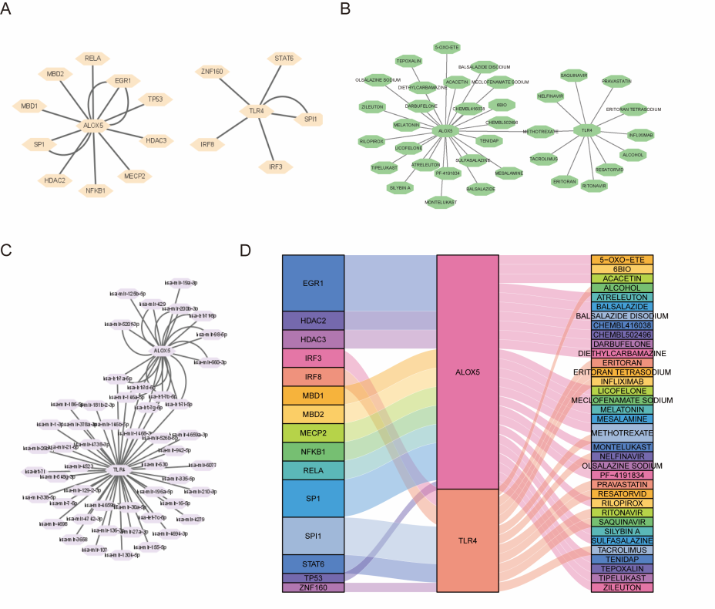
Figure S1. Network construction of TFs and small molecule drugs. (A) Construction of the TF regulatory network using Cytoscape. (B) Prediction of small molecule drugs. (C) miRNA regulatory network. (D) Sankey diagram displaying the TF-gene-drug network.

