Table S1. Spearman Correlation Coefficients of Gene Expression Between CD200R1 and NFKB1 Across Diverse Human Tissues from the GTEx Databaseª
Type | Cor | p.value
Spleen | 0.851613037 | 3.03E-29
Colon | 0.672349015 | 7.18E-42
Blood | 0.670675213 | 2.54E-59
Kidney | 0.662491654 | 0.000122631
Stomach | 0.655822818 | 9.16E-23
Vagina | 0.648900216 | 1.87E-11
Small Intestine | 0.583576809 | 1.03E-09
Esophagus | 0.553471233 | 1.11E-53
Lung | 0.502909824 | 7.23E-20
Adrenal Gland | 0.489886193 | 4.39E-09
Pancreas | 0.461526351 | 3.44E-10
Heart | 0.45145535 | 2.49E-20
Thyroid | 0.424931788 | 1.17E-13
Bladder | 0.422815787 | 0.256869573
Salivary Gland | 0.384059581 | 0.003794543
Ovary | 0.324913968 | 0.002010732
Blood Vessel | 0.324079954 | 2.76E-16
Brain | 0.315815049 | 4.27E-28
Pituitary | 0.303700001 | 0.001472436
Prostate | 0.303123604 | 0.002172389
Nerve | 0.289229886 | 9.30E-07
Uterus | 0.262119238 | 0.020433445
Liver | 0.255465199 | 0.007068852
Breast | 0.255298648 | 0.000562524
Muscle | 0.142352293 | 0.004535625
Testis | 0.103715665 | 0.184938478
Bone Marrow | 0.060081246 | 0.621255709
Adipose Tissue | 0.01145721 | 0.795340362
Skin | 0.001034055 | 0.976529108
Cervix Uteri | -0.021509418 | 0.95296991
Fallopian Tube | -0.231943047 | 0.707350638
ªType: The type of tissue from which the gene expression data was obtained.
Cor: The correlation coefficient, a measure of the strength and direction of the association between the expression levels of CD200R1 and NFKB1 in the tissue.
- Value: The p-value associated with the correlation coefficient.

Table S2: Quantitative Analysis of TH-Positive Neurons in the Substantia Nigra of NFKB1+/+ and NFKB1-/- Mice Treated with Saline or MPTPª.
Aspect of Analysis | Saline/NFKB1+/+ Group | Saline/NFKB1-/- Group | MPTP/NFKB1+/+ Group | MPTP/NFKB1-/- Group
Average Number of TH-positive neurons per animal | 3313 | 3110 | 2879 | 617
Range of TH-positive neurons counts per animal | 3064 to 3600 | 2964 to 3360 | 2324 to 3144 | 432 to 864
Total Neurons Counted of TH-positive neurons across all animals in this group | 19880 | 18664 | 17276 | 3702
Coefficient of Variation | 0.0234 | 0.0183 | 0.0387 | 0.0932
Section Thickness (um) | 20 | 20 | 20 | 20
ªThis table presents a quantitative analysis of TH-positive neurons in the substantia nigra of NFKB1+/+ and NFKB1-/- mice treated with saline or MPTP. The data include the average number of TH-positive neurons per animal, the range of neuron counts, the total number of neurons counted across all animals in each group, the Coefficient of Variation, and the section thickness used for analysis. The analysis compares four groups: Saline/NFKB1+/+ (control), Saline/NFKB1-/- (NFKB1 knock-out), MPTP/NFKB1+/+ (MPTP-treated control), and MPTP/NFKB1-/- (MPTP-treated knock-out).

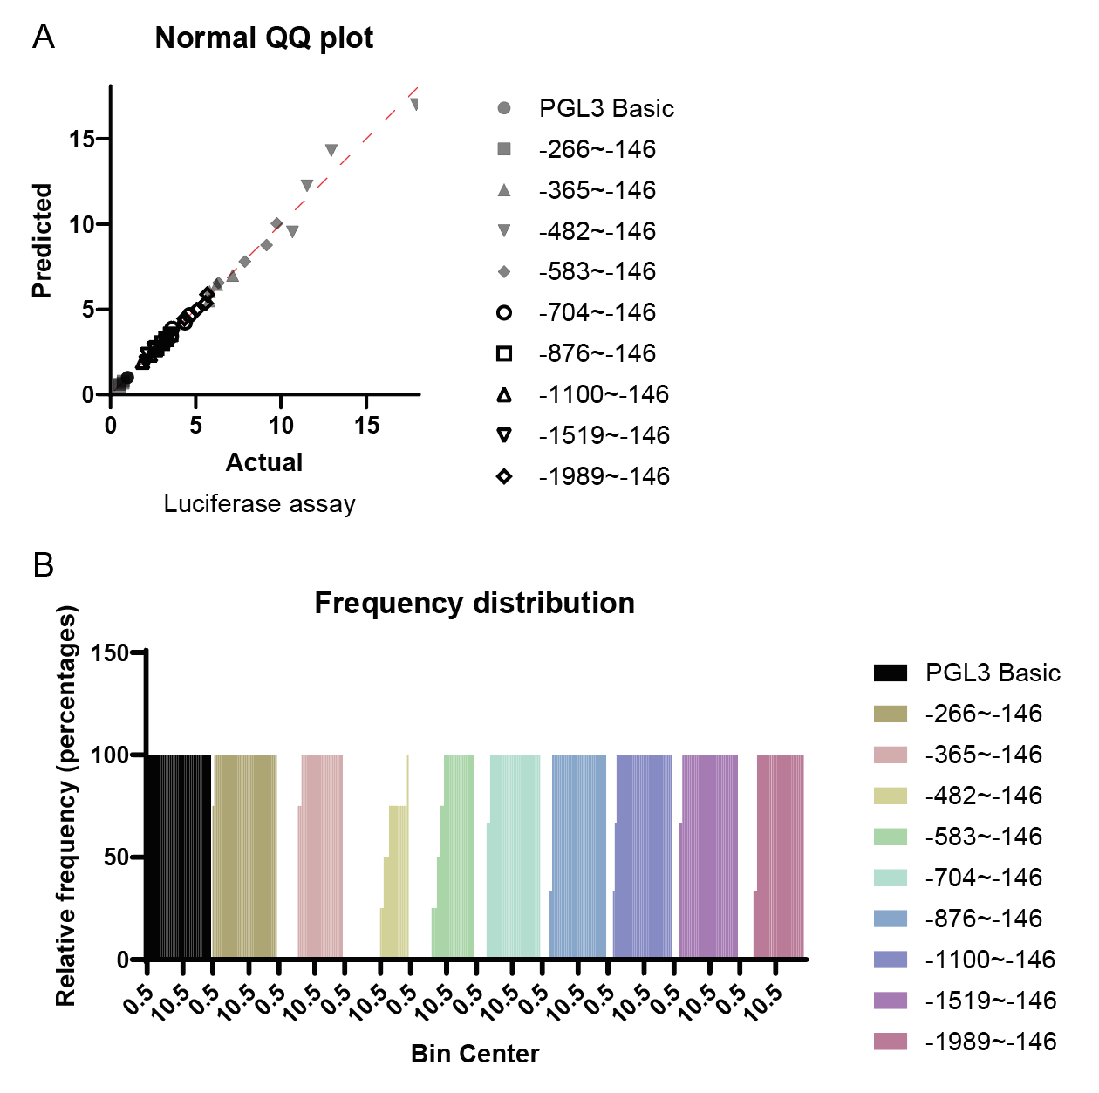
Figure S1. Validation of the promoter region of CD200R1 through luciferase reporter assay and distribution analysis.
(A) The Normal QQ plot compares the predicted luciferase activity (y-axis) with the actual luciferase assay results (x-axis) for various truncated constructs of the CD200R1 promoter region. Constructs include PGL3 Basic, -266~-146, -365~-146, -482~-146, -583~-146, -704~-146, -876~-146, -1100~-146, -1519~-146, and -1989~-146, which are labeled with different markers. The points fall closely along the diagonal line, indicating that the predicted values are consistent with the observed data.
(B) The frequency distribution histogram shows the relative frequency percentages of luciferase activity across different bin centers for each truncated construct, as listed in the legend. The histogram indicates the consistency in luciferase activity distribution among the different constructs, supporting the identification of the core promoter region within the -482 to -267 bp range upstream of the transcription initiation site (TIS) of CD200R1.

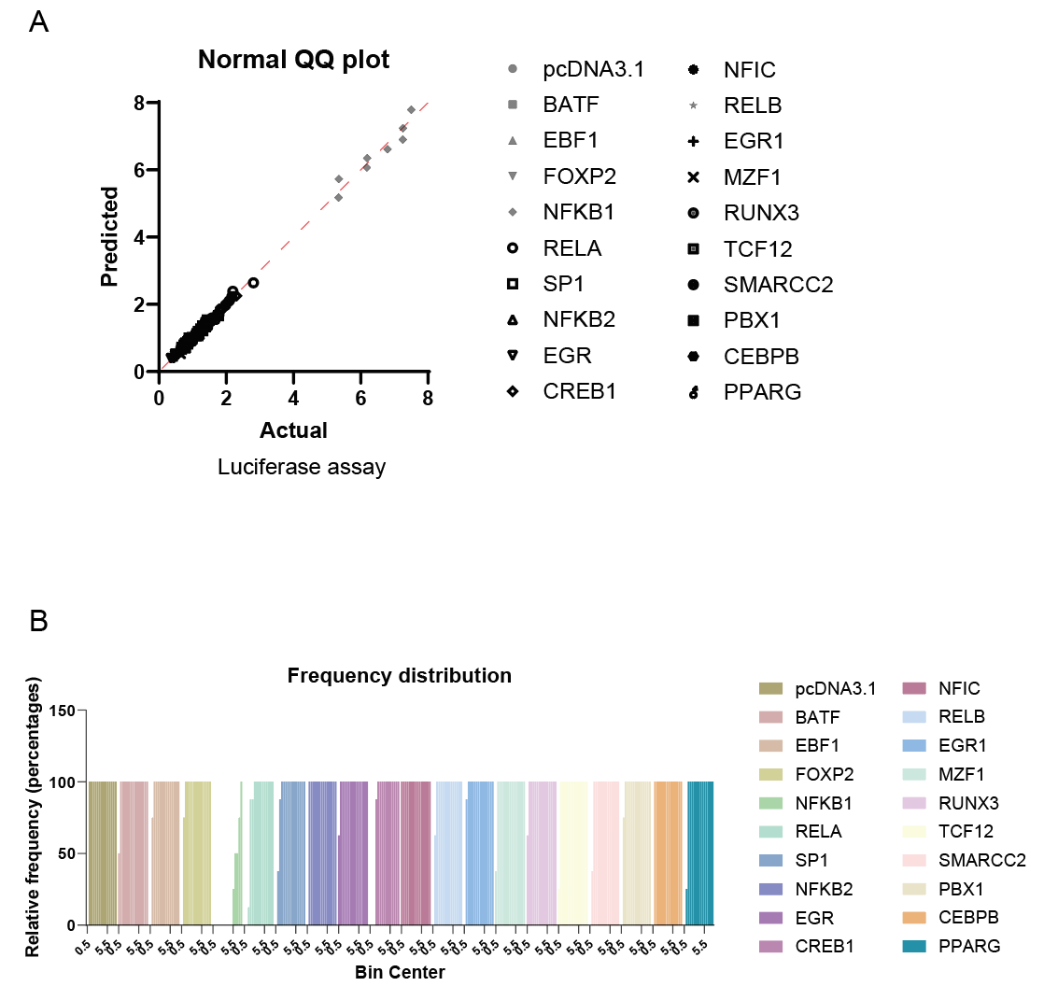

Figure S2. Analysis of transcription factors binding to the CD200R1 promoter and their impact on transcriptional activity.
(A) The Normal QQ plot illustrates the relationship between the predicted and actual luciferase activity following the overexpression of various transcription factors in HEK293T cells. Seventeen candidate transcription factors, including NFKB1, CREB1, and RELA, were analyzed for their ability to regulate CD200R1 promoter activity.
(B) The frequency distribution histogram shows the relative frequency percentages of luciferase activity across different bin centers for each transcription factor.

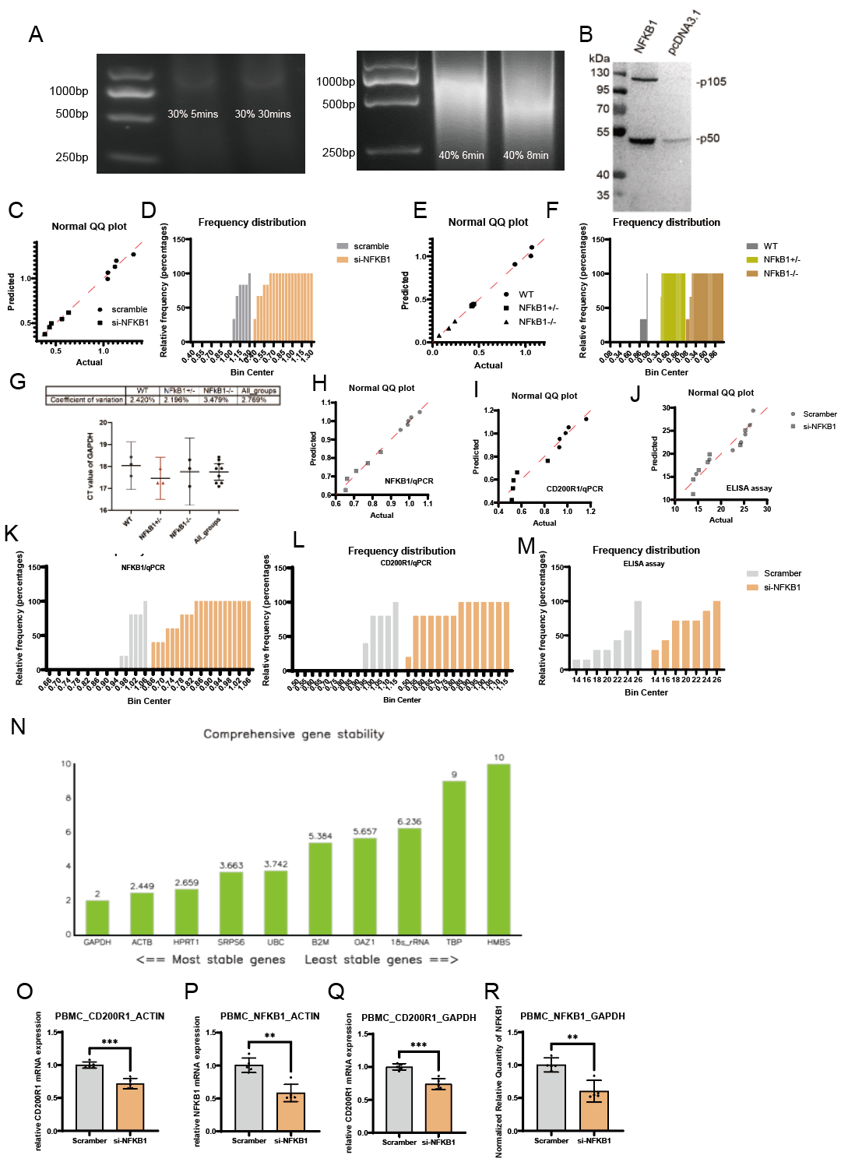
Figure S3. Impact of NFKB1 on CD200R1 expression and validation of experimental conditions.
(A) Sonication efficiency for chromatin fragmentation. Left panel: Chromatin was sonicated using different power and duration settings. Sonication at 30% power for 5 and 30 minutes, and 40% power for 6 minutes, resulted in suboptimal fragmentation. Right panel: Sonication at 40% power for 8 minutes produced the desired fragment sizes of 200-1000 bp, suitable for subsequent ChIP analysis.
(B) Western Blot (WB) Analysis: The WB figure displays protein expression levels in cells transfected with different vectors. The first column represents cells transfected with the NFKB1 overexpression vector, while the second column shows cells transfected with the control vector.
(C-D) Q-Q plot and frequency distribution analysis of CD200R1 promoter activity in HEK293T cells. Knocking down NFKB1 with siRNA significantly reduced CD200R1 promoter activity compared to the scramble control, as demonstrated by the Q-Q plot (C) and corresponding frequency distribution (D).
(E-F) Q-Q plot and frequency distribution analysis of CD200R1 mRNA levels in primary microglia. Primary microglia isolated from NFKB1+/+, NFKB1+/-, and NFKB1-/- mice were analyzed to assess CD200R1 mRNA expression. The Q-Q plot (E) and frequency distribution (F) show that the absence or reduction of NFKB1 led to a significant decrease in CD200R1 mRNA levels.
(G):Coefficient of Variation (CV) analysis of GAPDH Ct values in primary microglia from different NFKB1 genotypes. the variability in Ct values of GAPDH, used as a reference gene, across primary microglia from wild-type (WT), NFKB1+/-, and NFKB1-/- mice. The scatter plot shows the distribution of Ct values for each genotype, with horizontal bars representing the mean ± standard deviation. The corresponding CV values are provided in the table above the graph, indicating 2.420% for WT, 2.196% for NFKB1+/-, 3.479% for NFKB1-/-, and 2.769% across all groups.
(H-M) Q-Q plots and frequency distributions for qPCR and ELISA assays. NFKB1 silencing in PBMCs using siRNA resulted in a marked downregulation of CD200R1 mRNA levels (G-H, J-K) and a significant reduction in CD200R1 protein levels as confirmed by ELISA (I, L).
(N) Gene stability analysis of reference genes in PBMCs. Stability of reference genes (ACTB and GAPDH) was validated using RefFinder. The analysis integrates results from NormFinder, BestKeeper, and GeNorm algorithms.
(O-R) Quantitative PCR validation of CD200R1 and NFKB1 expression in PBMCs. CD200R1 mRNA levels were significantly reduced upon NFKB1 silencing, as normalized to ACTB (P) and GAPDH (R). Similarly, NFKB1 expression was significantly reduced in si-NFKB1 treated cells compared to scramble control when normalized to ACTB (Q) and GAPDH (S), confirming the robustness of the association between NFKB1 and CD200R1 expression.

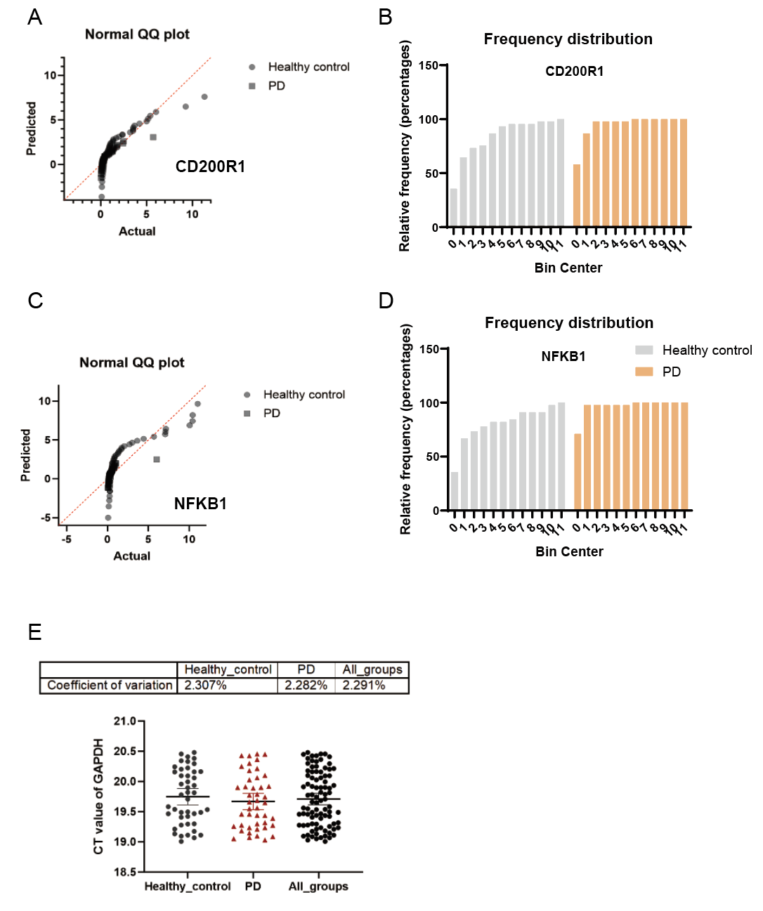
Figure S4. Comparative analysis of CD200R1 and NFKB1 expression in PBMCs from Parkinson's disease (PD) patients and healthy controls, and assessment of GAPDH as a reference gene.
(A-B) Q-Q plot and frequency distribution of CD200R1 expression.
(C-D) Q-Q plot and frequency distribution of NFKB1 expression.
(E) Coefficient of Variation (CV) of GAPDH Ct values. The Ct values of GAPDH, used as a reference gene in the qPCR analysis, were assessed for variability across all samples. The CV values for GAPDH were 2.307% in healthy controls, 2.282% in PD patients, and 2.291% across all groups.

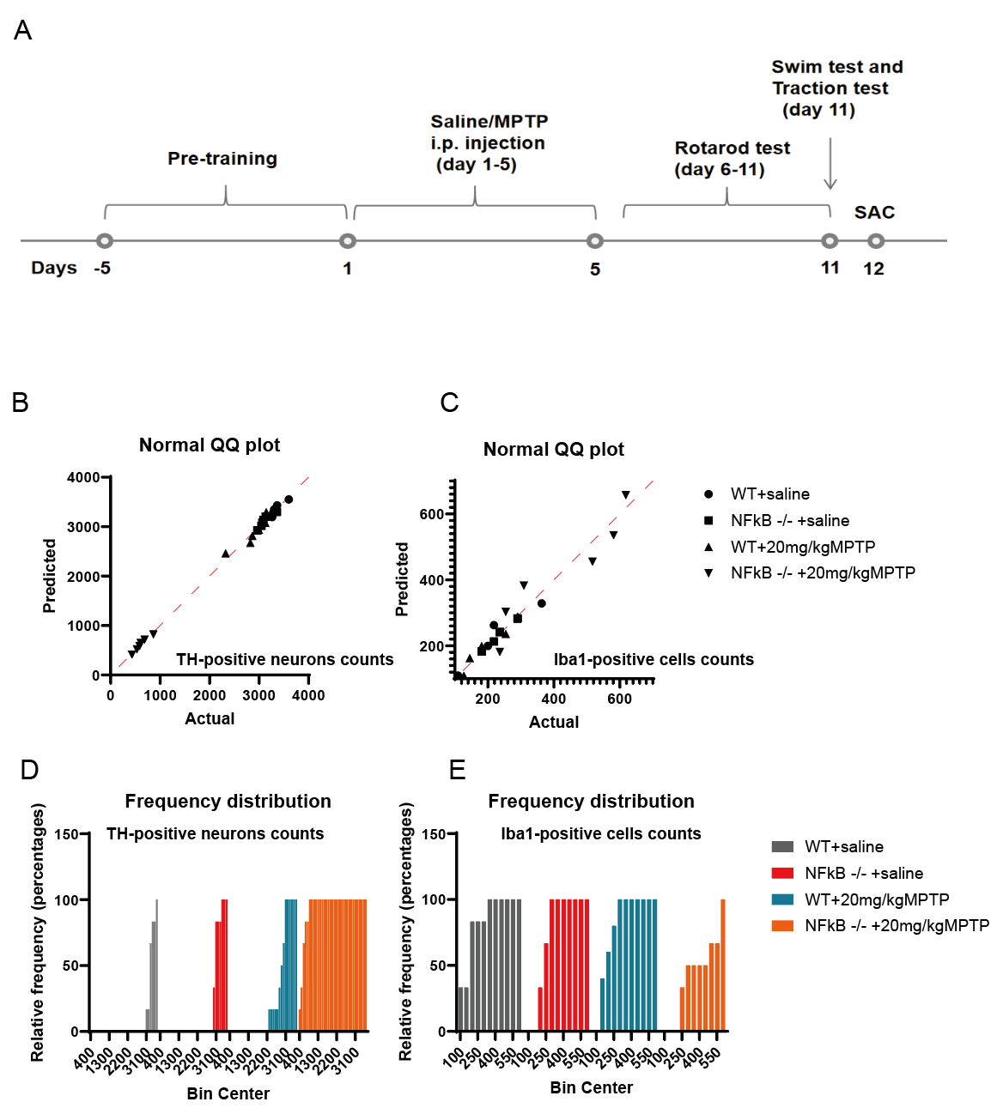
Figure S5. The effect of NFKB1 knockout on dopaminergic neuron loss and microglial activation in MPTP-induced Parkinson's disease (PD) model mice.
(A) Experimental timeline and treatment protocol. The timeline illustrates the pre-training period, intraperitoneal (i.p.) injection of saline or MPTP from day 1 to day 5, followed by motor function tests (rotarod, swim, and traction tests) from day 6 to day 11, with sacrifice (SAC) on day 12.
(B-C) Normal Q-Q plots comparing predicted and actual cell counts. (B) TH-positive neurons in the substantia nigra (SN) were quantified to assess dopaminergic neuron loss. (C) Iba1-positive microglial cells were counted to evaluate microglial activation.
(D-E) Frequency distribution histograms. (D) The distribution of TH-positive neuron counts shows significant neurodegeneration in NFKB1-/- mice treated with MPTP, with fewer neurons compared to WT mice. (E) The frequency distribution of Iba1-positive cells indicates heightened microglia activation in NFKB1-/- mice following MPTP treatment, compared to WT mice.

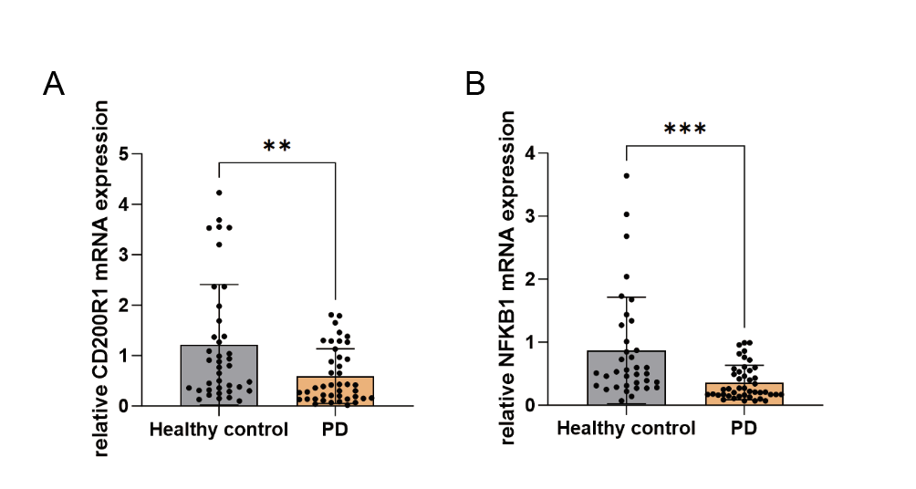Figure S6. Analysis of expression levels of CD200R1 and NFKB1 mRNA in Parkinson's disease (PD) patients after outlier removal.
(A, B) Relative mRNA expression levels of CD200R1 (A) and NFKB1 (B) were measured in peripheral blood mononuclear cells (PBMCs) from Parkinson's disease patients and compared with age- and sex-matched healthy controls using RT-PCR. Significant differences between groups indicated by p < 0.01 (**) and p < 0.0001 (****). Non-parametric tests were used for statistical comparison.

