Fig. S1. Experimental design and flow chart.

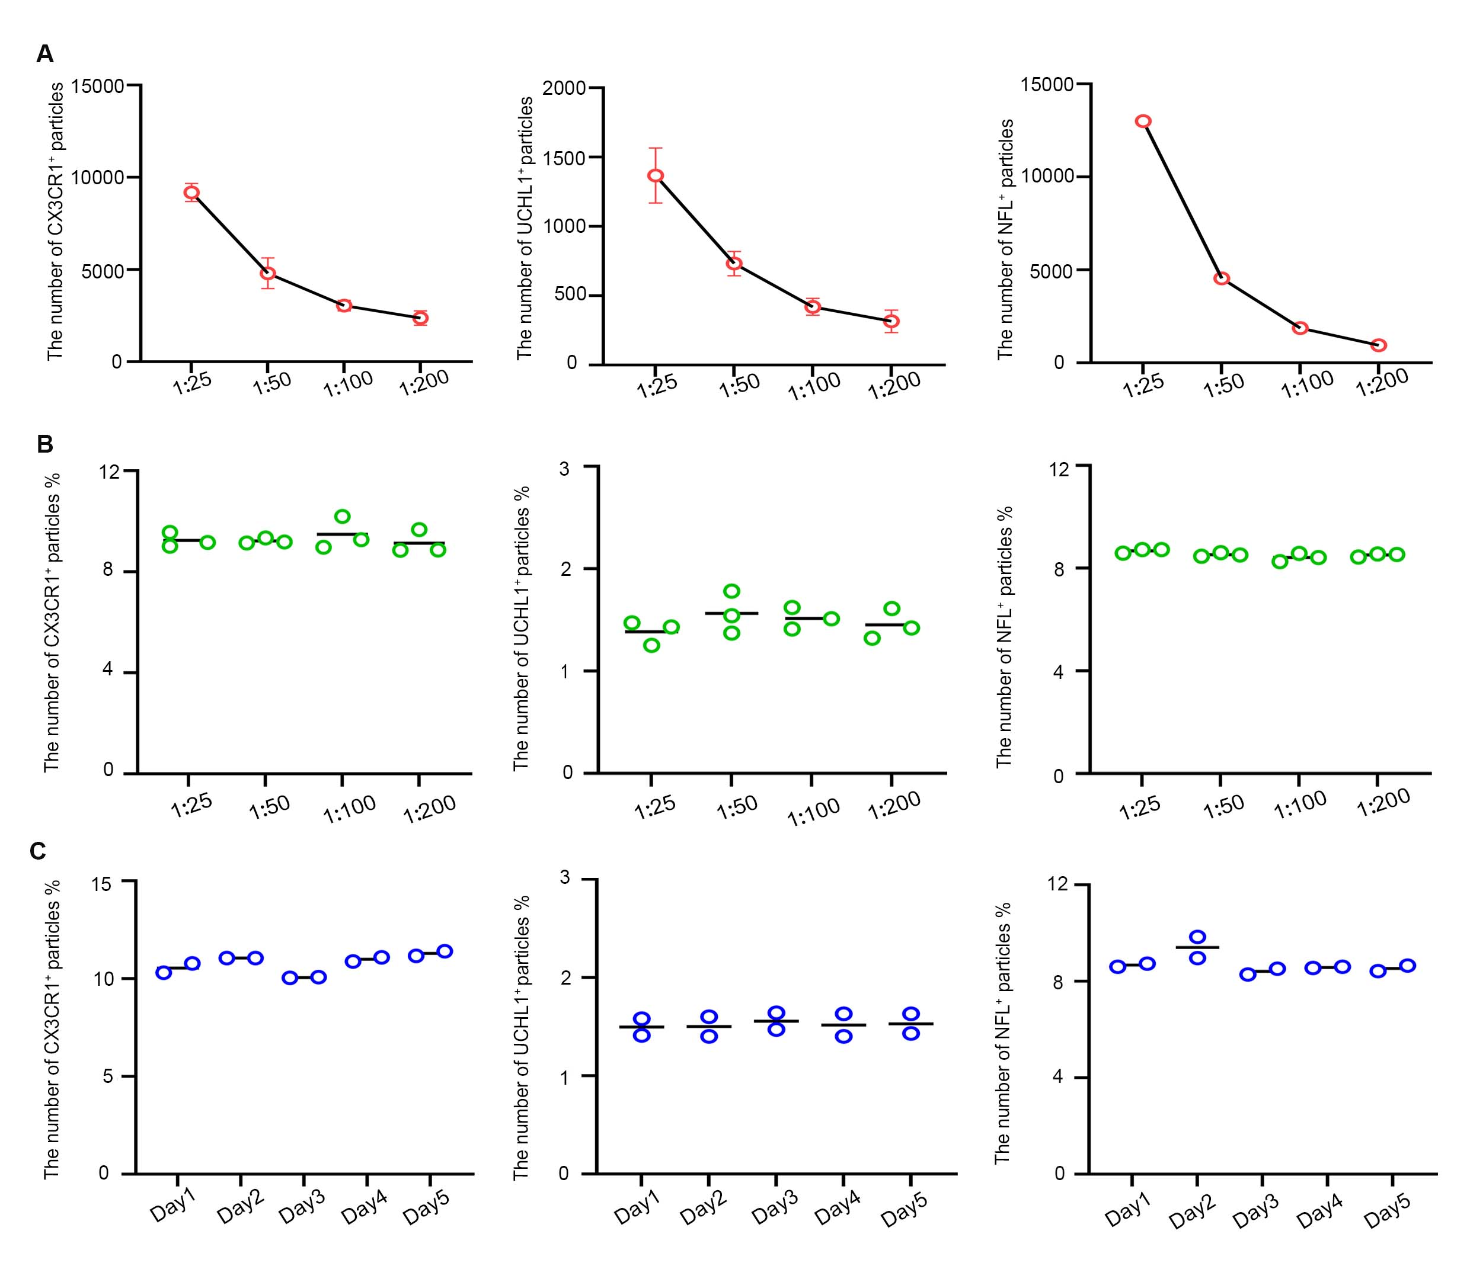
Fig. S2. Linearity in different dilutions and stability of reference plasma EVs. (A) The number of CX3CR1⁺, UCHL1⁺, and NFL⁺ particles after different dilutions of plasma EVs. (B) The percentage of CX3CR1⁺, UCHL1⁺, and NFL⁺ particles after different dilutions of plasma EVs. (C) Two replicates were run each day over 5 separate days of the experiment. The percentage of CX3CR1⁺, UCHL1⁺, and NFL⁺ particles in plasma EVs. All values are mean ± SEM. n=2-3 in each group.

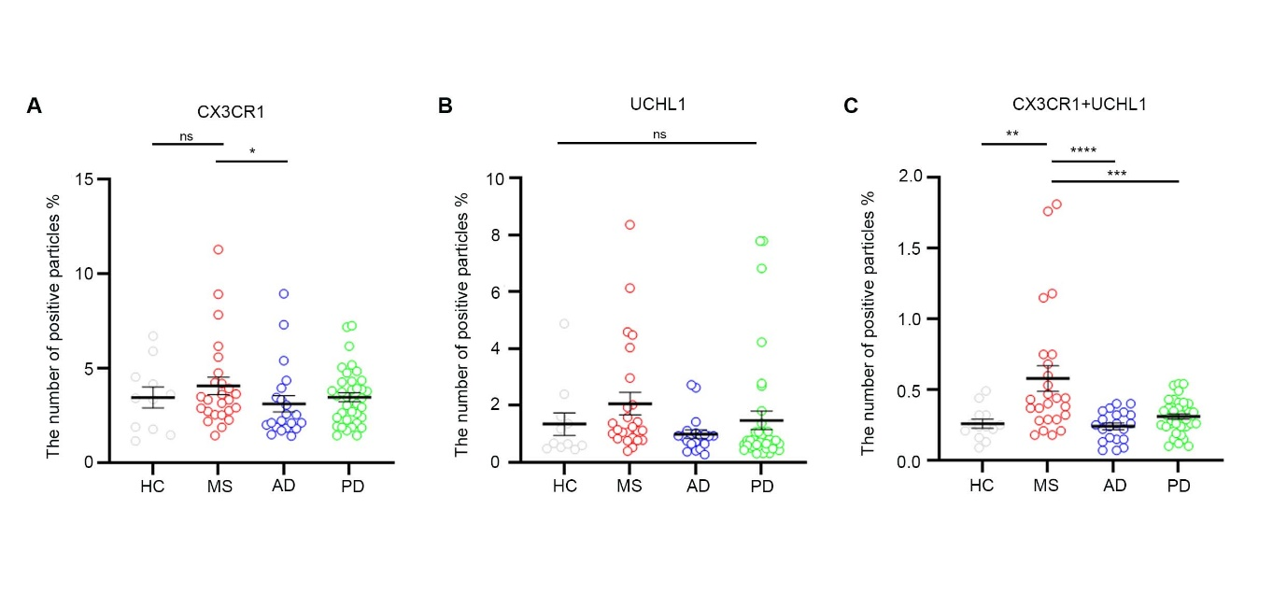
Fig. S3. Performance of microglia-derived EVs in MS, AD, and PD cohorts from Fujian Medical University. (A) The percentage of CX3CR1⁺ EVs was not significantly different among HC, MS, AD, and PD, except between MS and AD. (B) The percentage of UCHL1⁺ EVs was not significantly different among HC, MS, AD and PD. (C) The percentage of CX3CR1⁺/UCHL1⁺ EVs was higher in MS compared to those in other groups. n = 11 for HC, 21 for AD, 37 for PD, and 25 for MS. All values are mean ± SEM. *p < 0.05, **p < 0.01, ***p < 0.001, ****p < 0.0001. ns, no significance.

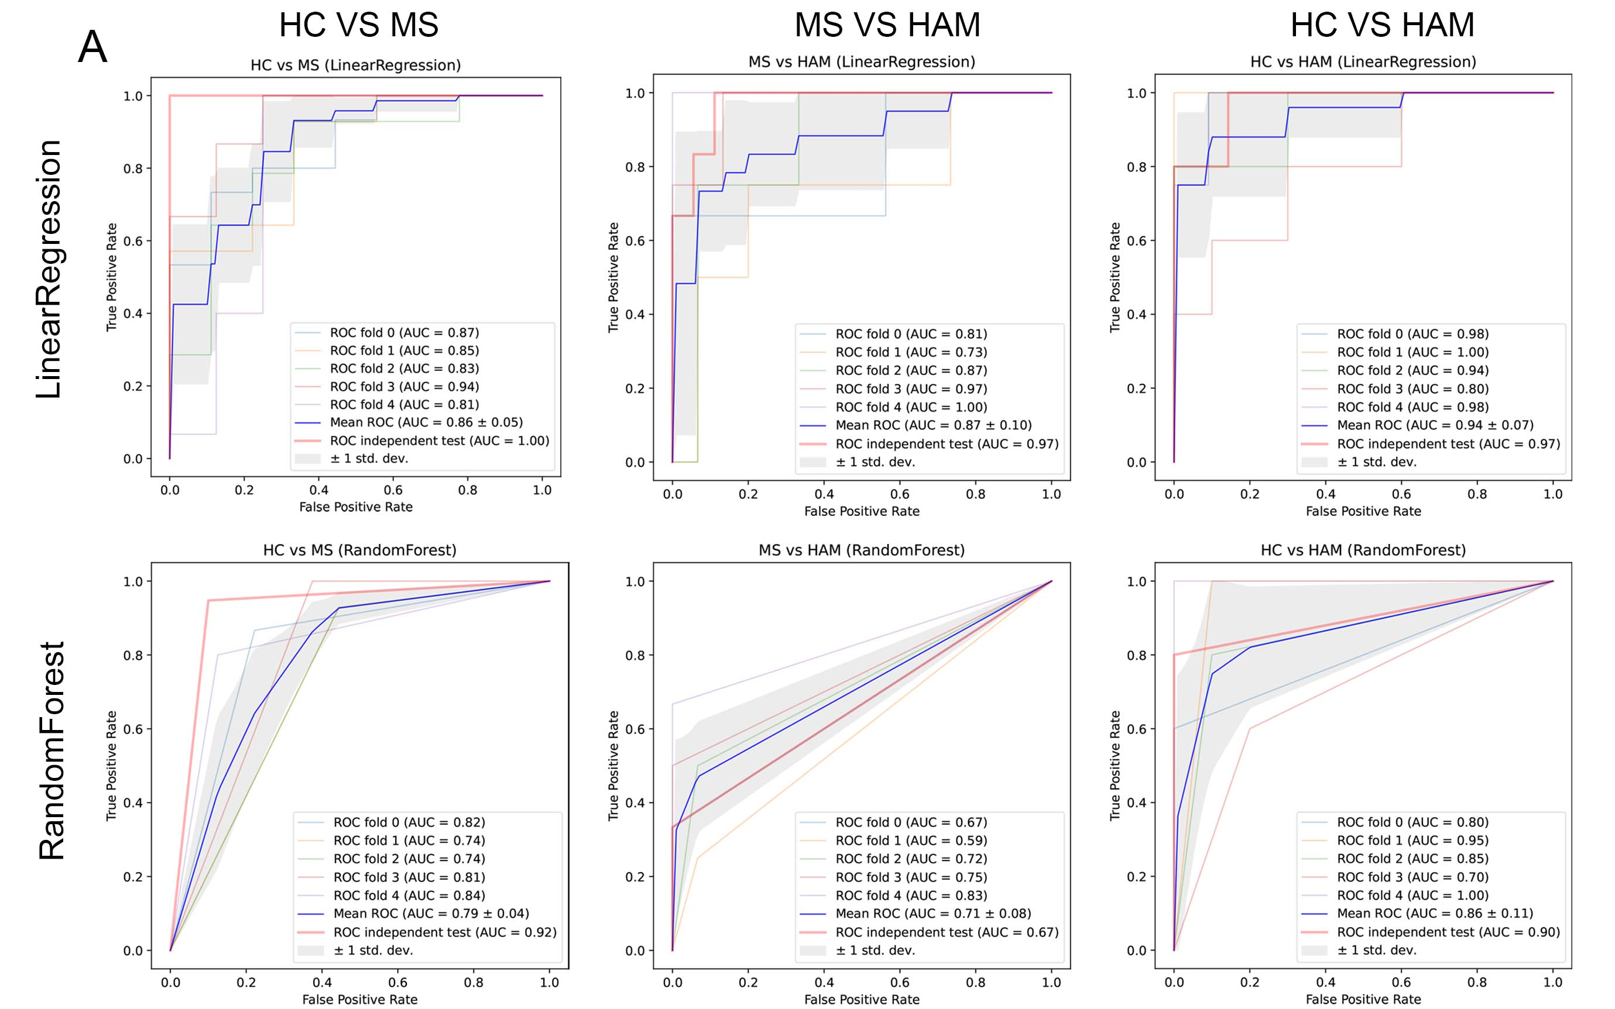
Fig. S4. ROC analysis of cross-validation and random forest. (A) The cohort was randomly split into the training and test datasets, respectively, at a ratio of 4:1, followed by cross-validation analysis. ROC fold 0-4 and Mean ROC were analyzed using training data. ROC independent test was analyzed using independent test data. n = 67 for HC, 113 for MS, and 29 for HAM.

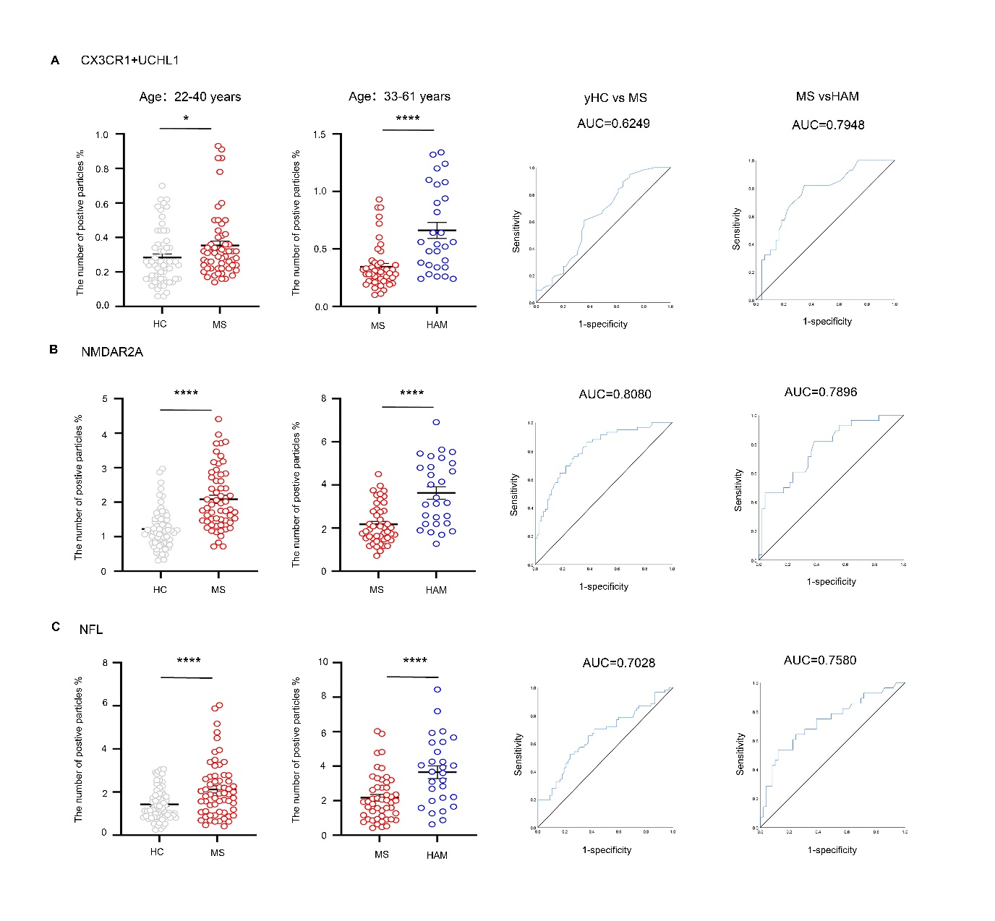
Fig. S5. Age differences were not responsible for the differences between MS, HAM and HC. The age of patients in the MS cohort was divided to match with those in the HC group (The range of age is 22-40 years) and the HAM group (the range of age is 33-61 years). (A) The percentage of CX3CR1⁺/UCHL1⁺ EVs was significantly higher in MS than in HC. In contrast, the percentage of CX3CR1⁺/UCHL1⁺ EVs was remarkably lower in MS than in HAM. ROC curves showed the separation of MS from HC and HAM using EVs carrying CX3CR1+UCHL1. (B) The percentage of NMDAR2A⁺ EVs was significantly higher in MS than in HC. The percentage of NMDAR2A⁺ EVs was remarkably lower in MS than in HAM. ROC curves showed the separation of MS from HC and HAM using EVs carrying NMDAR2A. (C) The percentage of NFL⁺ EVs was significantly higher in MS than in HC. The percentage of NFL⁺ EVs was remarkably lower in MS than in HAM. ROC curves showed the separation of MS from HC and HAM using EVs carrying NFL. In the 22-40 age cohort, n = 67 for HC and 61 for MS. In the 33-61 age cohort, n = 49 for MS and 28 for HAM. All values are mean ± SEM. *p < 0.05, ****p < 0.0001.

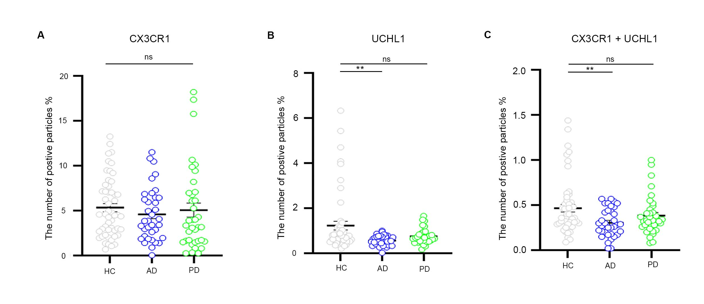
Fig. S6. Performance of microglia-derived EVs in AD and PD, compared to HC, cohort from the First Affiliated Hospital of Zhejiang University. (A) The percentage of CX3CR1⁺ EVs was not significant in HC, AD, and PD. (B) The percentage of UCHL1⁺ EVs was lower in AD than in other groups. (C) The percentage of CX3CR1⁺/UCHL1⁺ EVs was lower in AD than HC and PD. n = 53 for HC, 36 for AD, and 34 for PD. All values are mean ± SEM. **p < 0.01. ns, no significance.

Fig. S7. Performance of classic microglia markers and UCHL1 in EVs derived from BV2 and RAW264.7. (A) Representative images for labeling TMEM119 in BV2 and RAW264.7 EVs. (B) Representative images for labeling SALL1 in EVs from BV2 and RAW264.7. (C) Representative images for labeling HEXB in EVs from BV2 and RAW264.7. (D) Representative images for labeling P2RY12 in EVs from BV2 and RAW264.7. (E) Representative images for labeling CD11b in EVs from BV2 and RAW264.7. (F) Representative images for labeling CD45 in EVs from BV2 and RAW264.7. (G) Representative images for labeling UCHL1 in EVs from BV2 and RAW264.7. (H) Representative images for labeling isotype IgG in EVs from BV2 and RAW264.7.
Fig. S8. The relationship between freeform of NFL and NFL⁺ EVs in the same MS patients. The freeform of NFL was measured by Simoa (Single Molecular Array) in MS patients. (A) The correlation between the freeform of NFL and NFL⁺ EVs in MS patients. (B) The correlation between freeform of NFL and NFL⁺ EVs in MS patients with disease duration less than 5 years. (C) The correlation between freeform of NFL and NFL⁺ EVs in the MS patients with disease duration over 5 years. n = 53 for MS. *p < 0.05, **p < 0.01.

