Supplementary Information
For
Advanced paternal age exacerbates neuroinflammation in offspring via m6A modification-mediated intergenerational inheritance
Yiting Mao et. Al

Table S1. Primers used in this study.
Gene | Primer | Sequence (5'->3')
Nr4a2 | Forward | TGGACAACTACAGCACAGGC
 | Reverse | TGTGTGGCATCATCTCCTCG
Mettl3 | Forward | GAAACAGCTGGACTCGCTTC
 | Reverse | TCTCCTGACTGACCTTCTTGCTCTG
Mettl14 | Forward | CTGAGAGTGCGGATAGCATTG
 | Reverse | GAGCAGATGTATCATAGGAAGCC
Wtap | Forward | GAACCTCTTCCTAAAAAGGTCCG
 | Reverse | TTAACTCATCCCGTGCCATAAC
Fto | Forward | CTCACAGCCTCGGTTTAGTTCCAC
 | Reverse | CGTCGCCATCGTCTGAGTCATTG
Alkbh5 | Forward | CGCGGTCATCAACGACTACC
 | Reverse | ATGGGCTTGAACTGGAACTTG
Ythdc1 | Forward | ACCTCCACACCATCCTTACTACCAG
 | Reverse | TCTACTTCTCCGACCACTGACCAC
Ythdc2 | Forward | CCTGTTACTGTCCTGGTGTTCTGTG
 | Reverse | CTTCCATCTCACTGTCACTGCTGTC
Ythdf1 | Forward | AGCACACAACCTCTATCTTT
 | Reverse | TGTTTCGATTCTGTCTTTC
Ythdf2 | Forward | CTCTCAGTCCAGCAACAG
 | Reverse | GTCCTACTCCATTACCATCC
Ythdf3 | Forward | GATCAGCCTATGCCATATCTGAC
 | Reverse | CCCCTGGTTGACTAAAAACACC
iNOS | Forward | GTTCTCAGCCCAACAATACAAGA
 | Reverse | GTGGACGGGTCGATGTCAC
IL-1β | Forward | CTGTGACTCATGGGATGATGATG
 | Reverse | CGGAGCCTGTAGTGCAGTTG
TNFα | Forward | TGTCTCAGCCTCTTCTCATTCC
 | Reverse | TGAGGGTCTGGGCCATAGAAC
IL-6 | Forward | TAGTCCTTCCTACCCCAATTTCC
 | Reverse | TGGTCCTTAGCCACTCCTTC
IL-10 | Forward | TAACTGCACCCACTTCCCAG
 | Reverse | AGGCTTGGCAACCCAAGTAA
IL-4 | Forward | AAACGTCCTCACAGCAACGA
 | Reverse | GCATCGAAAAGCCCGAAAGA
IL-1ra | Forward | TAAGCAACCACCTTGAGCCT
 | Reverse | CCAGCAGATTTCCATCCCGA
Arg-1 | Forward | CAGCACTGAGGAAAGCTGGT
 | Reverse | CAGACCGTGGGTTCTTCACA
β-actin | Forward | GGCTGTATTCCCCTCCATCG
 | Reverse | CCAGTTGGTAACAATGCCATGT

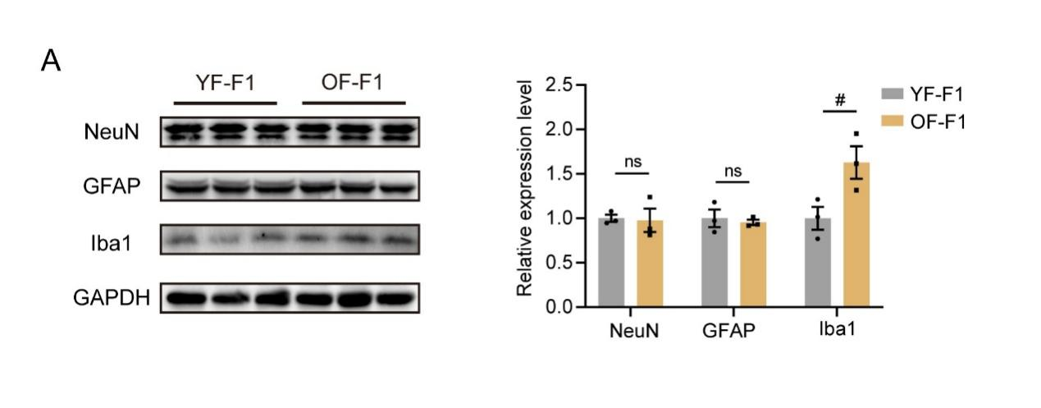
Figure S1. The protein level of neuron, microglia and astrocytes in offspring hippocampus. (A) Western blotting (left) of NeuN, GFAP and Iba1 in YF-F1 and OF-F1 hippocampus (replicates of three mice per group); Quantification of western blotting (right). Unpaired two-tailed Student’s t test: Iba1, df=4, R²= 0.662, P=0.0320.

Figure S2. The synapse loss in OF-F1 hippocampus. (A) Confocal images of DAPI (blue)-, SYN (green)- and PSD95 (red)-stained CA1 regions from YF-F1 and OF-F1 mice (n=6/group). (B) Quantification of SYN+/ PSD95+ synapse in each area; unpaired two-tailed Student’s t test: df=10, R²=0.5632, P=0.0049.

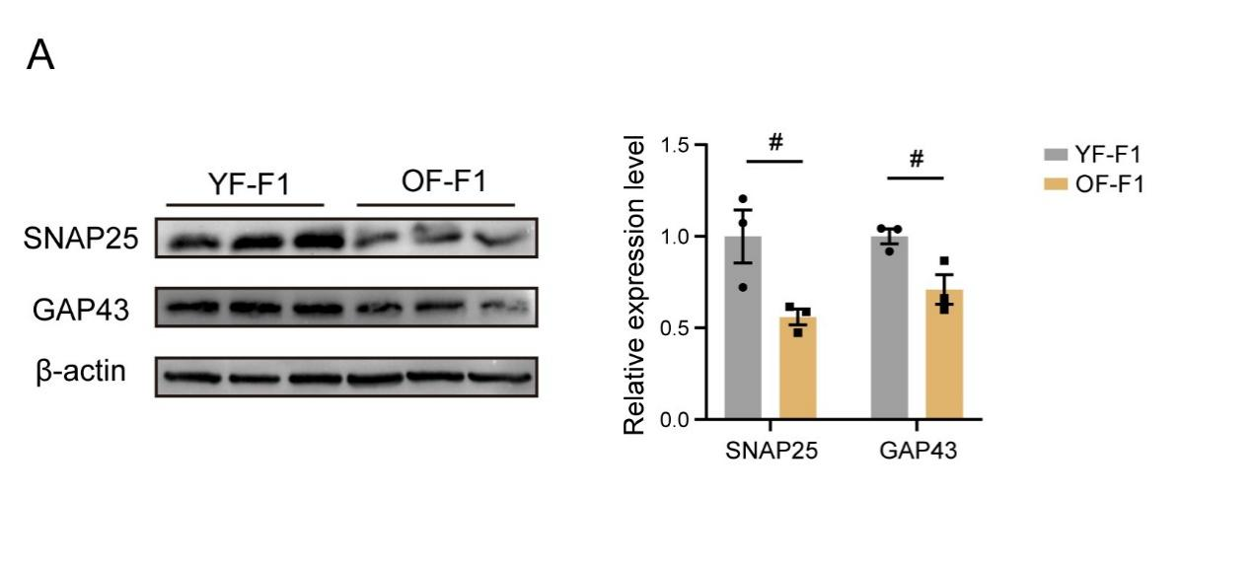
Figure S3. The deceased presynaptic protein OF-F1 offspring hippocampus. (A) Western blot (left) of SNAP25 and GAP43 in the YF-F1 and OF-F1 hippocampi (replicates of three mice per group); Quantification of western blot (right). Unpaired two-tailed Student’s t test: SNAP25, df=4, R²= 0.6821, P=0.0428; GAP43, df=4, R²= 0.7196, P=0.0328.

Figure S4. The synapse expression level after PLX3397 treatment in OF-F1 hippocampus. (A) Confocal images of DAPI (blue)-, SYN (green)- and PSD95 (red)-stained CA1 regions from YF-F1, OF-F1 and OF-F1-PLX mice (n=6/group). (B) Quantification of SYN+/ PSD95+ synapse in each area; two-way ANOVA with Tukey's multiple comparison test: F (2, 10) =12.53, ηp²=0.6644, P=0.0019.

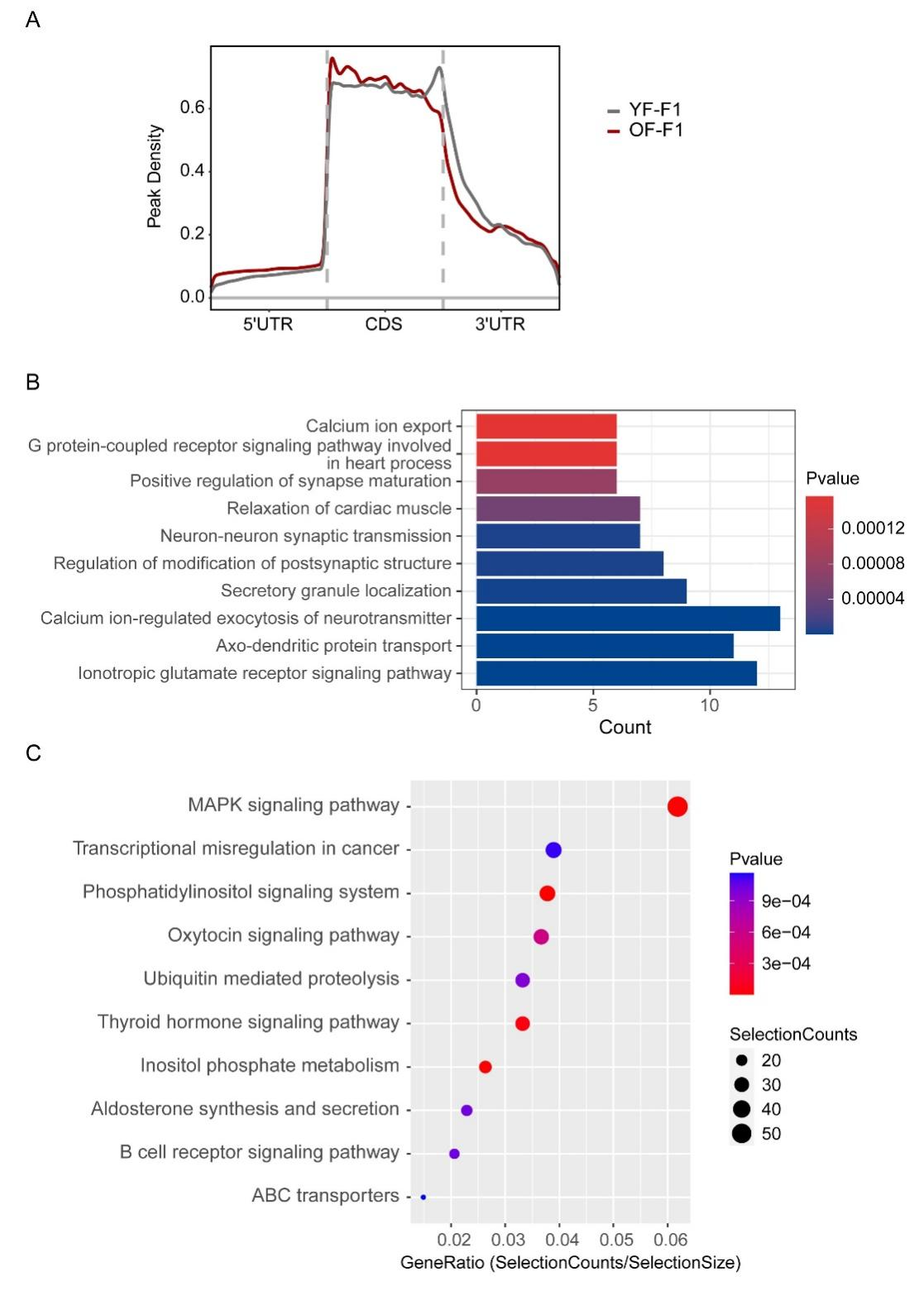
Figure S5. m6A modification results of paternal sperm and F1 hippocampus. (A) Peak density of YF-F1 and OF-F1 hippocampus m6A-modified sites. (B) Differentially hypermethylated genes were analyzed by GO in hippocampus (YF-F1 vs OF-F1). Fold change > 2.0, P< 0.0001. (C) KEGG enrichment of YF and OF hypo-modified m6A sites in sperm. Fold change > 2.0, P< 0.0001.

Figure S6. The strategy of selecting Nr4a2 as the targeted gene. (A) Overlapping genes in three gene sets including hypermethylated genes in OF sperm and OF-F1 hippocampus and the differentially expressed mRNA in OF-F1 hippocampus.

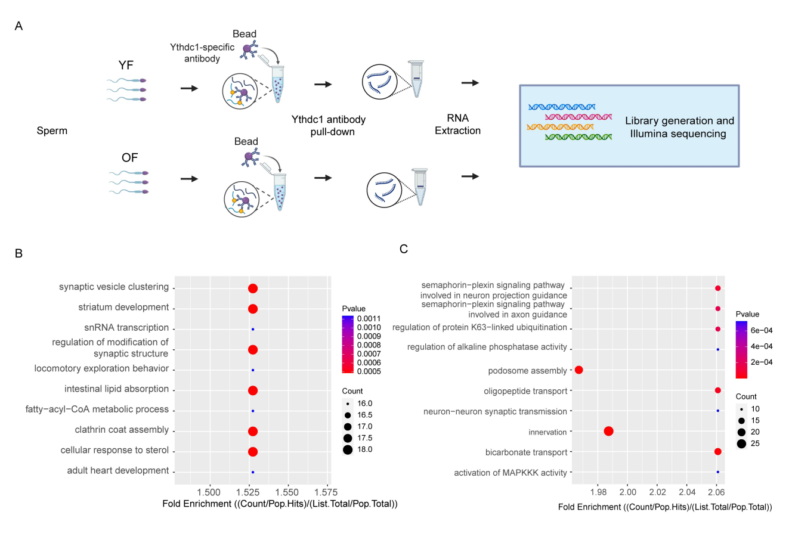
Figure S7. Ythdc1 targeted Rip-seq results. (A) The schema of Ythdc1 targeted RIP-seq of sperm. (B) GO enrichment of YF and OF hypo-binding genes in sperm. Fold change > 2.0, P< 0.0001. (C) GO enrichment of YF and OF hyper-binding genes in sperm. Fold change > 2.0, P< 0.0001.

Figure S8. The illustration of in situ injection in OF-F1 mice. (A) The diagram from brain atlas[1] (coordinates: anteroposterior (AP), -2.0 mm; mediolateral (ML), -1.55 mm; dorsoventral (DV), -1.55 mm). (B) Fluorescence images of DAPI-(blue) and EGFP-(green) after virus injection. Arrows represents the needle track of the injection.

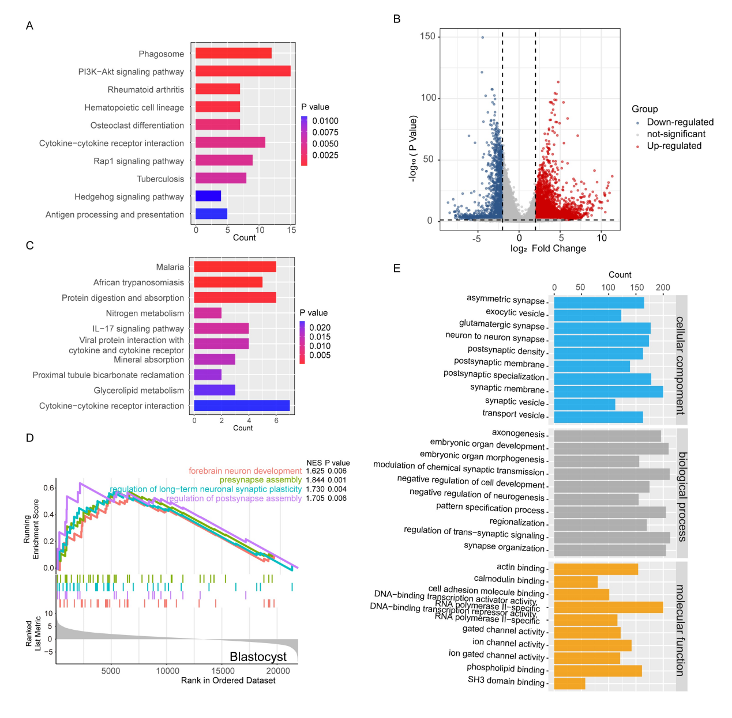
Figure S9. Embryo RNA-seq results in YF and OF groups. (A) KEGG analysis of up-regulated genes in two-cell stage. (Log₂|Fold change| > 1, p < 0.05). (B) The volcano depicted the differentially expressed genes in YF and OF blastocyst. Blue dots represent down-regulated transcription and red dots represent up-regulated transcription. (Log₂|Fold change| > 2, P< 0.05). Top 10 most significantly changed genes were noted. (C) KEGG analysis of down-regulated genes in two-cell stage. (Log₂|Fold change| > 1, p < 0.05). (D) GSEA analysis of differentially expressed genes in blastocytes between YF and OF groups. (Log₂|Fold change| > 1, P< 0.05). (E) GO term results of differentially up-regulated genes in OF Blastocyte. (Log₂|Fold change| > 1, P< 0.05)

Reference
1. Paxinos G, Franklin KB. Paxinos and Franklin's the mouse brain in stereotaxic coordinates: Academic press; 2019.

