WT XX
^{Blue: DAPI}
^{Red: Iba1}
^{Yellow:TMEM119}
^{Scale bar:10 μm}

Rad

LMol

PoDG

WT XY
^{Blue: DAPI}
^{Red: Iba1}
^{Yellow:TMEM119}
^{Scale bar:10 μm}

Rad

LMol

PoDG

FCG XX
^{Blue: DAPI}
^{Red: Iba1}
^{Yellow:TMEM119}
^{Scale bar:10 μm}

Rad
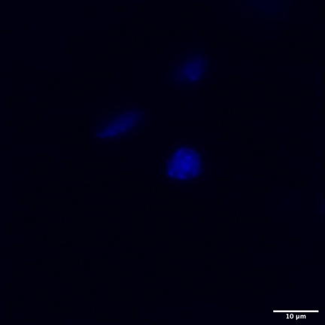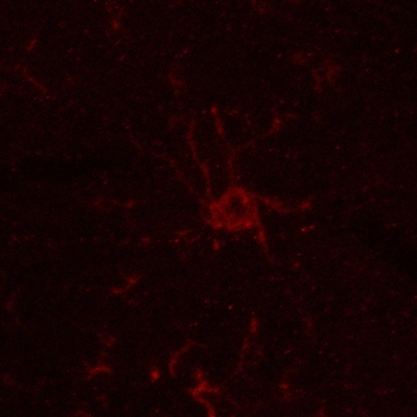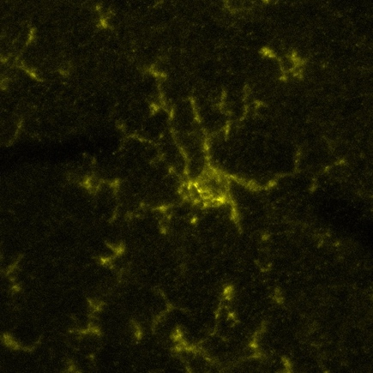

LMol

PoDG

Tg XY⁻
^{Blue: DAPI}
^{Red: Iba1}
^{Yellow:TMEM119}
^{Scale bar:10 μm}

Rad
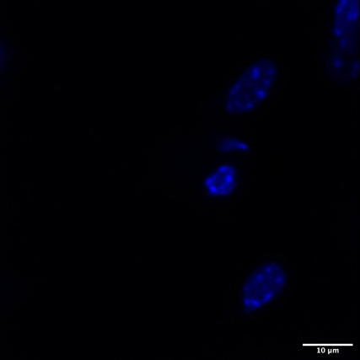

LMol
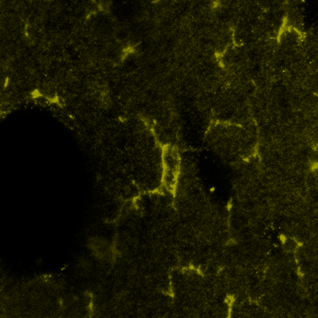

PoDG

Tg XX^{Sry}
^{Blue: DAPI}
^{Red: Iba1}
^{Yellow:TMEM119}
^{Scale bar:10 μm}

Rad

LMol

PoDG

Tg XY^{Sry}

^{Blue: DAPI}
^{Red: Iba1}
^{Yellow:TMEM119}
^{Scale bar:10 μm}

Rad

LMol

PoDG

