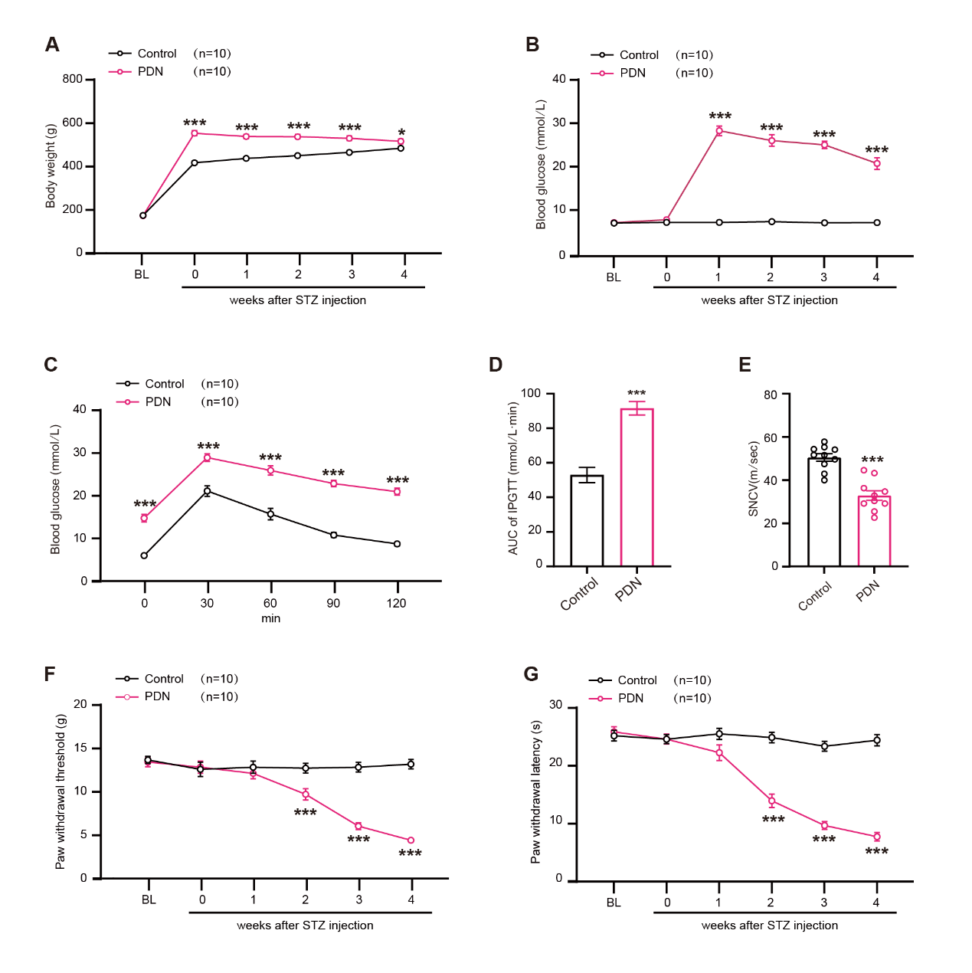
Supplement Figure S1. Establishment of the model.
(A, B) The body weights and blood glucose levels of rats from baseline (BL) to week 4 following streptozotocin (STZ) injection. (C, D) The evaluation involved the performance of the Intraperitoneal Glucose Tolerance Test (IPGTT) and the calculation of the Area Under the Curve (AUC) derived from IPGTT at week 4 post-STZ injection. (E) The statistical analysis of sensory nerve conduction velocity (SNCV) at week 4 post-STZ injection. (F, G) The test of mechanical allodynia and thermal hyperalgesia from BL to week 4 post-STZ injection. n = 10 for each group. Data are presented as mean ± SEM. *P < 0.05, ***P < 0.001 versus the control group; one-way ANOVA with Tukey’s multiple comparisons test for (D), (E); two-way ANOVA with Sidak’s multiple comparisons test for (A-C), (F), and (G).
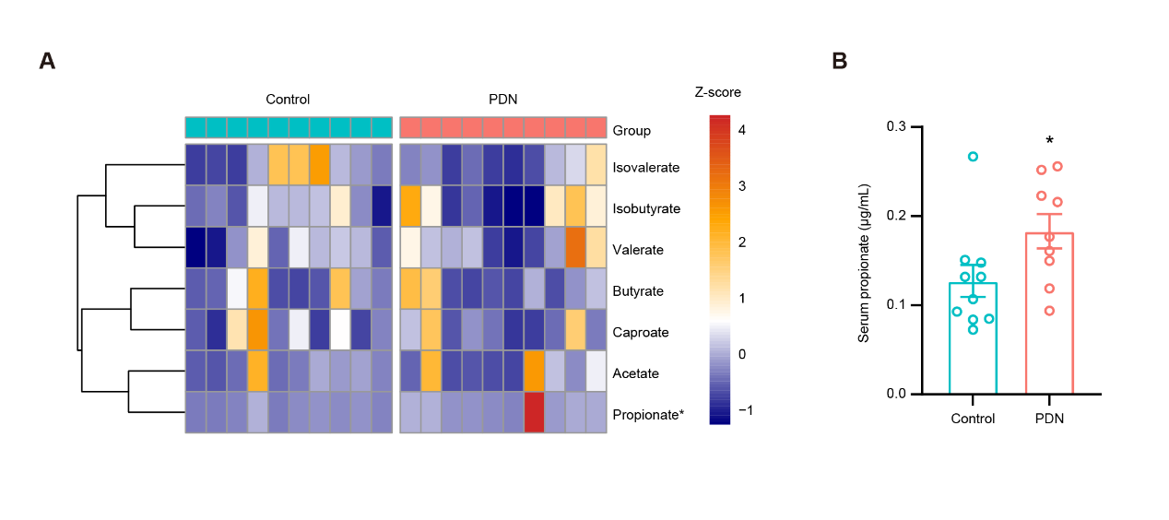
Supplement Figure S2. The changes in the serum SCFAs of PDN rats.
(A) The heatmap of serum SCFAs (n = 10 for each group). (B) Serum propionate concentration of control and PDN rats (n = 10 at Control, n = 9 at PDN). One PDN data point was removed based on the ROUT method to identify outliers. Data are presented as mean ± SEM. *P < 0.05. Student's t-test for (B).

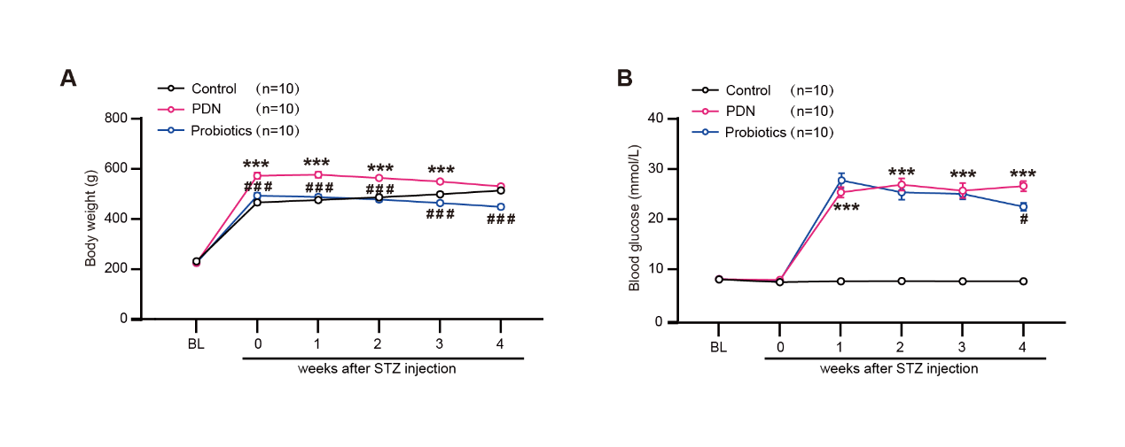
Supplement Figure S3. Probiotics treatment changed the body weight and blood glucose in PDN rats.
(A, B) The body weights and blood glucose levels of rats from baseline (BL) to week 4 after streptozotocin (STZ) injection. n = 10 for each group. Data are presented as mean ± SEM. ***P < 0.001 versus the control group; #P < 0.05, ###P < 0.001 versus the PDN group, two-way ANOVA with Sidak’s multiple comparisons test for (A, B).

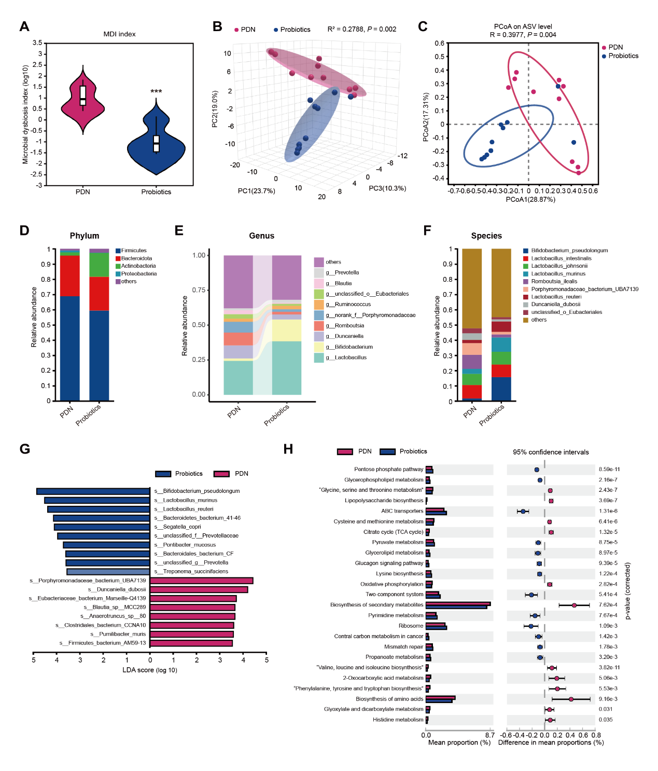
Supplement Figure S4. Probiotic treatment improved gut microbiota dysbiosis in PDN rats. (A) The microbial dysbiosis index (MDI). (B) Three-Dimension Principal Component Analysis (3D PCA) plot (PERMANOVA). (C) Principal Coordinates Analysis (PCoA) plot of Bray-Curtis dissimilarity at the ASV level (PERMANOVA). (D) Gut microbiota composition at the phylum level. (E) Relative abundance of gut microbiota at the genus level. (F) Relative abundance of gut microbiota at the species level. (G) Linear Discriminant Analysis (LDA) scores of differentially enriched bacterial species identified through LEfSe analysis, with LDA > 3.5 and P < 0.05. (H) Pathway enrichment analysis of significantly altered KEGG pathways. n = 10 for each group. Data are presented as mean ± SD. ***P < 0.001, Mann-Whitney U test for (A), PERMANOVA for (B) and (C), Welch's t-test for (H).

