Additional file 1
THBS1 in macrophage-derived exosomes exacerbates cerebral ischemia-reperfusion injury by inducing ferroptosis in endothelial cells
Chang Liu^{1,2,3,4}, Haijing Sui^{2,5}, Zhixi Li^{2,3,4,5}, Zhenyu Sun^{2,5}, Chenglong Li⁶, Guangmin Chen⁷, Zhaoxue Ma^{2,5}, Hang Cao^{2,5}, and Hongjie Xi^{2,5*}
¹ Department of Anesthesiology, Harbin Medical University Cancer Hospital, Harbin 150081, PR China
² The Key Laboratory of Anesthesiology and Intensive Care Research of Heilongjiang Province, Harbin 150001, PR China
³ The Key Laboratory of Myocardial Ischemia Organization, Chinese Ministry of Education, Harbin 150001, PR China
⁴ State Key Laboratory of Frigid Zone Cardiovascular Diseases, Harbin 150001, PR China
⁵ Department of Anesthesiology, Second Affiliated Hospital of Harbin Medical University, Harbin 150001, PR China
⁶ Department of Anesthesiology, Fourth Affiliated Hospital of Harbin Medical University, 37 Yiyuan Road, Harbin 150001, PR China
⁷ Department of Anesthesiology, First Affiliated Hospital of Harbin Medical University, 199 Dazhi Road, Harbin 150001, PR China

*Corresponding author
Department of Anesthesiology, Second Affiliated Hospital of Harbin Medical University, Harbin 150001, PR China.
E-mail address: xihongjie@hrbmu.edu.cn
Phone number: +86 18686719297

Table S1. Characteristics of the study population.
Characteristics | AIS | HV | P value
Characteristics | （n=56） | （n=32）
Age, y | 65.33 ± 15.4 | 62.37 ± 10.86 | 0.341
Gender, m/f | 33/23 | 20/12 | 0.742
Total cholesterol (mmol/L) | 5.34 ± 0.66 | 3.7 ± 0.41 | 0.001
Triglycerides (mmol/L) | 2.58± 0.52 | 1.35 ± 0.27 | 0.001
LDL (mmol/L) | 4.52 ± 0.62 | 1.89 ± 0.49 | 0.001
HDL (mmol/L) | 0.94 ± 0.27 | 1.37 ± 0.53 | 0.001
C-reactive protein (mg/L) | 5.77 ± 0.99 | 1.22 ± 0.34 | 0.001
D-dimer (mg/L) | 0.68 ± 0.19 | 0.64 ± 0.25 | 0.400
Fibrinogen (g/L) | 4.98 ± 0.92 | 2.05 ± 0.75 | 0.001
APTT (sec) | 29.12 ± 3.05 | 27.77 ± 4.62 | 0.103
PT (sec) | 11.58 ± 0.89 | 11.35 ± 1.1 | 0.288
Erythrocytes (×10¹²/L) | 4.23 ± 0.51 | 4.37 ± 0.44 | 0.197
Platelets (×10⁹/L) | 229.76 ±25.77 | 241.65 ± 26.11 | 0.041
Leukocytes (×10⁹/L) | 7.33 ± 1.97 | 5.67 ± 0.92 | 0.001
Neutrophils (%) | 75.81 ± 3.69 | 67.14 ± 5.12 | 0.001
Monocytes (%) | 6.77 ± 0.36 | 5.19 ± 0.84 | 0.001
Lymphocytes (%) | 28.14 ± 3.05 | 24.85 ± 5.5 | 0.001
Eosinophils (%) | 2.6 ± 0.24 | 2.58 ± 0.47 | 0.792
Basophils (%) | 0.34 ± 0.11 | 0.29 ± 0.07 | 0.023
NIHSS score | 13(8-25) | - | NA
Previous AIS or TIA (n) | 6 | - | NA
Hypercholesterolemia (n) | 32 | 9 | 0.009
Hypertension (n) | 26 | 13 | 0.492
Diabetes mellitus (n) | 23 | 11 | 0.535
Cigarette smoking (n) | 24 | 19 | 0.136
Pharmacological therapy
Antiplatelet (n) | 21 | - | NA
Anticoagulant (n) | 15 | - | NA
Fibrinolysis (n) | 18 | - | NA
ACE inhibitor or ARB (n) | 11 | 12 | 0.067
Statin (n) | 16 | 8 | 0.717
AIS, acute ischemic stroke; HV, healthy volunteers; HDL, high-density lipoprotein; LDL, low-density lipoprotein; APTT, activated partial thromboplastin time; PT, prothrombin time; APTT, activated partial thromboplastin time; AIS, acute ischemic stroke; TIA, transient ischemic attack. Data expressed as the means±SD, unless indicated otherwise. P < 0.05 was considered statistically significant.

Table S2. Primer pairs for Quantitative real-time PCR
Human TNF-α-F | CCAGGGACCTCTCTCTAATCA
Human TNF-α-R | TCAGCTTGAGGGTTTGCTAC
Human IL-6-F | CACTCACCTCTTCAGAACGAAT
Human IL-6-R | GCTGCTTTCACACATGTTACTC
Human IL-1β-F | CAGAAGTACCTGAGCTCGCC
Human IL-1β-R | AGATTCGTAGCTGGATGCCG
Human THBS1-F | GCCTCTCCTGTGATGAACTATC
Human THBS1-R | CTCTGTTCTCTTCCGTCACTTT
Mouse Thbs1-F | GGGGAGATAACGGTGTGTTTG
Mouse Thbs1-R | CGGGGATCAGGTTGGCATT
Human GAPDH-F | GTGCCGCCTGGAGAAAC
Human GAPDH-R | AAGGTGGAAGAGTGGGAGT
Mouse Gapdh-F | AGGTCGGTGTGAACGGATTTG
Mouse Gapdh-R | TGTAGACCATGTAGTTGAGGTCA

Table S3. Small interfering RNA sequences
Name | Sense | Anti-sense
mThbs1-1 | CUGUAGGUUAUGAUGAGUUUAdTdT | UAAACUCAUCAUAACCUACAGdTdT
m Thbs1-2 | GACGCAUGACUGCAACAAGAAdTdT | UUCUUGUUGCAGUCAUGCGUCATdT
m Thbs1-3 | CCUUGACAACAACGUGGUGAAdTdT | UUCACCACGUUGUUGUCAAGGdTdT
Negative-control | UUCUCCGAACGUGUCACGUdTdT | ACGUGACACGUUCGGAGAAdTdT
hTHBS1-1 | GCGUUGGUGAUGCAACAGAAAdTdT | UUUCUGUUACAUCACCAACGCdTdT
hTHBS1-2 | GAAGCAAGUCACCCAGUCCUAdTdT | UAGGACUGGGUGACUUGCUUCdTdT
hTHBS1-3 | GACUAUGACAAGGAUGGAAUUdTdT | AAUUCCAUCCUUGUCAUAGUCdTdT
Negative-control | UUCUCCGAACGUGUCACGUdTdT | ACGUGACACGUUCGGAGAAdTdT

Table S4. The top 15 compounds targeting THBS1
ID | Name | MMGBSA dG Bi | 2D structure
T5S1526 | Apigenin-7-O-(2G-rhamnosyl) gentiobioside | -65.97 | 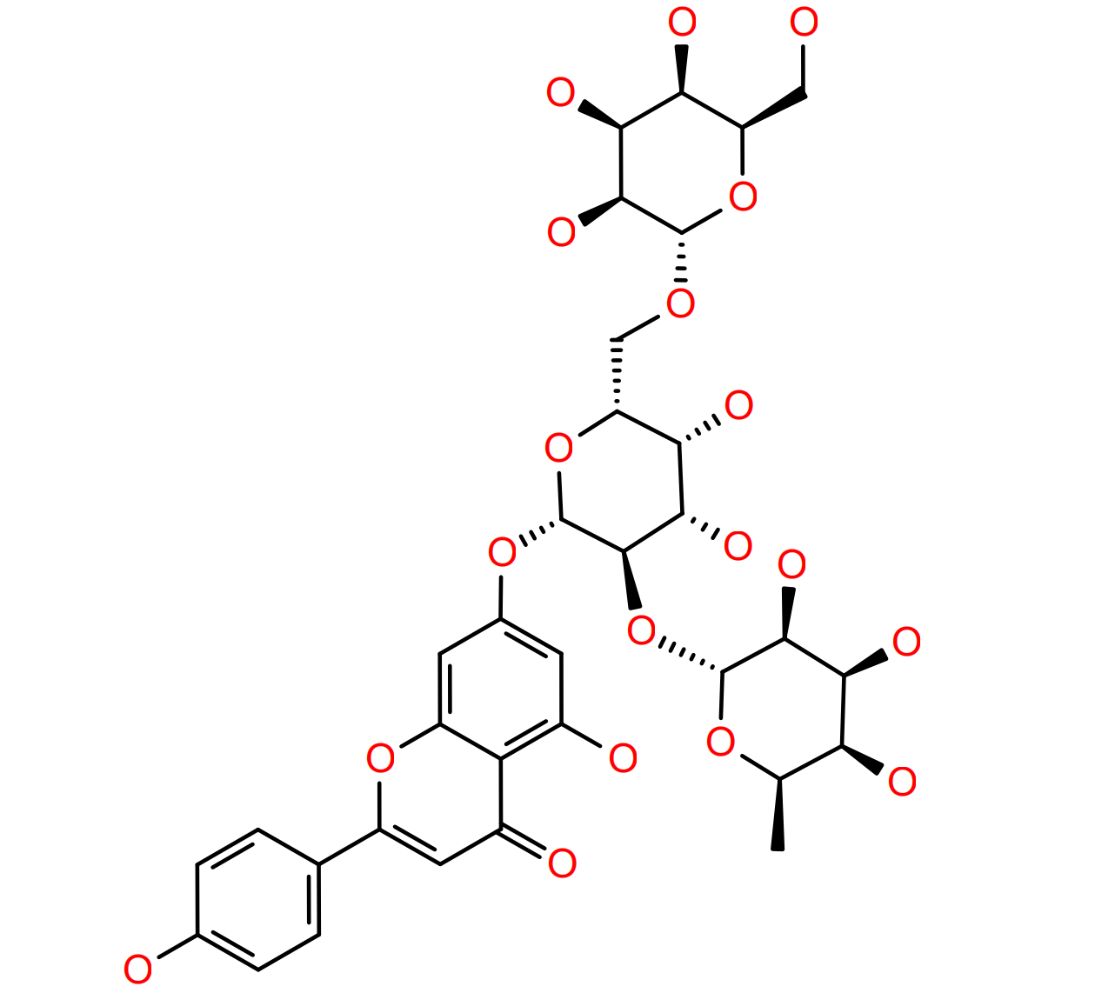
T2727 | Salvianolic acid B | -62.21 | 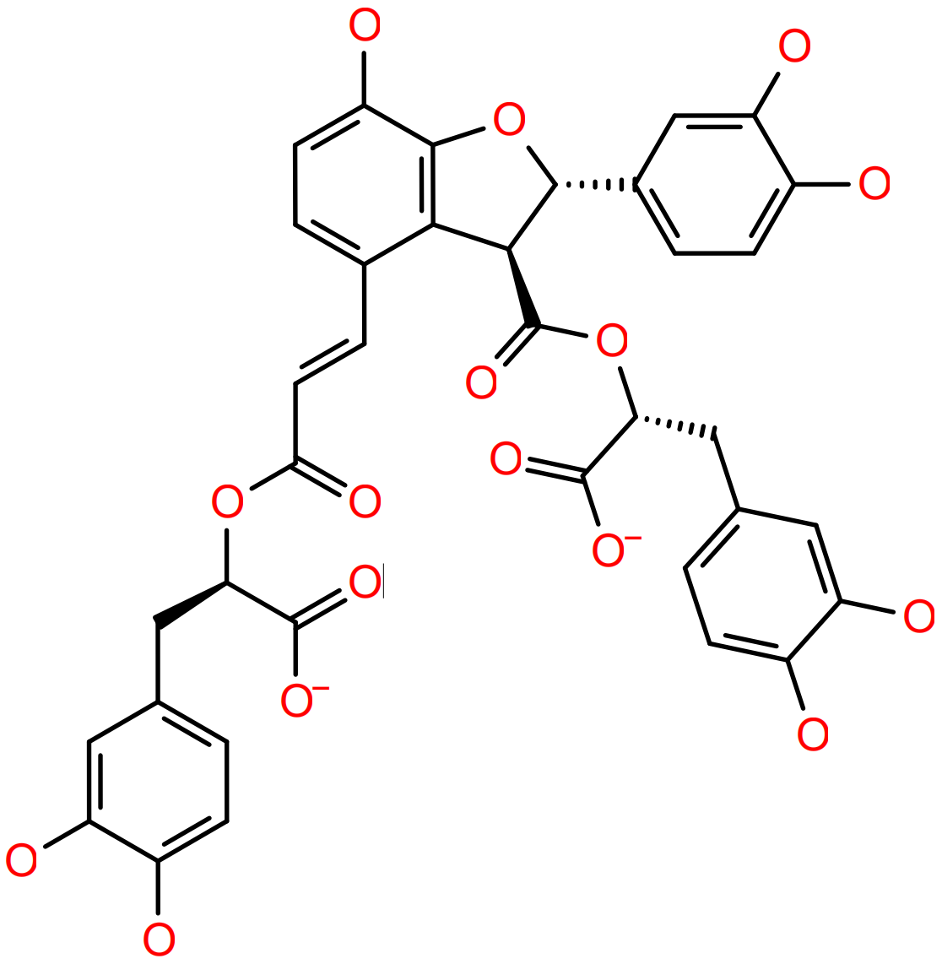
TQ0054 | Purpureaside C | -59.35 | 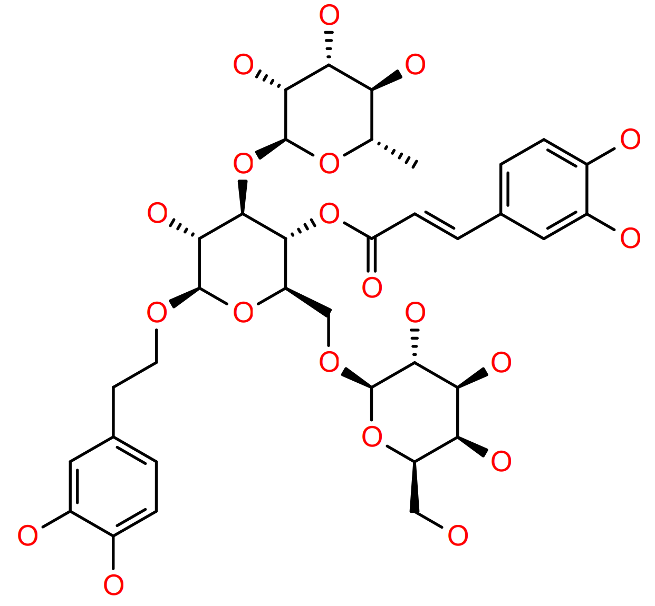
T5796 | Plantainoside D | -59.32 | 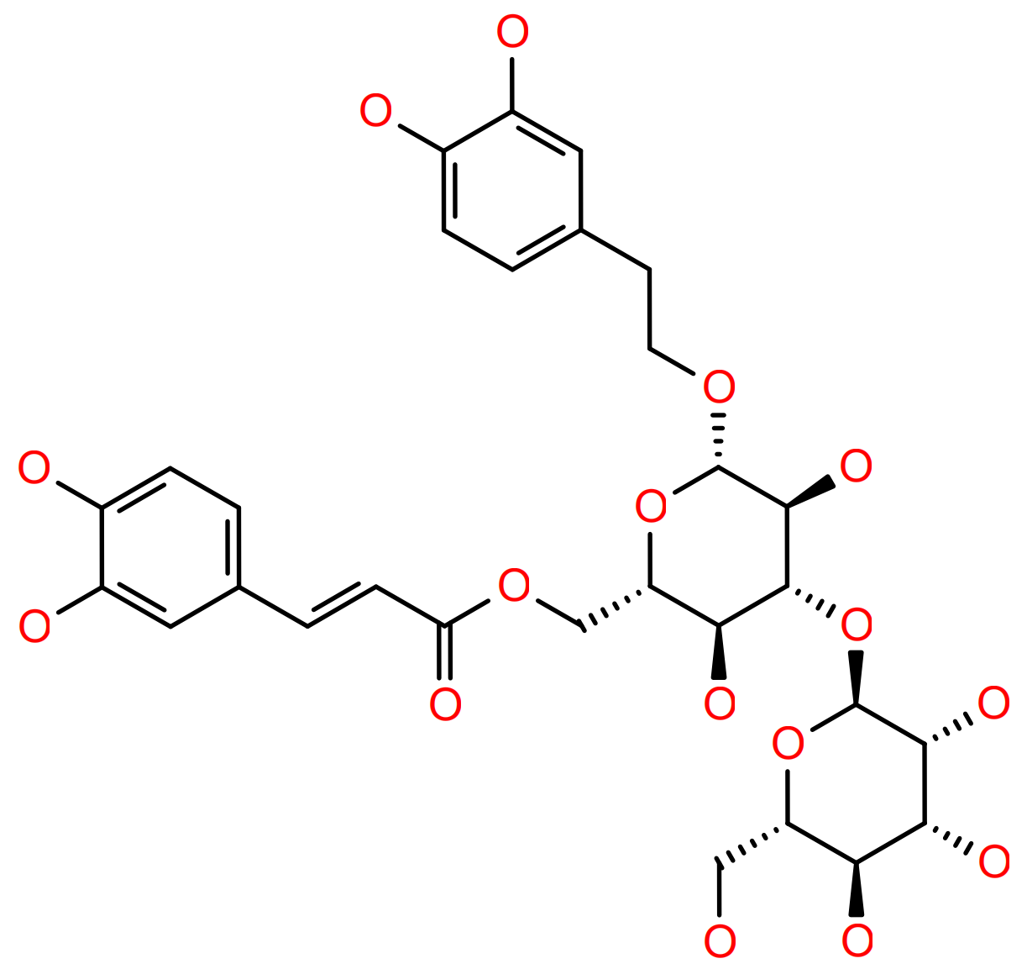
T5790 | 1,1,1,1-Kestohexaose | -57.96 | 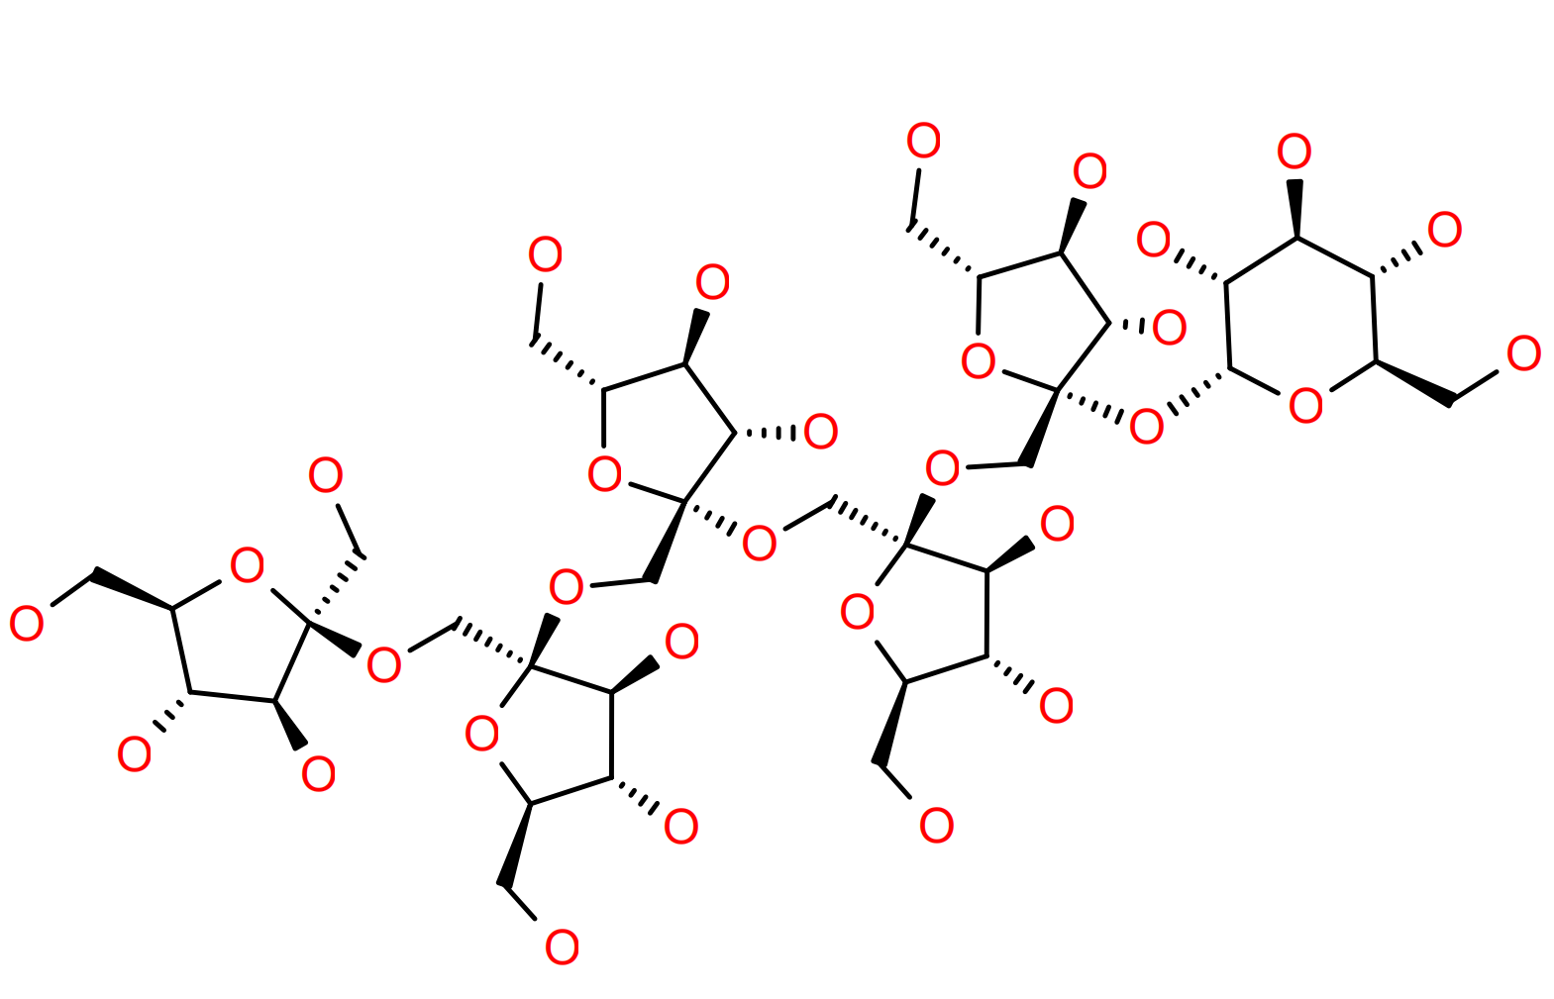
TN7085 | Myricoside | -57.3 | 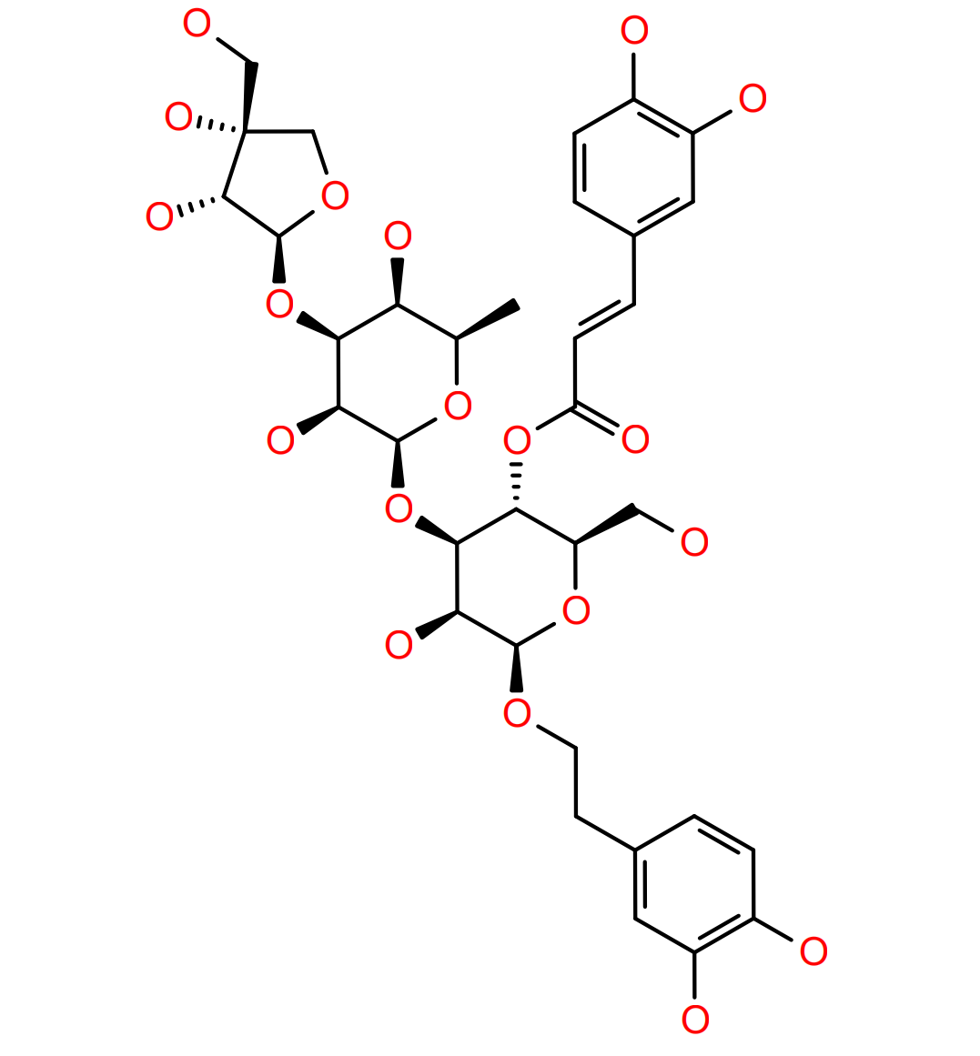
T3794 | Pentagalloylglucose | -54.61 | 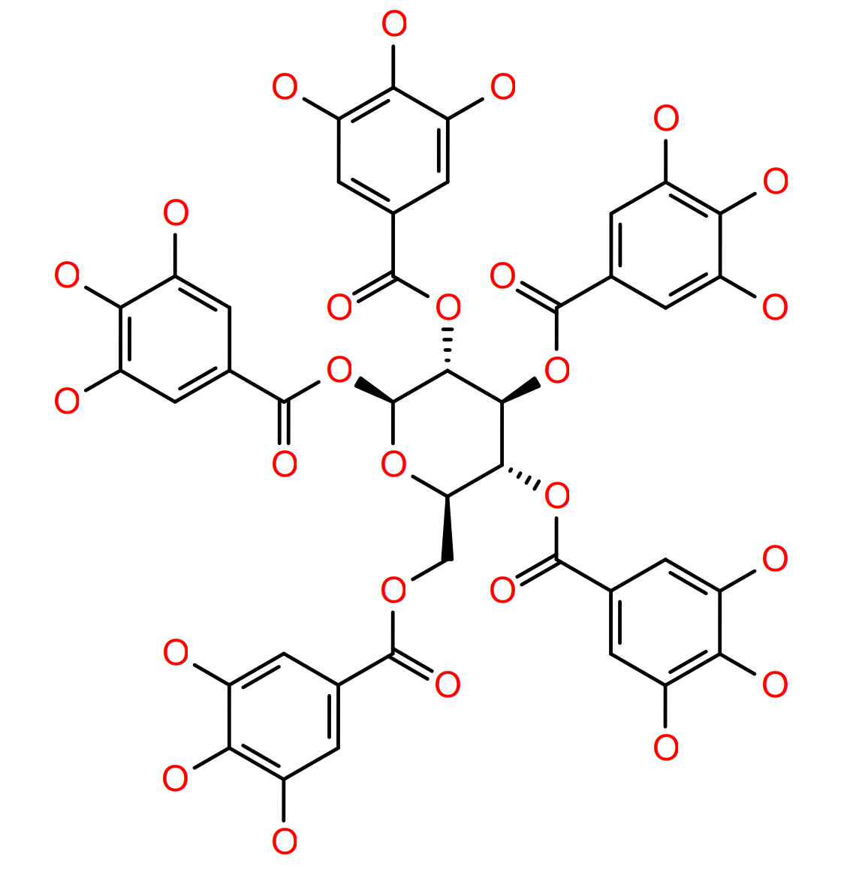
T3409 | Plantamajoside | -53.5 | 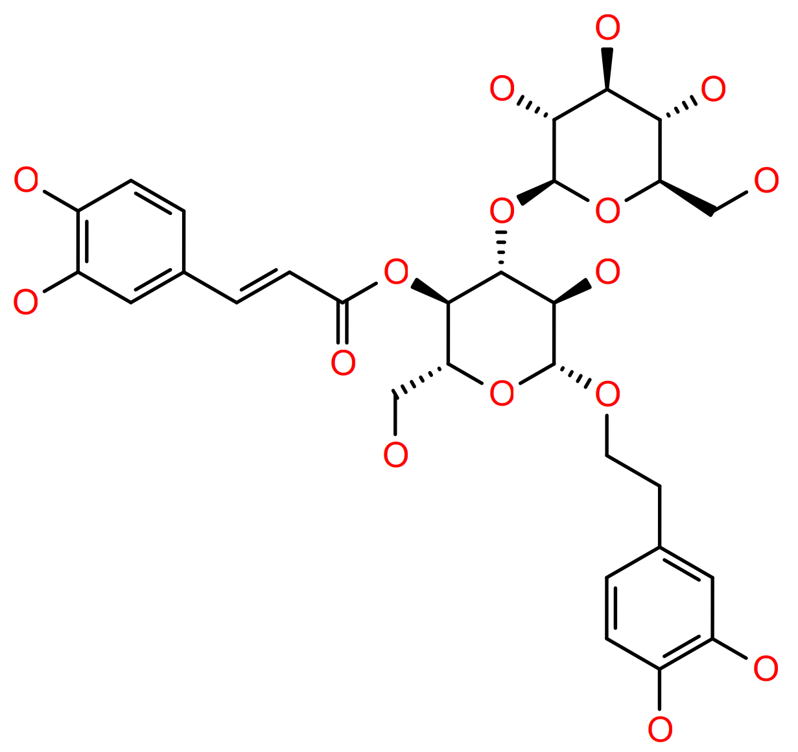
T22417 | Rutin hydrate | -52.15 | 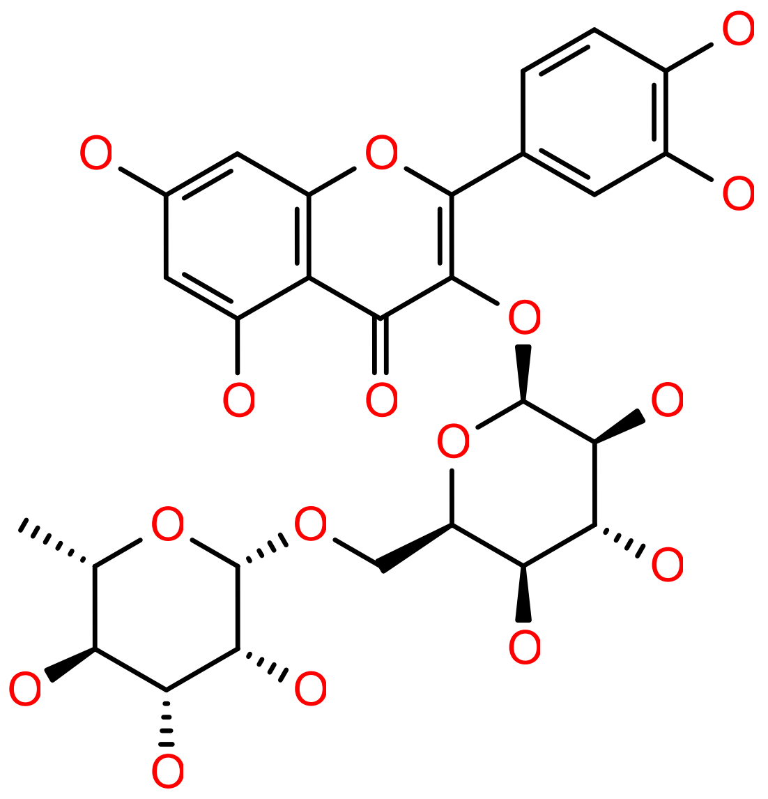
T6S2146 | Epimedin B | -50.65 | 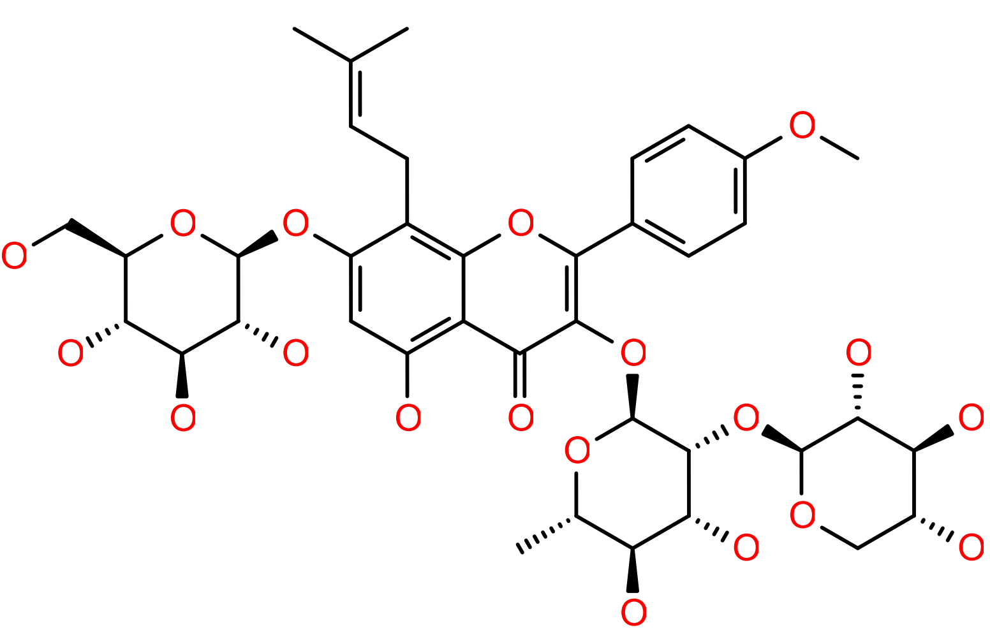
T3S1641 | Esculentoside H | -50.63 | 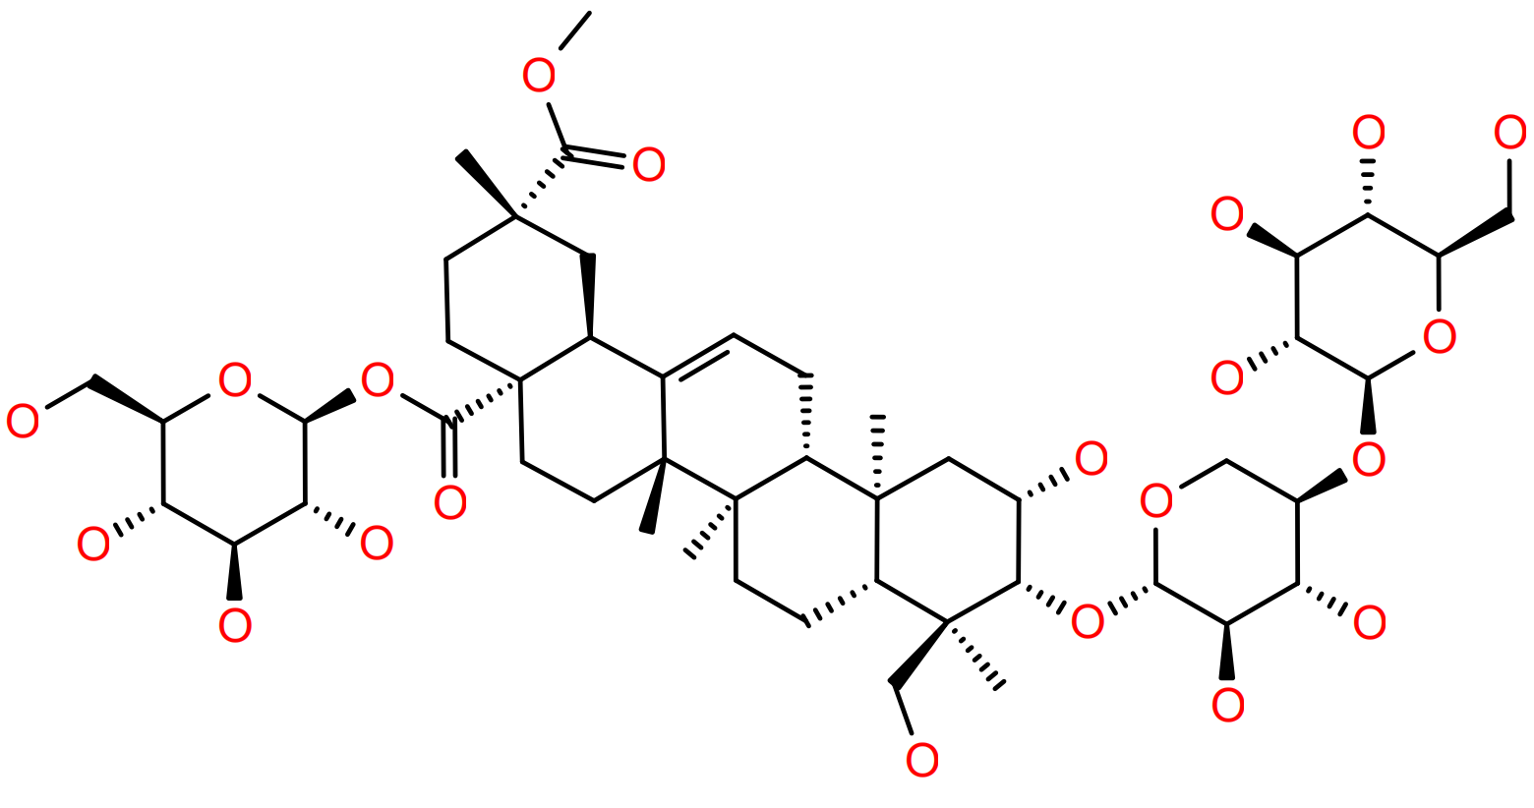
T8846 | beta-Escin | -50.47 | 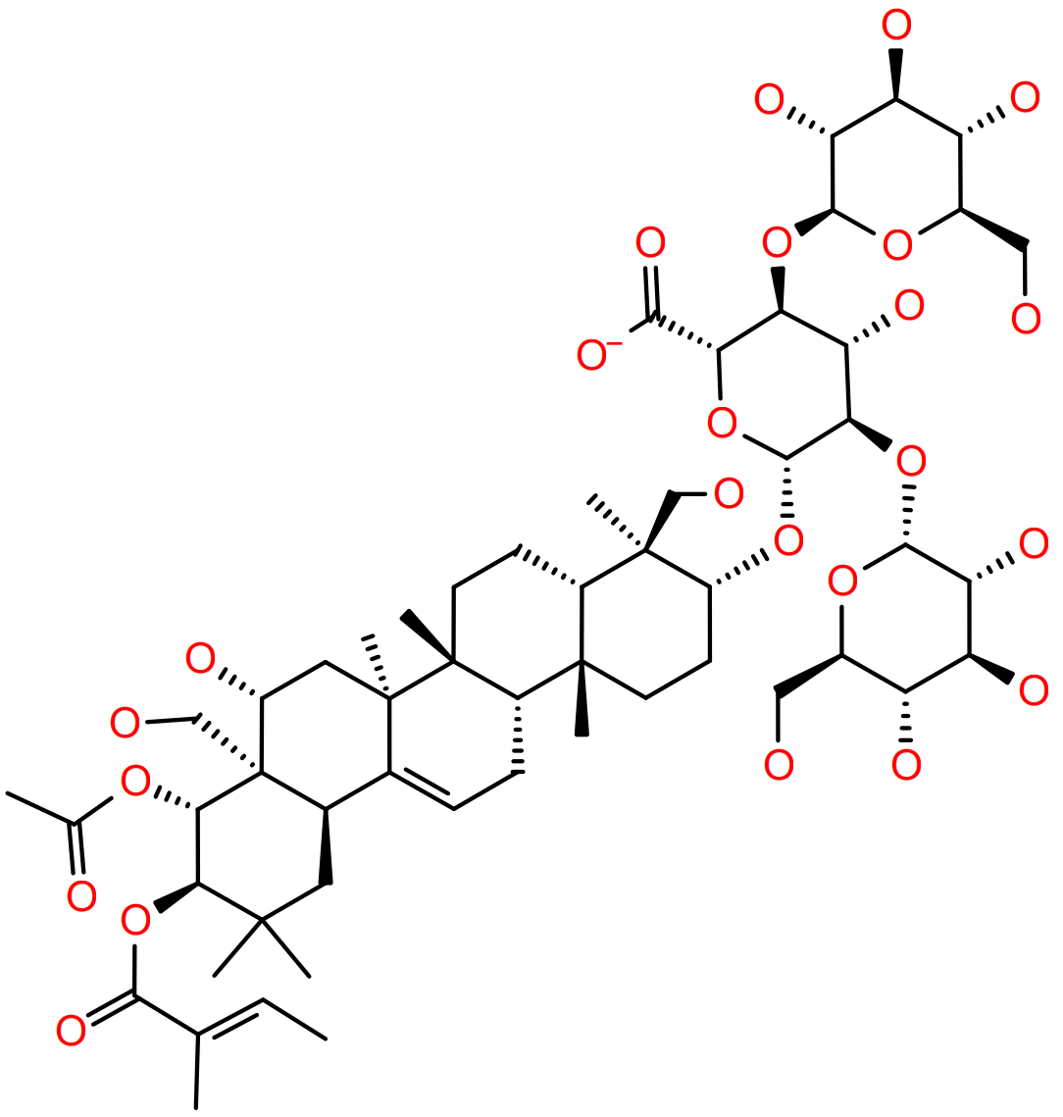
TN7216 | Magnoloside F | -50.39 | 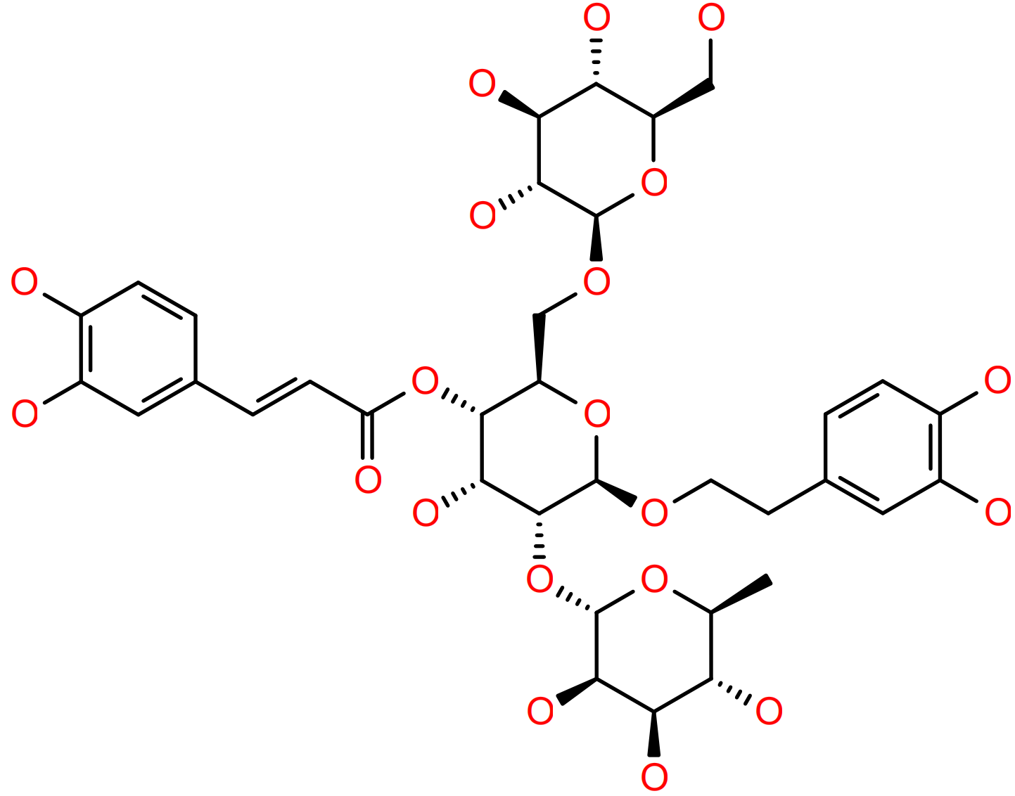
TN1166 | 1,3,6-Tri-O-galloyl-beta-D-glucose | -50.16 | 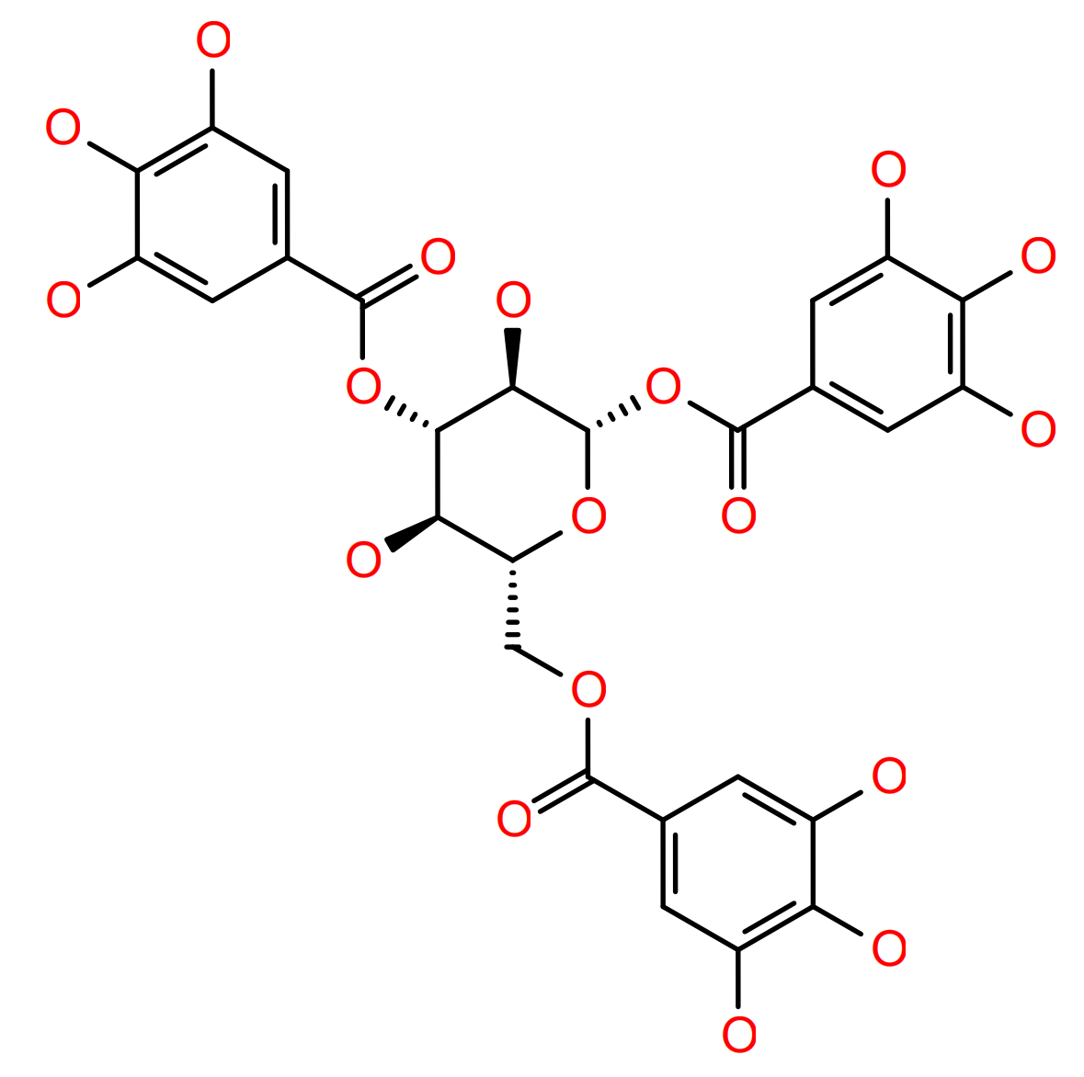
T5772 | 1F-fructofuranosylnystose | -50.03 | 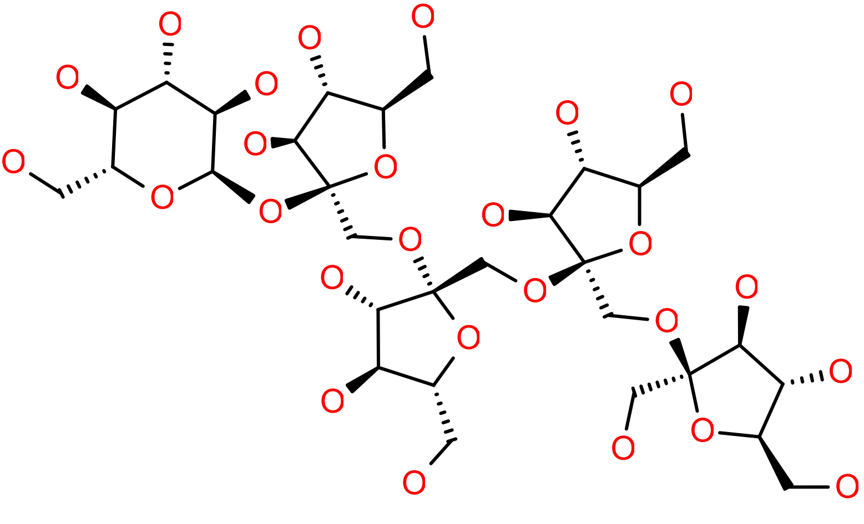

Fig. S1. OGD/R treatment induces a heightened pro-inflammatory response in THP-1 cells. (A) Representative bright field images of THP-1 cells after OGD/R treatment. Scale bar = 100 μm. (B, C) Quantification of IL-6 (B) and TNF-α (C) in THP-1 cells. Data are presented as mean ± SD. **P < 0.01, ***P < 0.001 and ****P < 0.0001.
Fig. S2. Flowchart of exosome enrichment by ultracentrifugation.
Fig. S3. THBS1 is highly expressed in OGD/R-treated macrophages. (A) Relative mRNA levels of THBS1 in THP-1 cells (n = 4). (B) Representative images and statistical graphs of immunofluorescence staining of THBS1 in THP-1 cells (n = 3). Scale bar = 20 μm. (C) Relative mRNA levels of THBS1 in RAW264.7 cells (n = 4). (D) Representative images and statistical graphs of immunofluorescence staining of THBS1 in RAW264.7 cells (n = 3). Scale bar = 20 μm. Data are presented as mean ± SD. *P < 0.05, **P < 0.01, ***P < 0.001, and ****P < 0.0001.
Fig. S4. Macrophage-derived exosomes are involved in si-ALI through THBS1-induced ferroptosis. (A) Representative immunoblotting for efficiency validation after silencing THBS1 in RAW264.7 cells (n = 4). (B) Transmission electron microscopy (TEM) images of the isolated exosomes from OGD/R-treated RAW264.7 after silencing THBS1. Scale bar = 100 nm. (C) Representative immunoblotting of THBS1 after overexpressing THBS1 in RAW264.7 cells (n = 4). (D) TEM images of the isolated exosomes of OGD/R-treated RAW264.7 after overexpressing THBS1. Scale bar = 100 nm. (E) Relative content of Evans blue in mouse brains (n = 8). (F, G) Representative images of Tunel (F) and DHE (G) staining of mouse brains. Scale bar = 200 μm. (H, I) Representative immunoblotting and quantification of barrier-associated proteins (ZO-1, Occludin and Claudin5) and GPX4 proteins in mouse brains (n = 3). Data are presented as mean ± SD. *P < 0.05, **P < 0.01, ***P < 0.001, and ****P < 0.0001.
Fig. S5. Validation of the biosafety and efficiency of macrophage-specific knockdown of THBS1 in mice. (A) Representative HE-staining images of the brains from mice treated with AAV-NC or AAV-Thbs1. Scale bar = 50 μm. (B) Representative images of DAPI/F4/80/THBS1 immunofluorescence staining in mouse brains. Scale bar = 100 μm.
Fig. S6. THBS1 does not directly interact with GPX4. (A, B) Representative images of co-immunoprecipitations used to assess the binding between THBS1 and GPX4.

