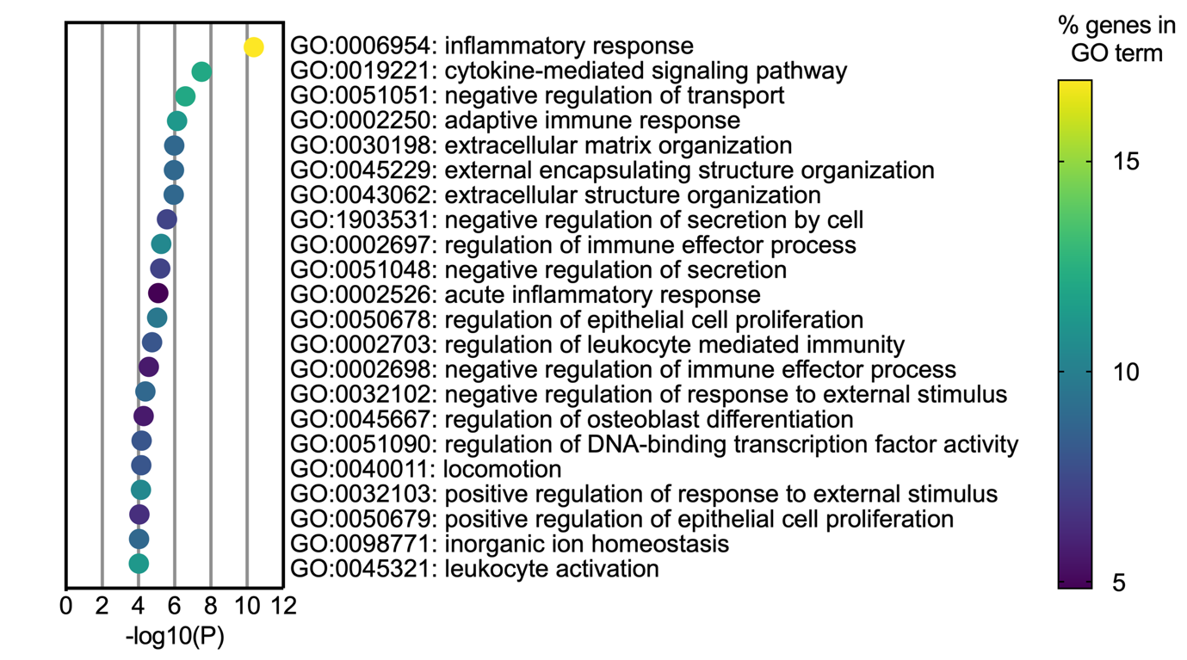

Supplemental Figure 1: Top Gene Ontology terms.
List of top Gene Ontology (GO) terms enriched in the list of genes differentially expressed between OIR-Norm and OIR-CIH retinas. Terms are ordered by -log10(P) value and points are color coded by the percentage of genes in the list associated with the corresponding GO term.

